 | Summerhill Care Home
April News Letter
Welcome |  |  | 
Welcome to April’s newsletter, we hope everyone had a wonderful Easter, with lots of Easter eggs and Hot cross buns eaten. We had a lovely time celebrating with chocolates given to all residents and we had a special visit from some lambs.

We have enjoyed some trips out this month, I now have business insurance and can take out a couple of residents at a time which gives us a little more freedom on the outings, even if its just for a coffee.

The silent disco was a huge hit, which you can see during this newsletter, we will certainly be having them back in the future, it was very inclusive and allowed those who stay in their rooms to be included also.

We have sent off for our wonderful hanging baskets to be filled and will hopefully have them back mid-May, these are a wonderful addition to the home in the summer months and look spectacular when in bloom.
Activities & Events
BIRTHDAY  Happy Birthday to Anne |  | BOARD  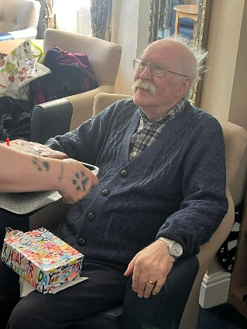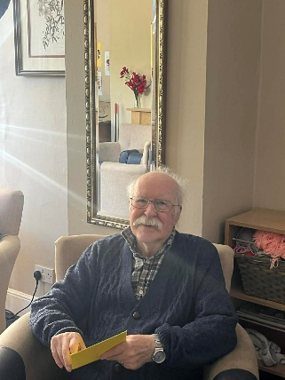  Happy Birthdat to Richard who has the best smile  Happy birthday to Tom, the residents enjoyed a fabulous chocolate cake that was made for him by our cook Kelly – Tom also enjoyed a trip to McDonalds for lunch with me– he was proper  spolied  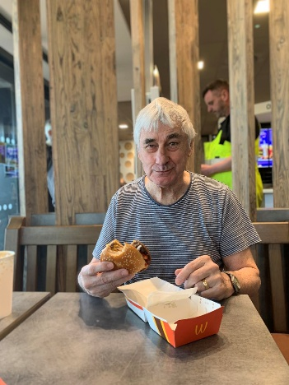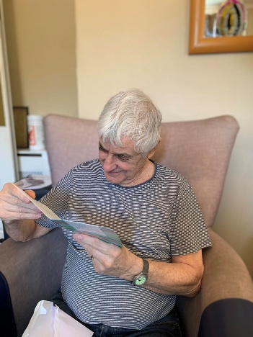  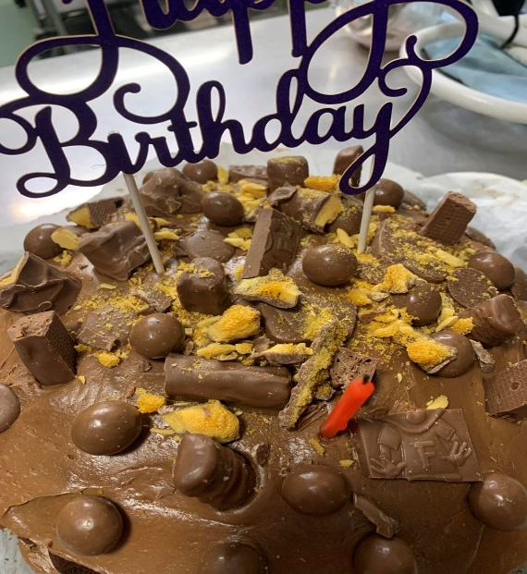  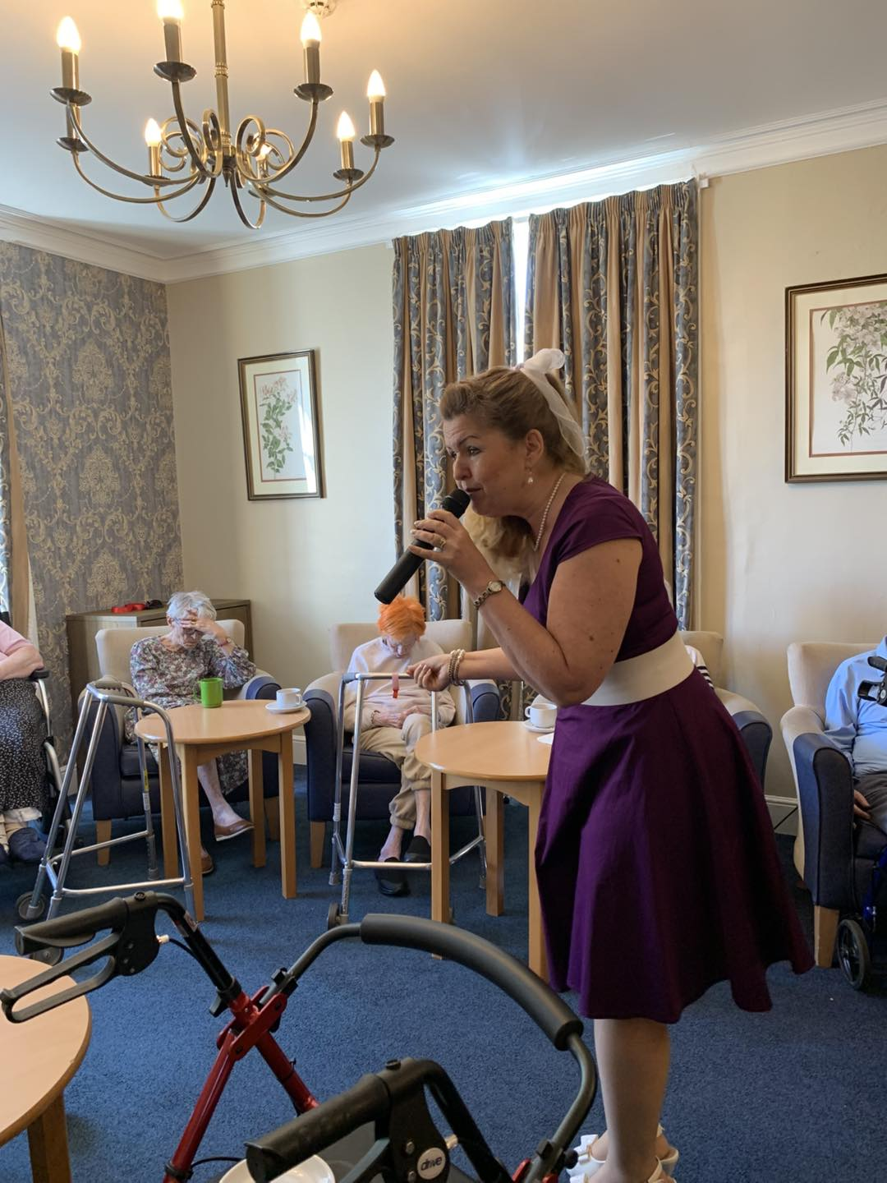  Richard enjoying the music  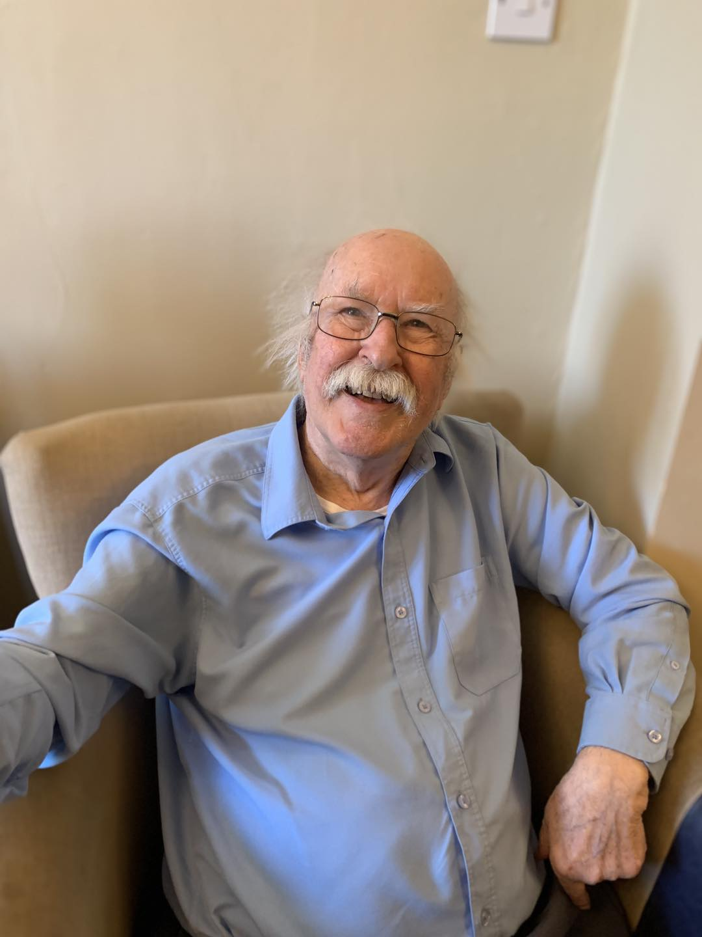  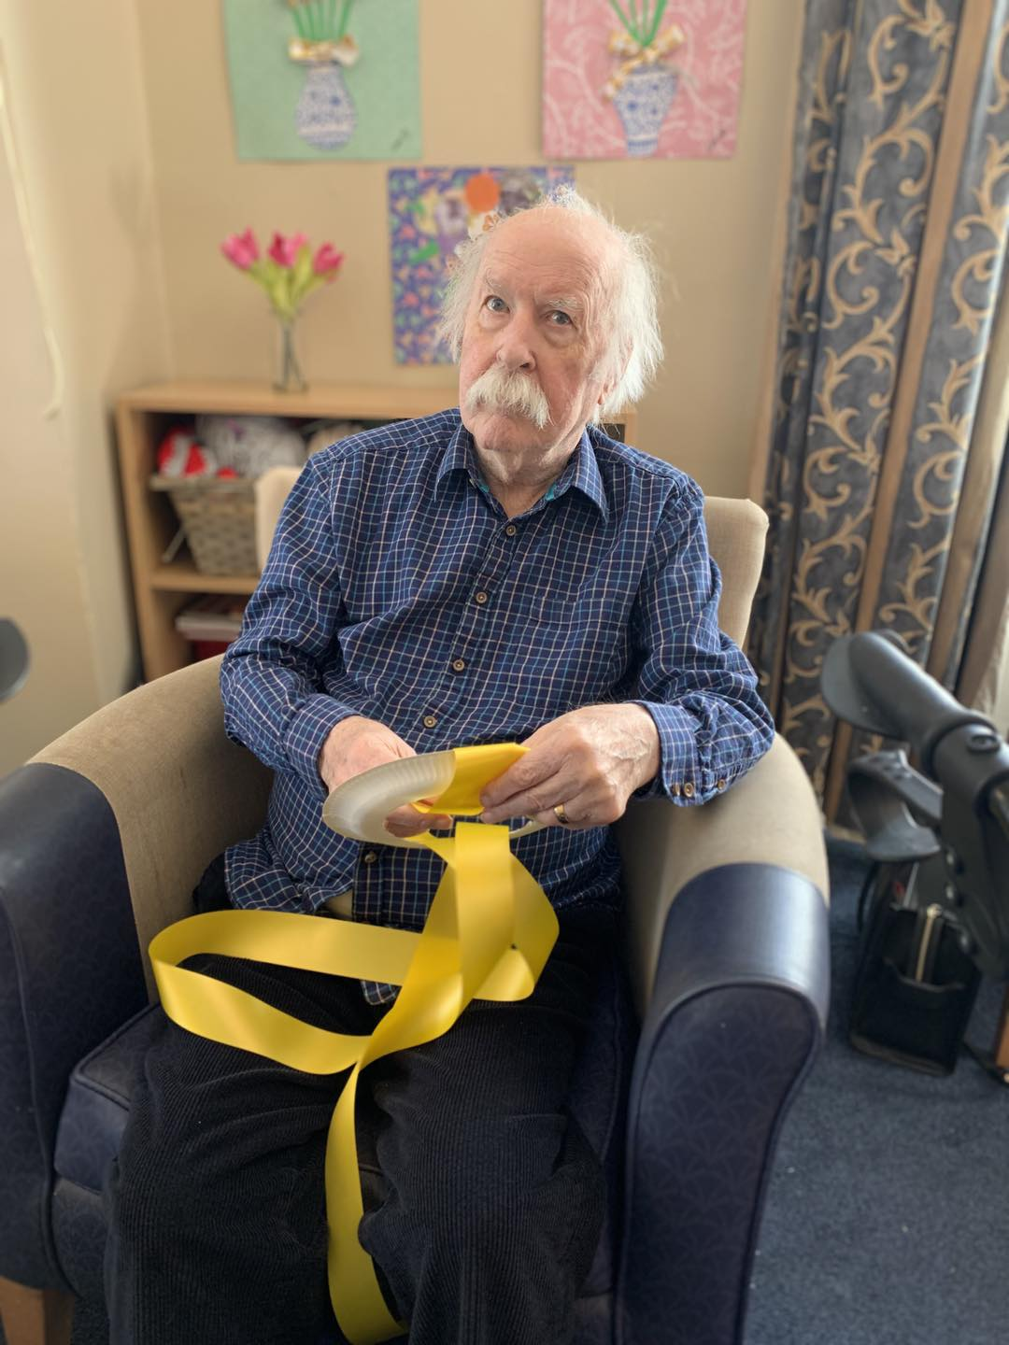  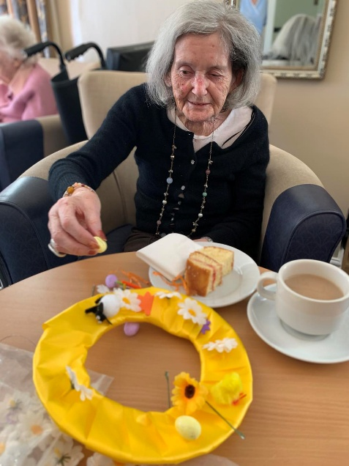  We had a lovely morning making some Easter wreathes to decorate the lounge with, those that participated enjoyed their morning showing their creative side whilst enjoying the company and community spirit.  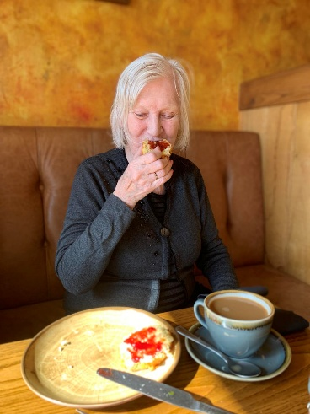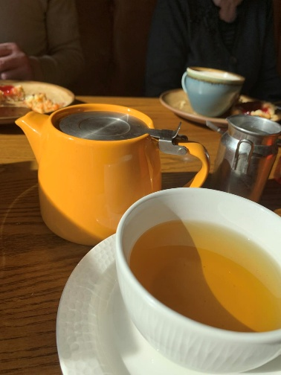  Yvonne enjoyed her trip out to Amble for scone and jam  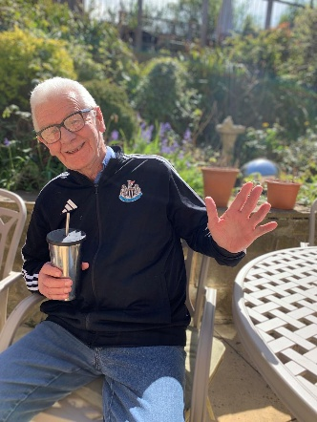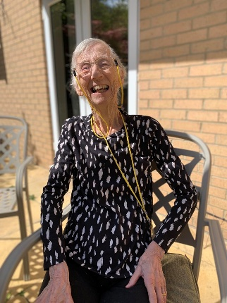  Paul and Jenny enjoying the Sun in our yard   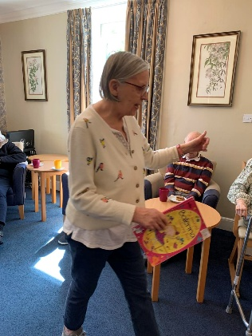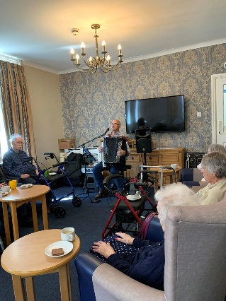  Anne and the gang enjoying our monthly visits from Robert Whitehead – he has been visiting us now for a good few years and is still as popular today as he was then  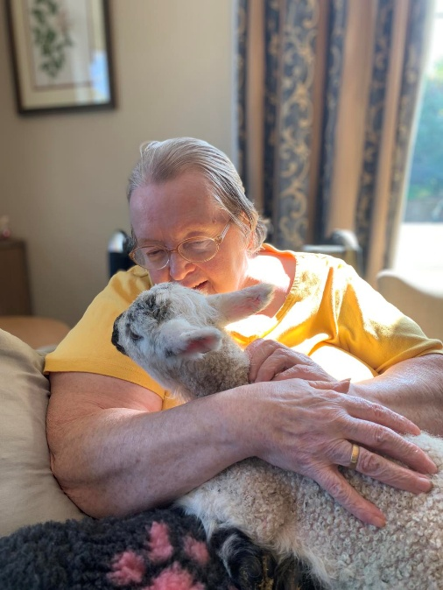  Linda enjoying a cuddle and reminiscing about her days on the farm  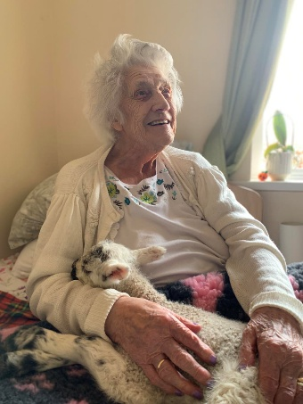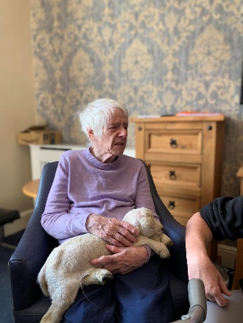  Everyone really enjoyed the Lamb’s visiting, it evoked so many memories with the residents  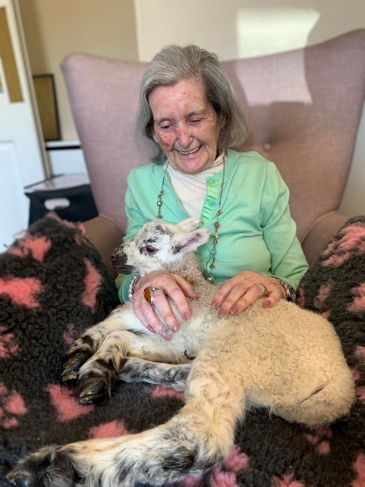  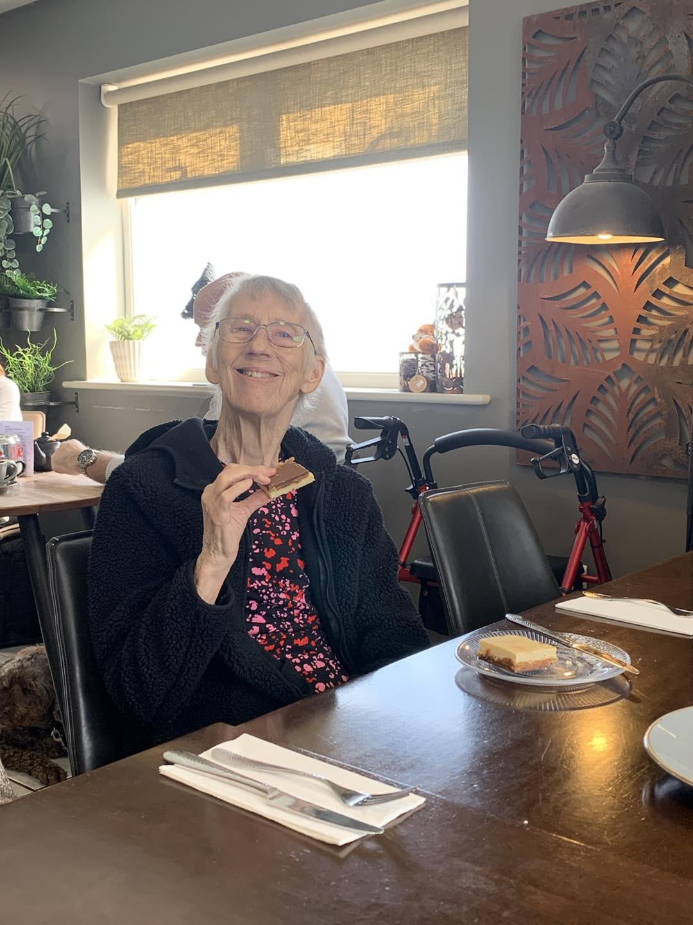  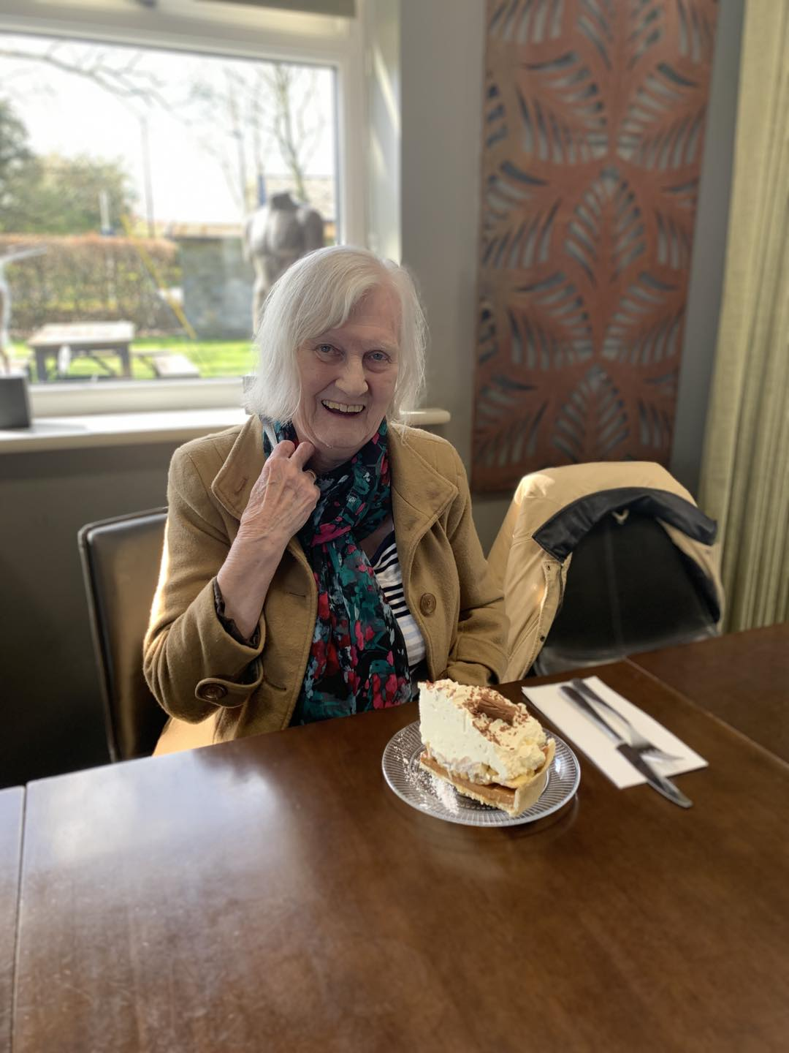  Yvonne enjoyed her Banoffee pie as you can see by the smile on her face!!  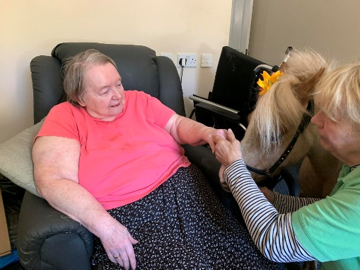  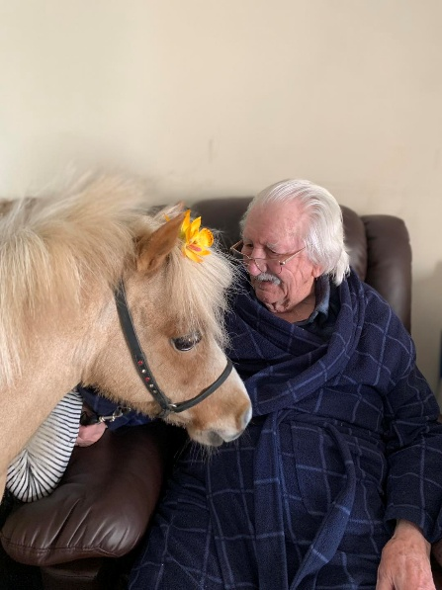  Having the therpy pony visit provides significant mental and physical health benefits, including reduced stress anxiety and blood pressure while promoting social interaction and joy for the residents  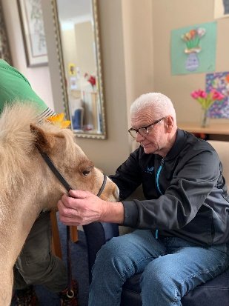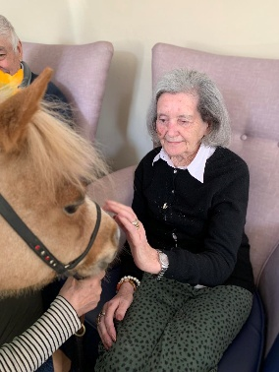  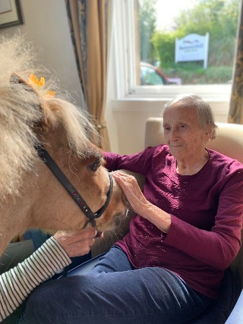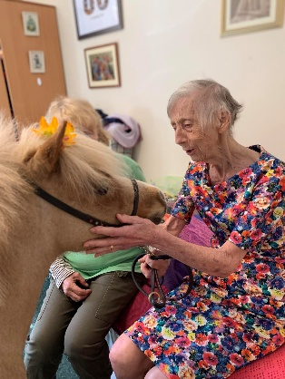  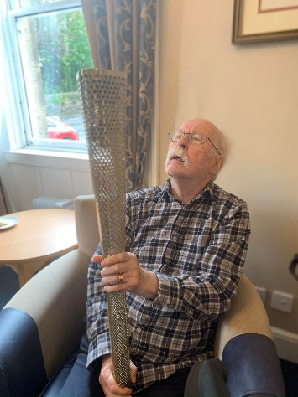  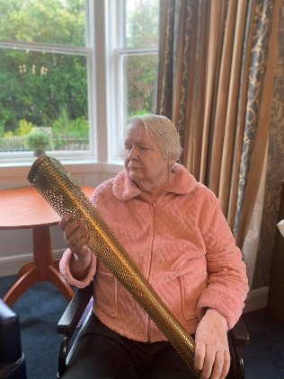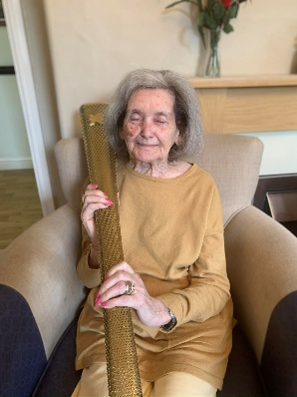  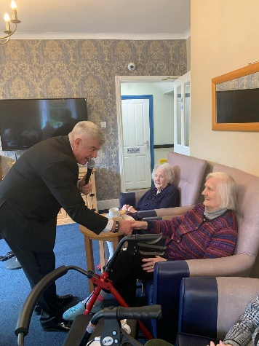  John was kind enough to bring in his Olympic torch to show us and everyone had a hold, it was heavier than expected – John told us the story that he had raised money for a local charity and his company had put him forward for a reward and his reward was to be part of carrying the torch for the 2012 London Olympics – he made such an impact on his company that they bought the torch for John to keep – what a wonderful surprise for us all – he then put on his fabulous show with singing all songs from The Rat Pack  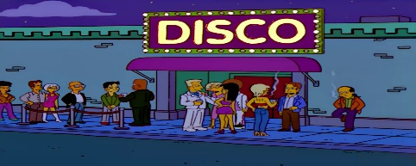  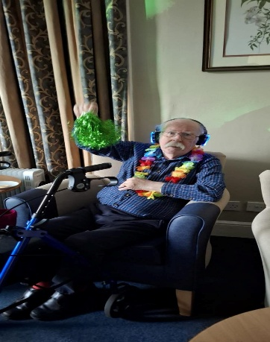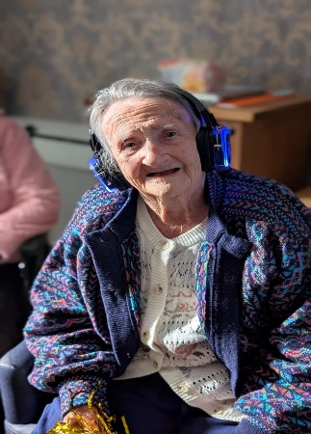  The silent disco was a hoot, this was such an inclusive activity, those that were in their rooms also had headphones and could listen to the music and the compare had everyone’s names, so was chatting to them through the mike – some carers also had them on so they could also hear what the residents were listening too. It certainly had everyone smiling and up dancing – we will certainly be inviting John back for another session in the futur  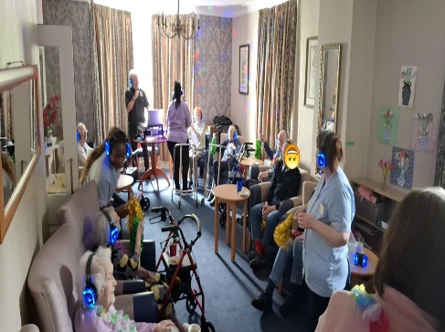  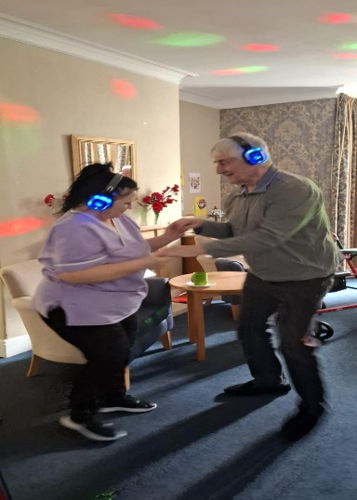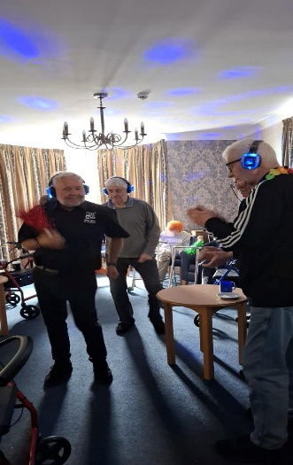  We welcomed Mike Memphes back as Elvis, he is fabulous with the residents, very inclusive and makes everyone feel special – takes time to greet everyone and haver a little fun - he even visits individuals’ rooms for a little sing along which is great for those who a poorly or choose not to leave their rooms.  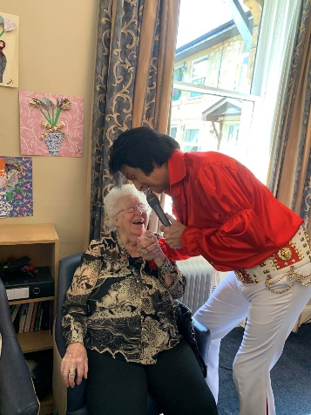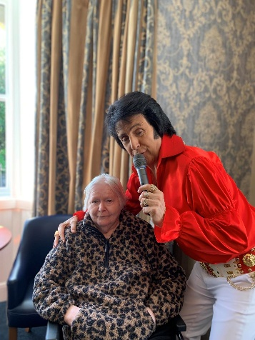  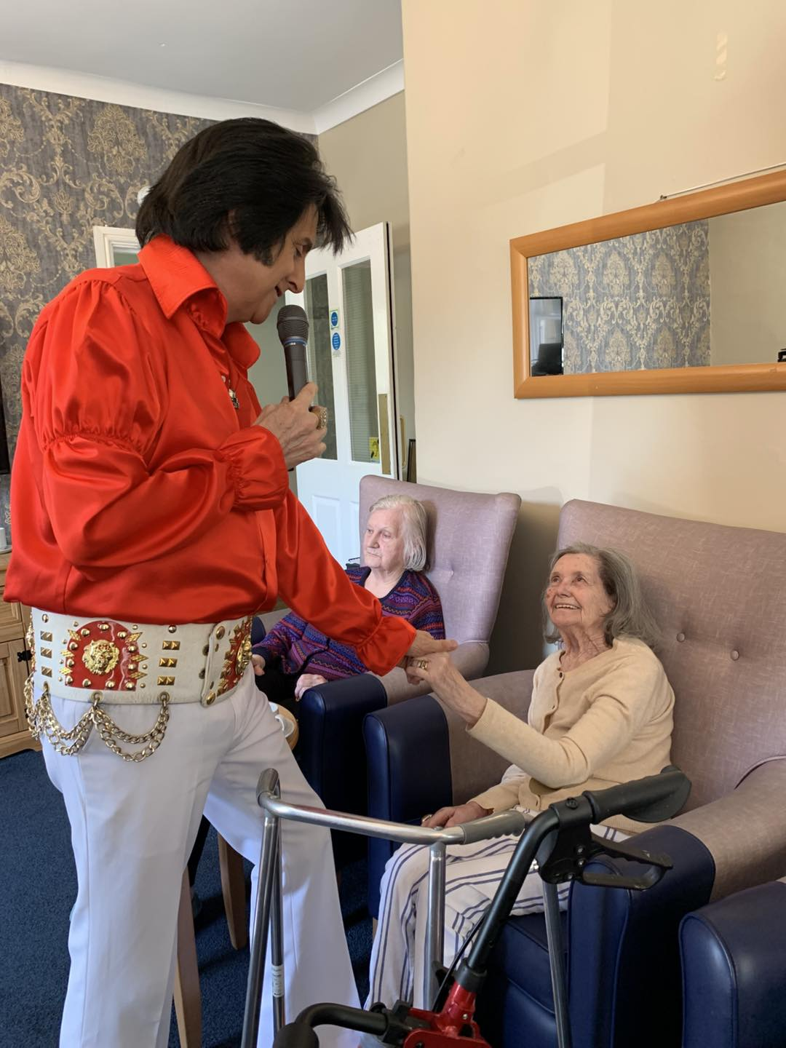    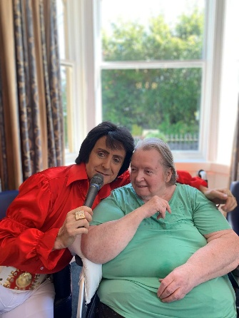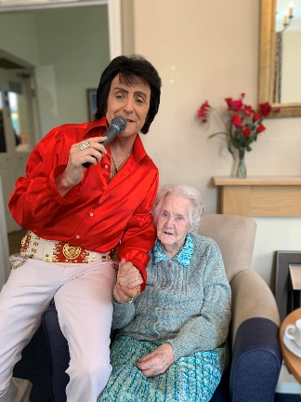  Some more great pictures from Elvis  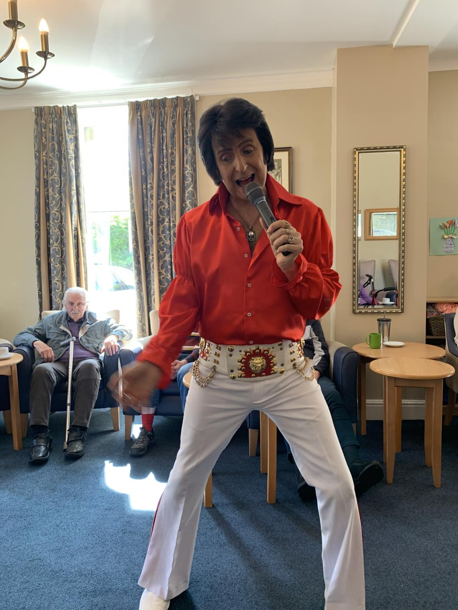  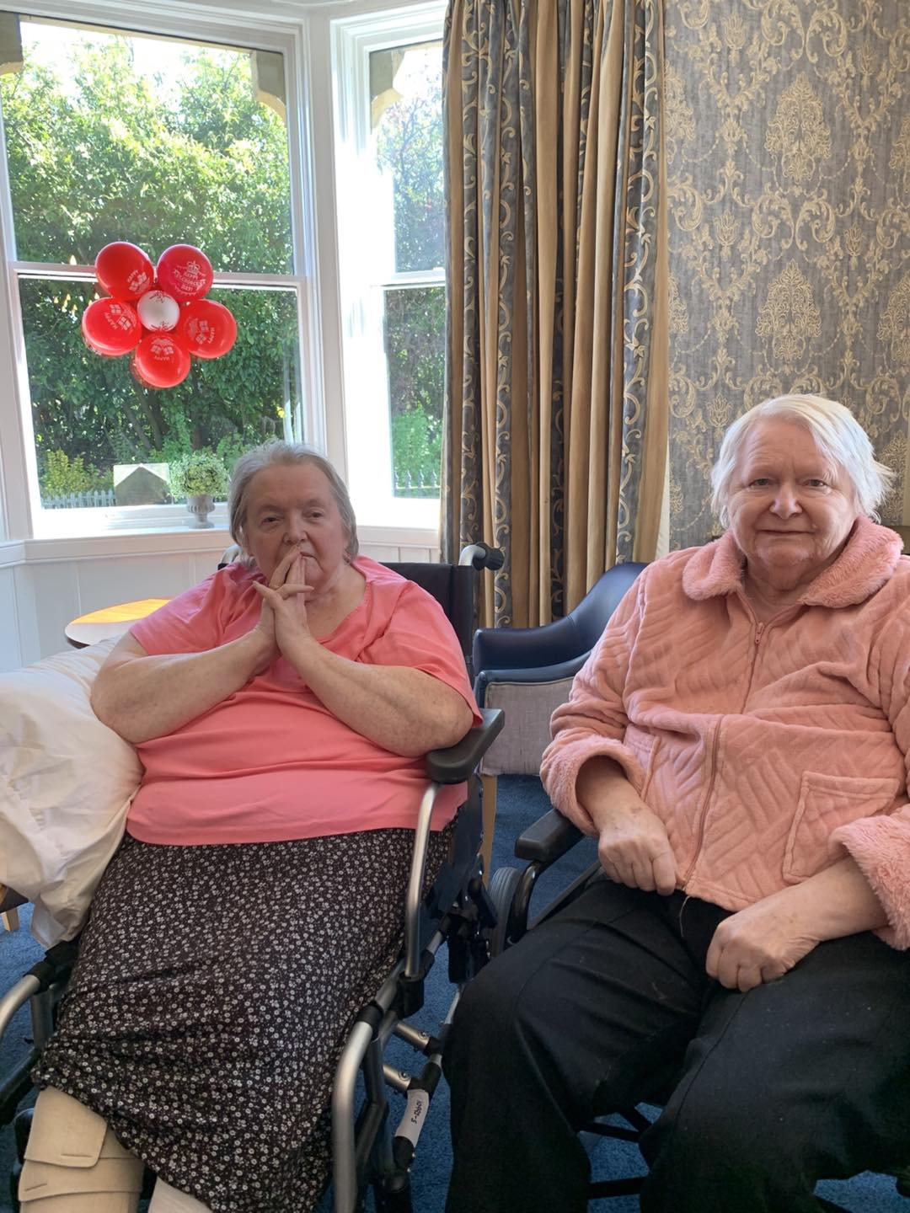  We had a fabulous morning celebrating St Georgs Day, we listened to poems, sang some great English songs and watched some traditional Morris dancing and May Pole dancing  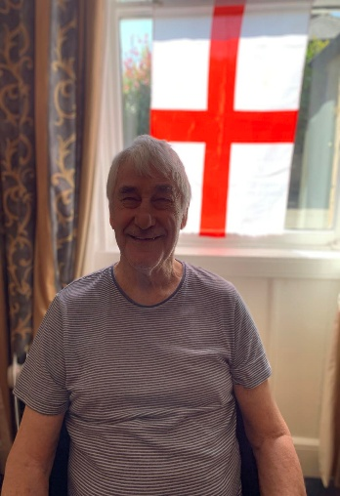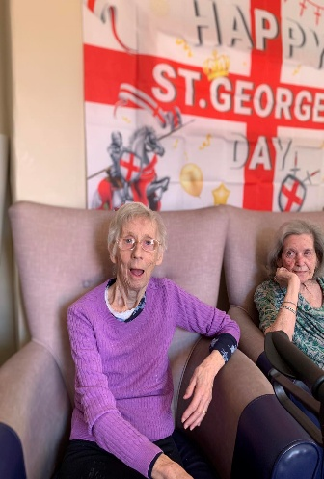  Congratulations to Amanda who won the easter hamper  Monday 18th May– We will be doing an infused glass workshop in the dining room @11am  Tuesday 19th May – Join us in the large lounge with singer Derek Hodgson in the large lounge @11am  Tuesday 26th May – Join us in the large lounge for our monthly Church Service @11am  Thursday 28th May – Join us ion the large lounge with Robert Whitehead, playing his accordion @ 11am  Friday 29th May – Join us in the large lounge for Elvis @ 1.45pm
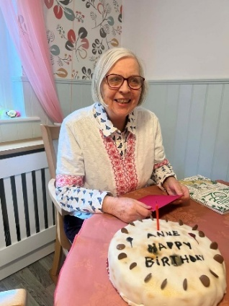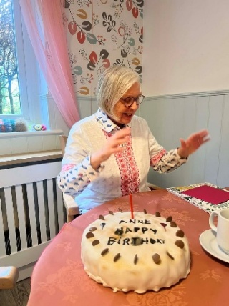

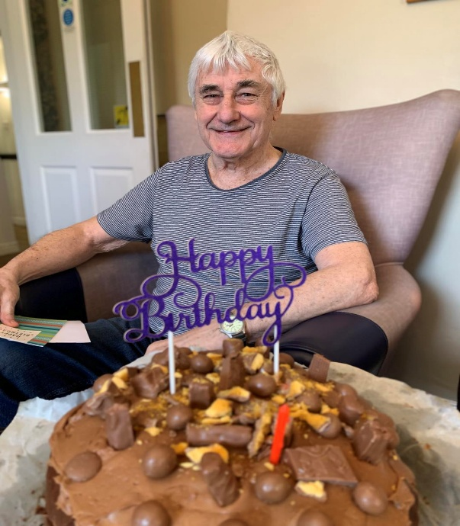

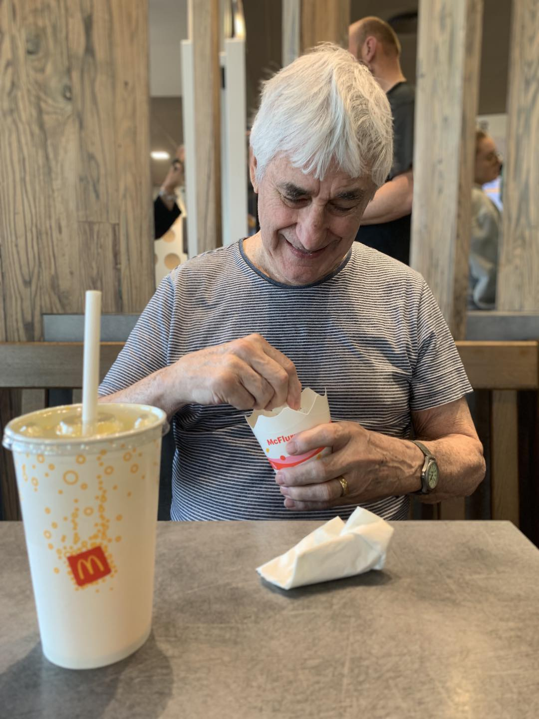

We welcomed Christine Rosemond for the first time,
Everyone enjoyed a session from the Fabulous 50’s remembering all the old songs, it was a toe tapping morning!!

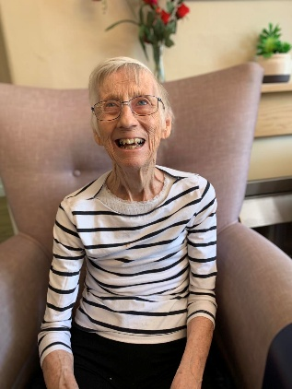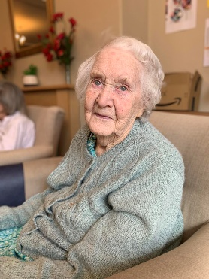

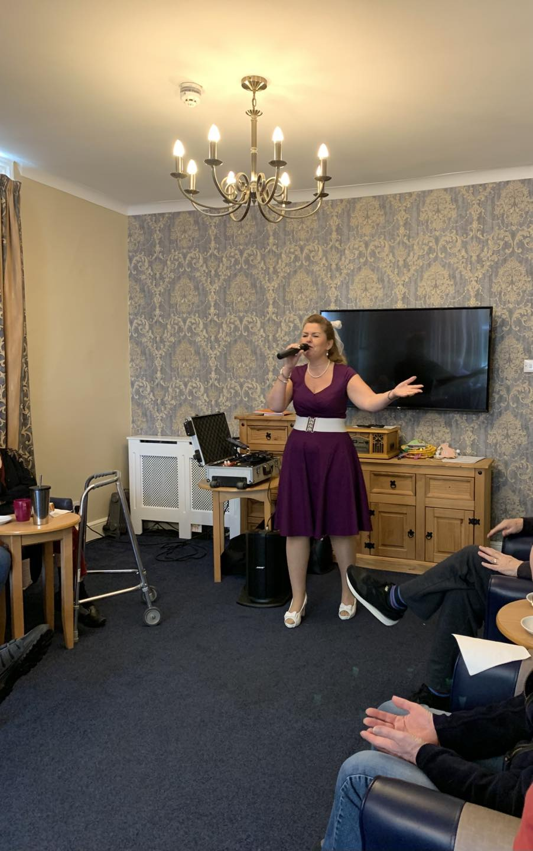

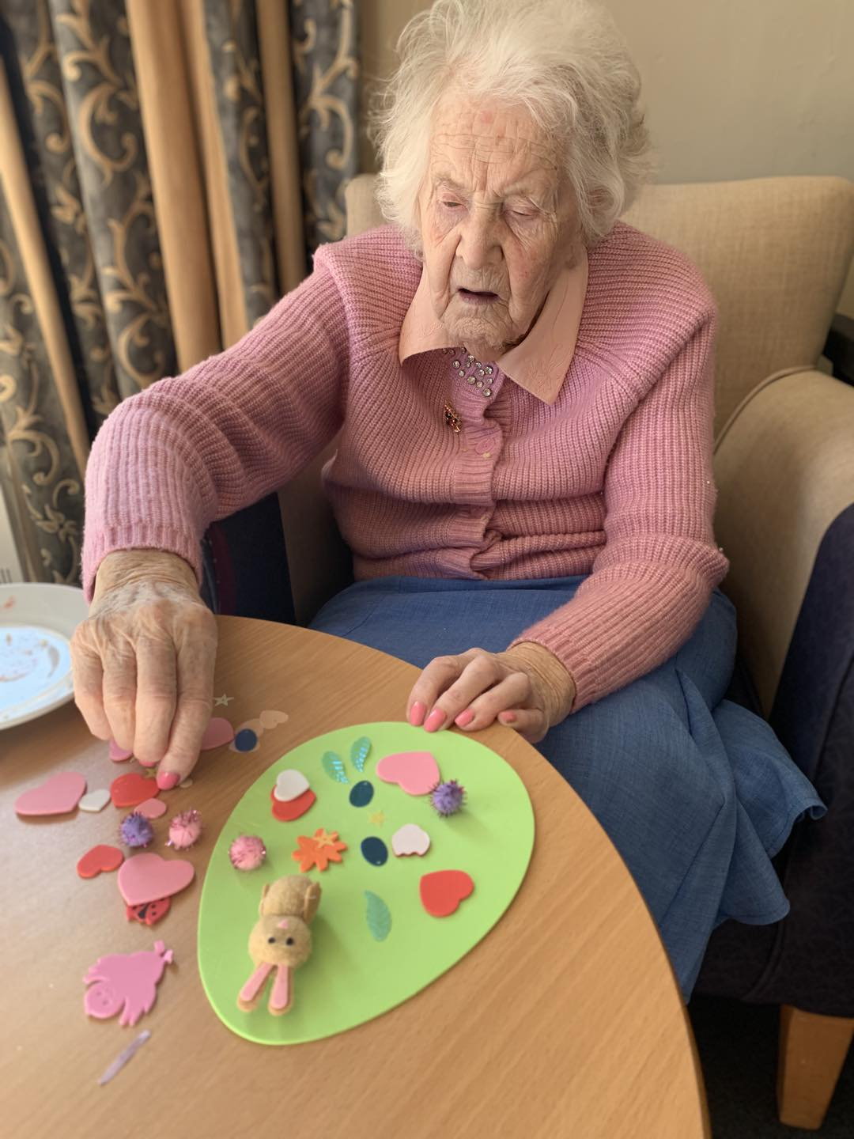

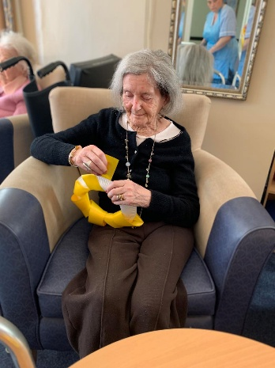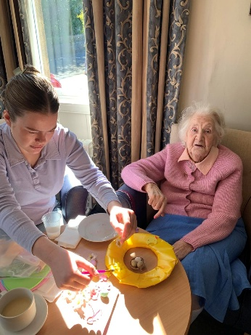

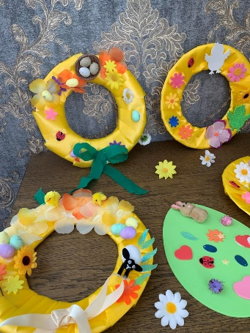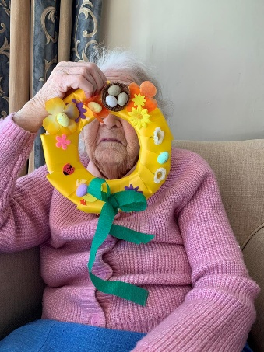

We have enjoyed our usual activities, exercises, our weekly visits from King, making the most of the weather and sitting in the garden, bingo and as always, the amazing Robert Whitehead
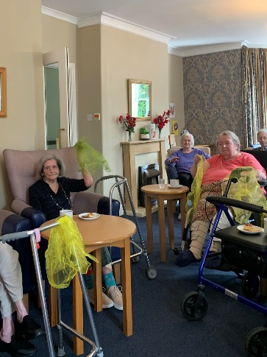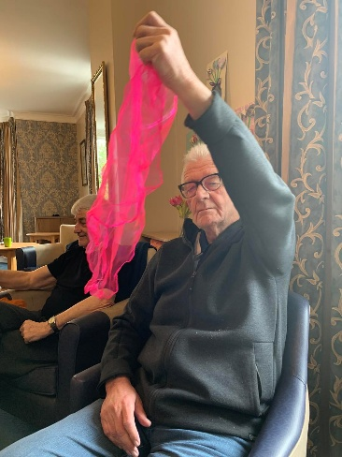
Armchair exercises with scarfs

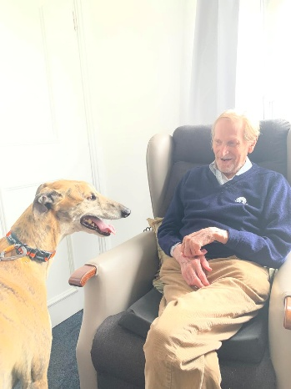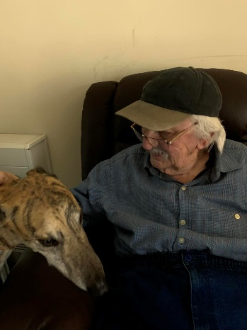
Arthur and Derek enjoying a visit from King

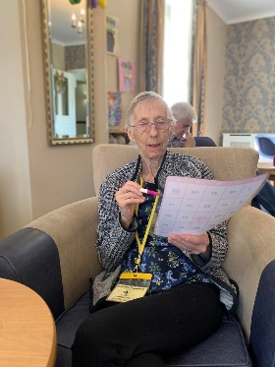
Look at the concentration on Jenny’s face

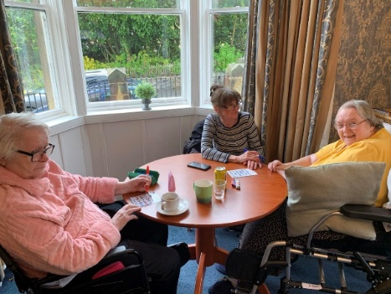

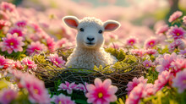

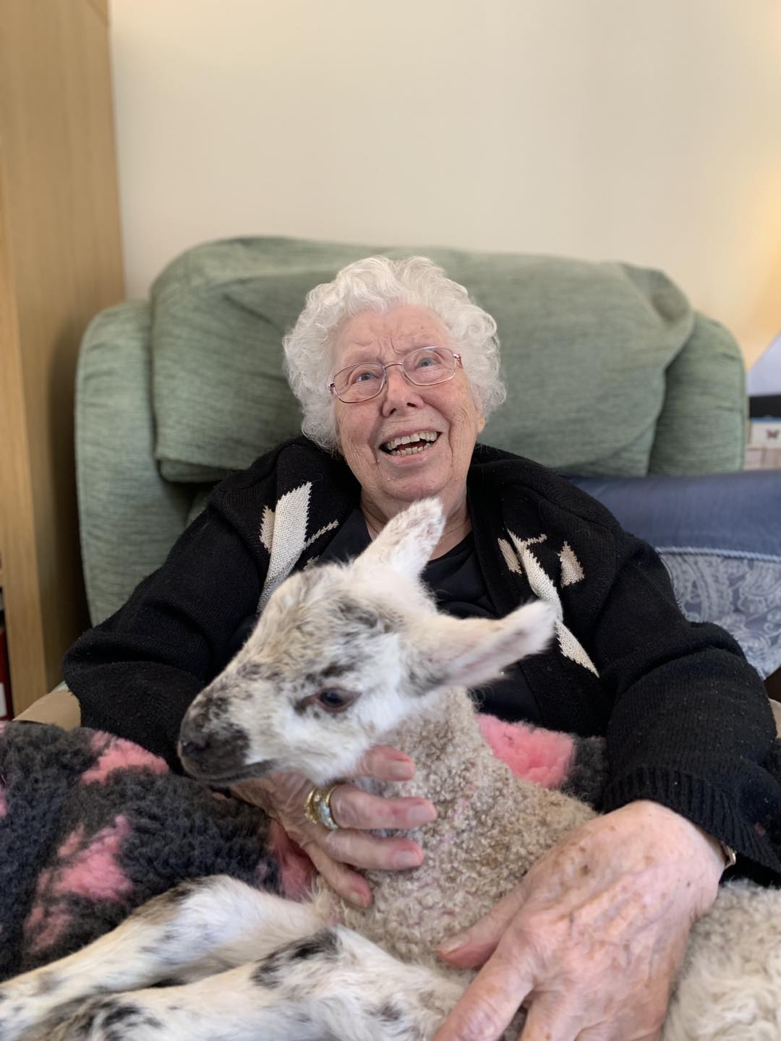

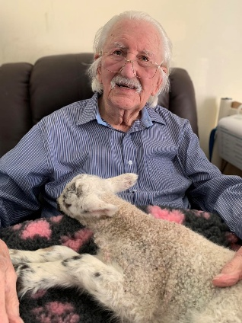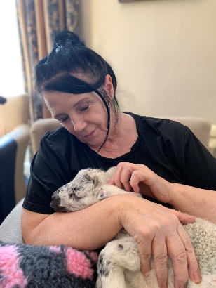

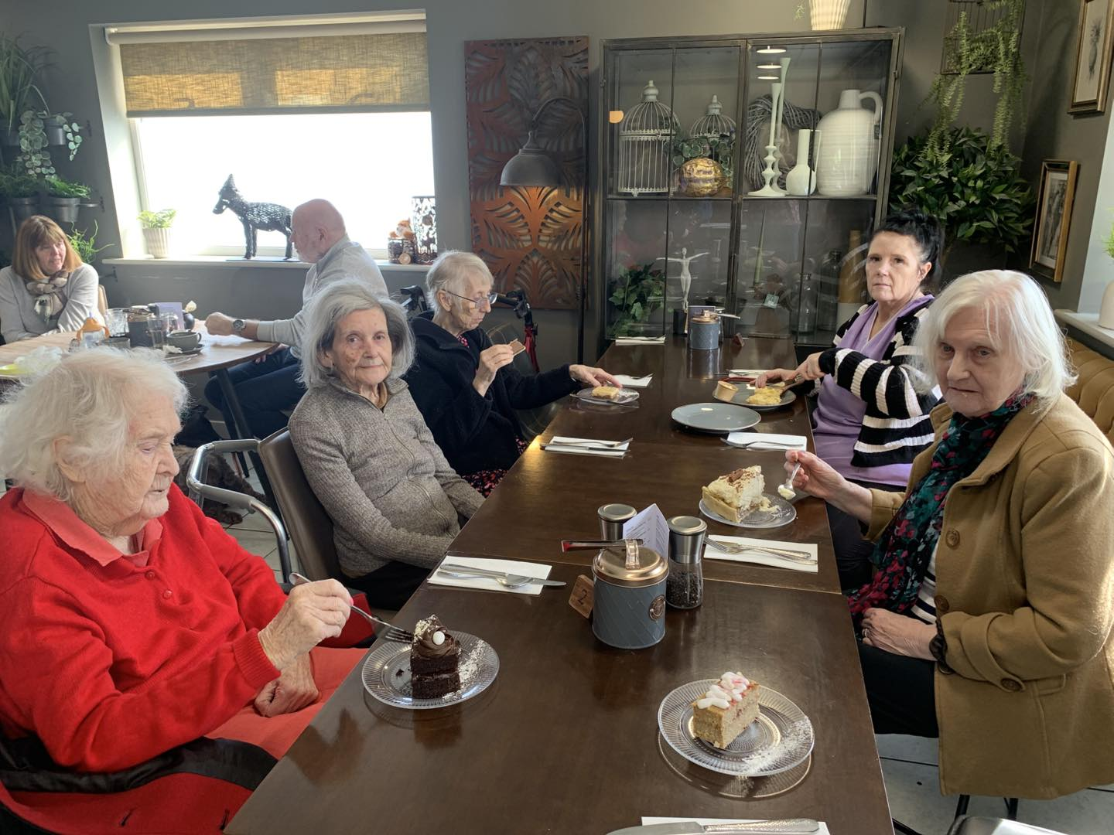

We had a lovely afternoon at the running fox

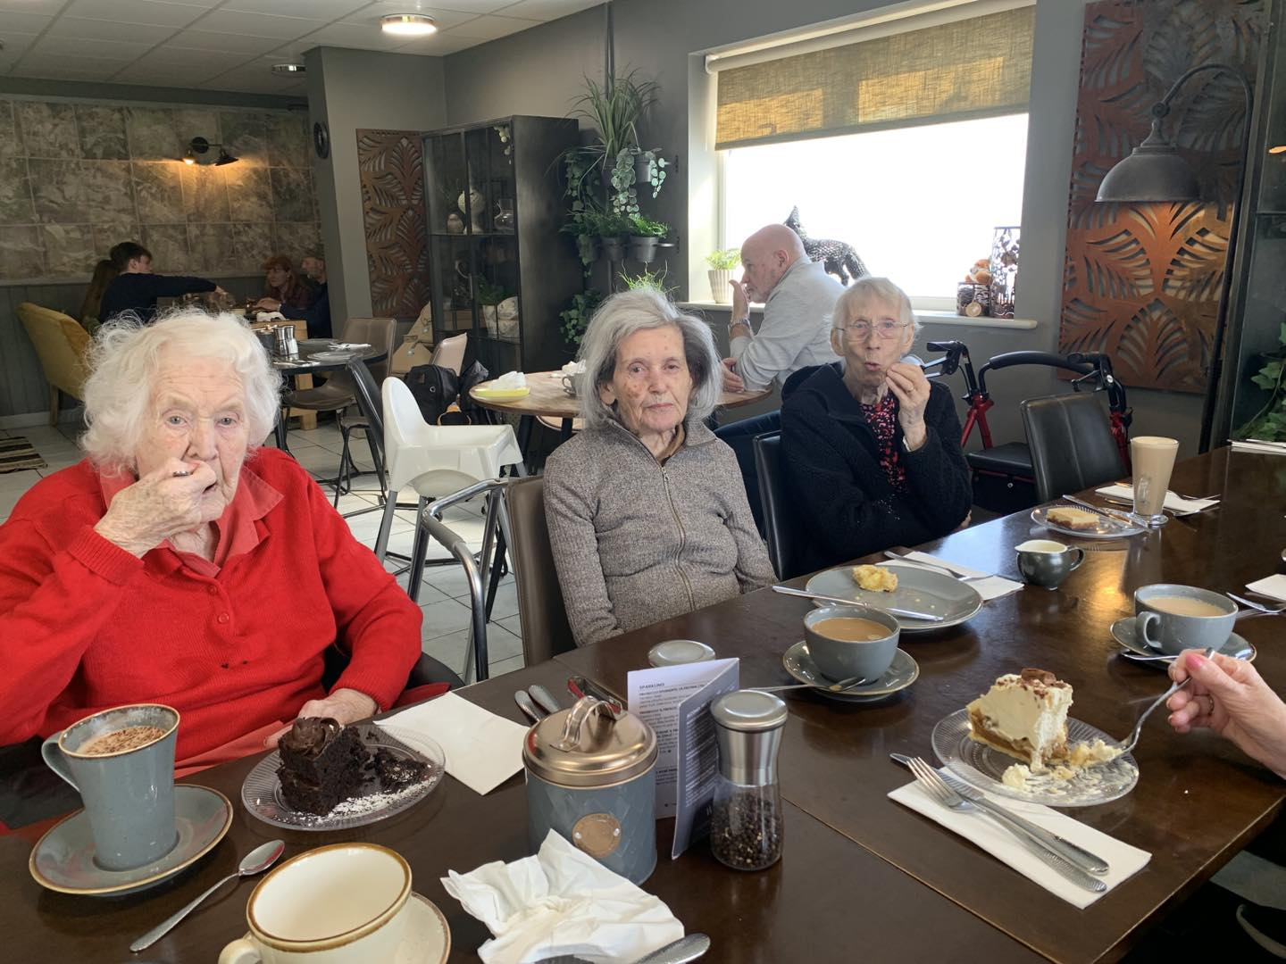

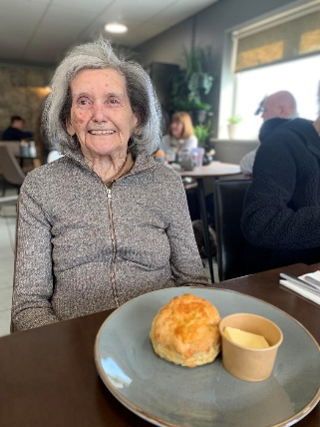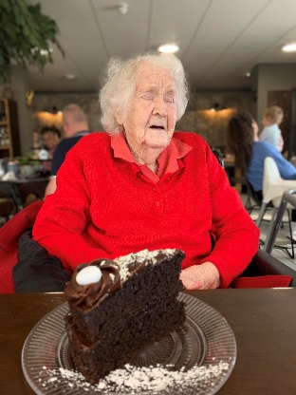
Margaret and Joan enjoying their scones and cake……..looks delicious!!

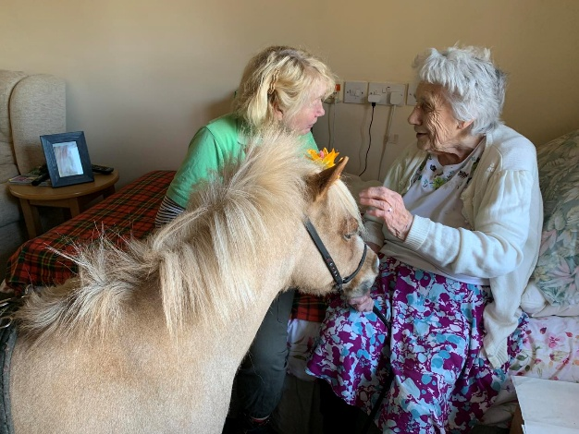
MARY ENJOYING A VISIT FROM SUNSHINE!

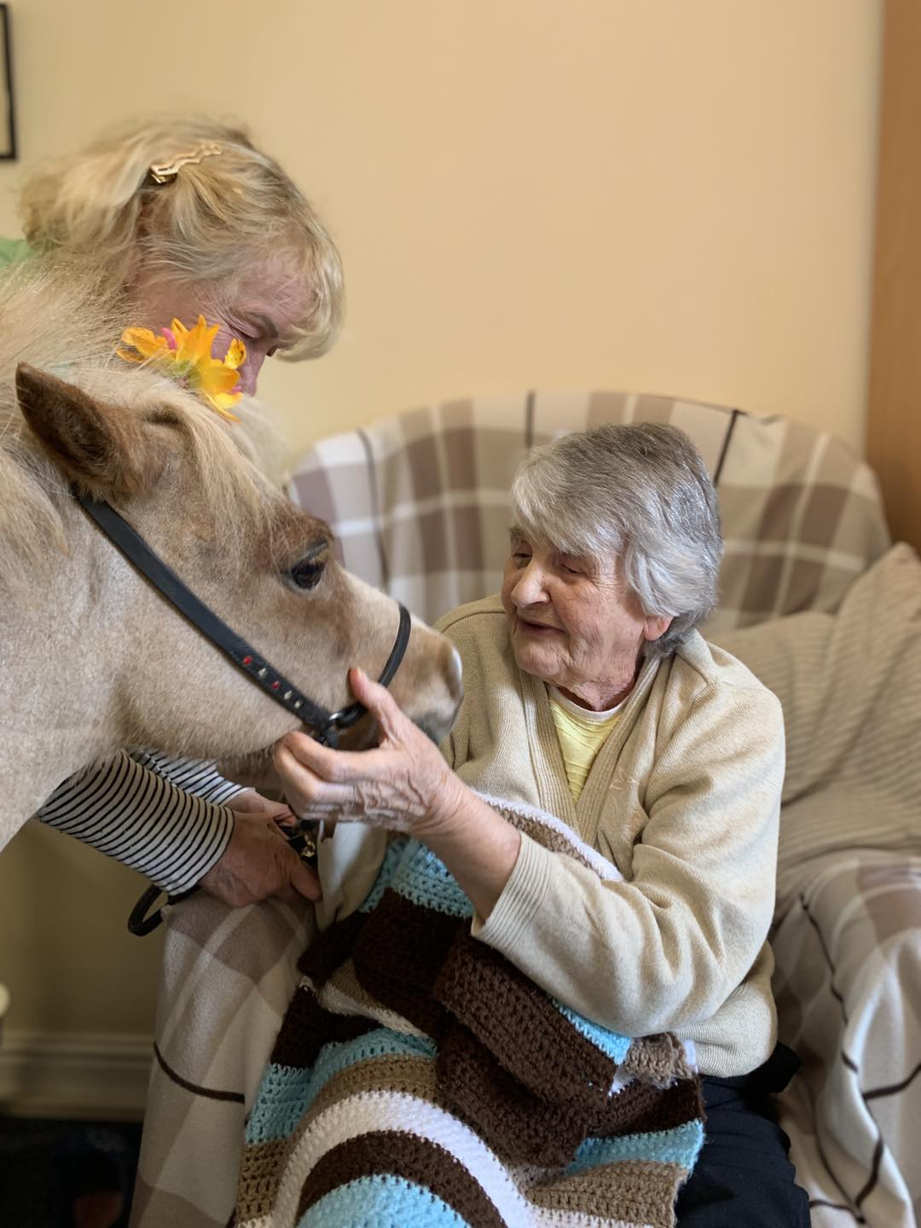

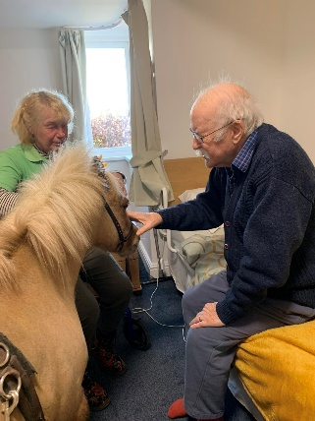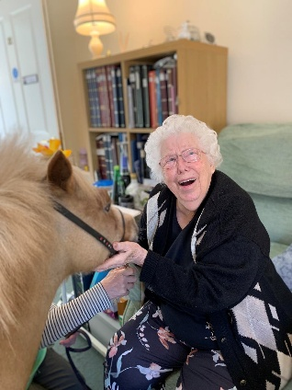

SINGER – JOHN FLETCHER

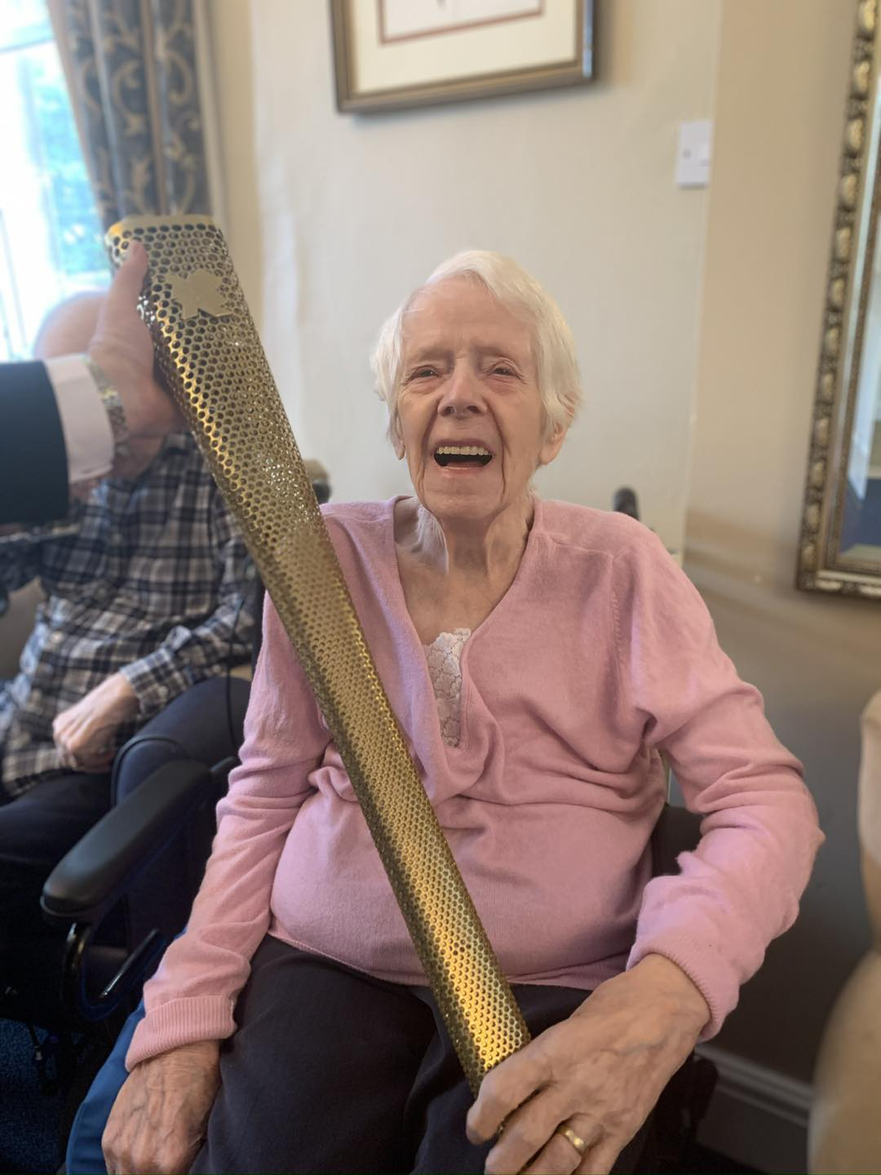

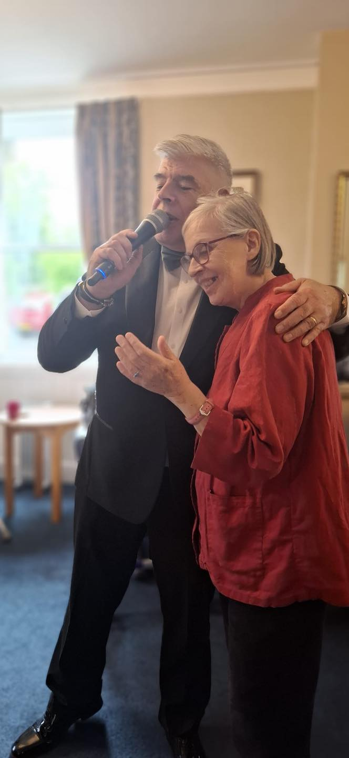

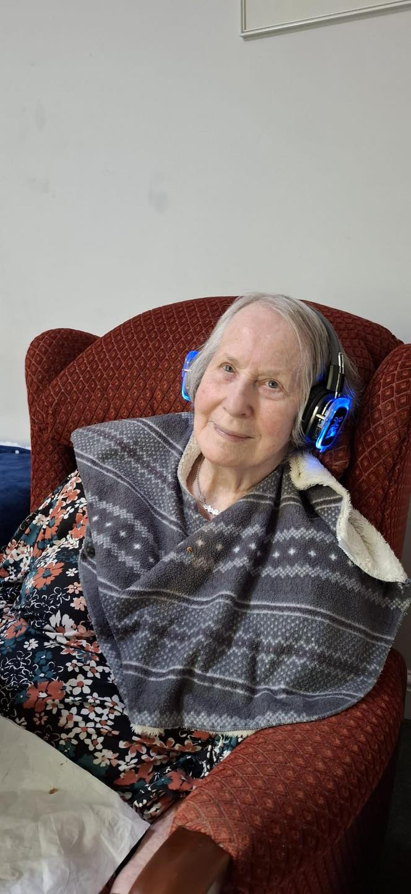

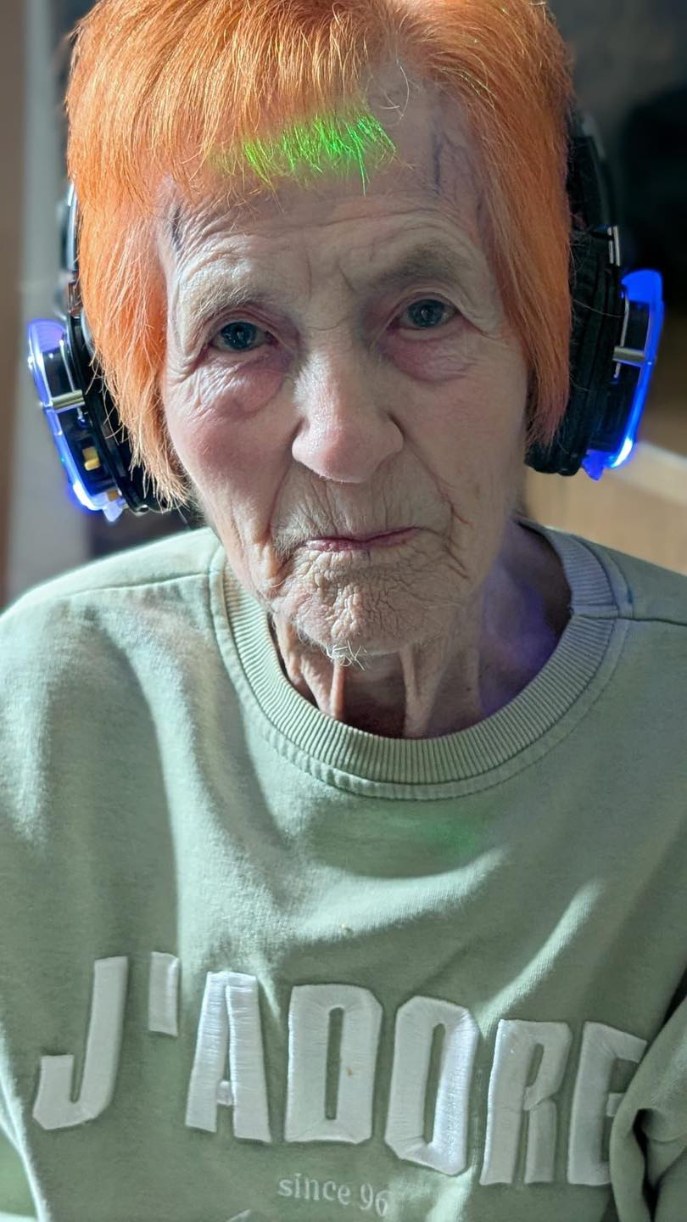



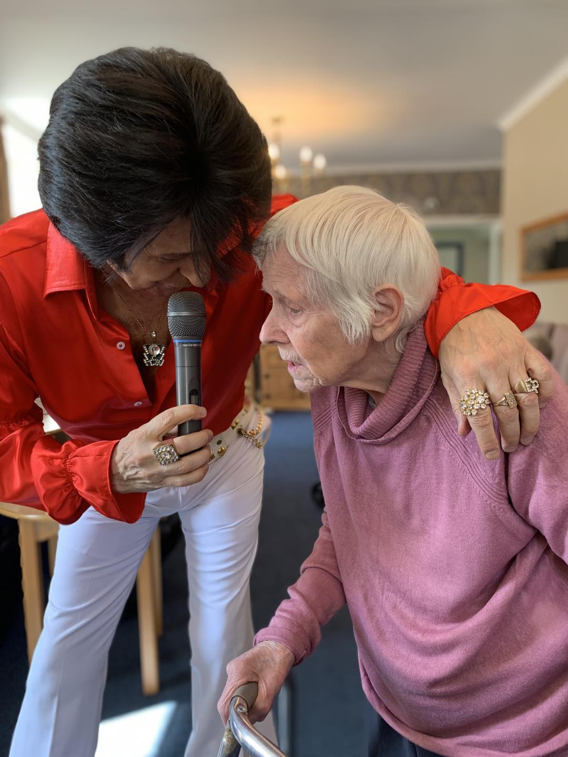

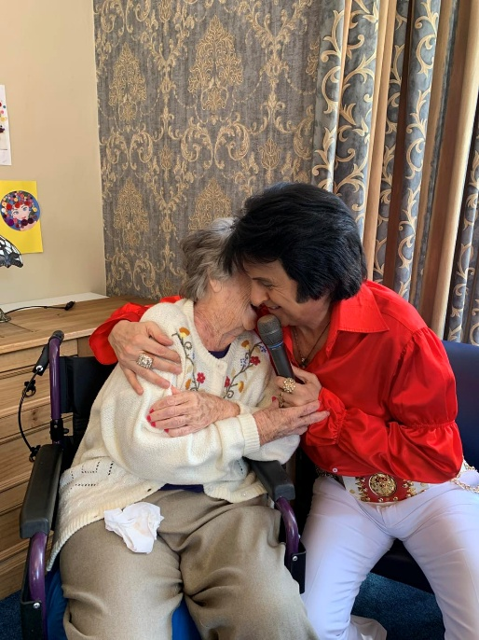

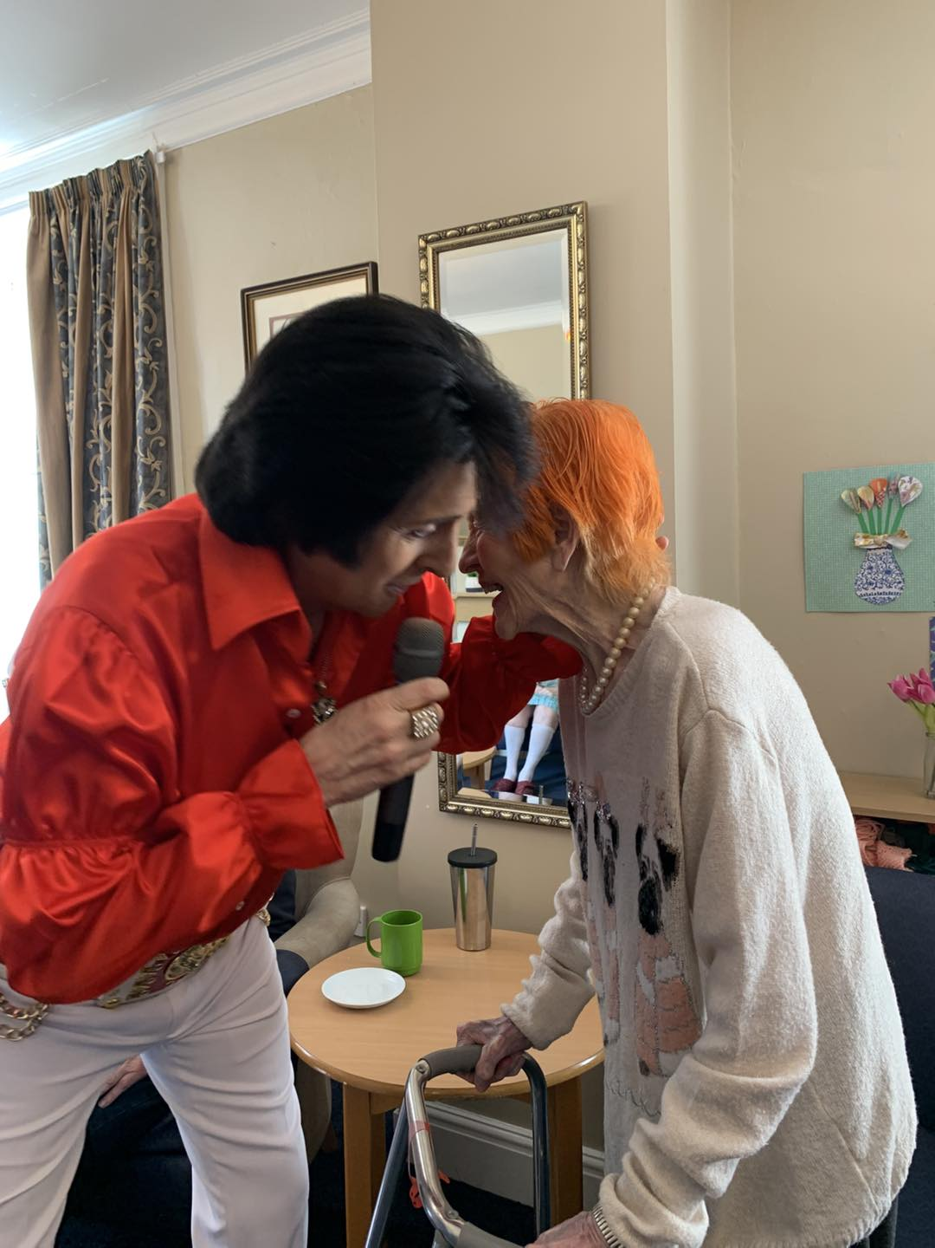

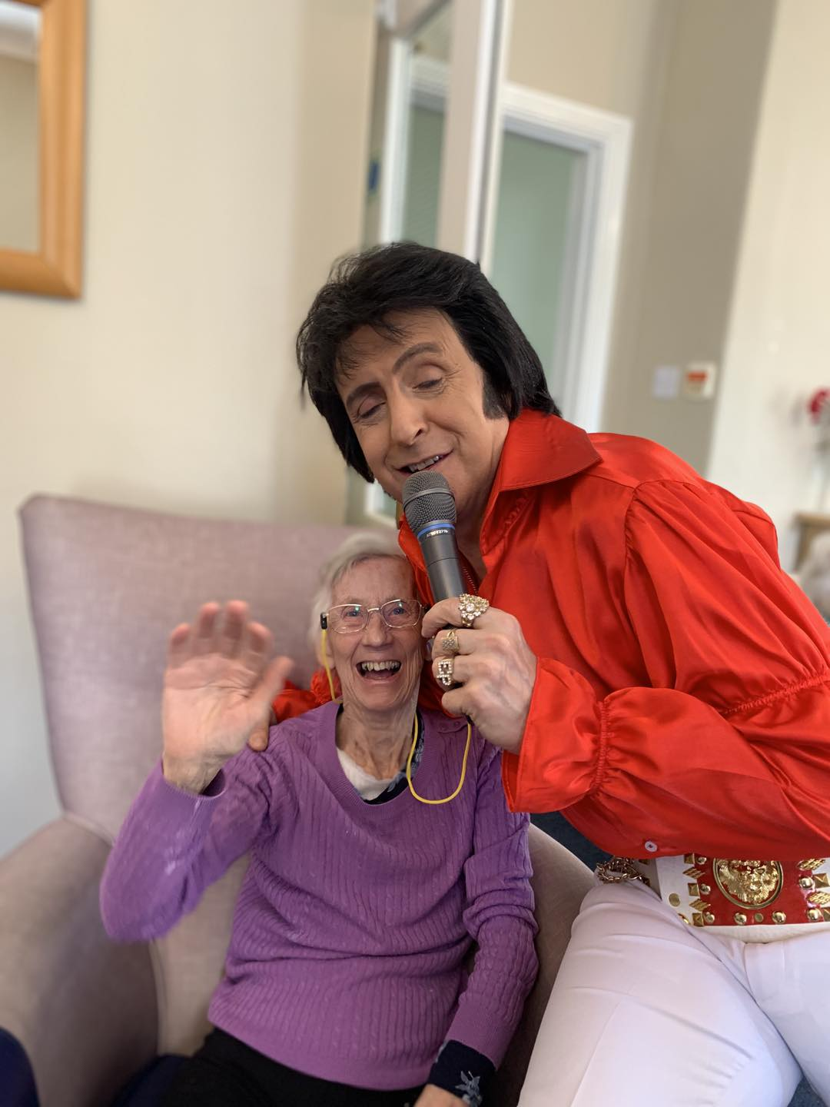
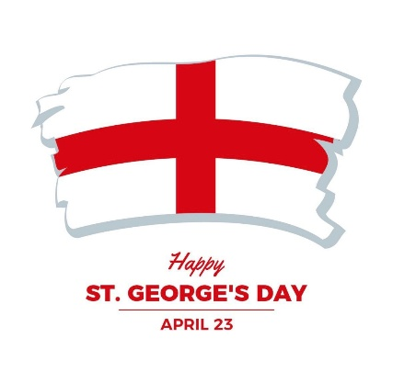

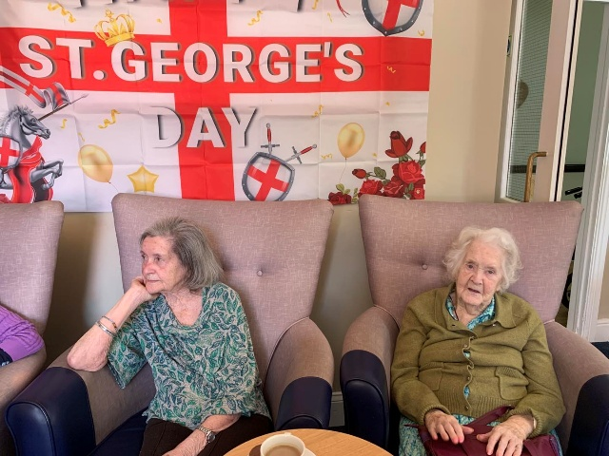

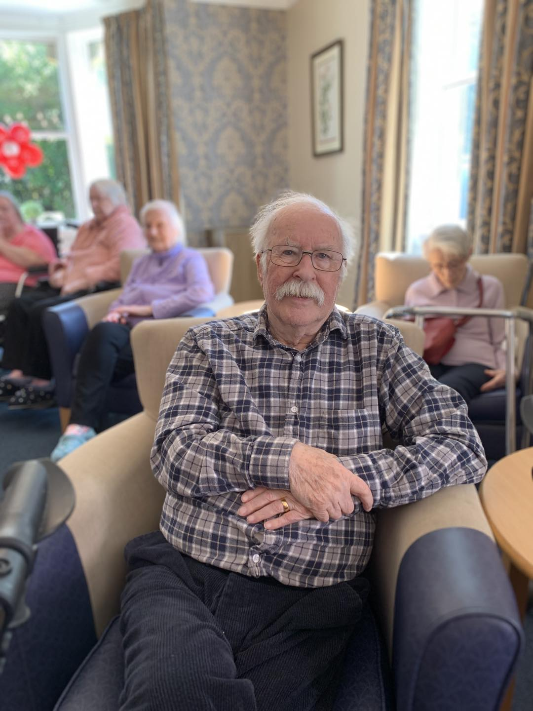

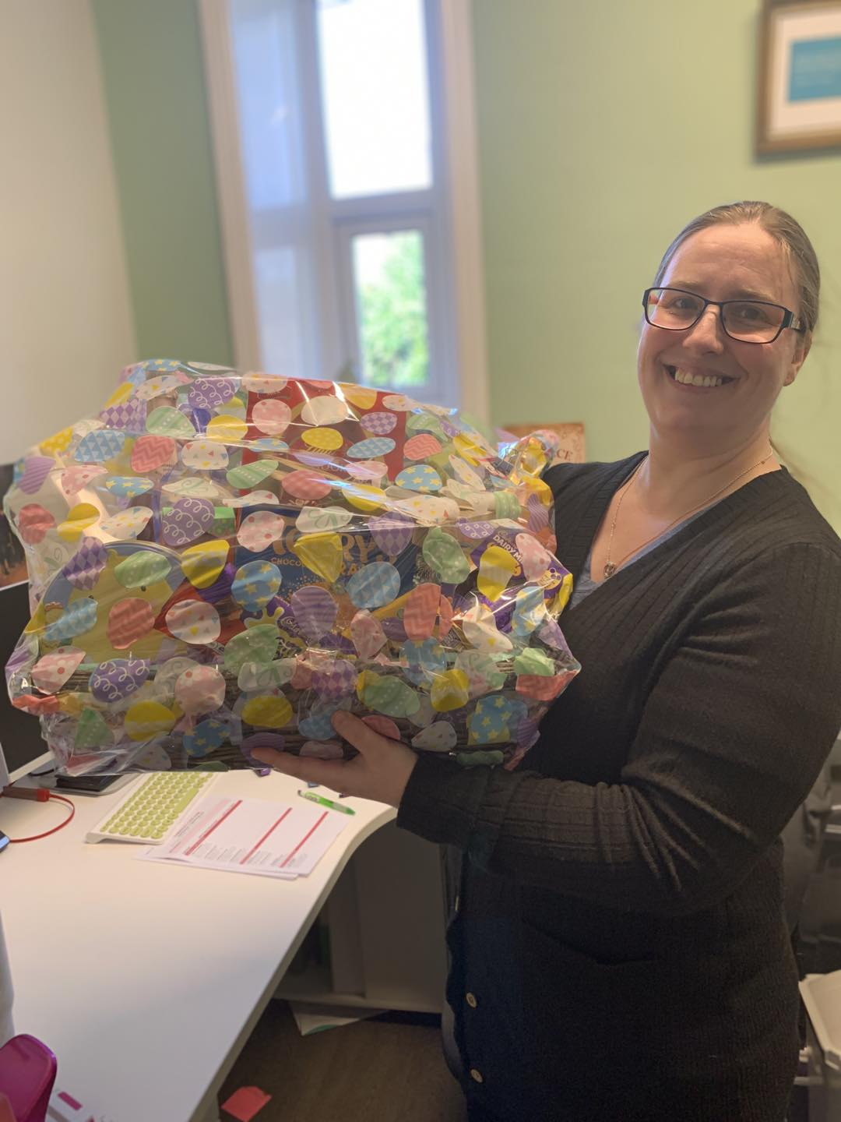

Upcoming Key Dates

Friday 1st May– We will be joined by The Puppets, with a sing along to war songs

Tuesday 5th May – join ius in the large lounge with singer Sam Naylor @ 11am

Friday 8th May – Join jus in the large lounge with our VE Day celebration, we will be joined by singer Elaine Morris @11am

Monday 11th May– We will be joined by singer John Fletcher sing songs from the Rat Pack in the large lounge @11am

Tuesday 12th May– Denise will join us for her arts and craft session in the dining room @ 11am

Thursday 14th May – we will be joined by singer Alex Hall in the large lounge @ 11am

Friday 15th May– We will be joined by Animal Antics in the large lounge @11am
Contact details
If you have any questions in regards activities or any suggestions for future activities, please do not hesitate to contact me Michelle Holder via email at wellbeing@summerhillcare.com

