 | Summerhill Care Home
February News Letter
Welcome |  |  | 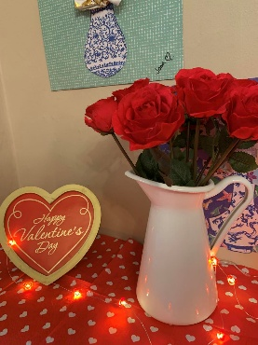
Welcome to February’s newsletter. Love is in the air this month as we celebrate Valentine Day with the fabulous Elvis.
We have enjoyed an array of activities again this month, we welcomed back the Pony and as always, a big hit with the residents. We have enjoyed pancakes and our first trip out of the year.
Next month is Mother’s Day and we will be doing something special for that, so keep an eye out for details.

We welcome three new Carers David and ade for day shift and on night shift

Activities & Events
Some of our ladies have enjoyed a pamper, getting their nails done |  | 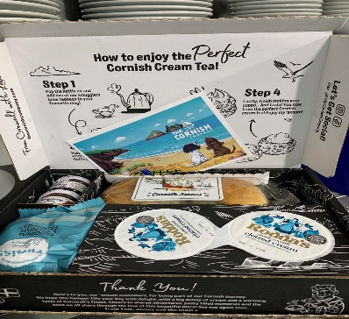  I have enjoyed some lovely 1-1’s this month with a little treat of scones, cream and jam for Pat and Copper  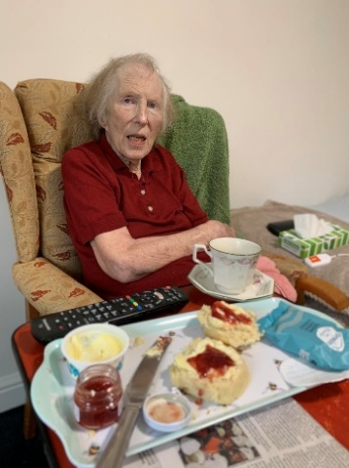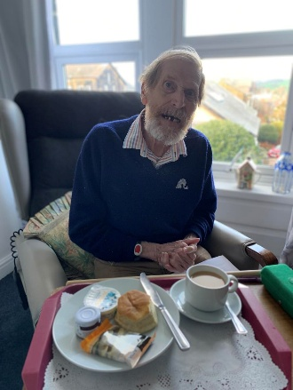    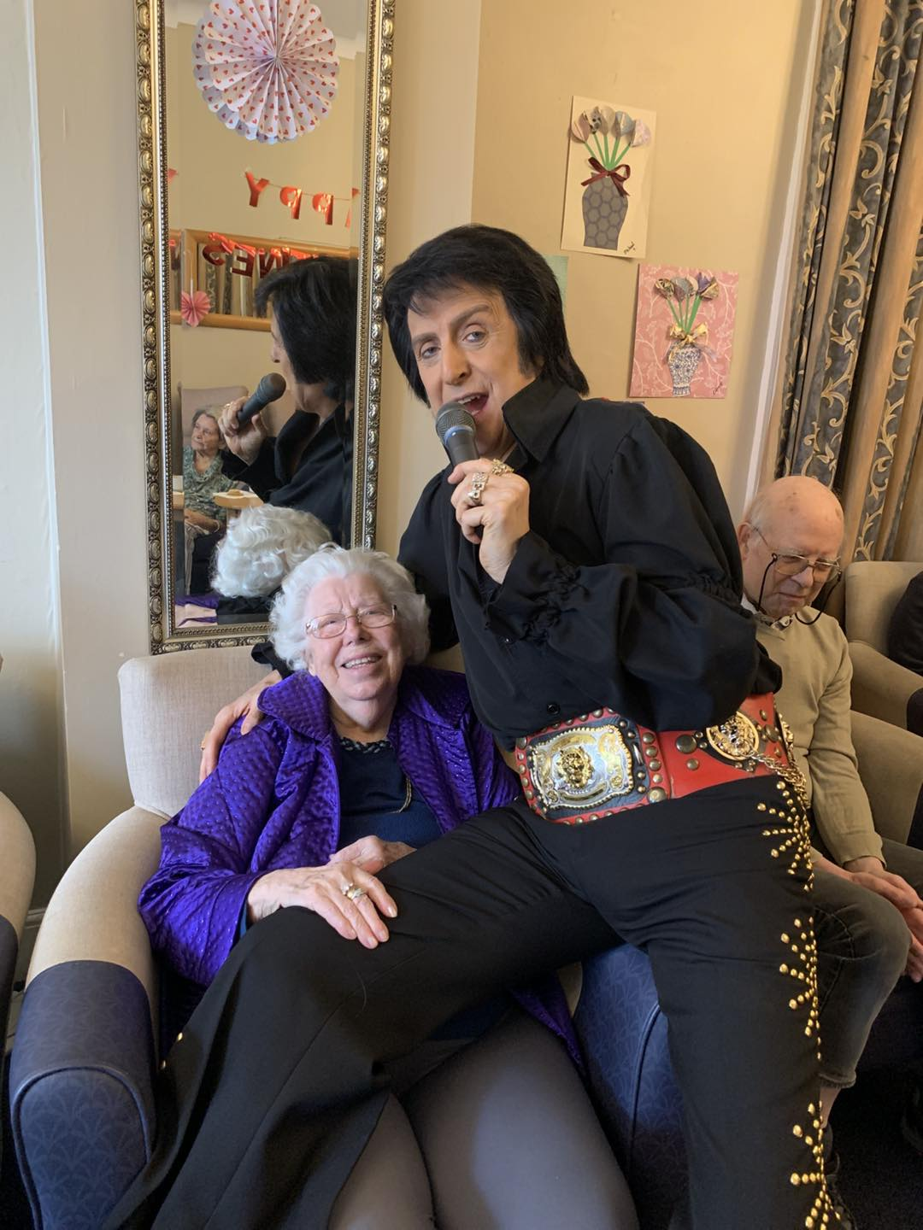  Jean having a good time  Tom and Paul enjoying a dance  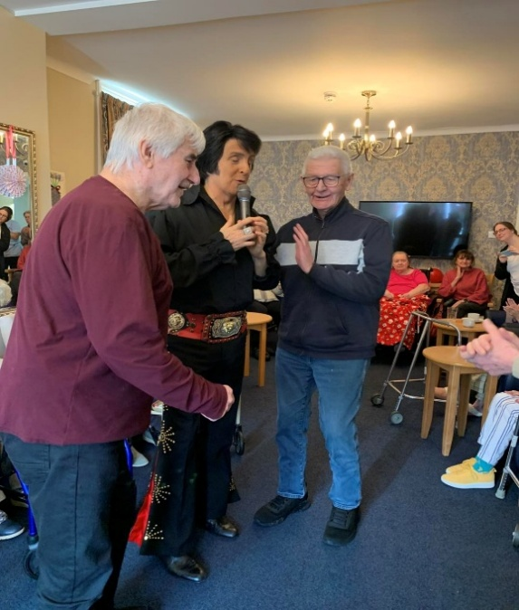  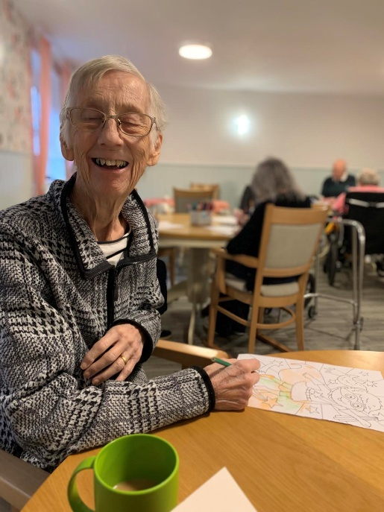  We enjoyed a morning of mindful colouring. This reduces anxiety and stress. It enhances cognitive function; boosts focus and improves hand eye coordination. It also encourages interaction when done in groups so a lovely social activity.  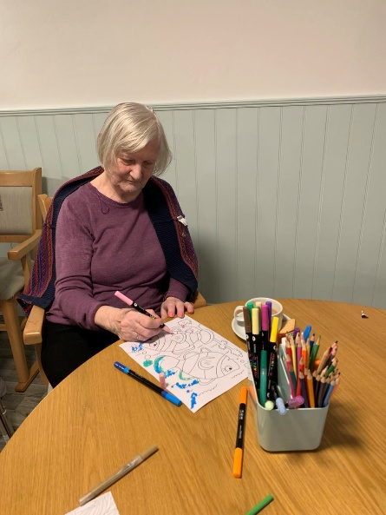  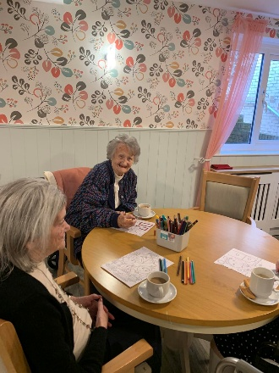  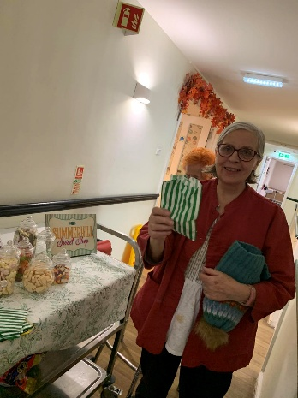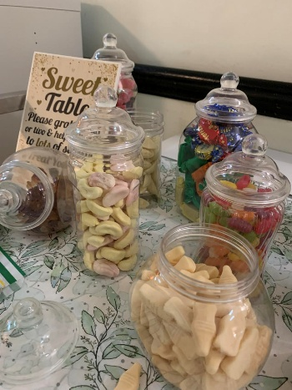  Anne full of beans with her  Sweets xx  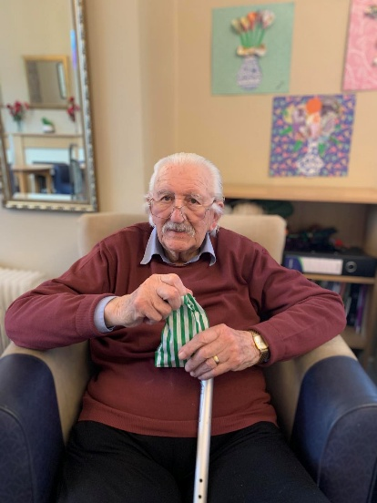  Derek enjoying his sweets  We welcomed Fran from St Michael’s; this was her first visit to us after Annette has stepped back.  Everyone enjoyed the service especially the hymns Fran had chosen.  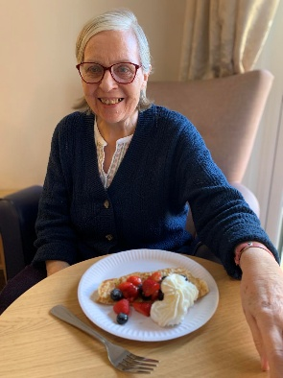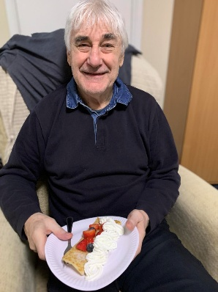  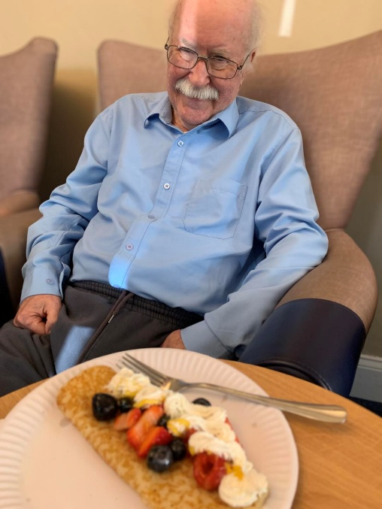  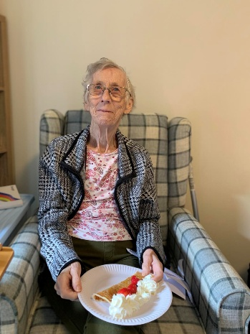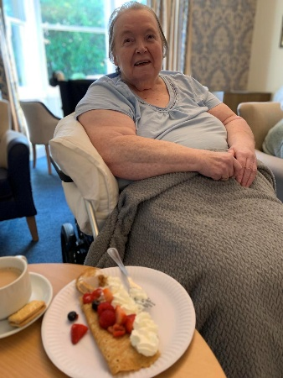  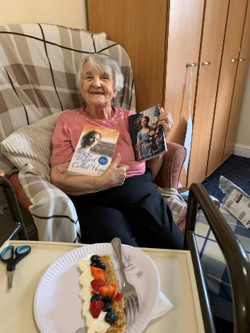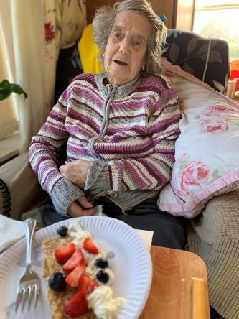  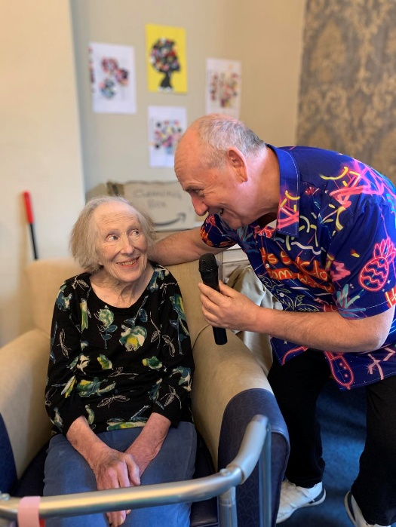  We had fabulous singers Kev the Carehome Singer and Derek Hodgson entertaining us this month with their great session of music.  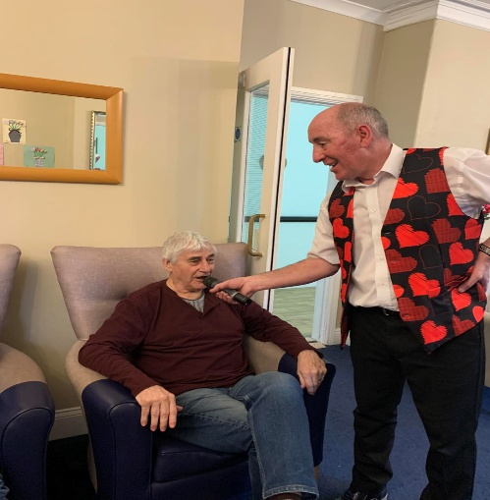  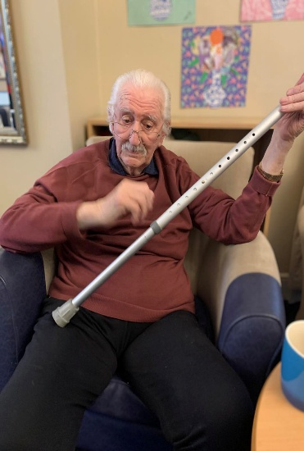    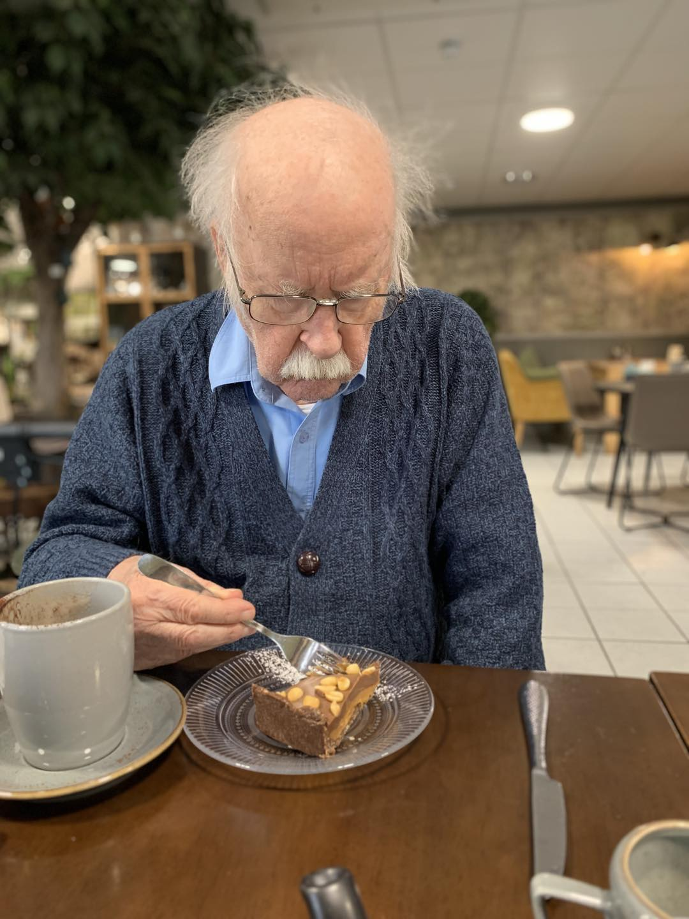  We had a fabulous trip to The Running Fox for our first trip out of the year. All the boys together, they all enjoyed a cuppa and a slice of cake.  Sunday 15th March – Singer Tont DaSousa in the large lounge for our Mother’s Day celebrations @11am  Tuesday 17th March – we will be joined by The Puppets for our St Patricks celebrations in the large lounge @11am  Friday 20th March – Elvis will join us in the large lounge @2pm  Wednesday 25th March – Join us in the large lounge for our monthly church service with Fran from St Michaels  Thursday 26th March – Join us in the large with Robert Whitehead playing his accordion @11am  Congratulations to Jossy for employee of the month, Jossy is a team player helping all departments out with a smile on her face – Jossy is great with our residents and always has time for them
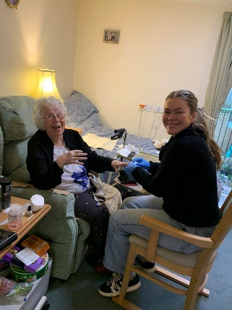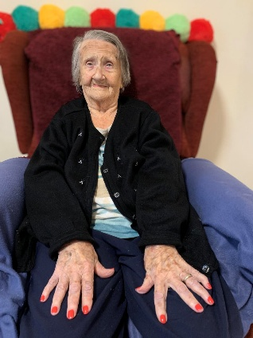

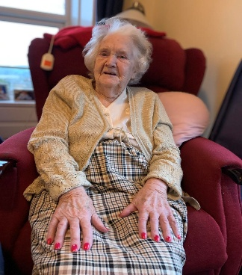

We welcomed Elvis back for our wonderful Valentine party…..it is safe to say that everyone had a wonderful time – everyone enjoyed some fantastic food from our cook Ruth

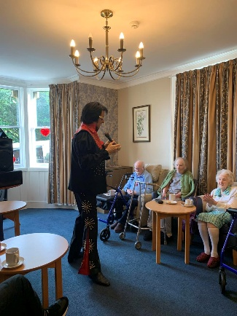

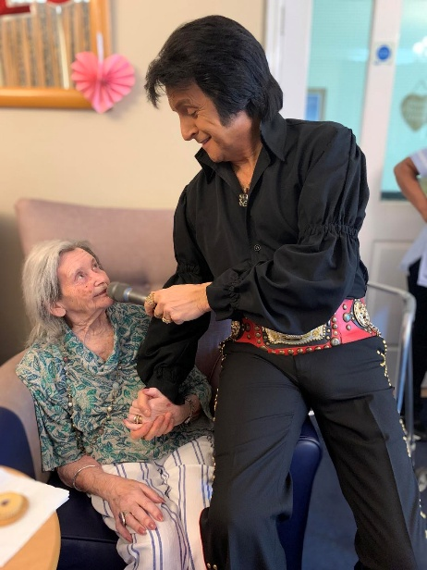

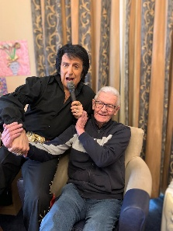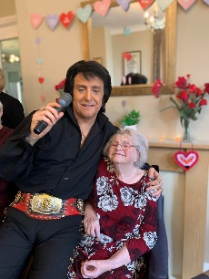
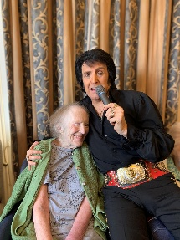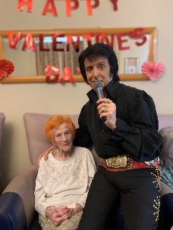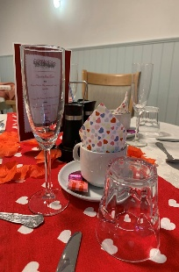

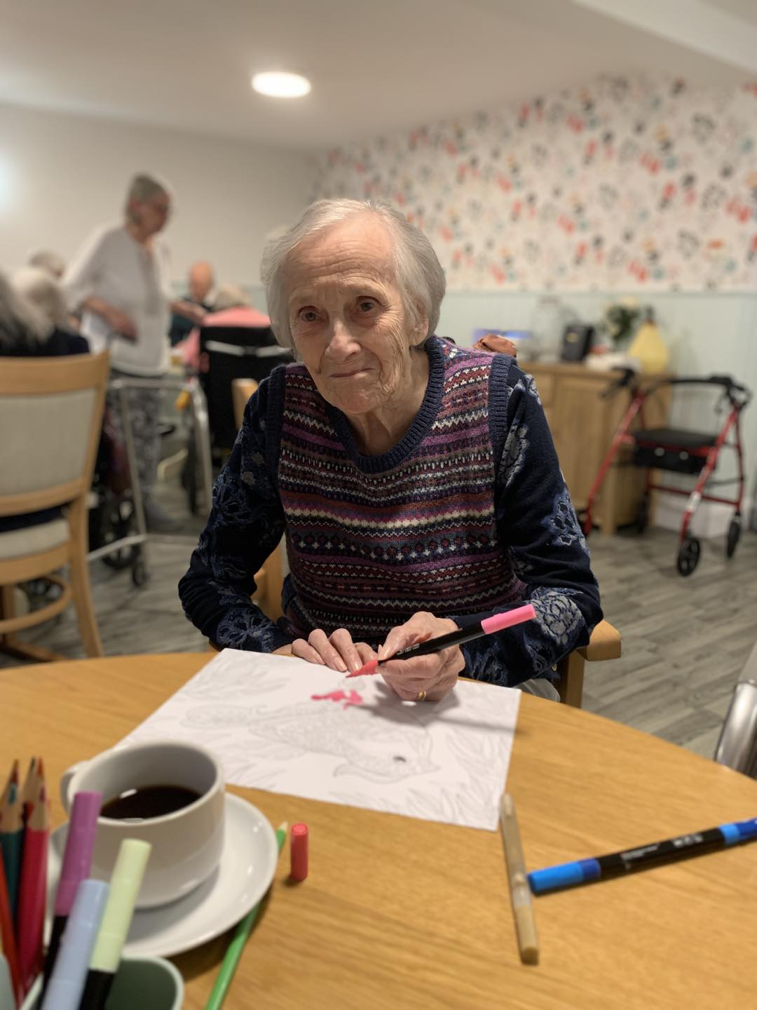

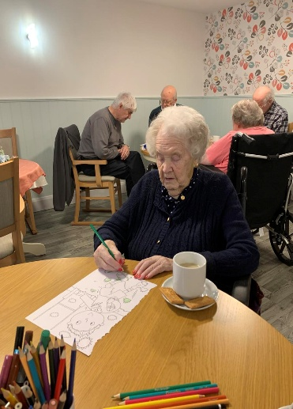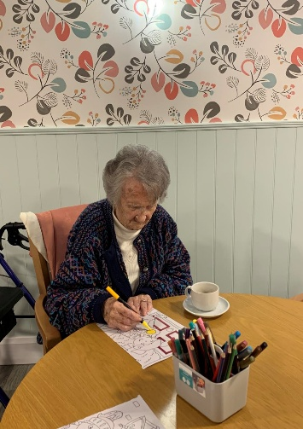

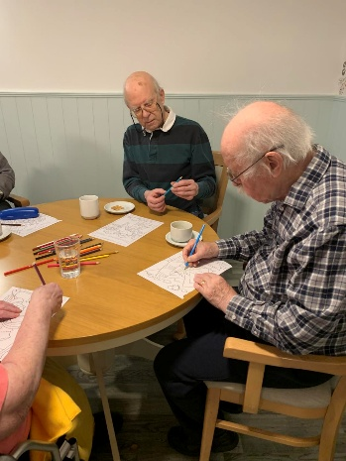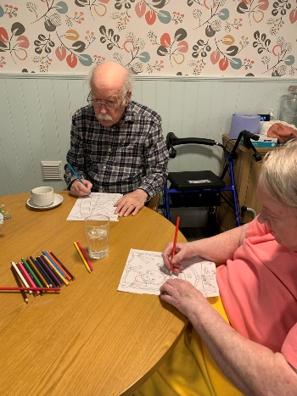

We have also enjoyed some of our usual activities, such
As bingo, sweets from The Summer Hill Sweet Trolly, quiz mornings, watching the Winter Olympics and our monthly Church service
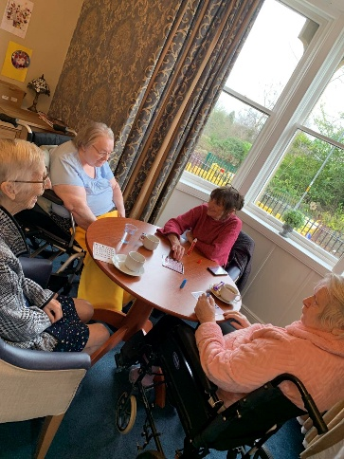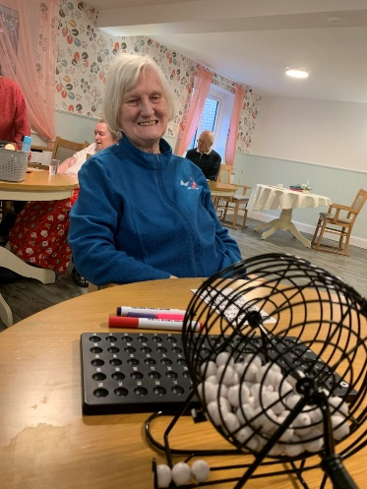

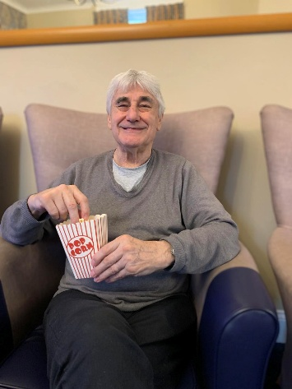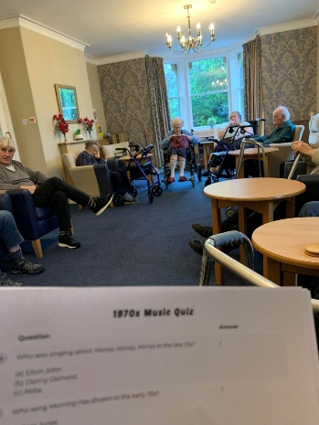
Tom enjoying some popcorn We enjoyed a morning of
While watching the Winter quizzing
Olympics

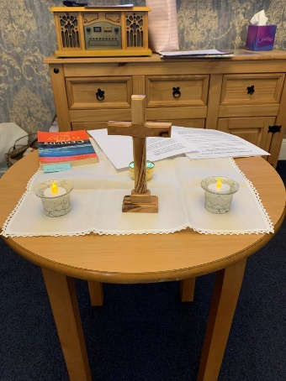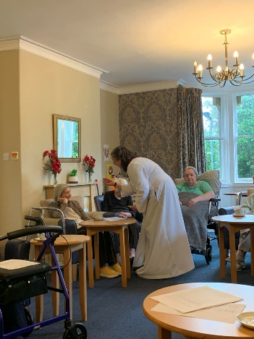



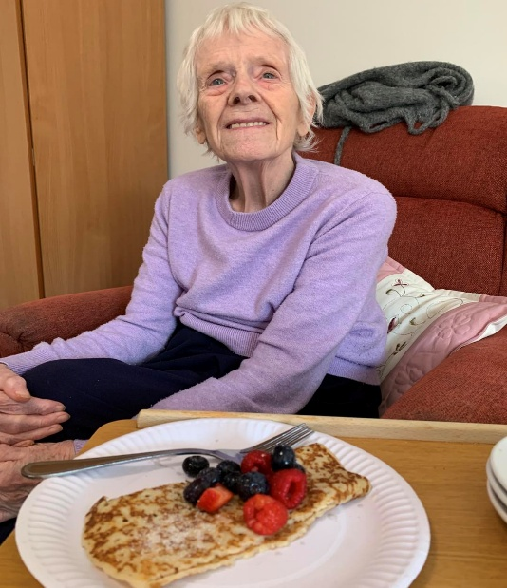

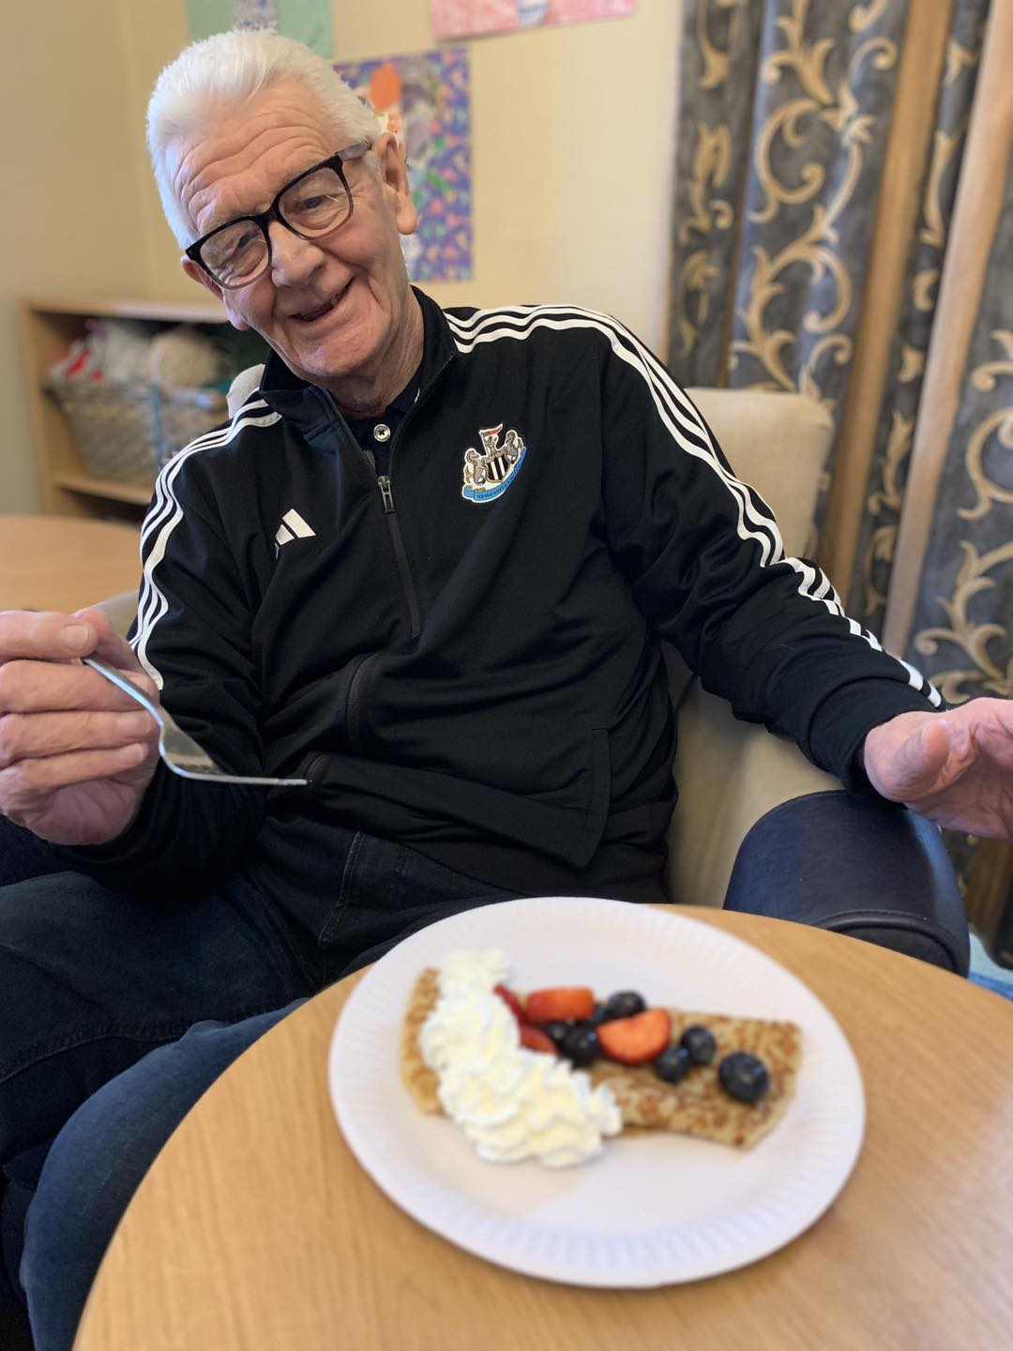

Safe to say eveyone enjoyed their panckaes on Shrove
Tuesday

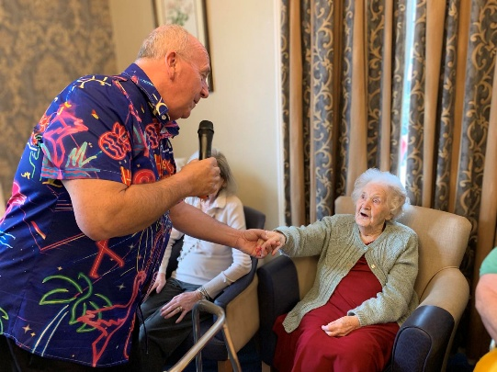

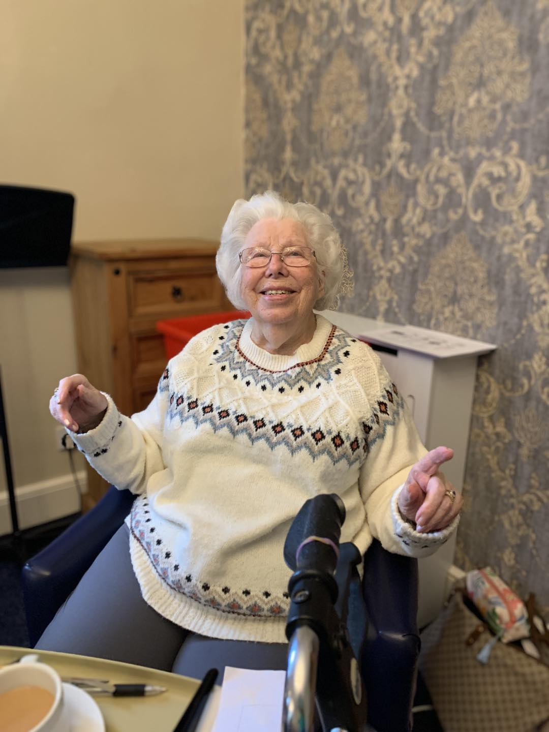

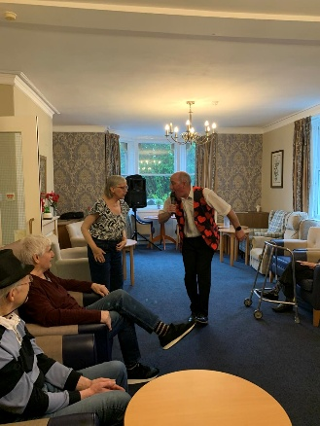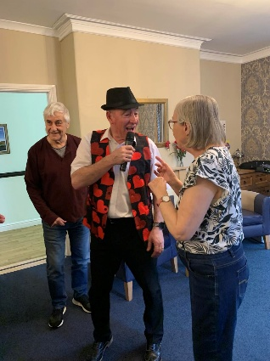

FIRST TRIP OUT

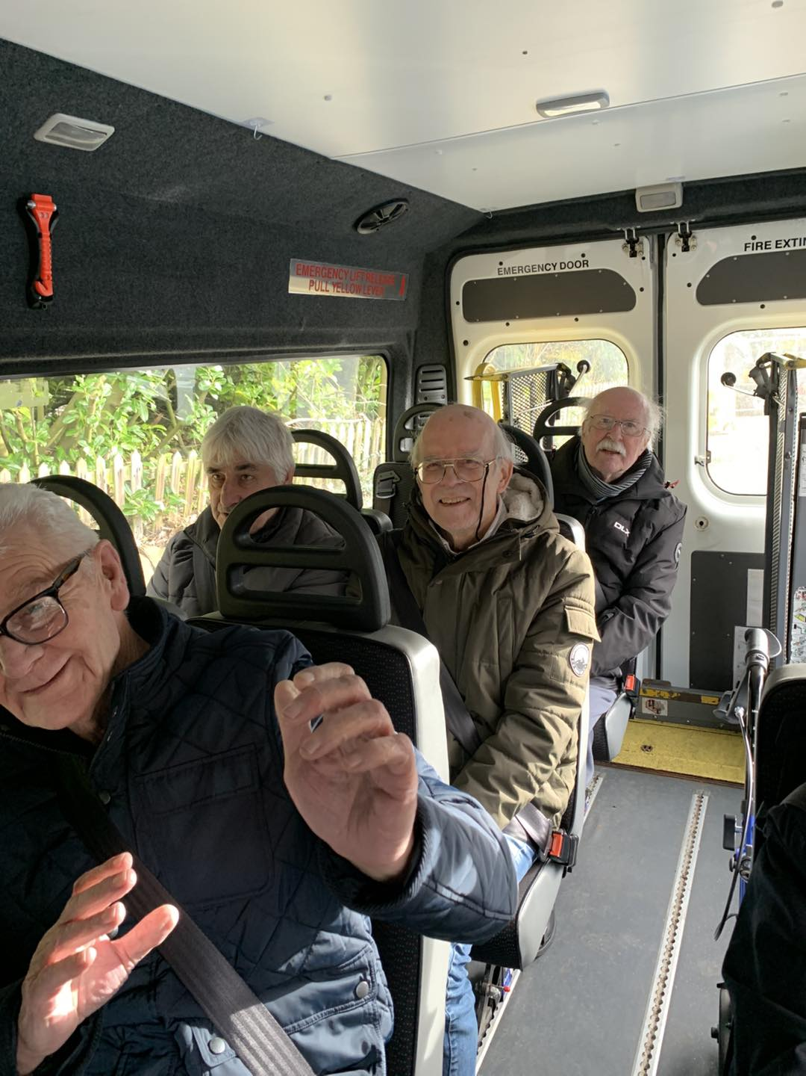

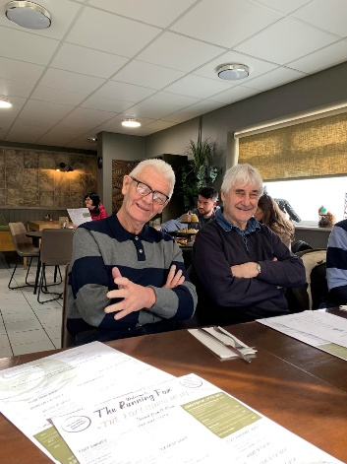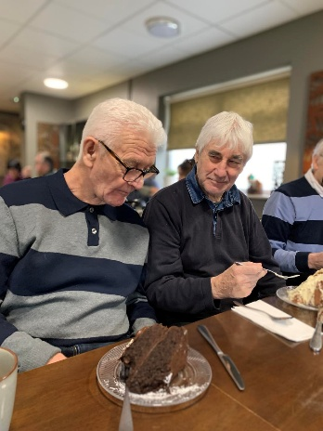

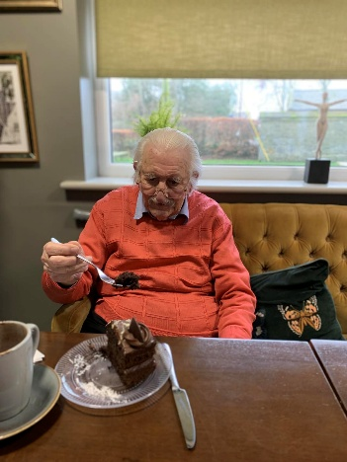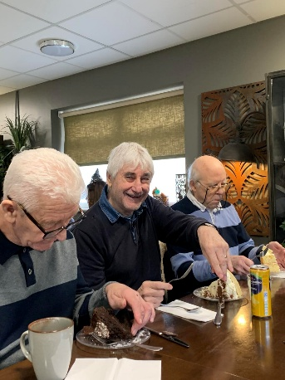

Upcoming Key Dates

Monday 2nd March– Singer Sam Naylor in the large lounge @11am

Tuesday 3rd March– Singer Alex Hall in the lounge @11am

Wednesday 4th March – Singer John Fletcher in the large lounge @11am

Tuesday 10th March– Singer Steven Swales in the large lounge @11am

Thursday 12th March – we will be joined by Denise for Easter arts and crafts in the dining room @11am

Friday 13th and 27th - we will be joined by King our therapy
Dog, visiting all rooms for cuddles

Employee of the Month

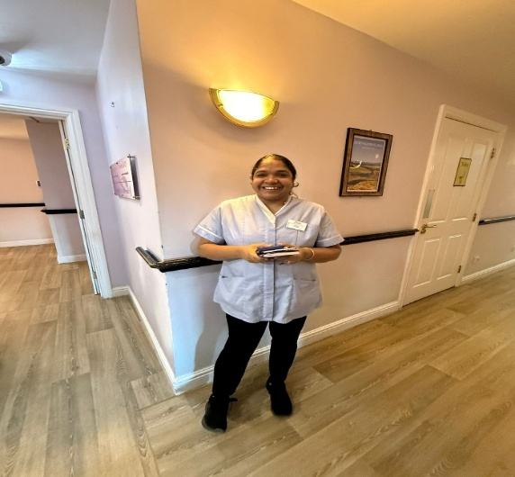

Contact details
If you have any questions in regards activities or any suggestions for future activities, please do not hesitate to contact me Michelle Holder via email at wellbeing@summerhillcare.com

