 | Summerhill Care Home
May News Letter
Welcome |  |  | 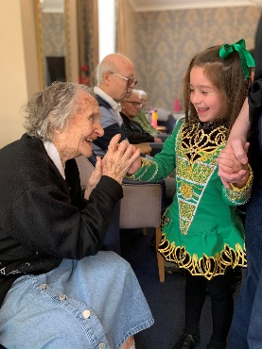
Welcome to May’s new letter, well, I thought the weather would be a little better than it has been, it’s been very hit and miss and quite frankly some days have been freezing. Let’s hope with the coming of June it improves. I am hoping to get some bedding plants in the back yard with the residents, this will bring some lovely colour and floral views from the balcony’s, we should also be getting our hanging baskets hung for the front of the home.

We have had some great activities in May, trying something new with the glass infusion workshop, all residents that took part really enjoyed that one and the finished designs were fantastic, this was also something that the residents could keep.

We have enjoyed our usual singers, welcoming Derek back this month, he is so good with all the residents, inclusive and puts a smile on everyone face with his mad antics.

We had a lovely morning celebrating VE Day with Elaina Morris doing her wartime session, it bought back many memories for the residents giving them a chance to talk and reminisce.

I will also be taking a few residents to a Dementia Disco in Seahouses, this is held on the first Saturday of each month, I will see how it goes for June and hopefully we can return again
Activities & Events
BIRTHDAY  BOARD  Happy Birthday to our wonderful  Ethel   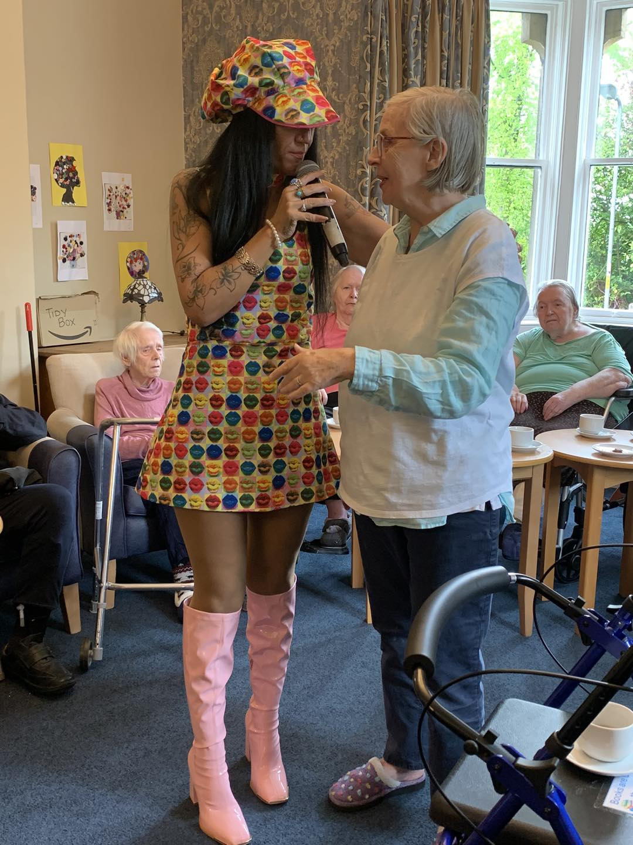 |  | 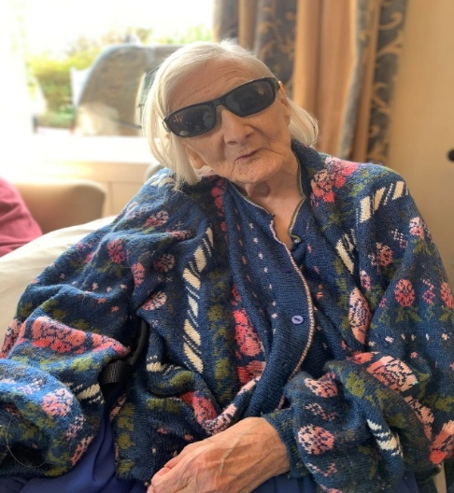  We started the month off strong with singer Sam Naylor, she is a big hit with the residents and we always try and guess what she is going to wear as she has numerous outfits – we think this perticular one was fabulous!  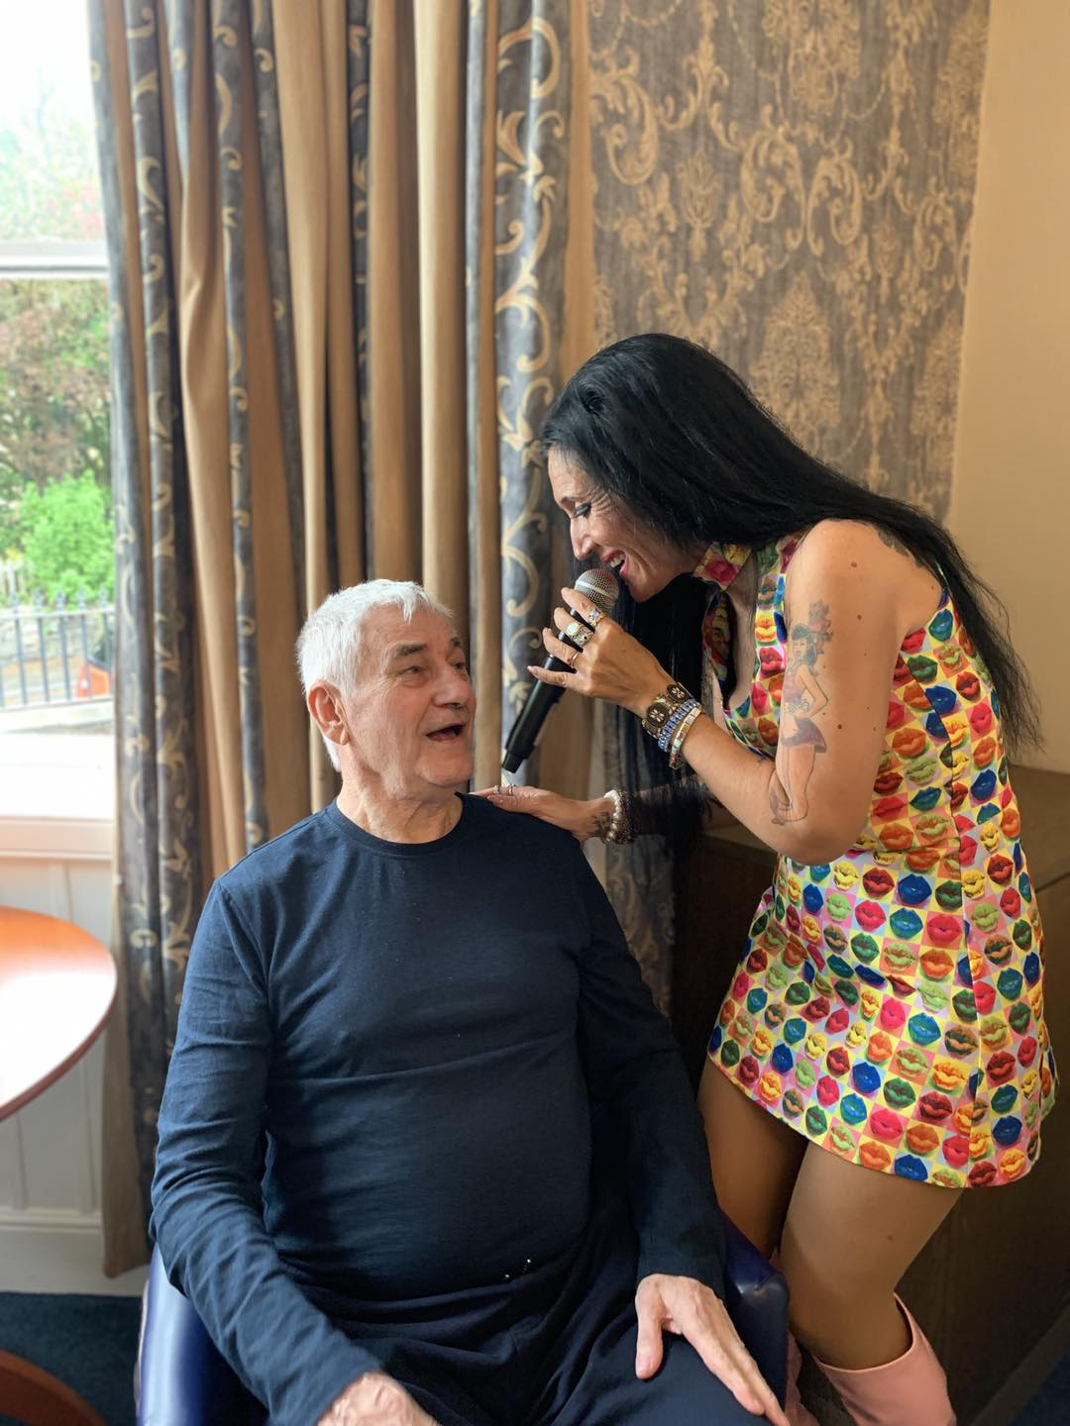  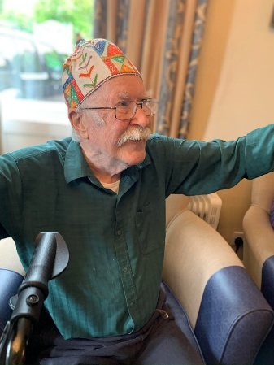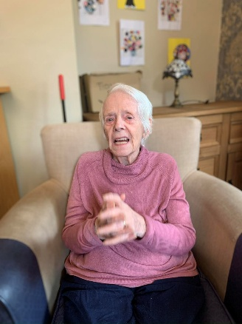  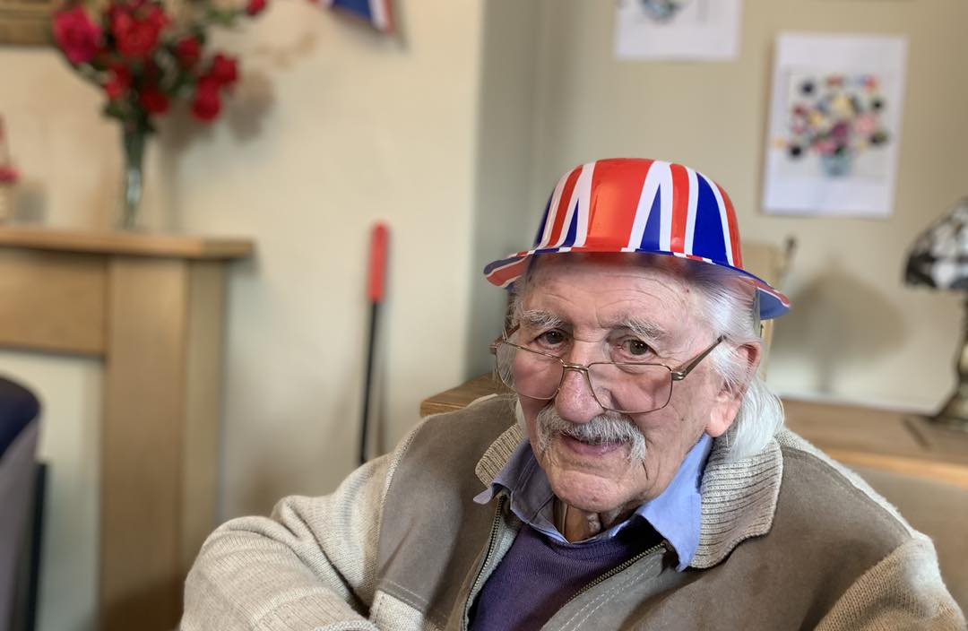  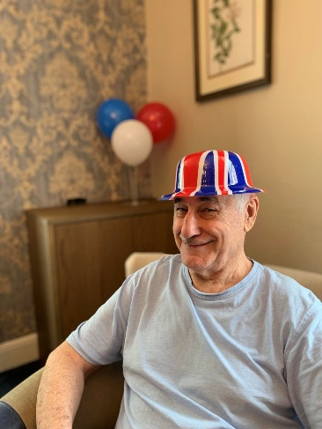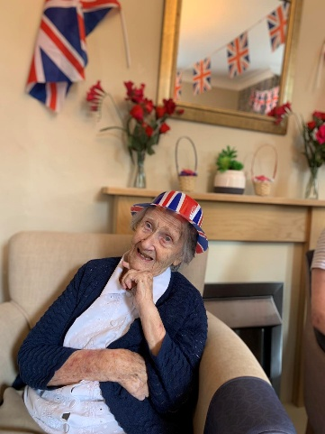  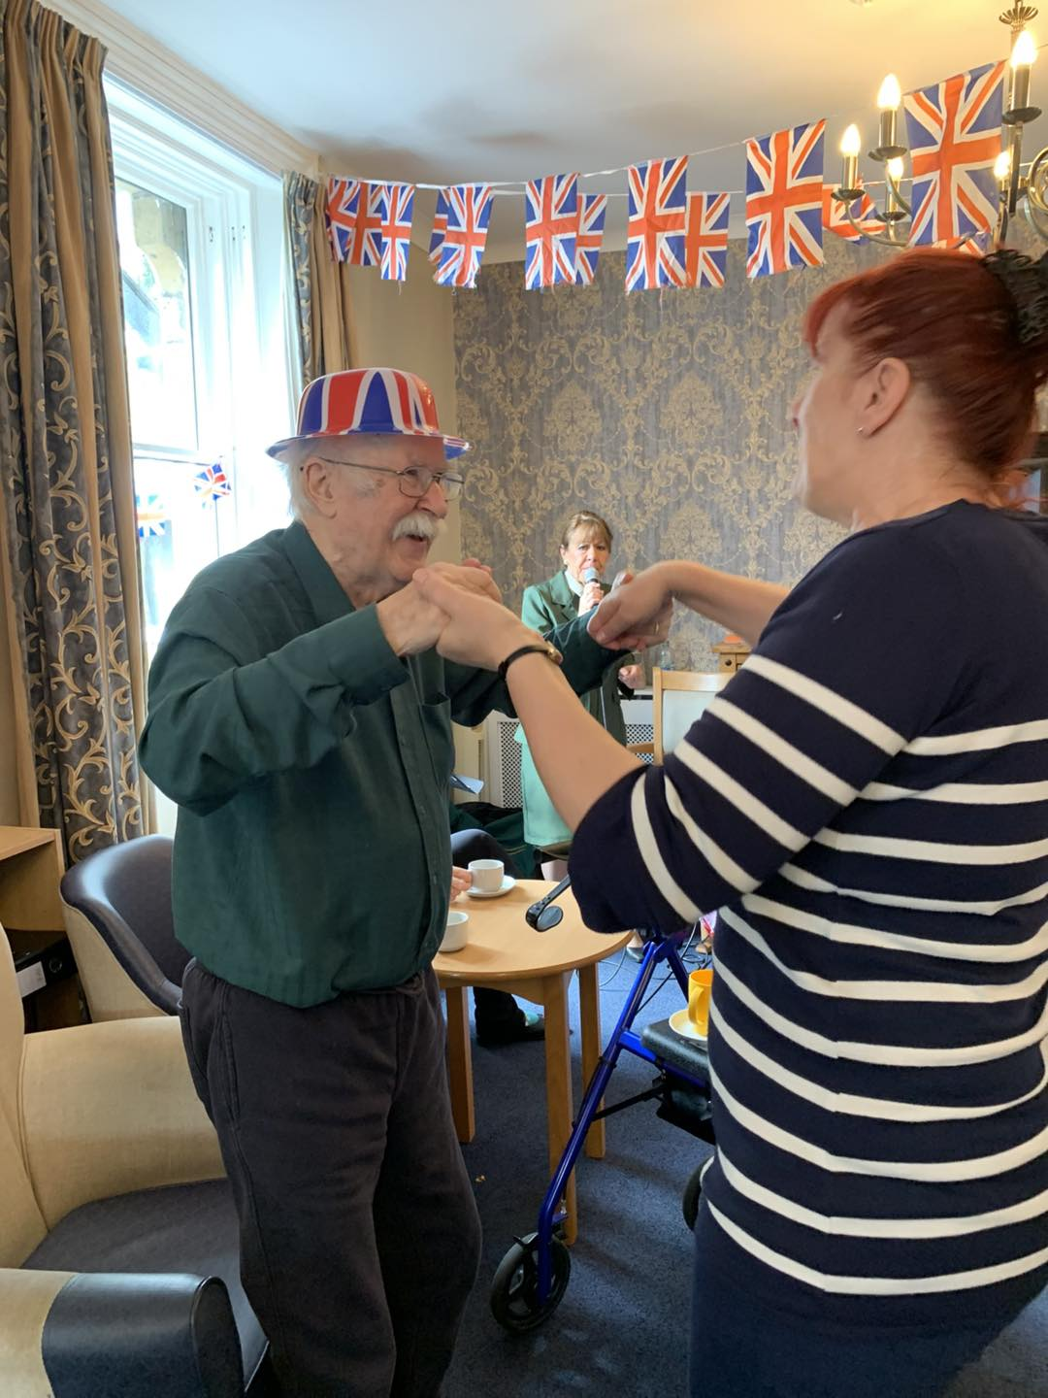  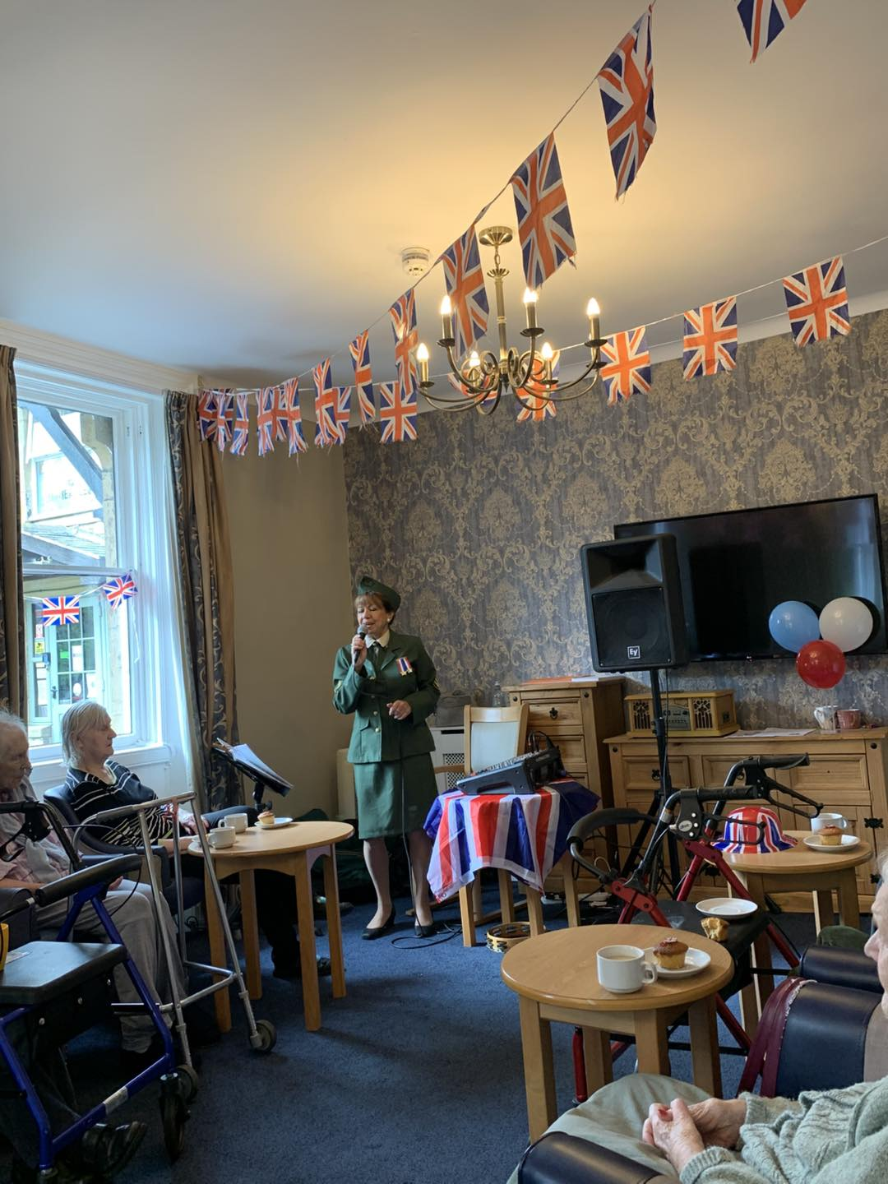  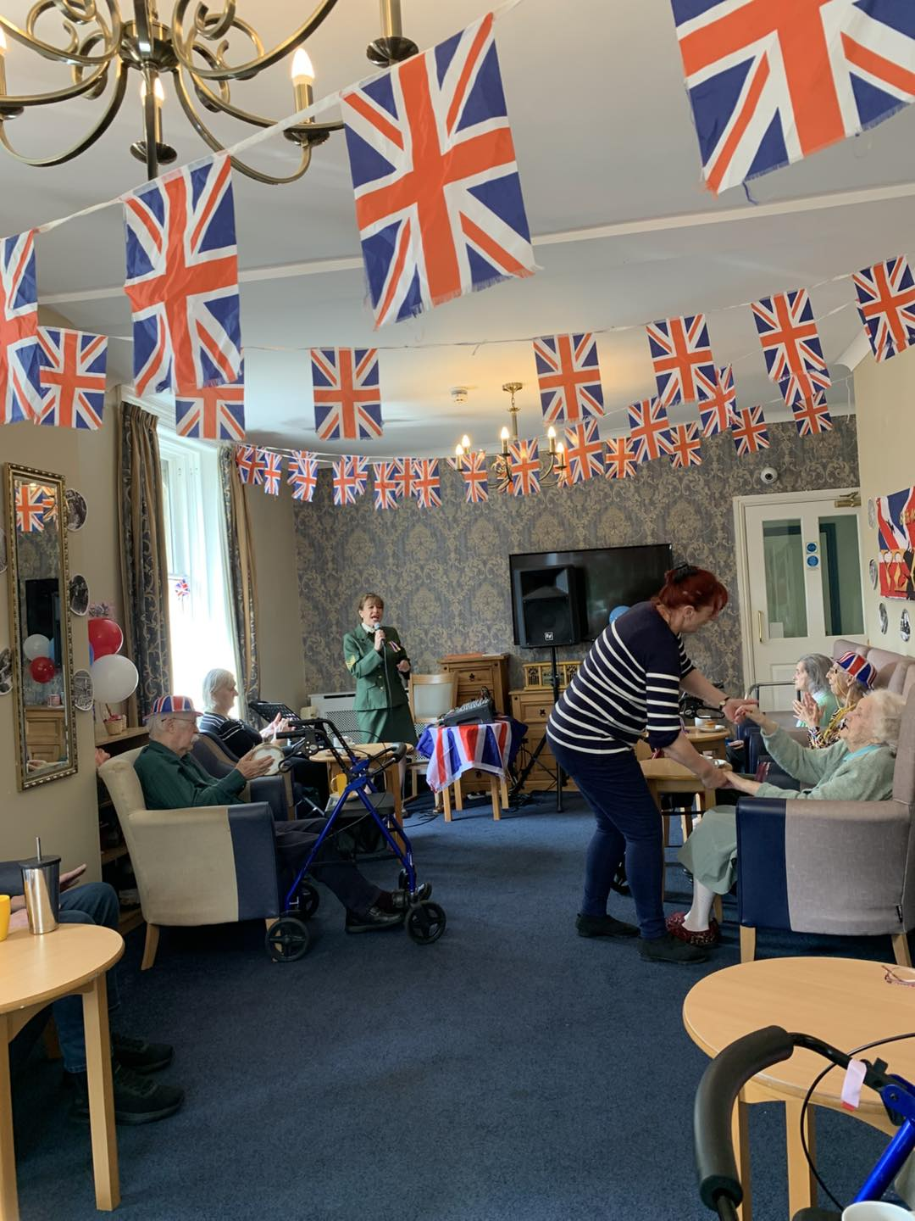  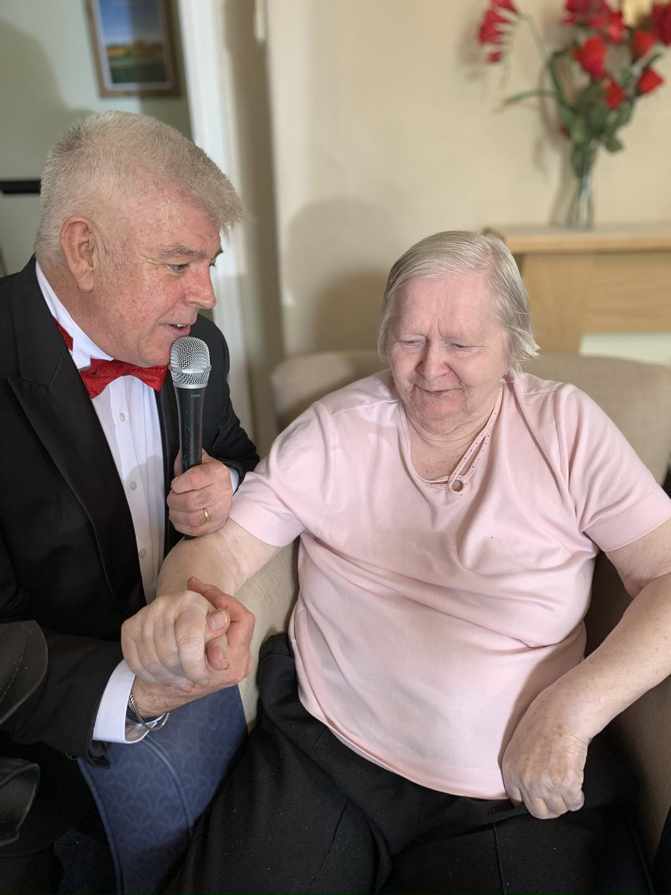  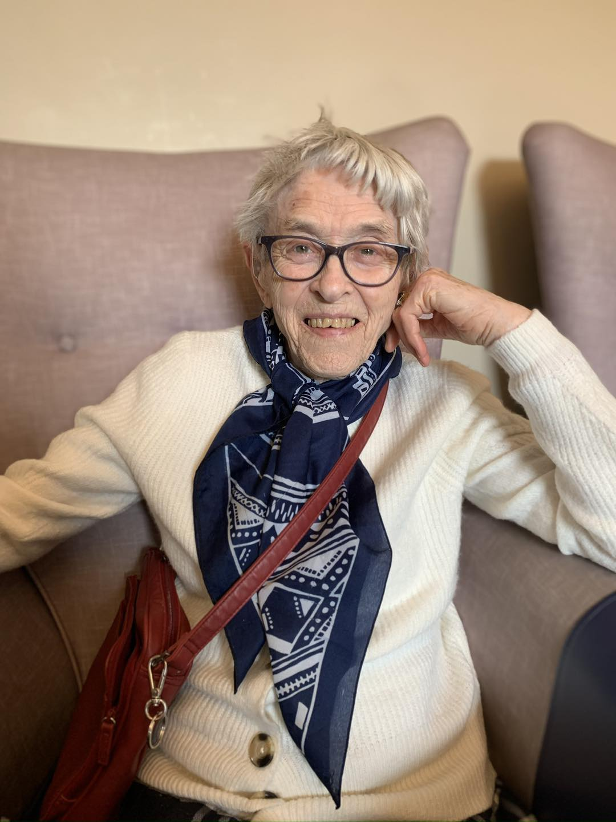  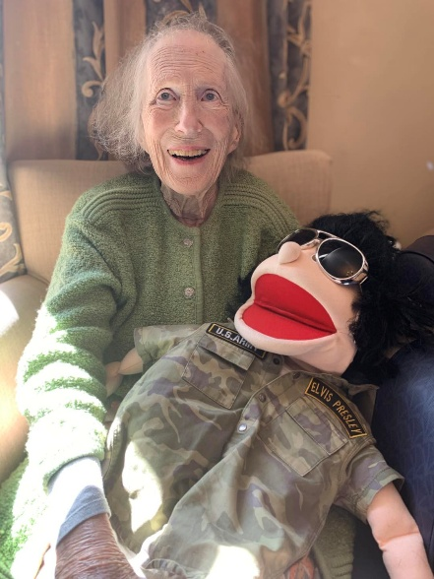  We had a lovely morning with the puppets, with plenty of songs from yesteryear for our continuing VE Day celebrations. The residents also enjoy having a hold of their favourite puppet after the performance.  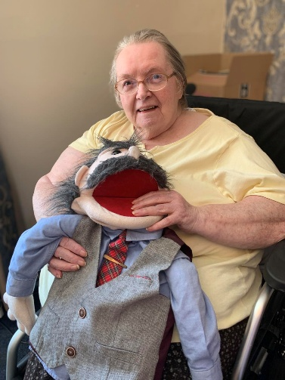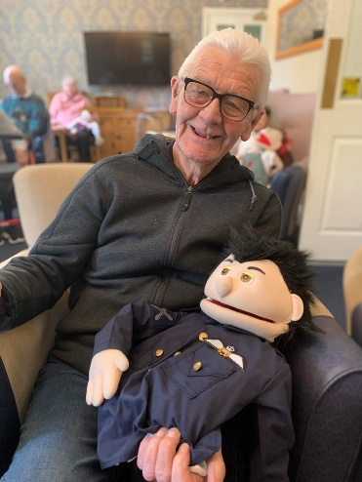  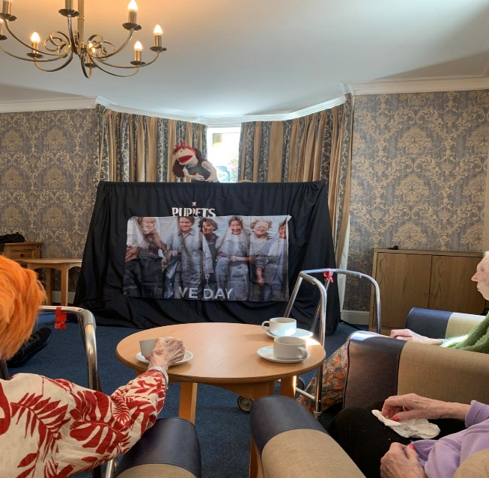  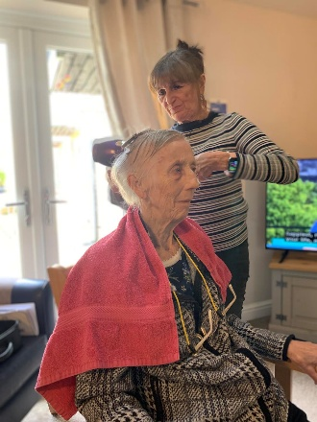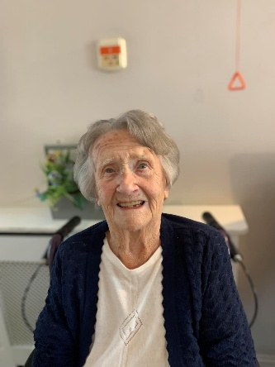  Jenny enjoying her weekly pamper with the hairdresser and Edna looking fabulous after getting her hair done  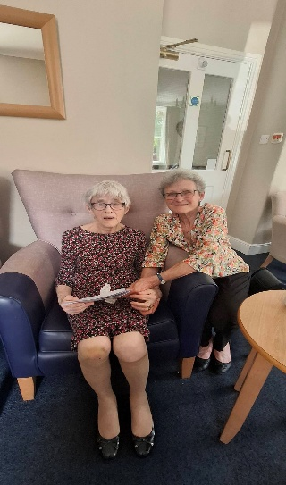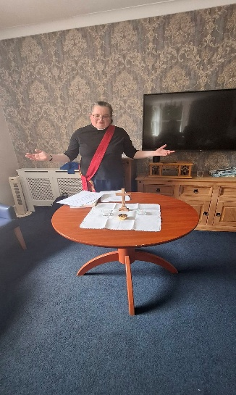  Meg and her daughter enjoying the monthly church service  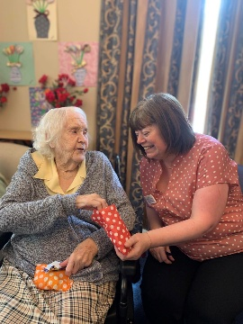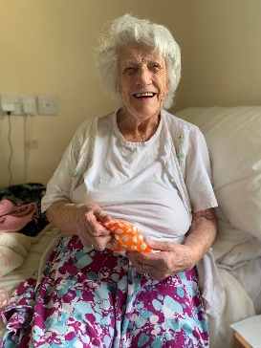  Joan, Helen and Mary enjoying their sweets from the Summerhill sweet trolly 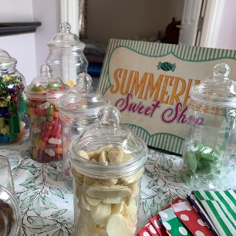  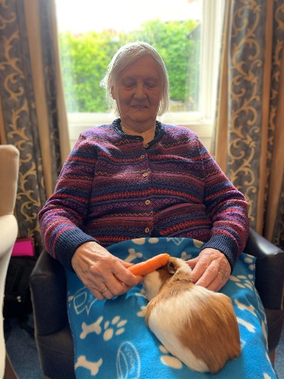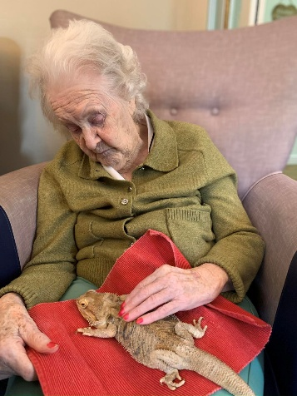  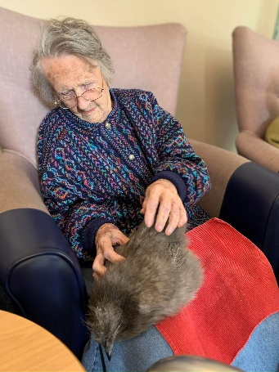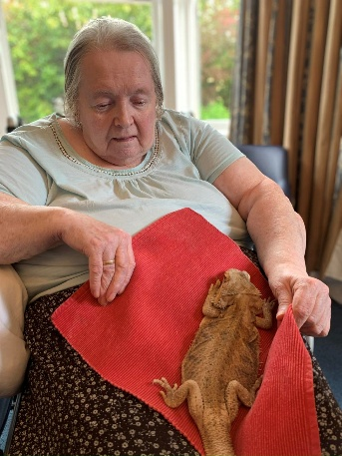  We enjoyed having Animal Antics back – we were lucky as Steff bought all fluffy ones this time……we may not be so lucky next time   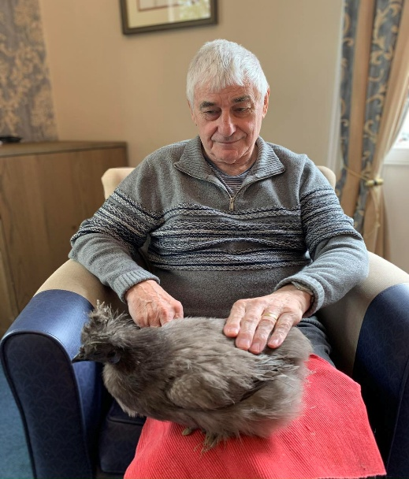  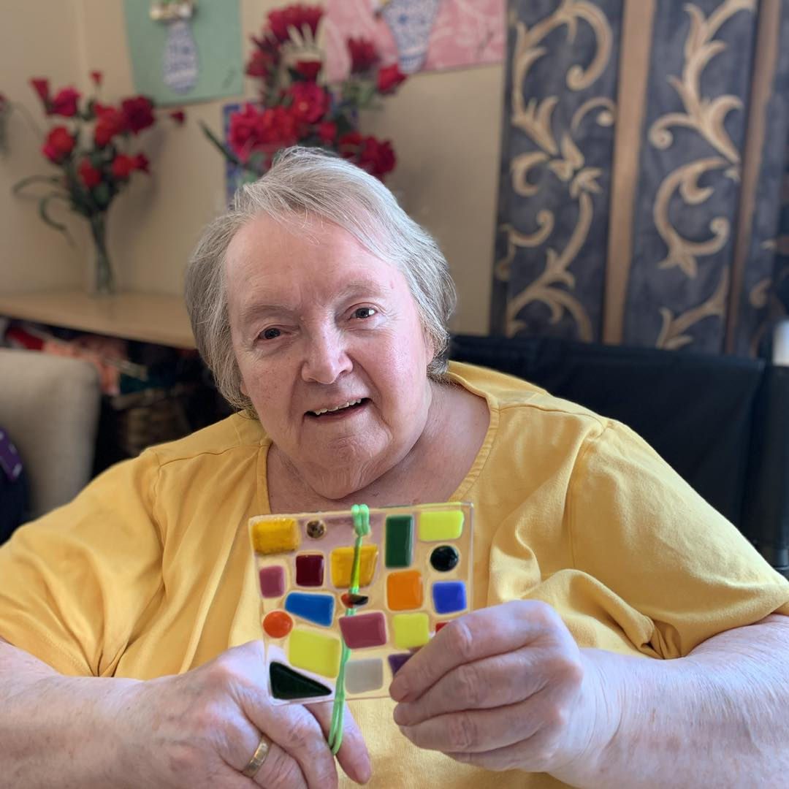  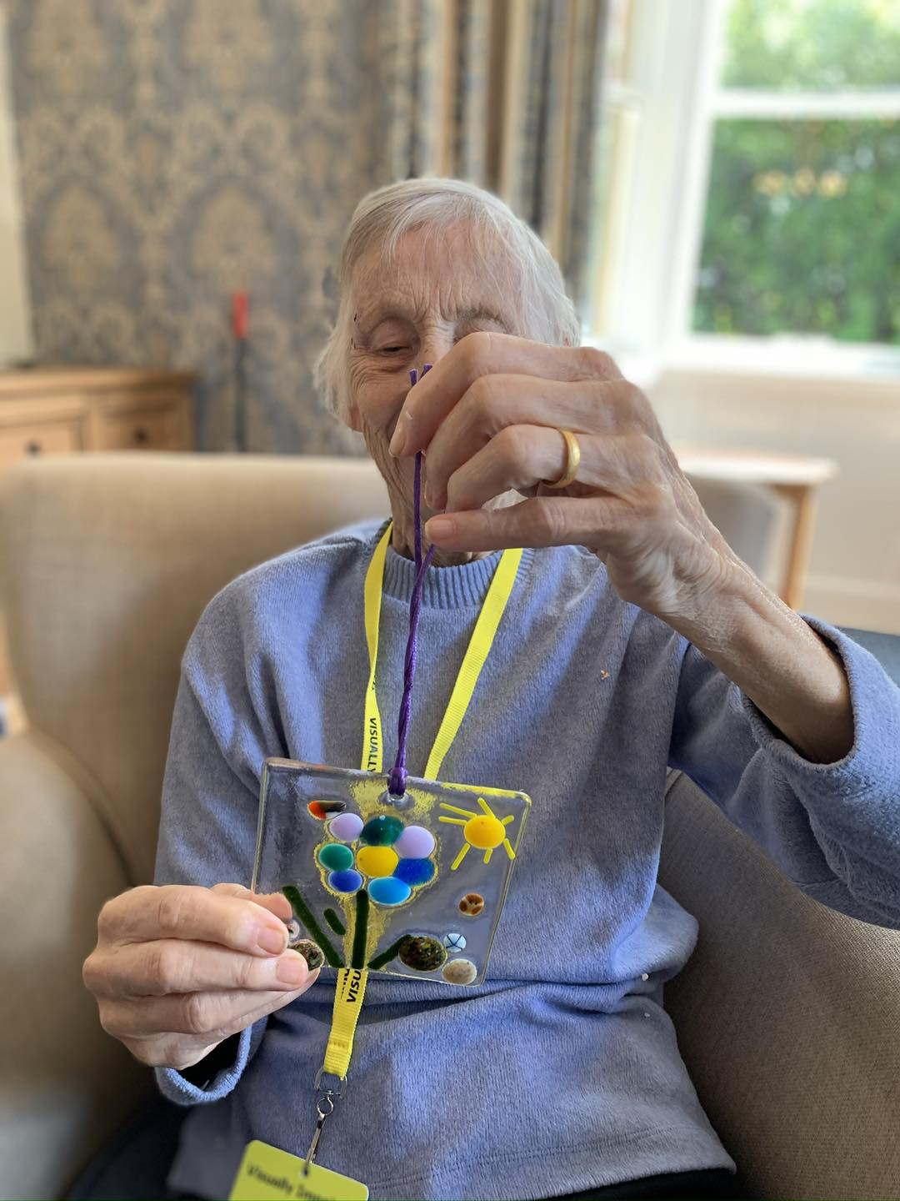  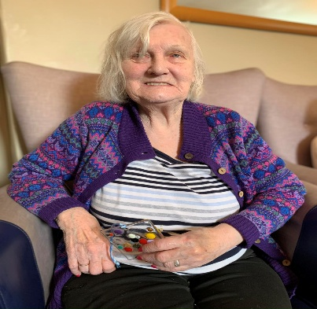  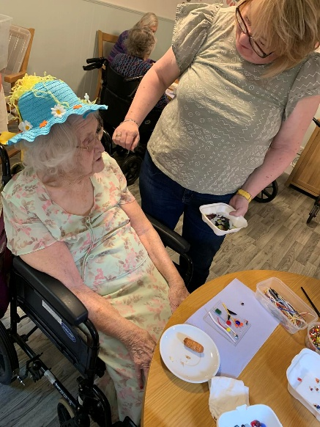  Here are some pictures of the residents making their infused glass pieces  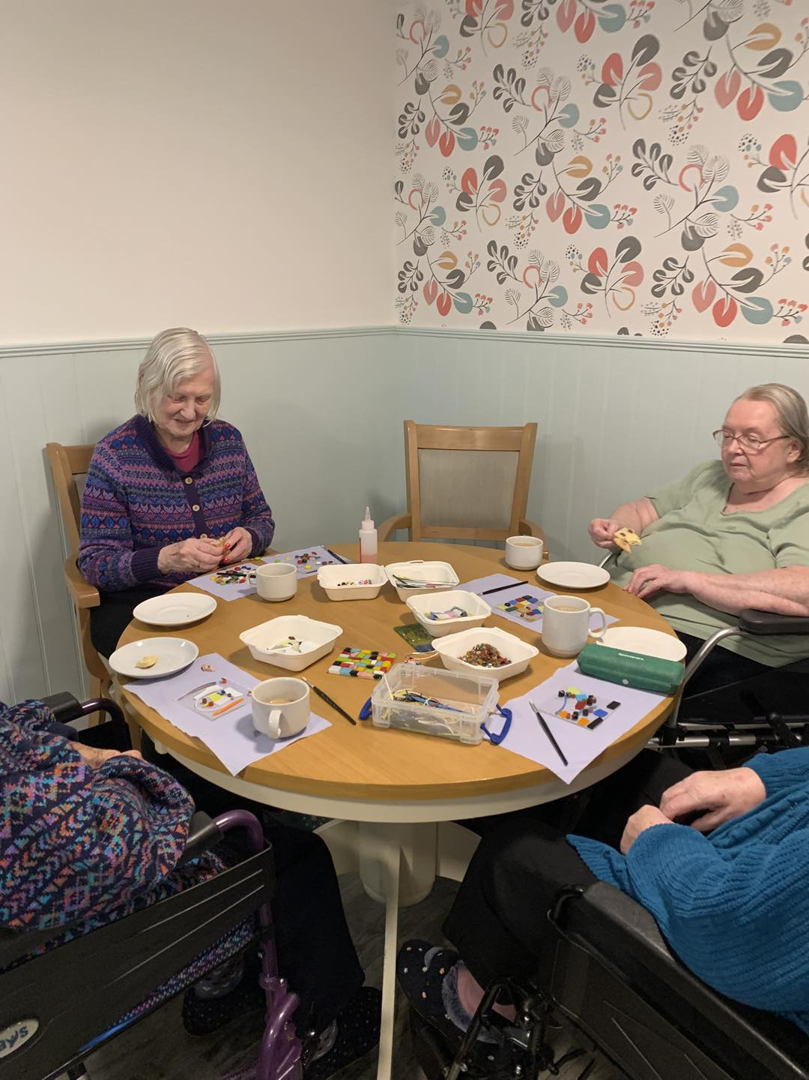  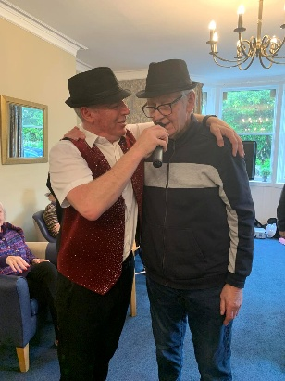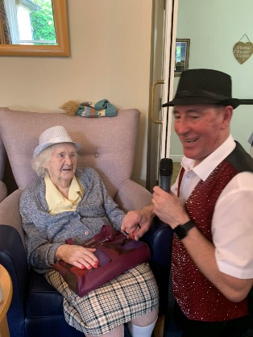  Always a party when Derek is in the house  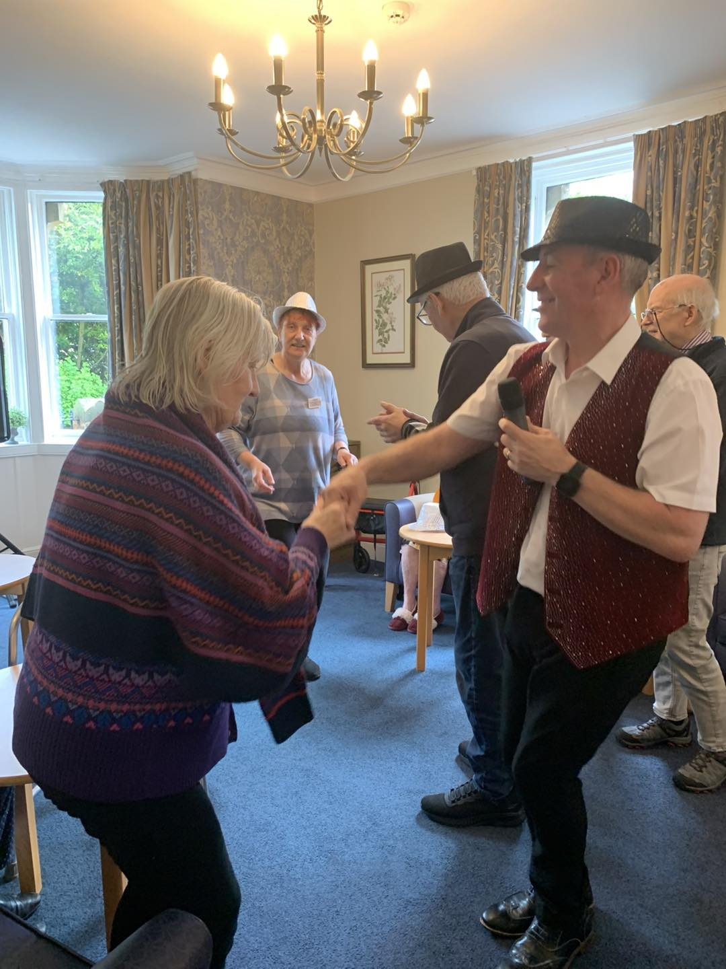  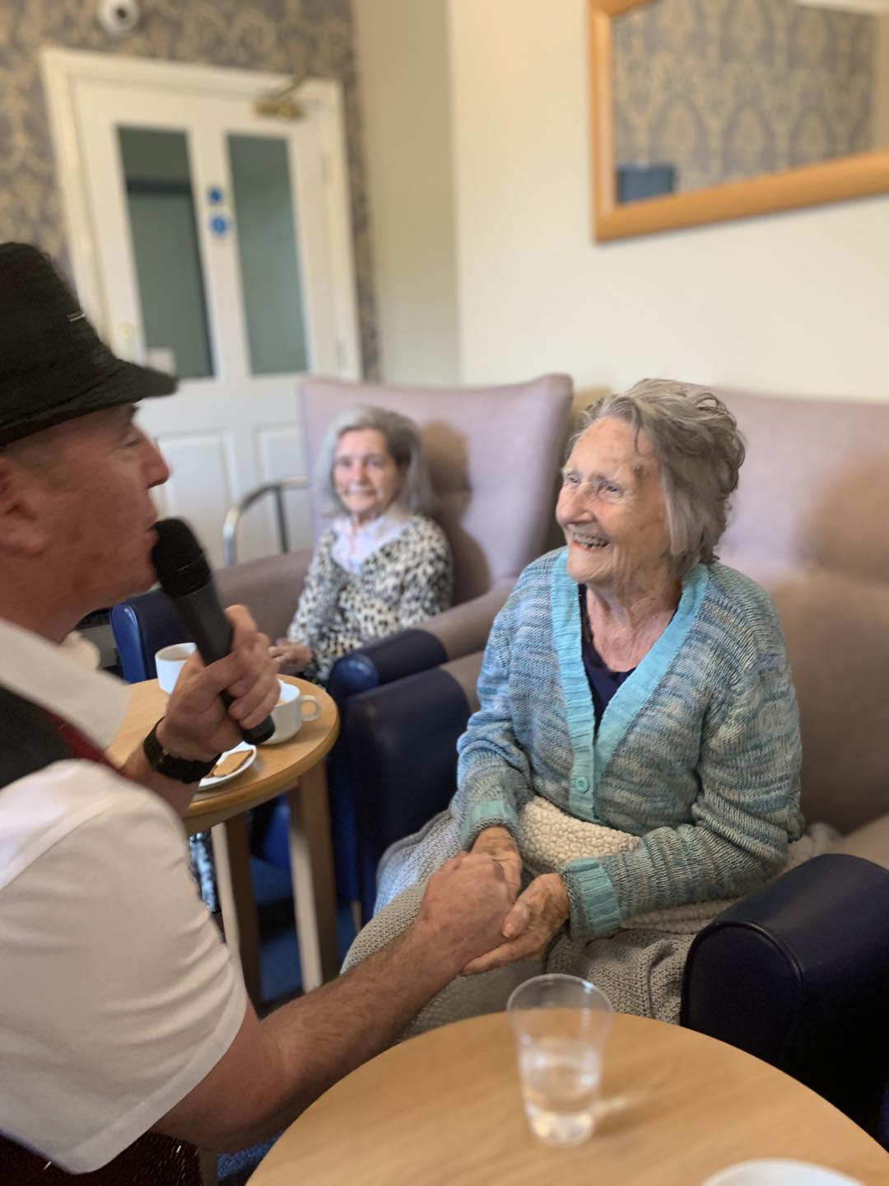  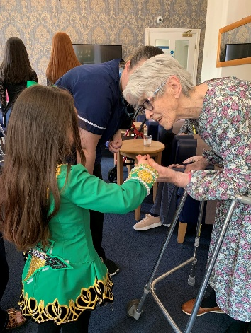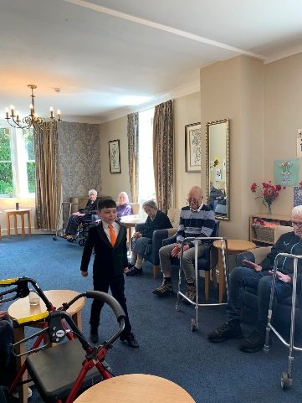  We had some dancers join us from the Kelly Hendry school of Irish dance, 2 older girls and 2 little cuties, the residents were overwhelmed and became quite tearful watching the little ones. What a joy this session was, we will be getting the dancers back in the summer holiday’s    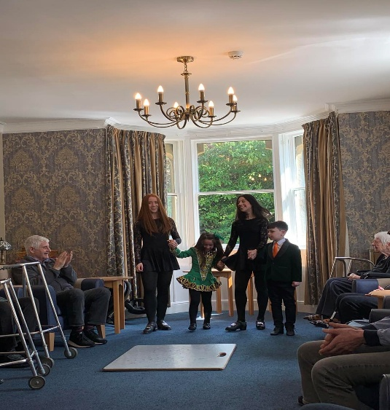  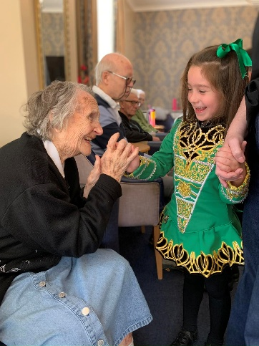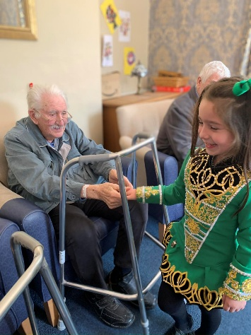  We welcomed back cheeky singer alex hall, another singer who is great with the resident’s - very inclusive and gets everyone involved    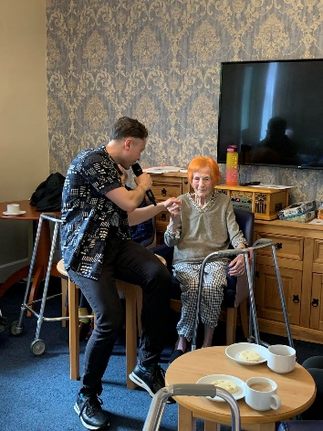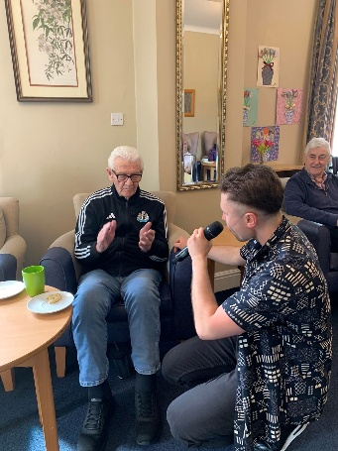  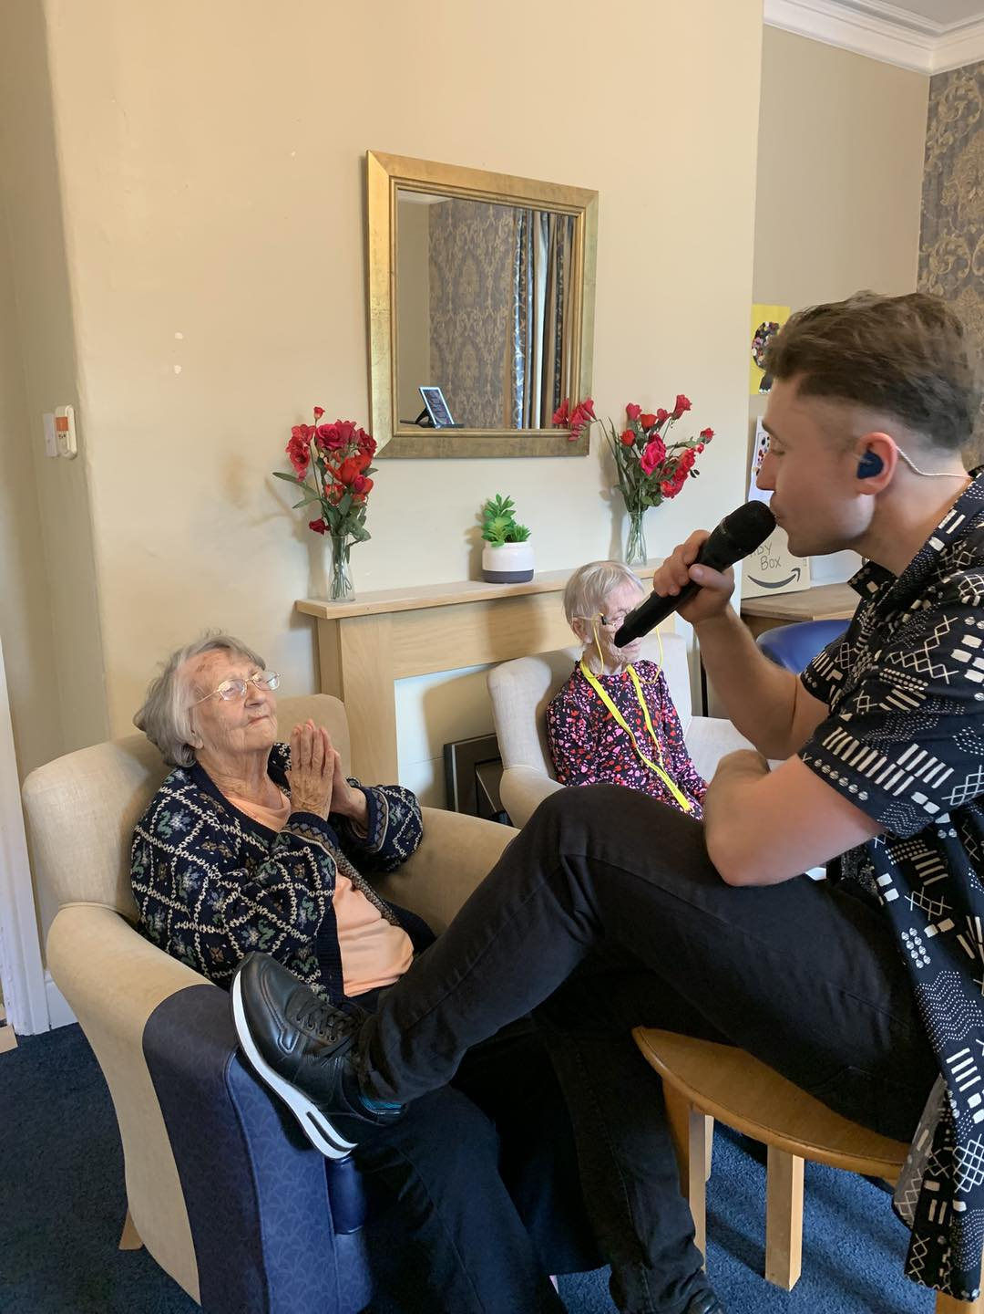  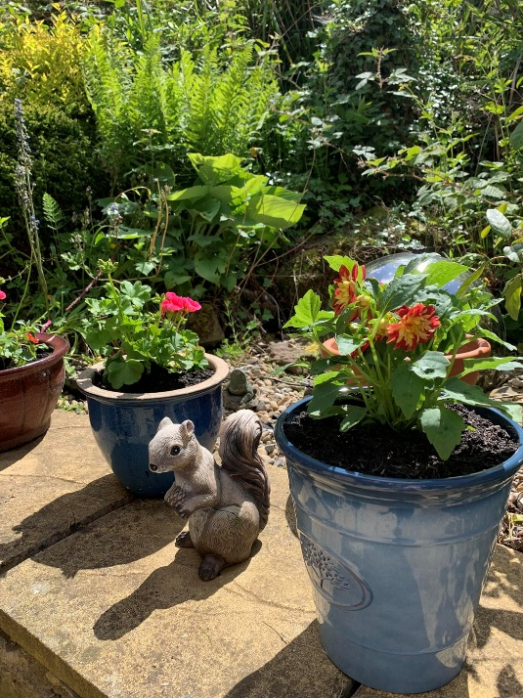  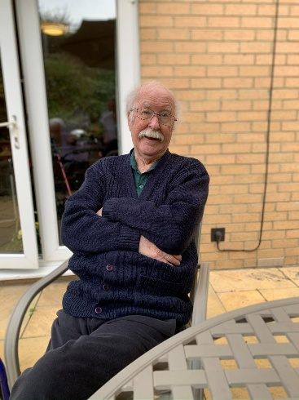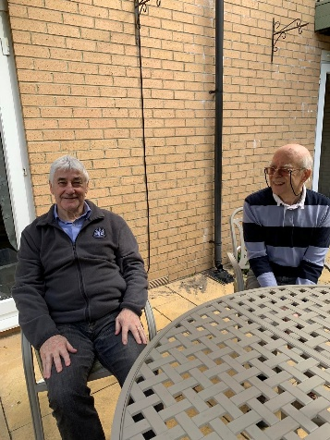  We did manage to get outside and get a little planting done – what a difference a few flowers make  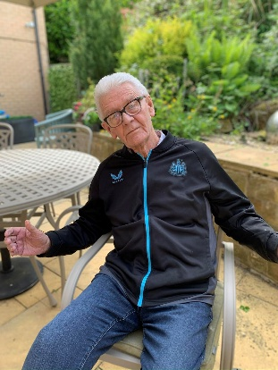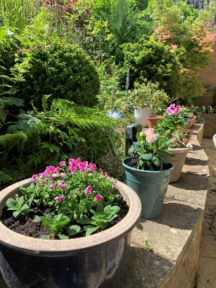  WELLDONE TO SUSAN WHO RECEIVED EMPLOYEE OF THE MONTH, NOMITAED BY THE STAFF HERE AT SUMMERHILL – WELL DESERVED AS SUSAN IS ALWAYS HAPPY TO HELP OUT IN ALL DEPARTMENTS    Thursday 25th June – We will be joined by Robert Whitehead playing his accordion - 11am in the large lounge  Friday 26th June – We will be joined by Elvis – 11am in the large lounge  Monday 29th June – We will be joined by Colin the Care home singer – 11am in the large lounge
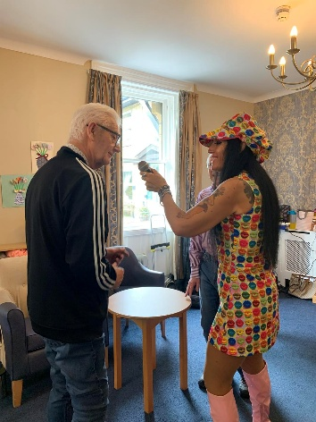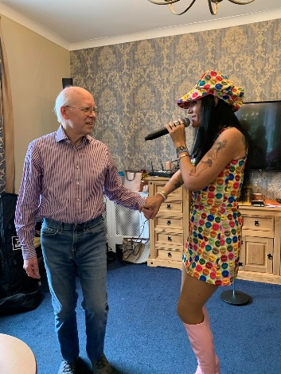

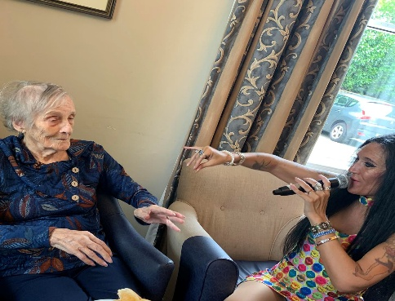



We celebrated VE Day with singer Elaina Morris, she satred her session of with some lovely old time tunes then finished with some more lively rock and roll music – those rhat could enjoyed a dance. Afterwards this gave the residents a chance to chat about what they remenbered from that time and share with other residents.

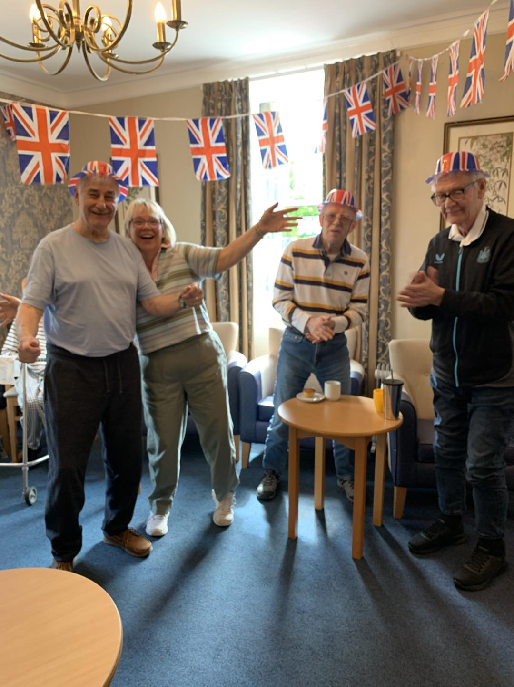

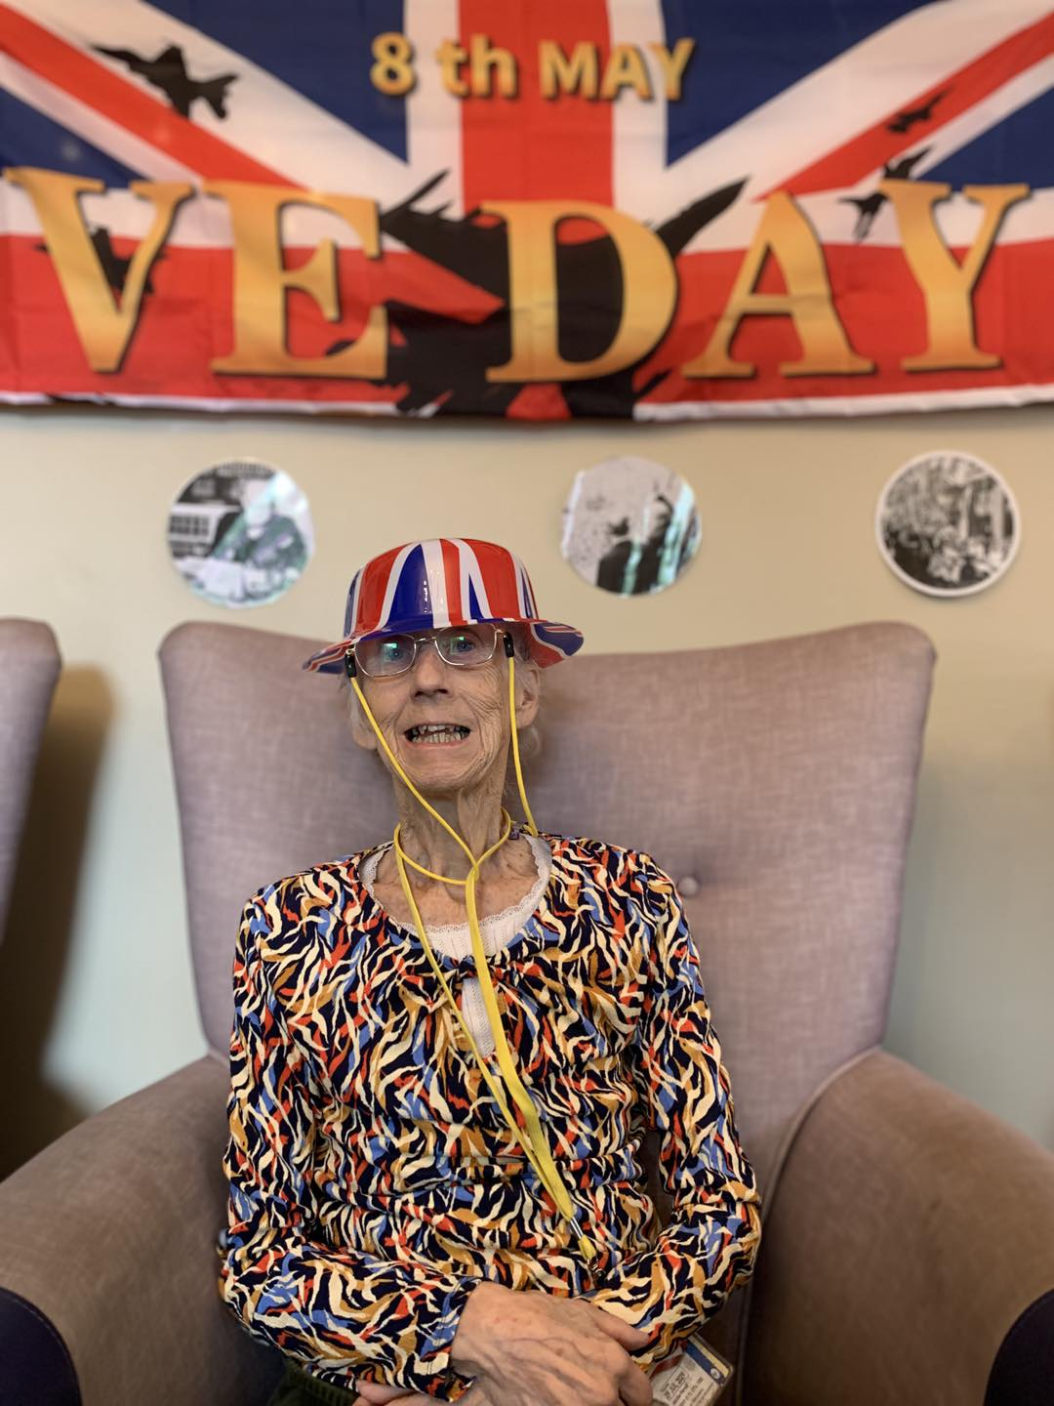

SOME MORE GREAT PICTURES FROM VE DAY

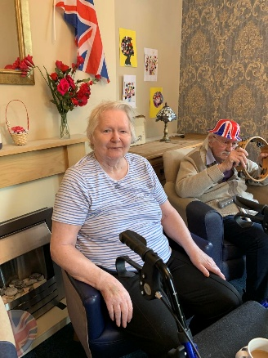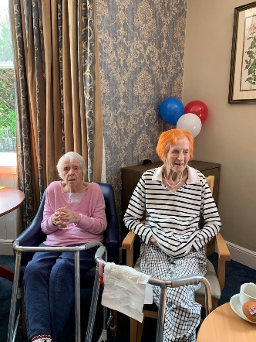

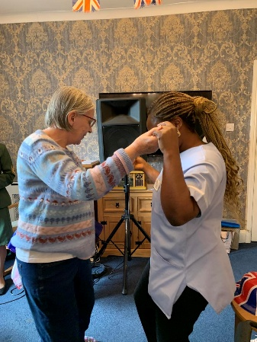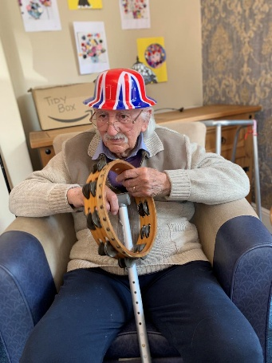

We welcomed back John Fletcher singing his Rat Pack session – these are such chilled sessions with everyone just relaxed and listening to the faboulos music

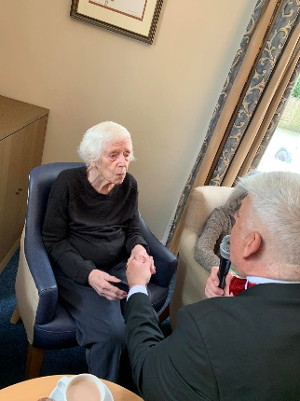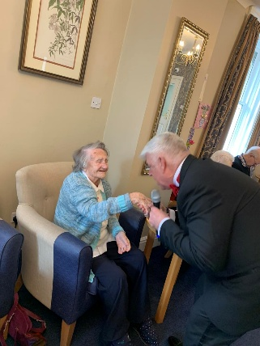

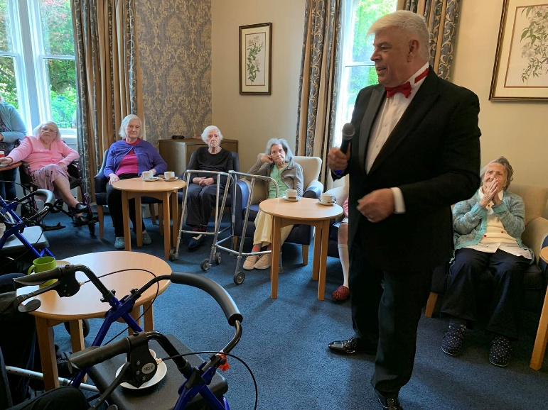

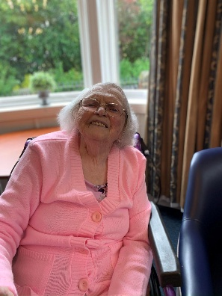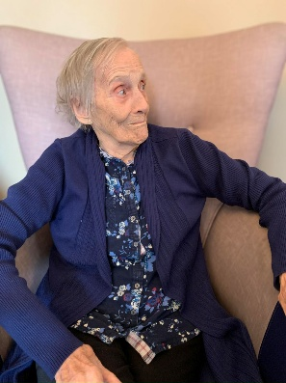

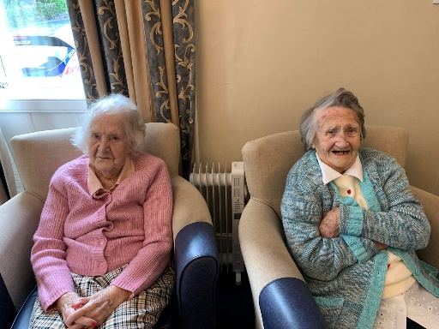

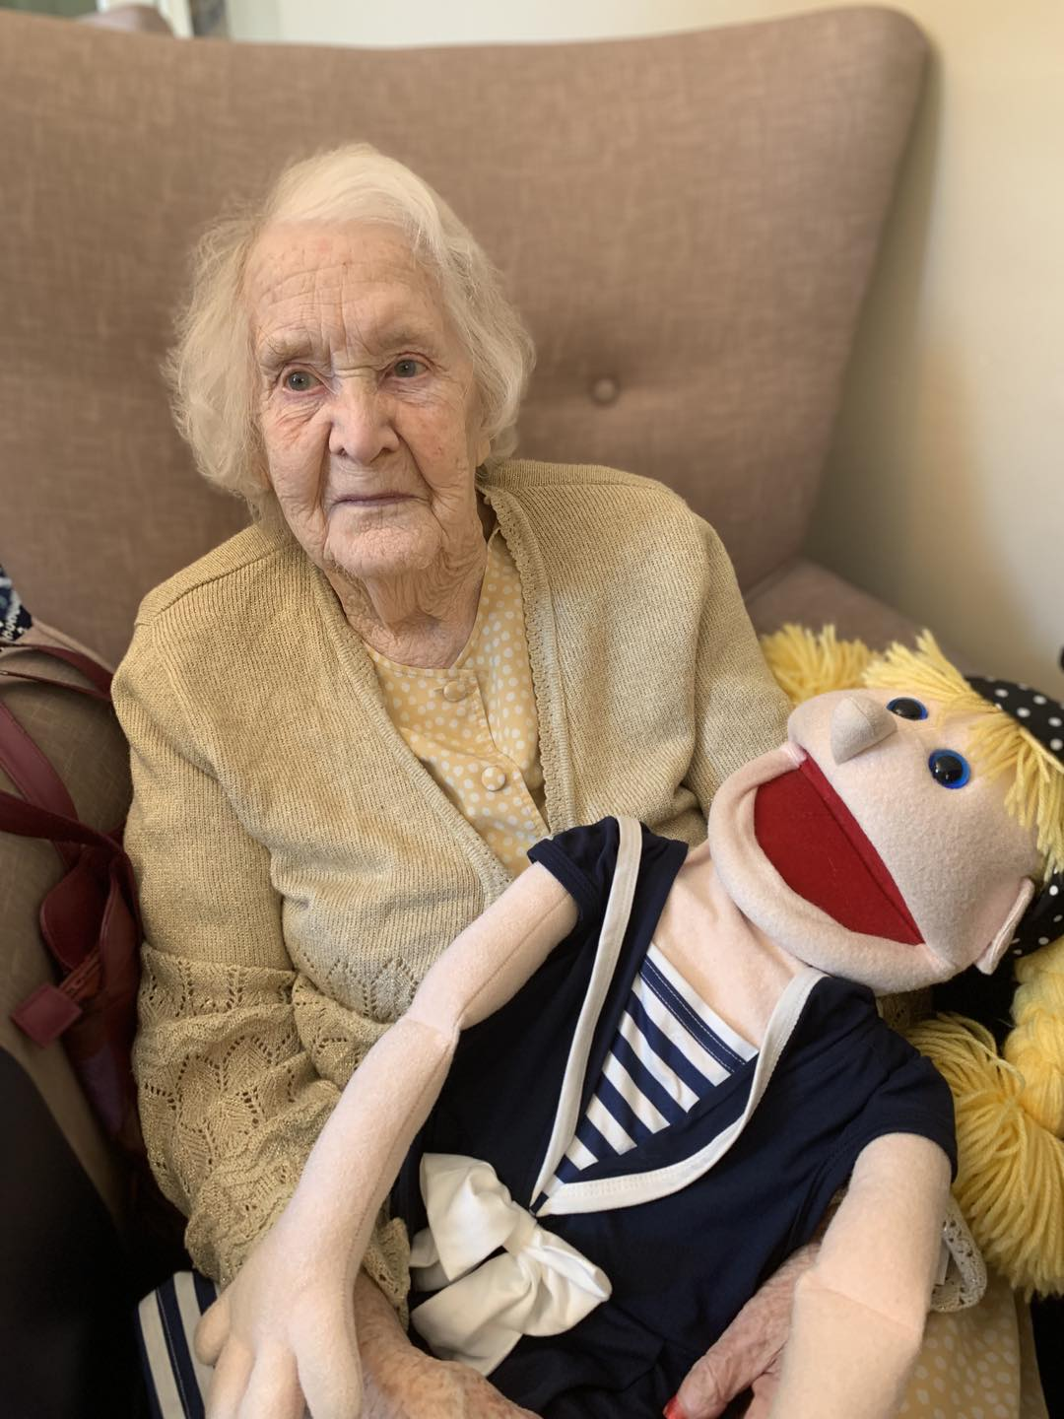

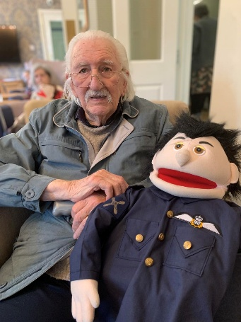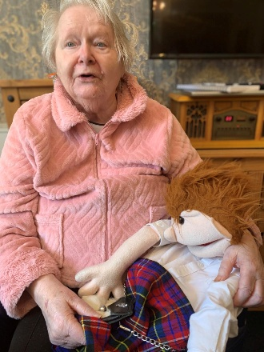

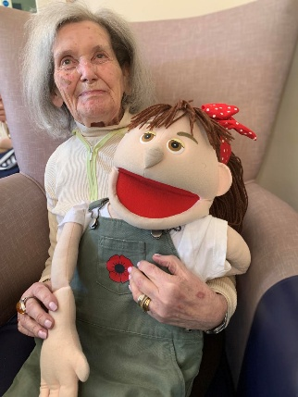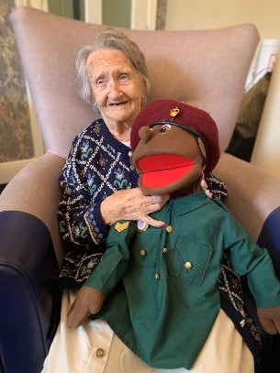

We have enjoyed our usual activities this month, monthly coffee morning, visits from King, bingo, hairdresser visits,
Church service and the sweet trolly.

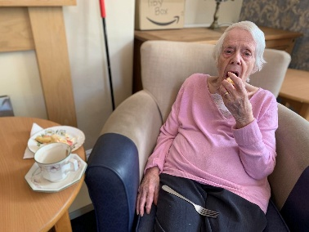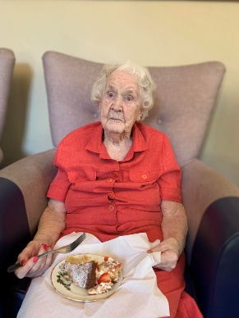
Margaret and Joan enjoying their coffee morning

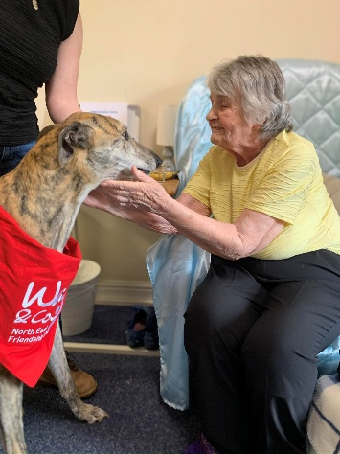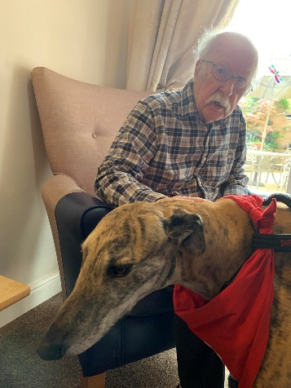

Joan and Richard enjoying a visit from King

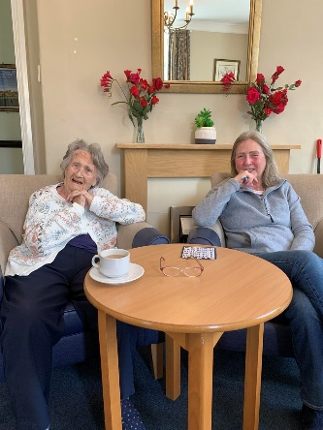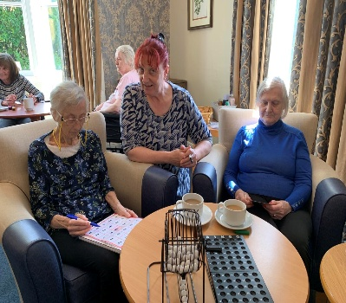

Enda joined by her daughter for bingo x

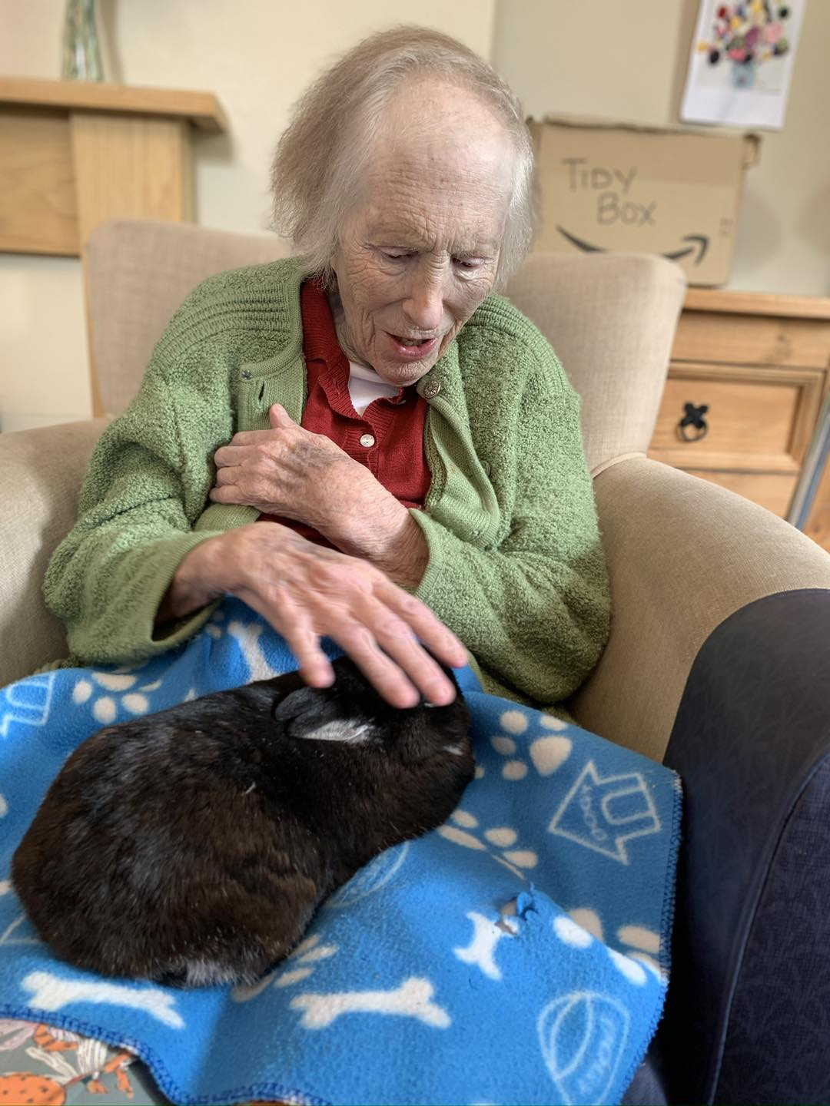

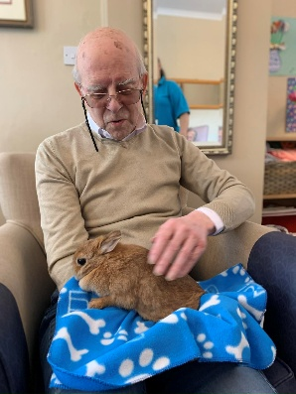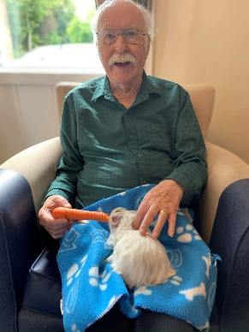

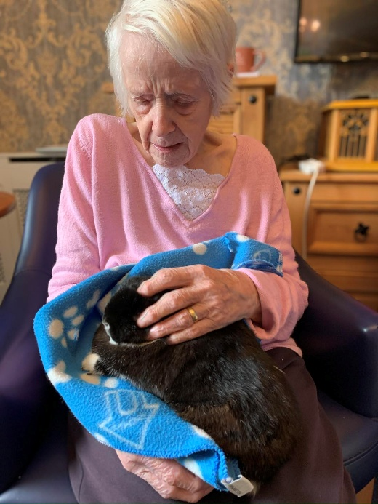

WE HAD A LOVELY GLASS INFUSED SESSION, EACH RESIDENT HAD THE CHANCE TO MAKE THEIR OWN UNIQUE GIFT FOR THEMSLEVES – AND THEY TURNED OUT WONDERFUL

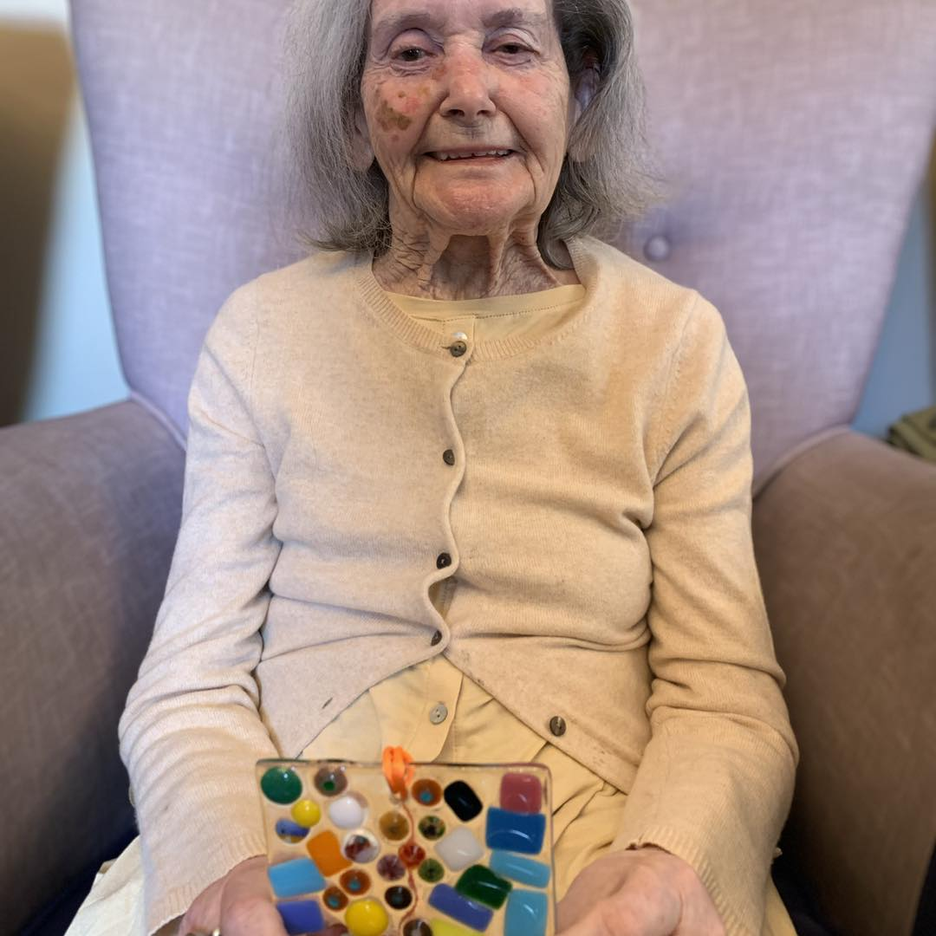

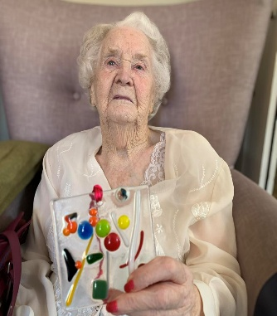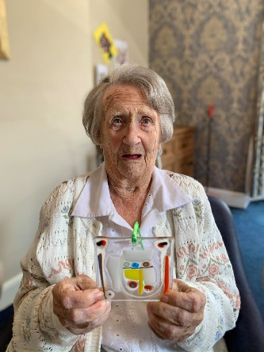
Joan and Edna looking pleased with themselves at making something spectacular

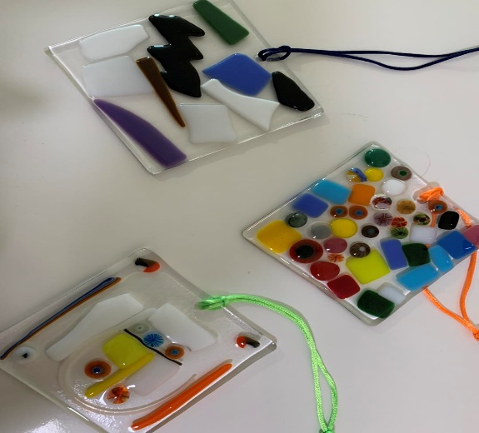

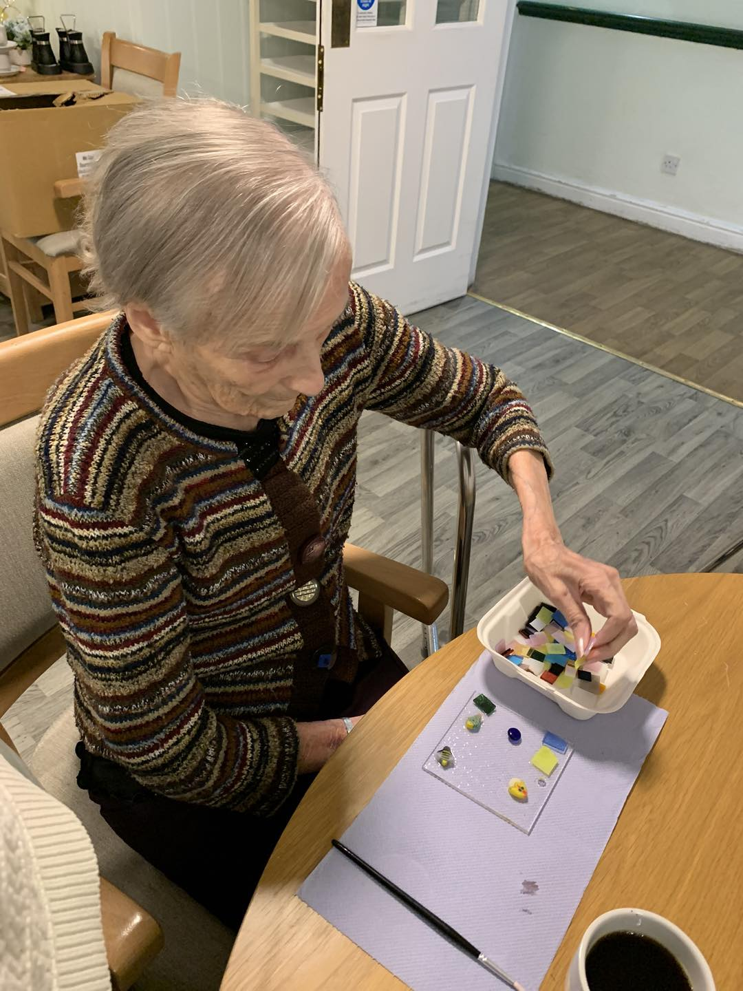

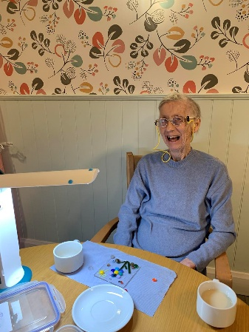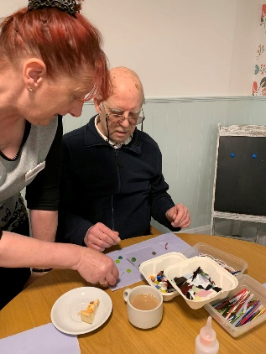

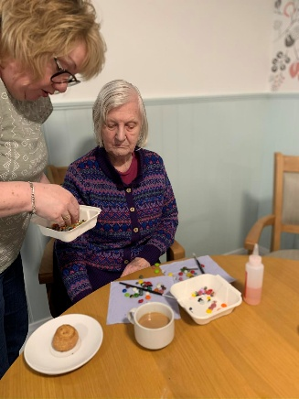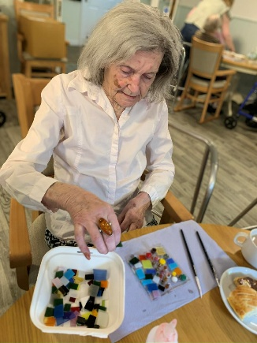

SINGER DEREK HODGSON – THIS MAN IS SUCH A JOY TO WATCH, HE SO INCLUSIVE WITH THE RESIDENTS MAKING THEM SMILE FROM EAR TO EAR WITH HIS SILLY ANTICS – HE HAS ALWAYS SAID TO ME THAT LIFE IS TOO SHORT TO BE TAKEN SERIOULSY AND HE ALWAYS GOES ABOVE AND BEYOND

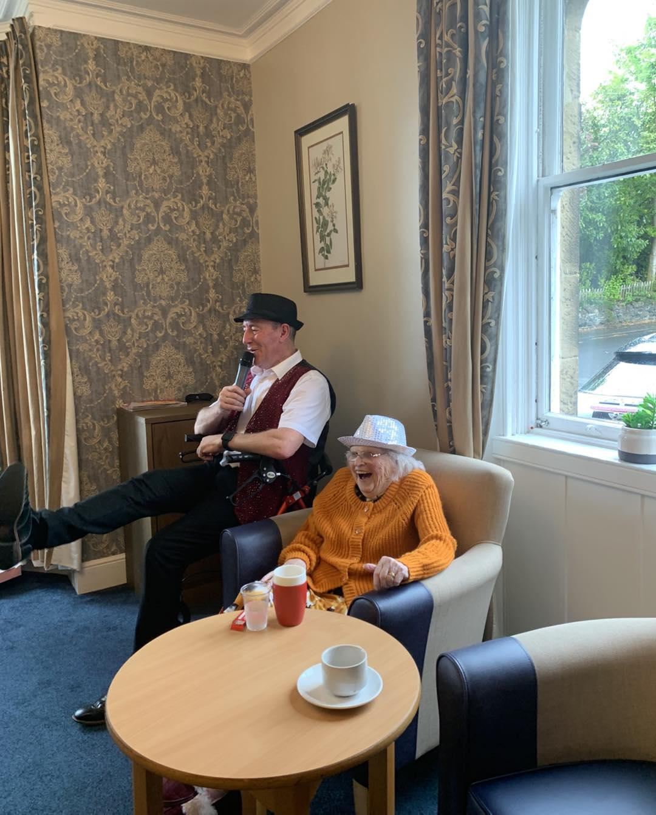

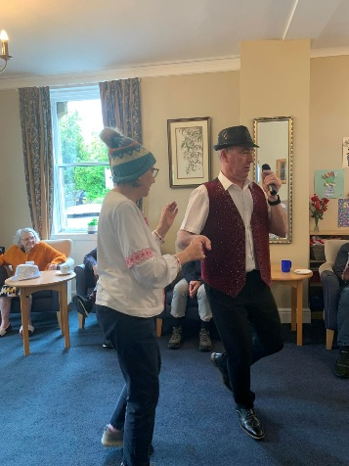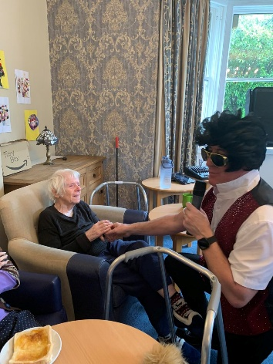
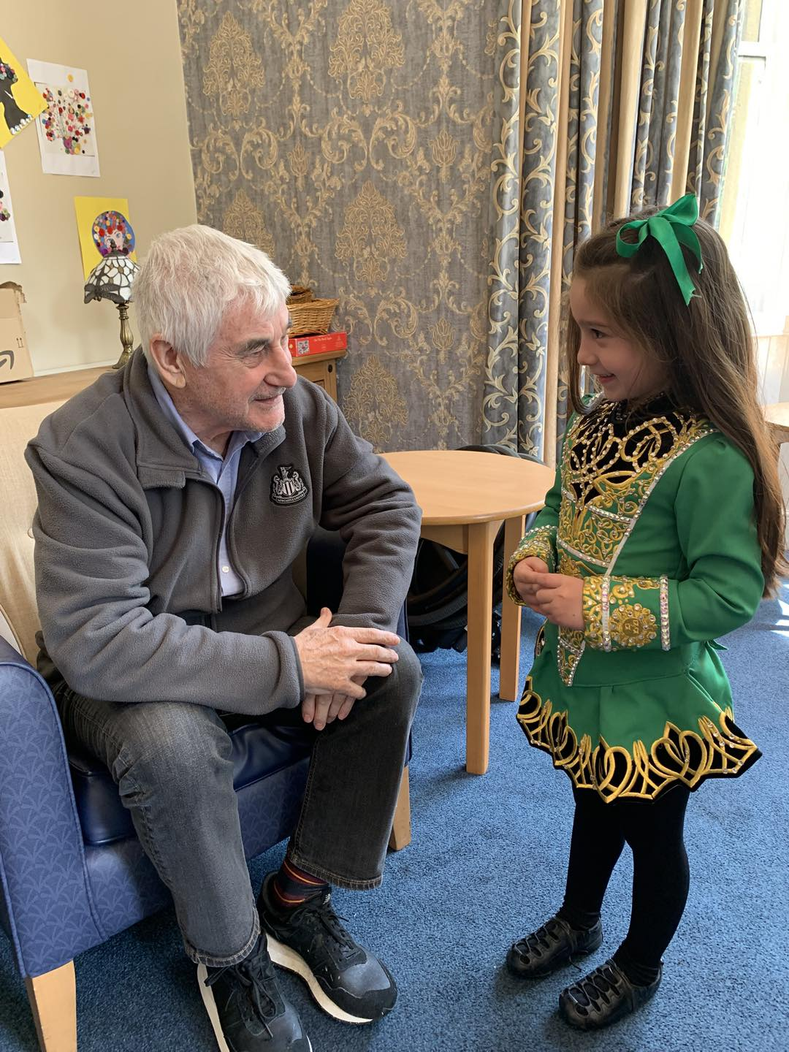

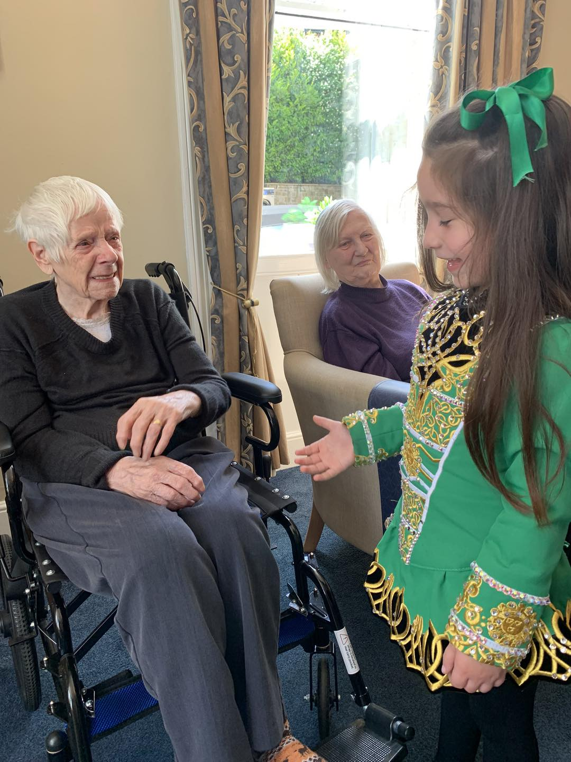

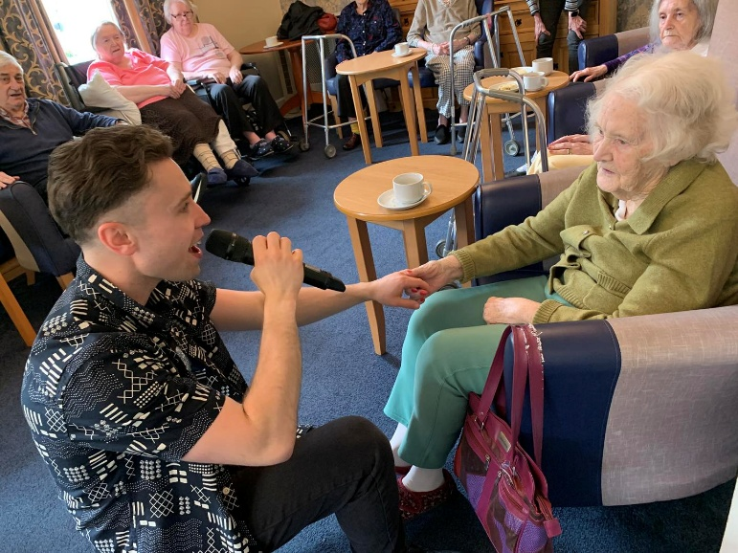

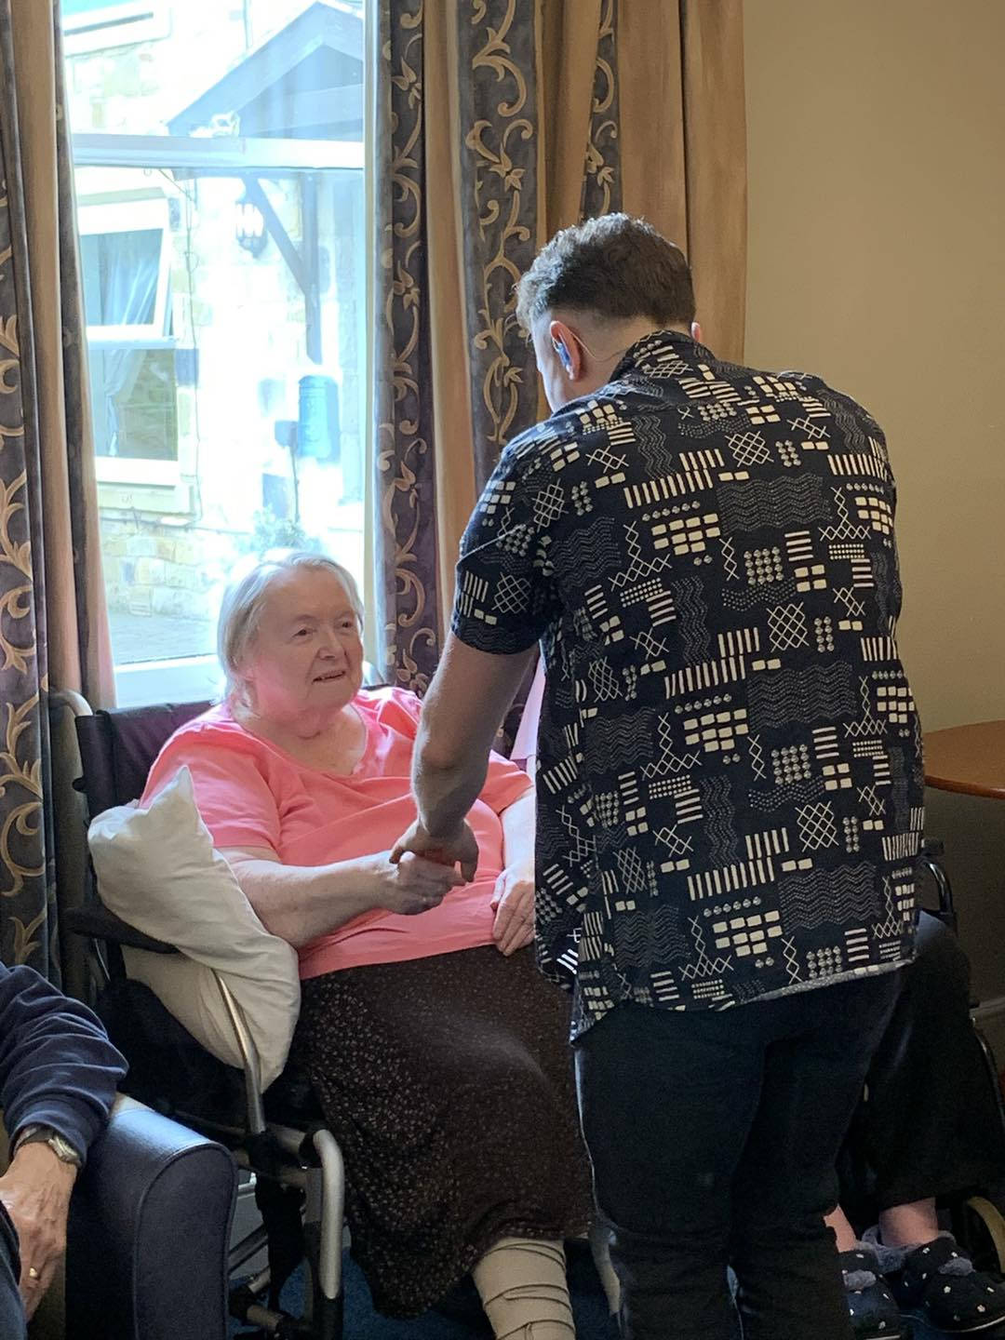

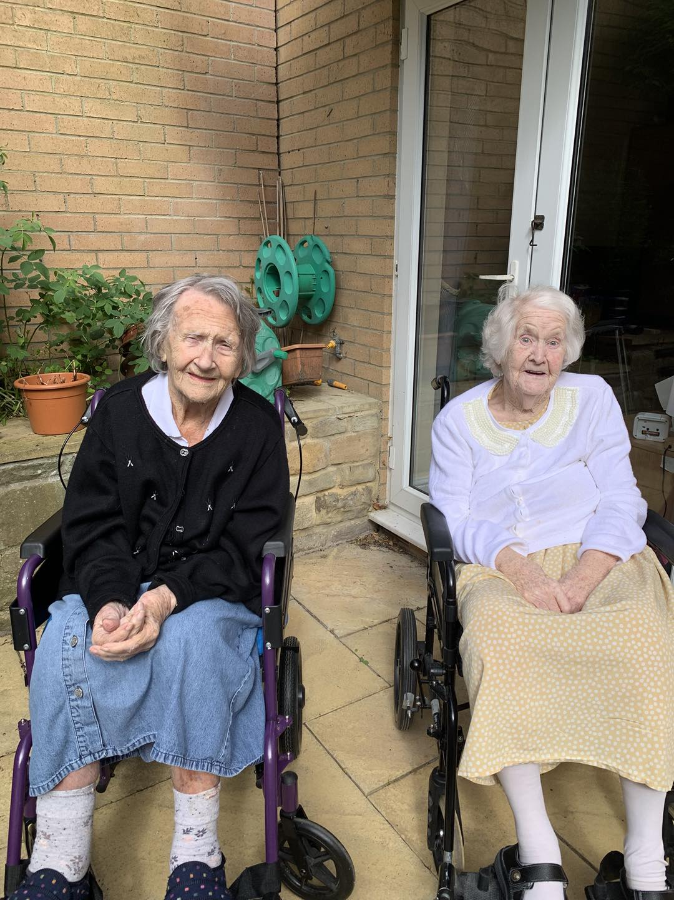

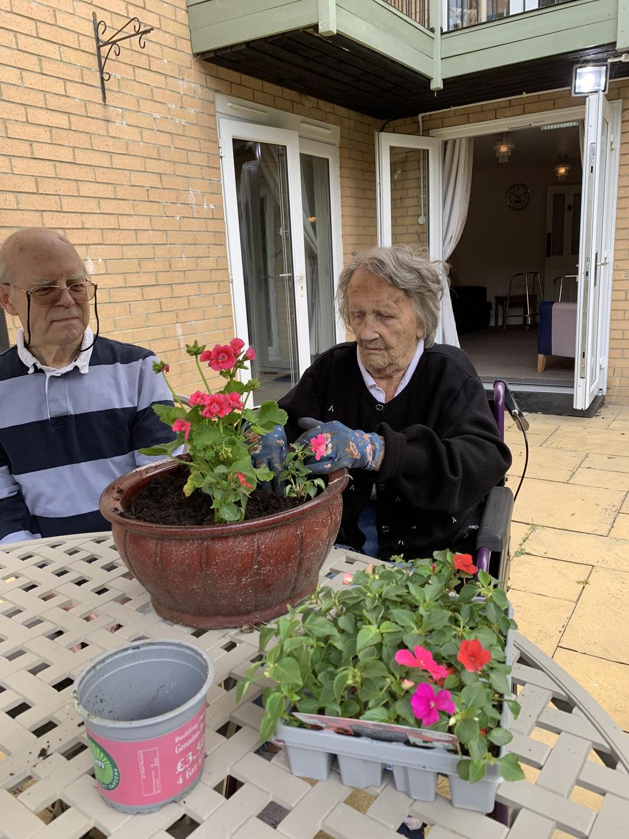

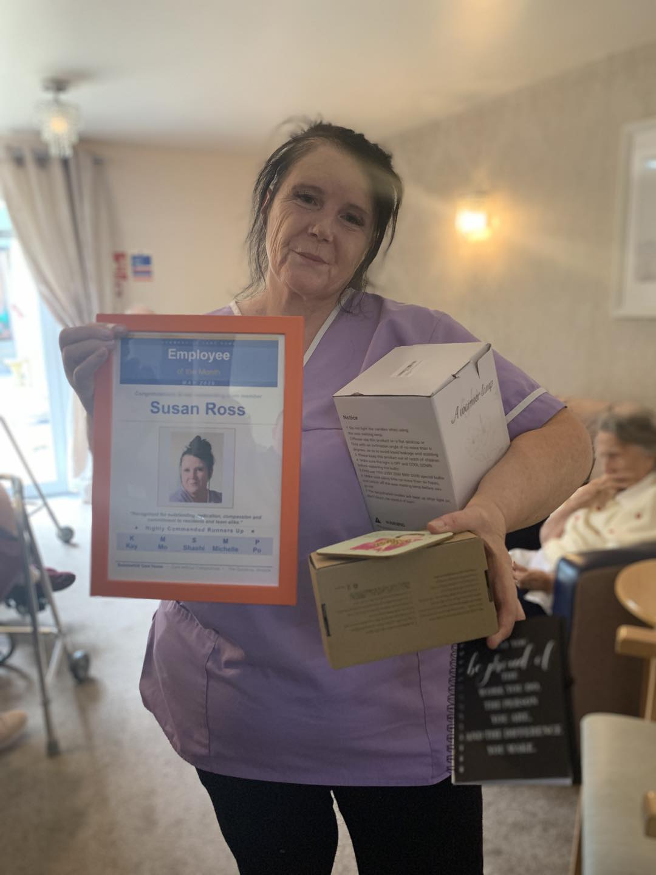

Upcoming Key Dates

Tuesday 2nd June – We will be joined by Rat Pack singer John Fletcher – 11am in the large lounge

Friday 5th June – We will join by singer Sam Naylor as we celebrate Pride – she will be doing her drag act – 11am in the large lounge

Monday 8th June – we will be joined by Animal Antics – 11am large lounge

Thursday 11th June– We will be joined by Kev the Care home singer – 11am in the large lounge

Tuesday 16th June - – We will be joined by singer Steven Swales – 11am in the large lounge

Sunday 21st June – we will be joined by singer Tony DaSousa to celebrate Father’s Day

Tuesday 23rd June – Join us in the large lounge for our monthly Church Service @11am
Contact details
If you have any questions in regards activities or any suggestions for future activities, please do not hesitate to contact me Michelle Holder via email at wellbeing@summerhillcare.com

