 | Summerhill Care Home
June News Letter
Welcome |  |  | 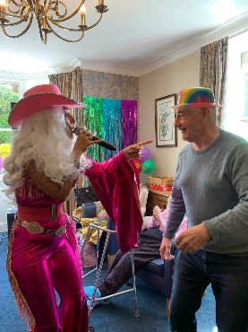
Welcome to June’s newsletter. Firstly, I would like to welcome Fiona to our team, as I embark on my part time hours, Fiona will be working on Thursday’s and Friday’s and I will be here on Monday, Tuesday and Wednesday.

Hopefully you have all seen the wonderful hanging baskets and on display to the front of Summerhill, they look absolutely gorgeous and add some lovely colour for the summer month.

As June is Pride month, we have enjoyed a Pride party with one of our resident singers Sam Naylor dressing up in drag, we all had a fab time and Sam also bought in her multitude of wigs for us all to try.

Fiona and I took several residents to a Disco in Seahouses, this was great fun and we will defiantly be going again, this is all run by volunteers and is a fantastic way for our residents to meet with other people and belonging to the community. We will also be celebrating Father’s Day this month with singer Tony DaSousa.

Hopefully with the good weather on its way, I can get more residents out and about, so watch out to see if your loved one has been anywhere.

Activities & Events
Welcome to Fiona, who will be working on Thursday’s and Friday’s doing activities.  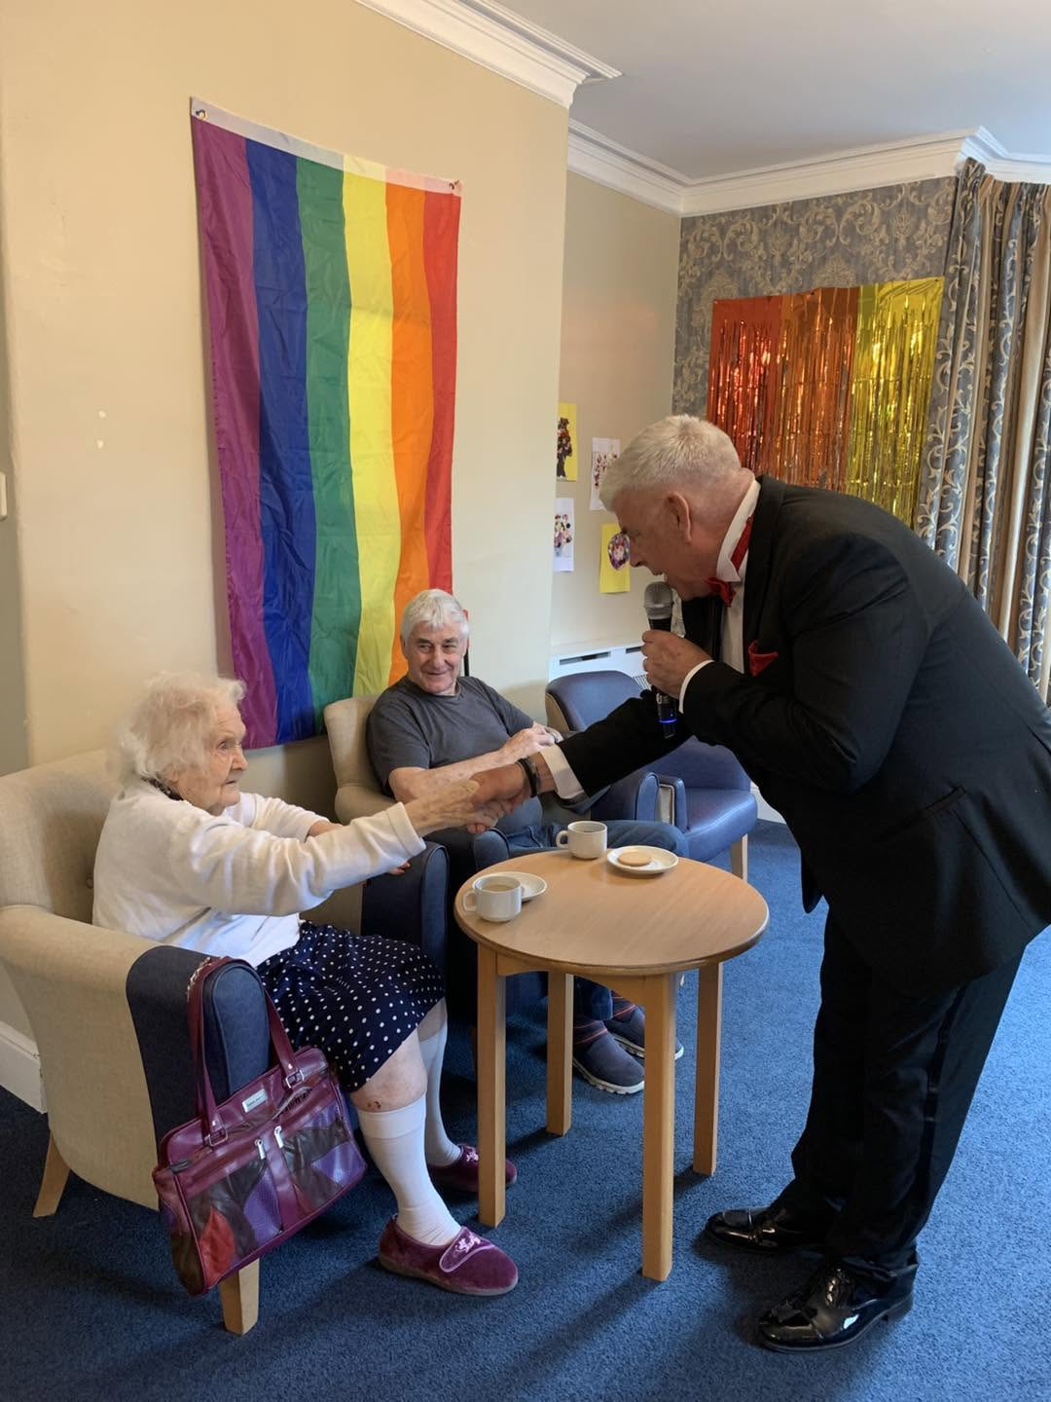 |  | 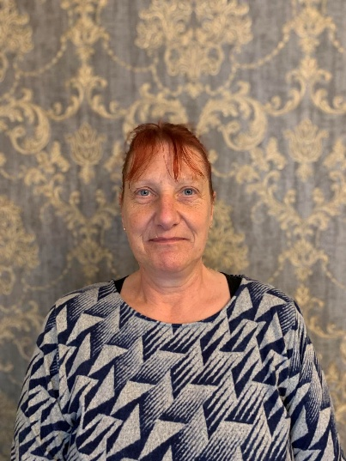  We welcomed John Fletcher back this month, another firm favourite with our residents with his fantastic Rat Pack session, he gets everyone sining along with the classics.  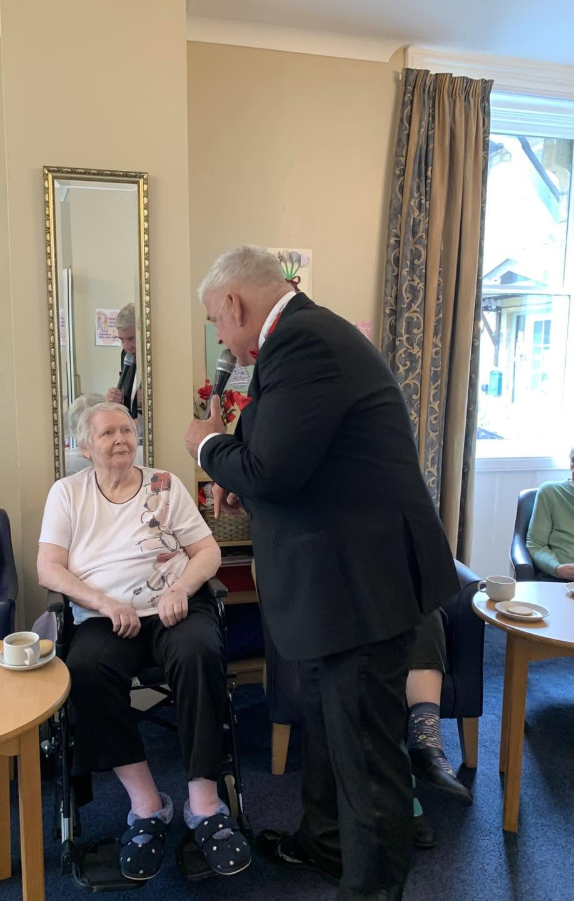  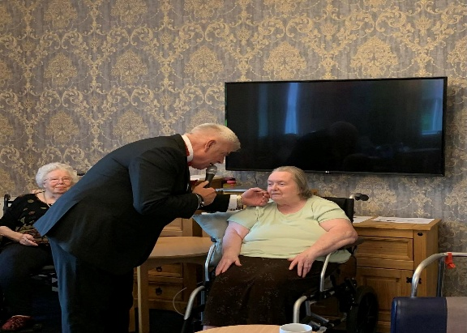  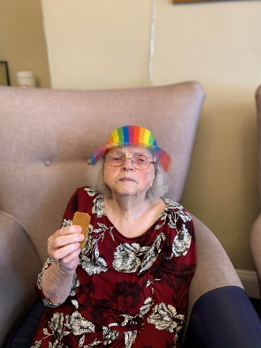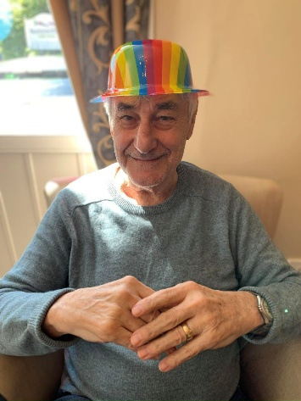  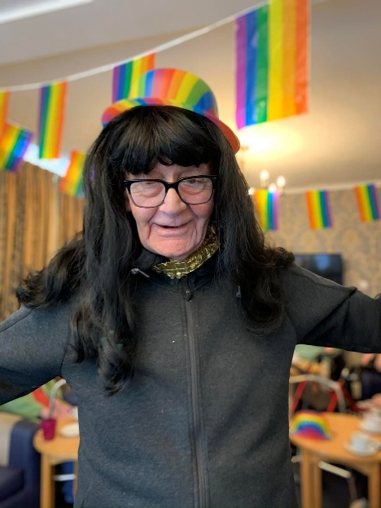  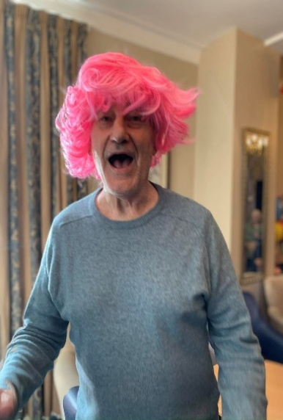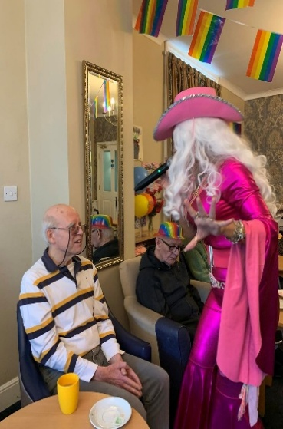  Looks like Tom is having a ball!  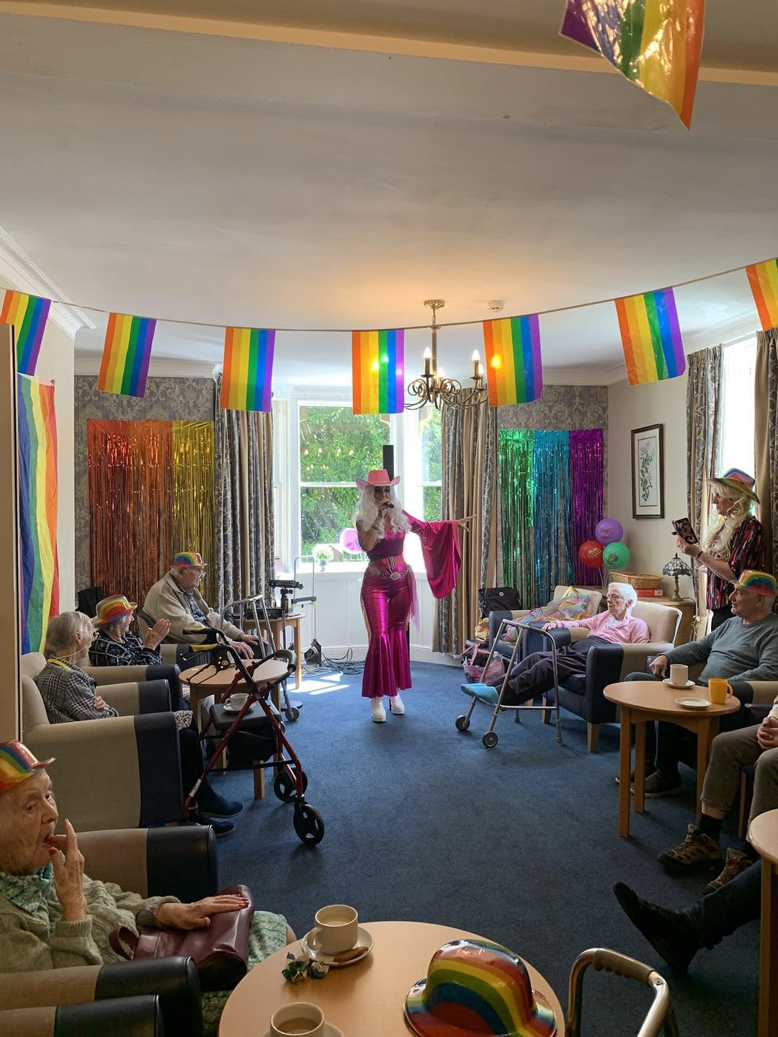  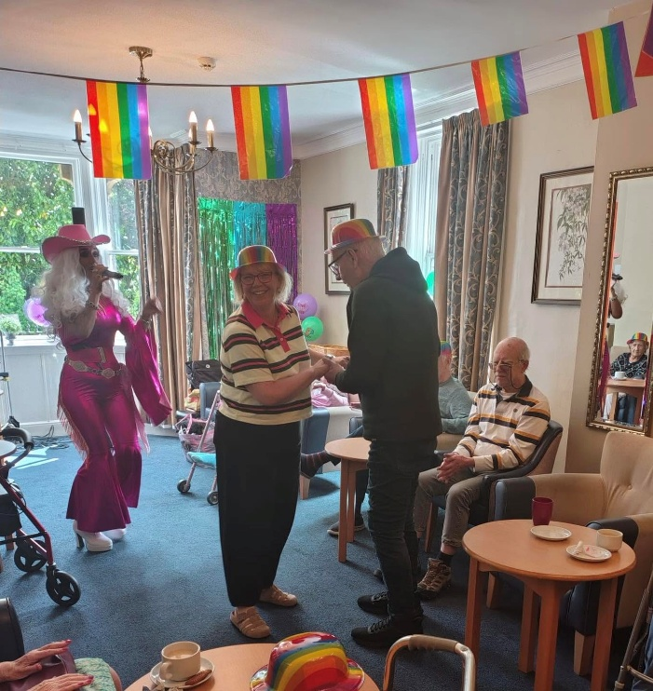  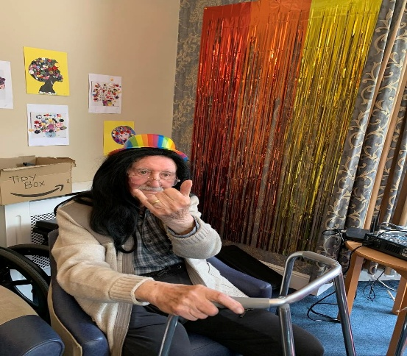  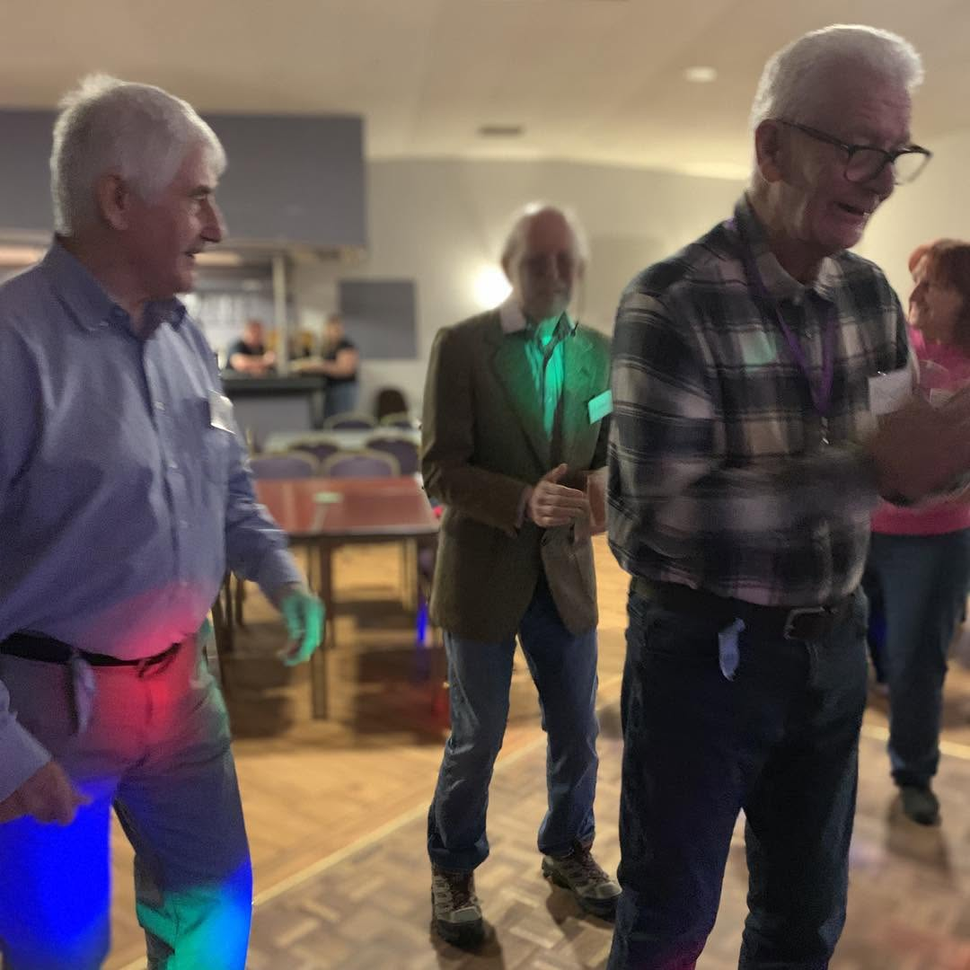    DISCO  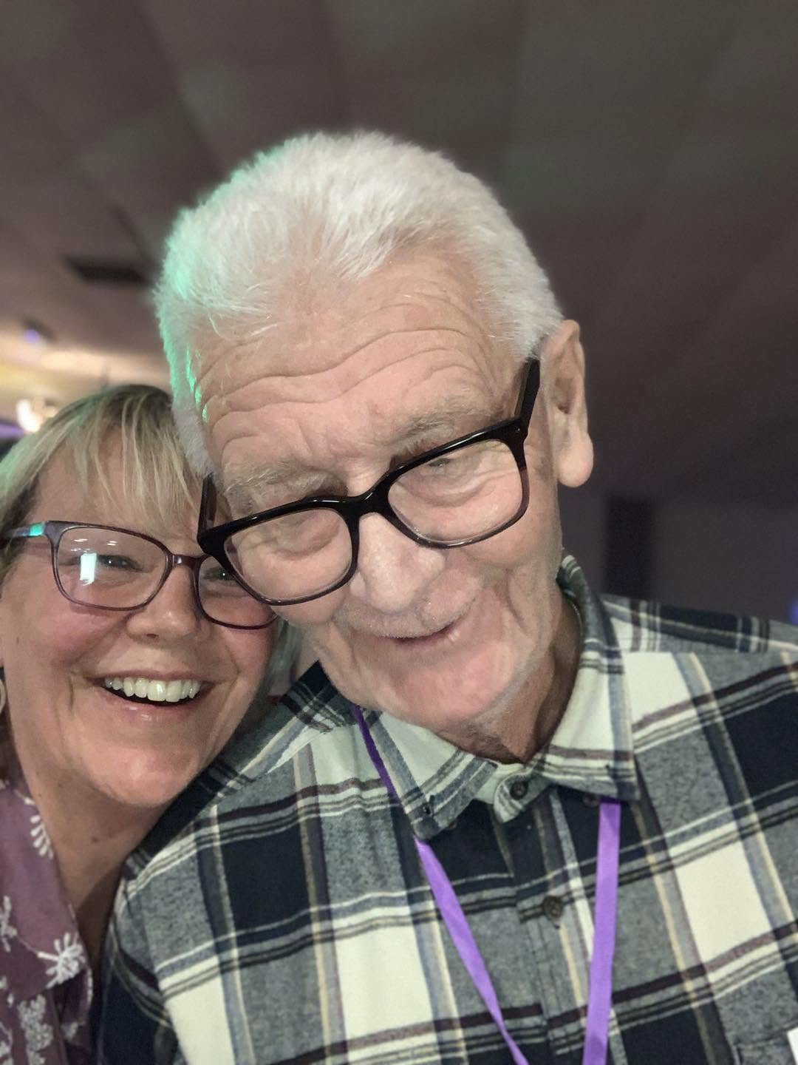  SOME MORE GREAT PICTURES FROM THE DISCO  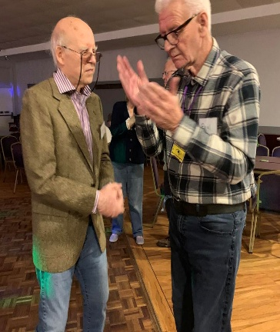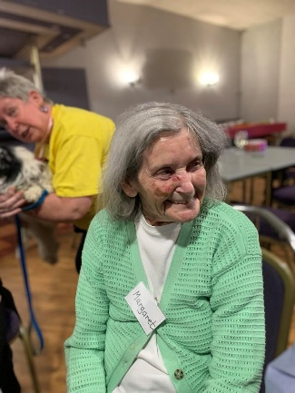  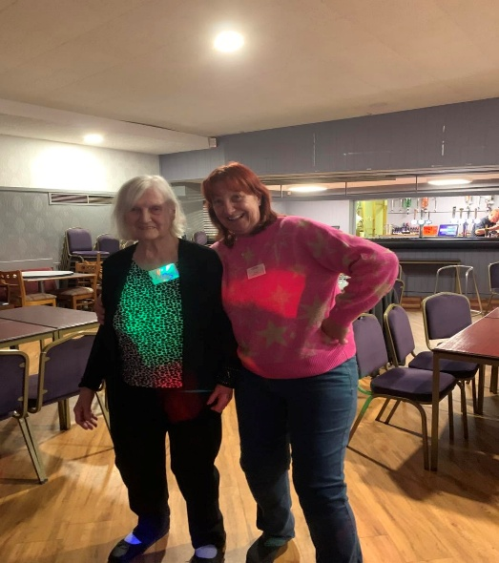  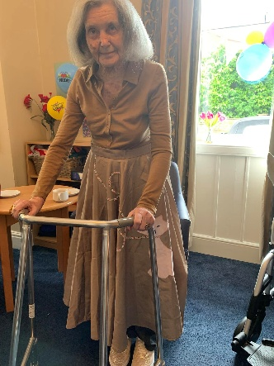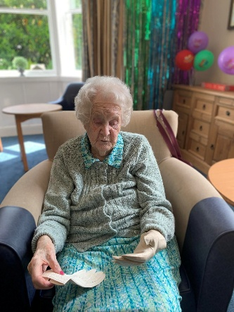  We enjoyed a reminiscing morning with woman’s glamour, here is Margaret and Joan trying some bits on.  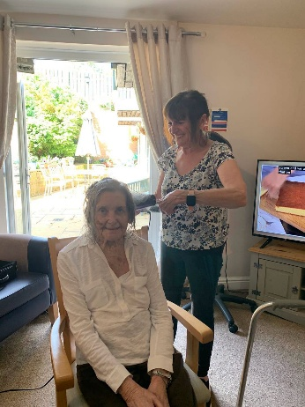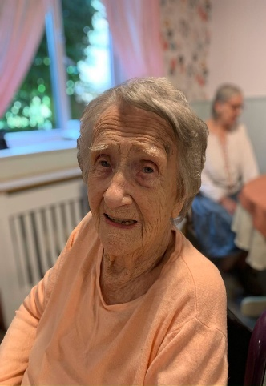  Margaret and Edna enjoying their weekly pamper with Helen the hairdresser  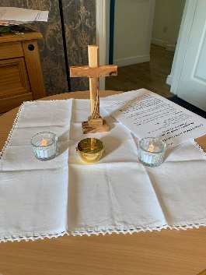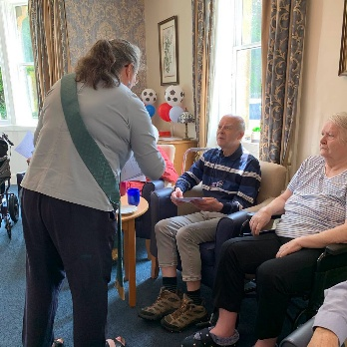  Our weekly Church service with Fran from St Michael’s Church, Alnwick  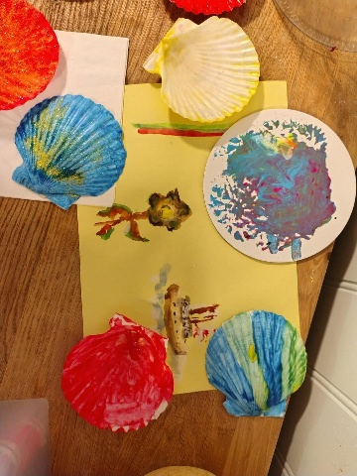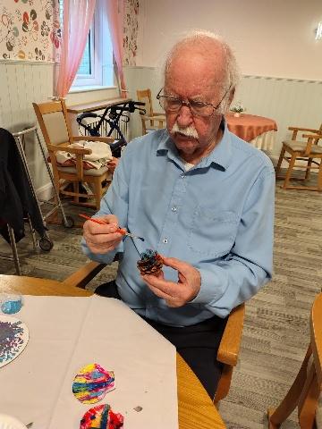  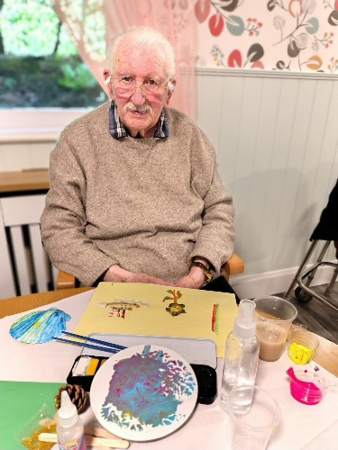  Fiona has done some lovely craft sessions with the residents this month, they have made some wonderful art pieces to keep  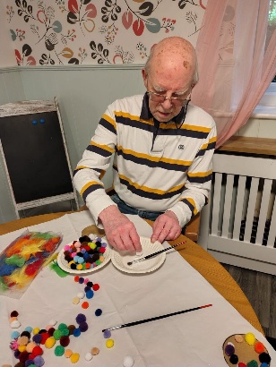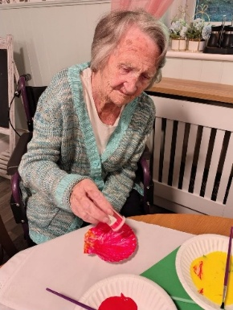  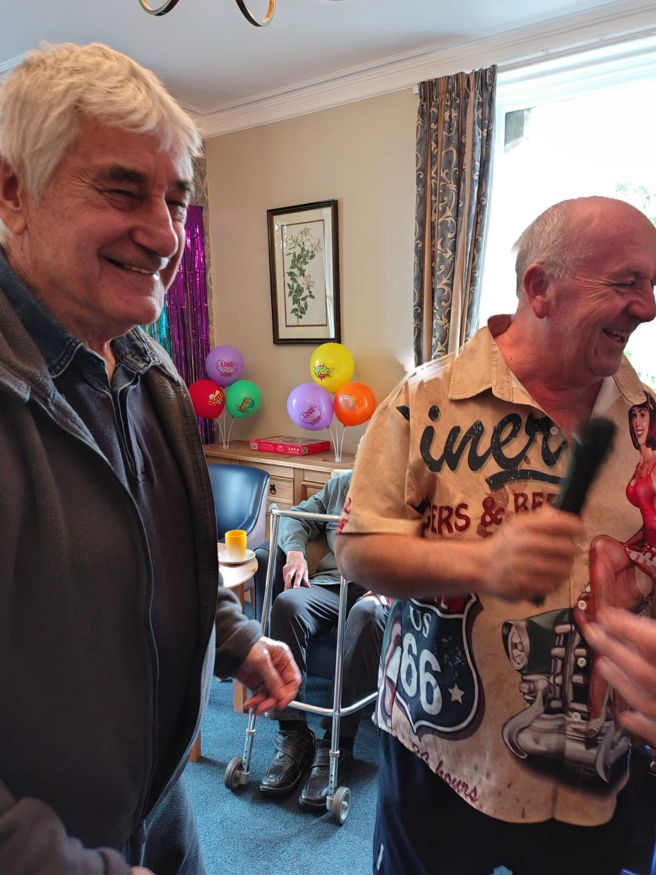  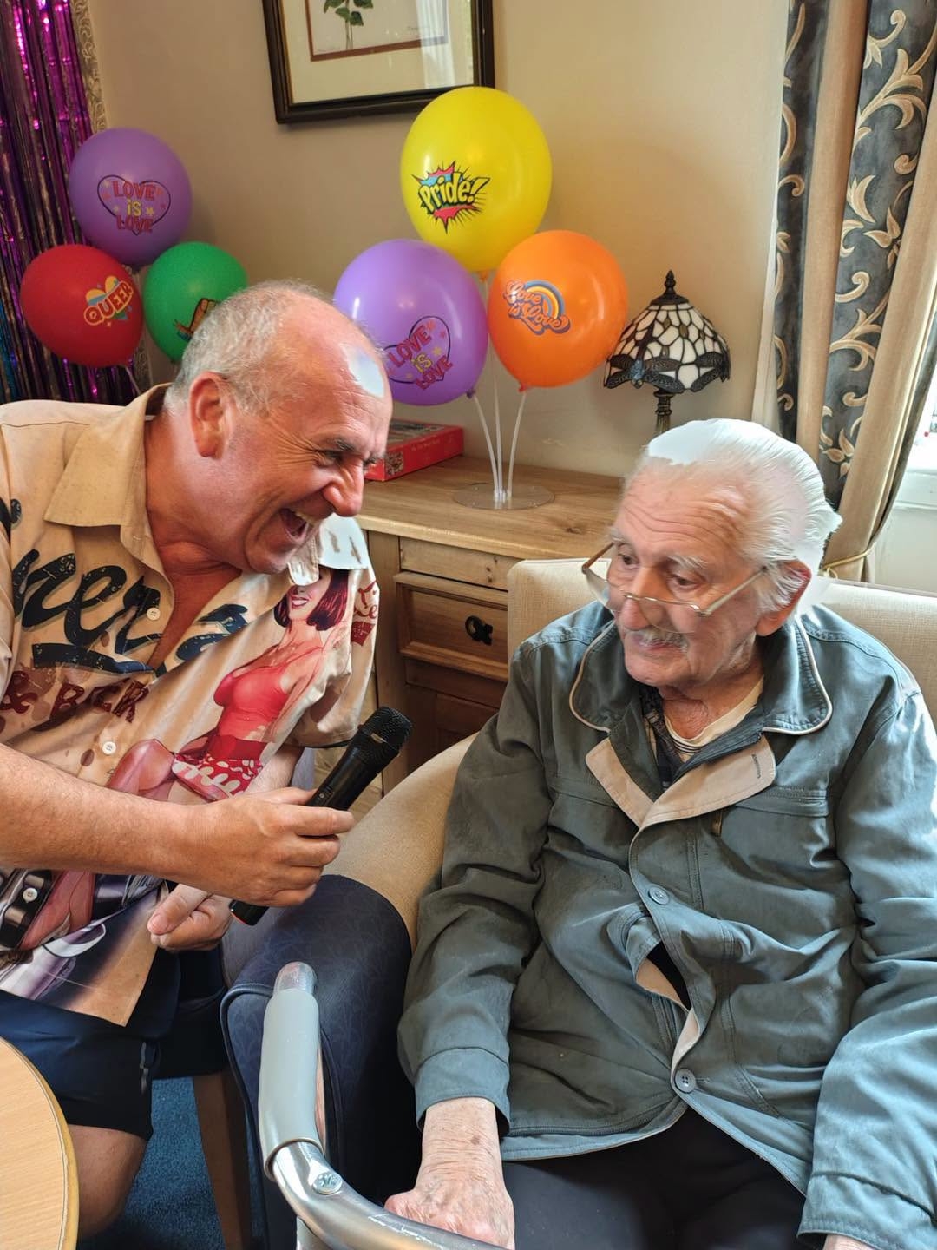  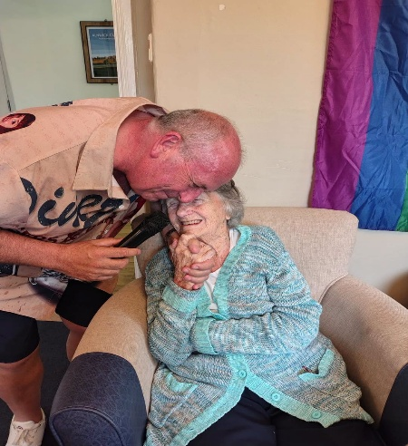  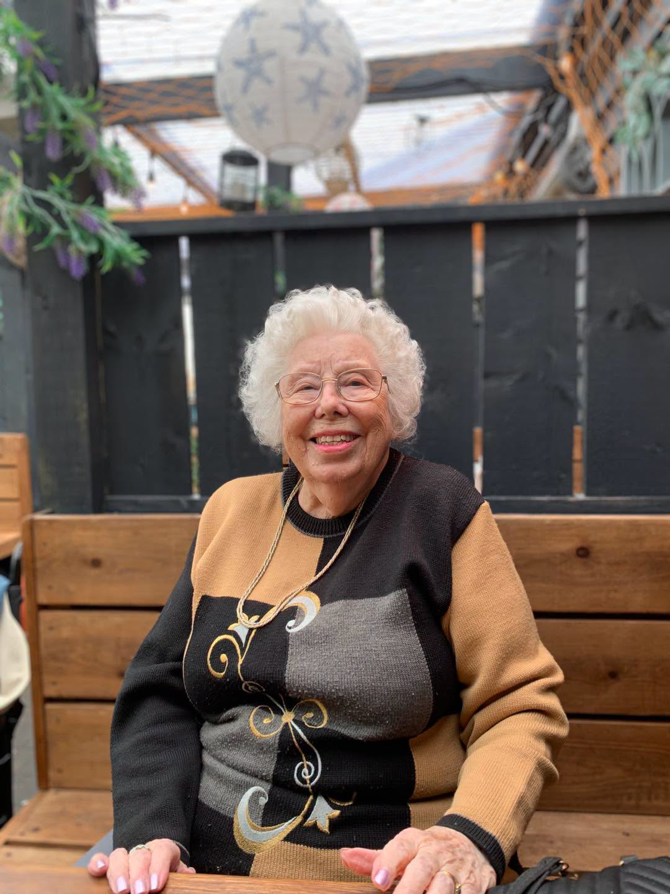  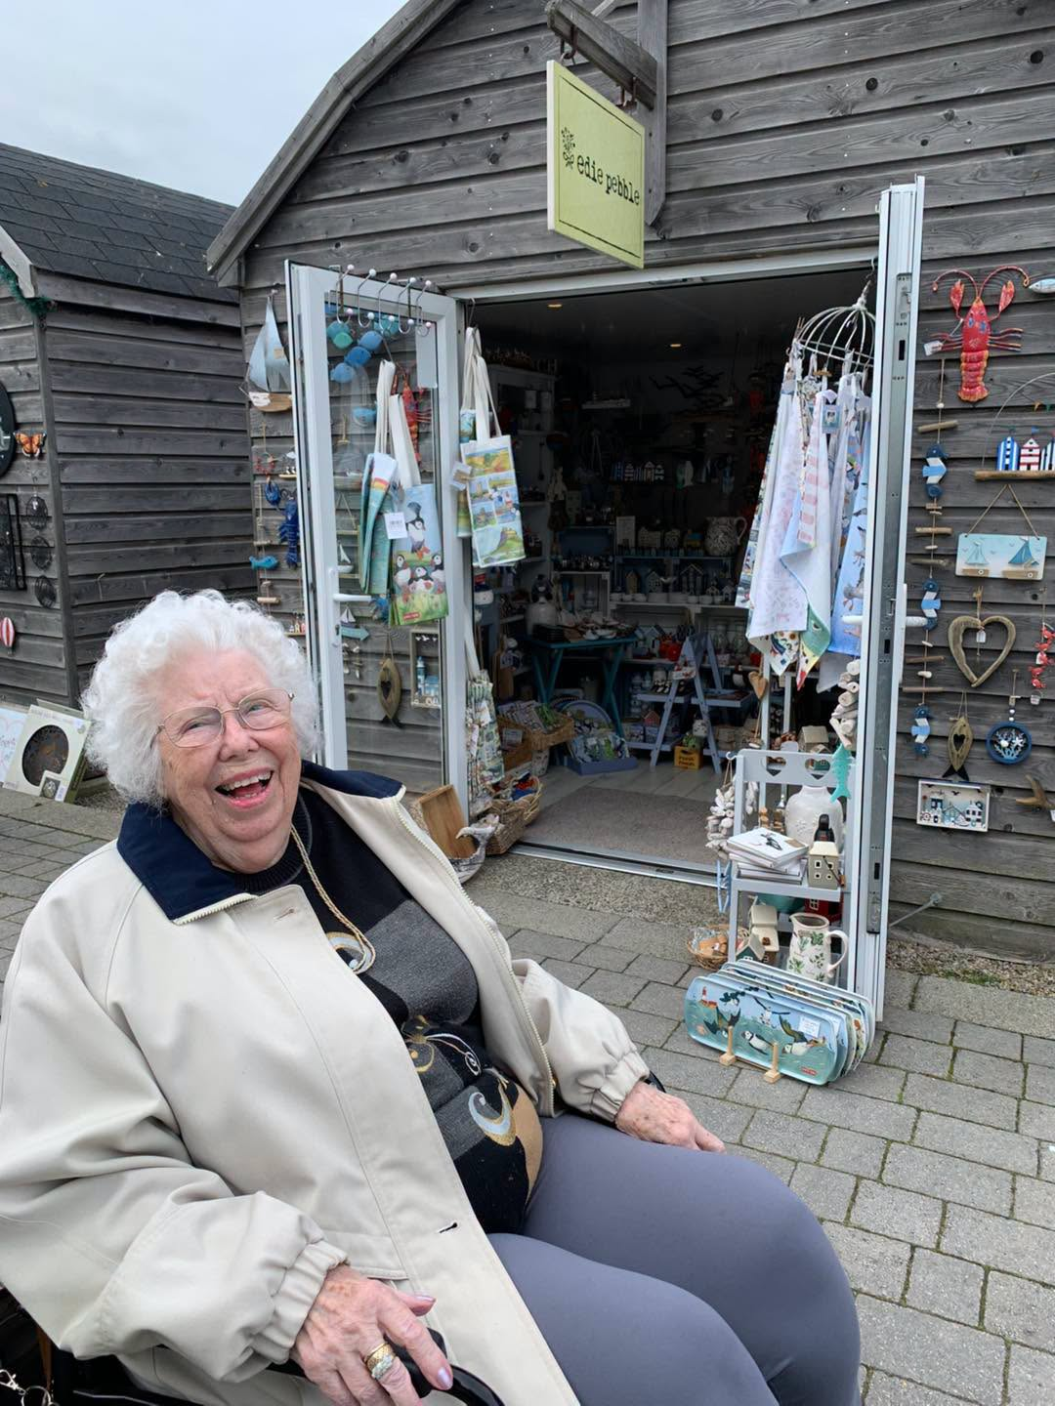  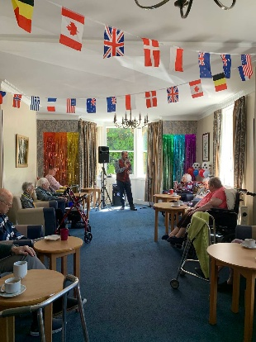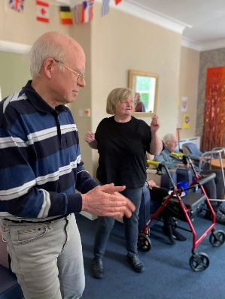  We had a lovely morning celebrating father’s day  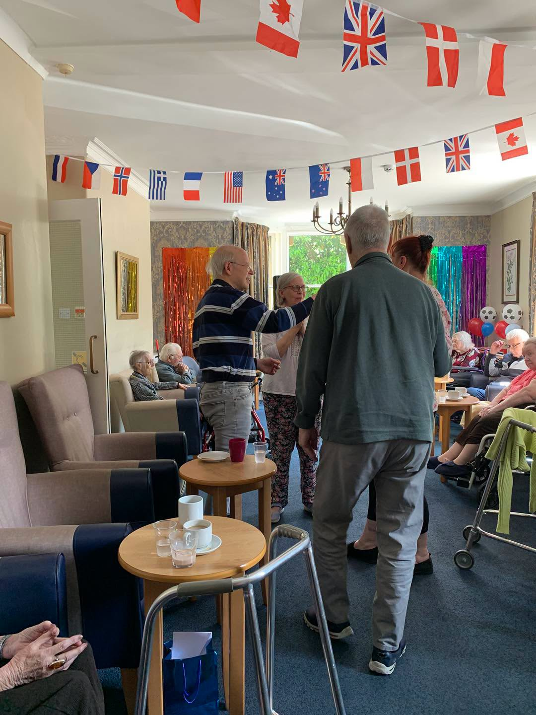  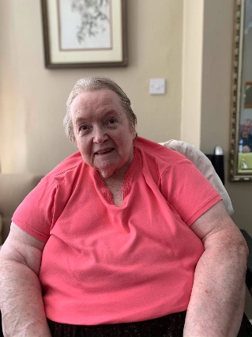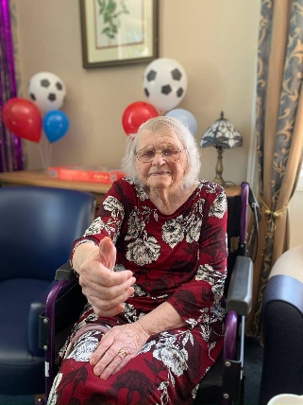  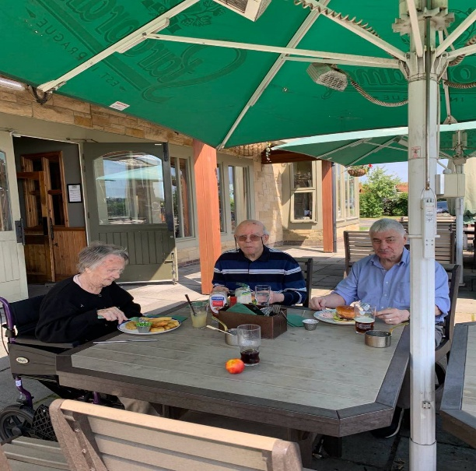  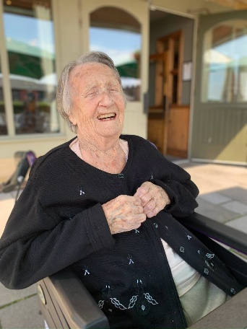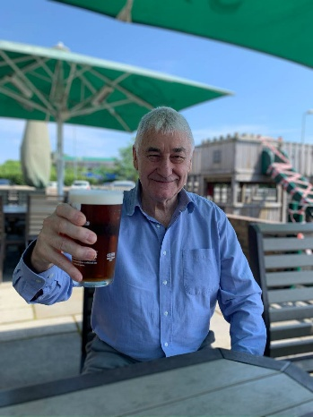  A few of our residents enjoyed lunch at the Hog’S Head in Alnwick, it was such a beautiful warm summers day and they all enjoyed themselves – they all said it was so noice to get out in the glorious weather  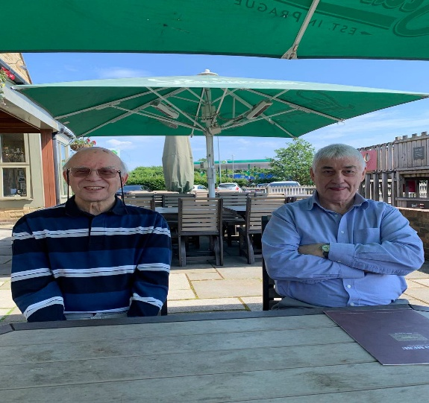  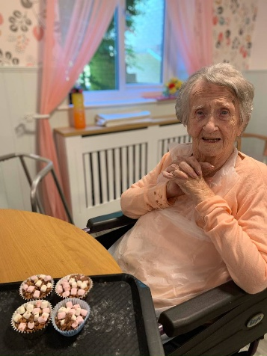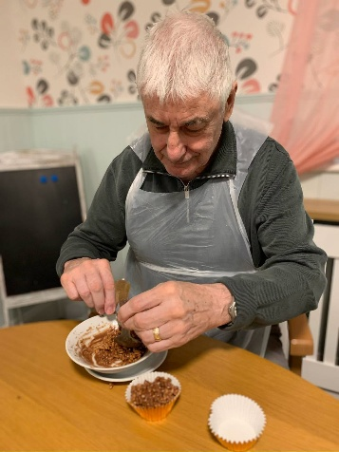  We had a great morning making rice krispie cakes, however I think they ate more than they got in the cases    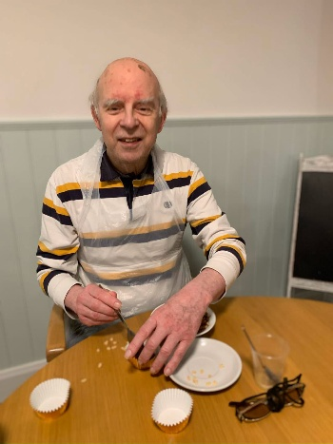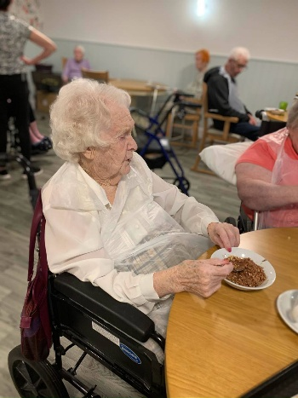  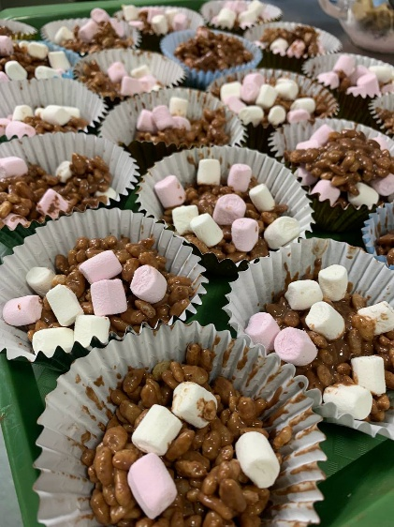  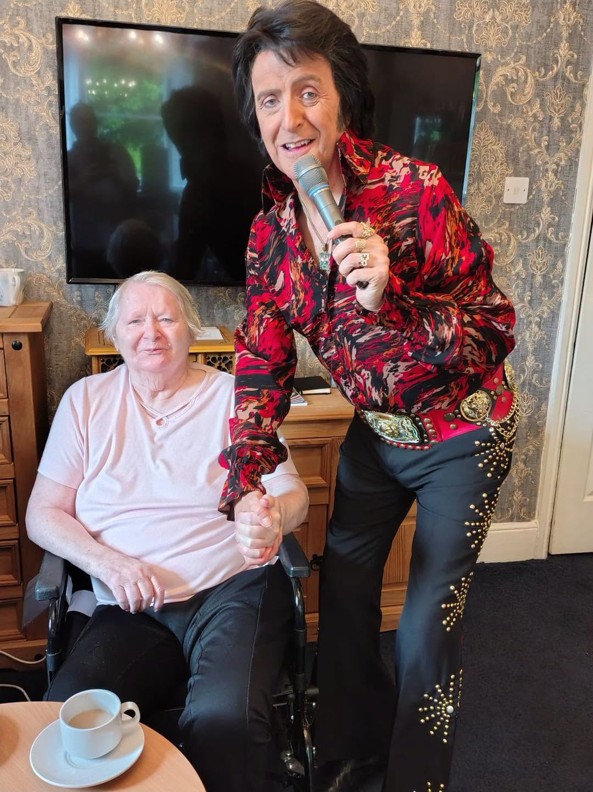  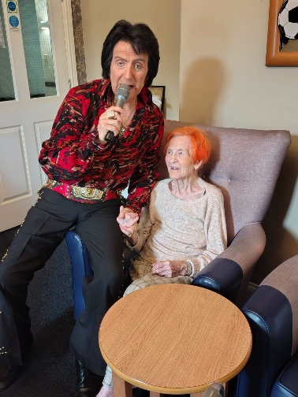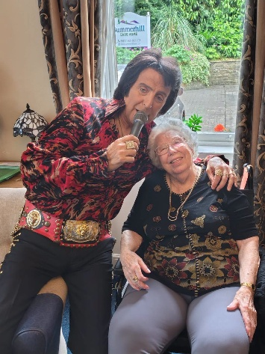  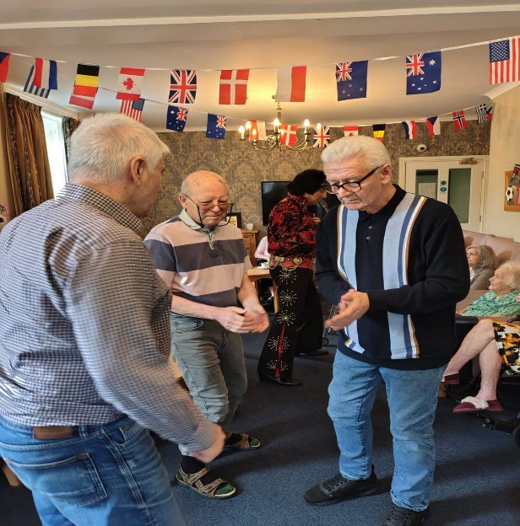  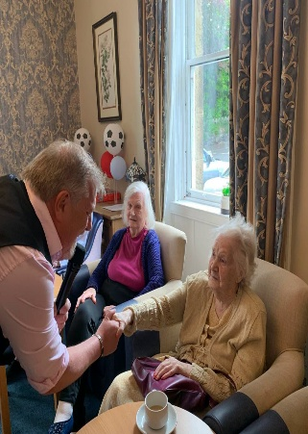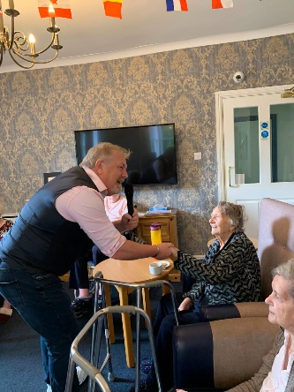  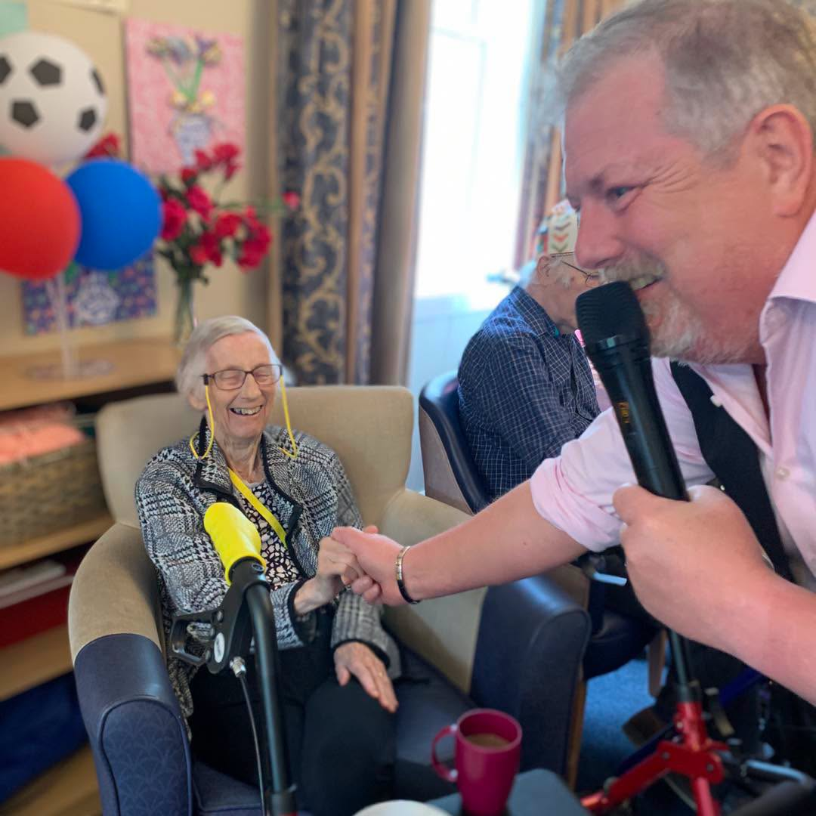  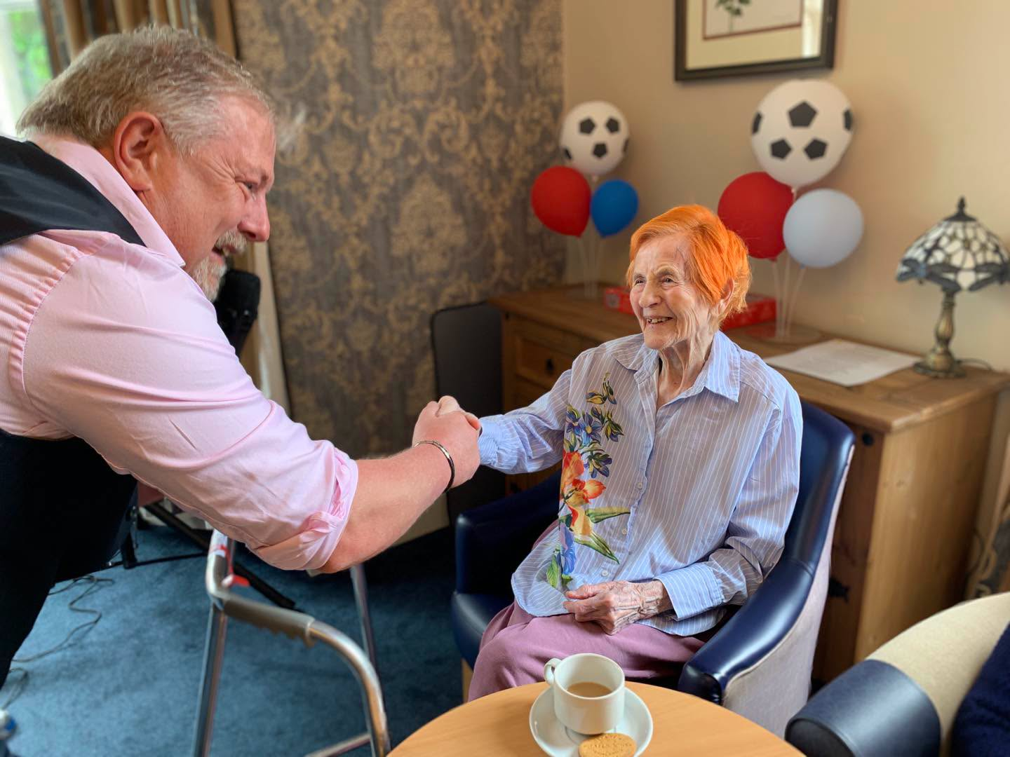  WE WELCOMED COLIN BACK AND WHAT A SHOW HE PUT ON FOR US, SOME GREAT CHOICE OF SONGS  AND GOT THE BOYS UP DANCING, INCLUDING ANNE WHO WAS HAVING A FABULOUS TIME – WE WILL SEE COLIN AGAIN SOON  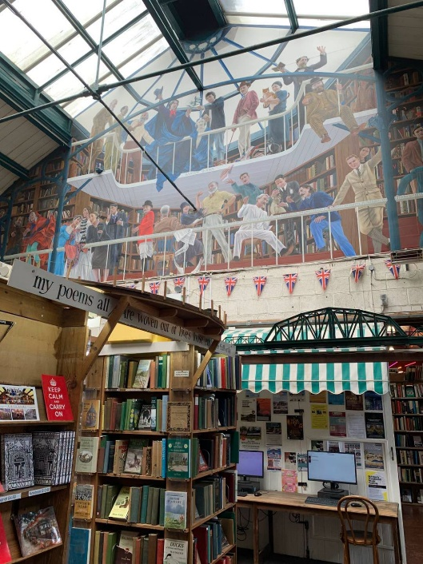  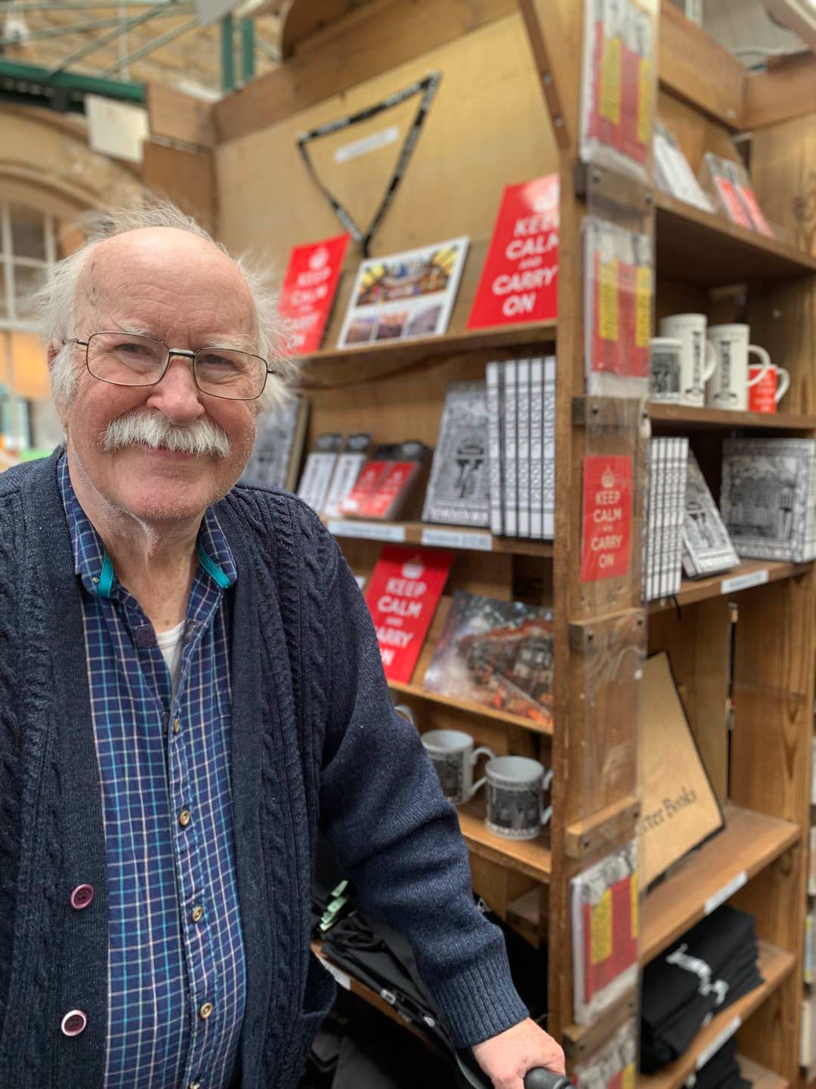  RICHARD HAS A LOVE OF BOOKS, I TOOK HIM TO BARTER BOOKS FOR THE AFTERNOON WHERE HE WALKED THE ISLES OF MANY DIFFERENT BOOKS AND ENJOYED A CUPPA AND TEACAKE  WELLDONE TO SHASHI AND HELEN WHO RECEIVED EMPLOYEE OF THE MONTH, NOMITAED BY THE STAFF HERE AT SUMMERHILL    Friday 17th July – We will be joined by singer Derek Hodgson – 11am in the large lounge  Monday 20th July – We will be visiting all rooms with KL PONY from 11am  Friday 24th July – We will be joined by singer Sam Naylor with her Hawaiian special – 11am in the large lounge  Monday 27th July – We will enjoy a trip out with some of the residents to Northumbria Zoo in the morning  Tuesday 28th July – We will be joined by Fran from St Michale’s for our monthly church service – 11am in the large lounge  Wednesday 29th July – We will be joined by Robert Whitehead playing his accordion – 11am in the large lounge
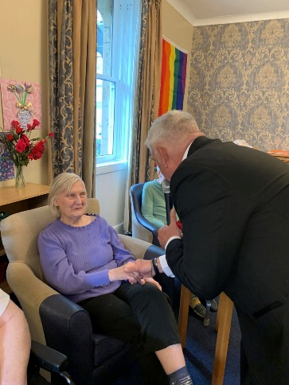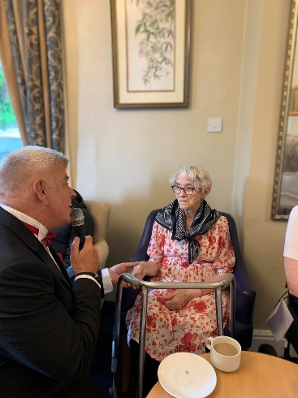

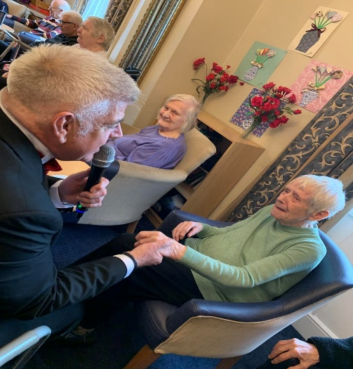



June is Pride month and we had a great party with singer Sam Naylor, she came dressed in drag looking fabulous as usual!! Sam also bought with her a multitude of wigs and other dressing up items, our residents had a grat time trying things on and really got into the spirit of it all.

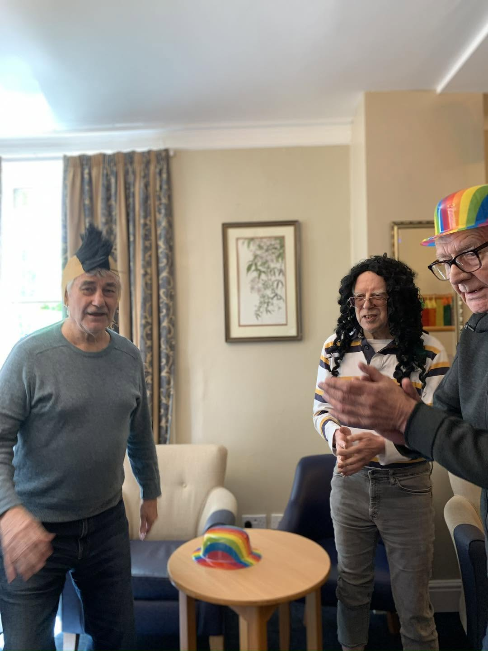

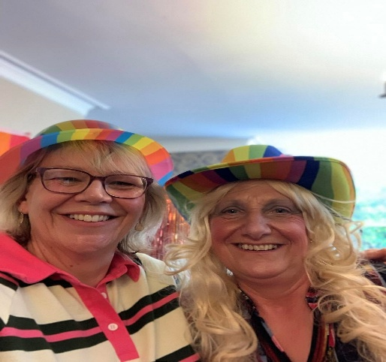

Fiona entertaining the residents

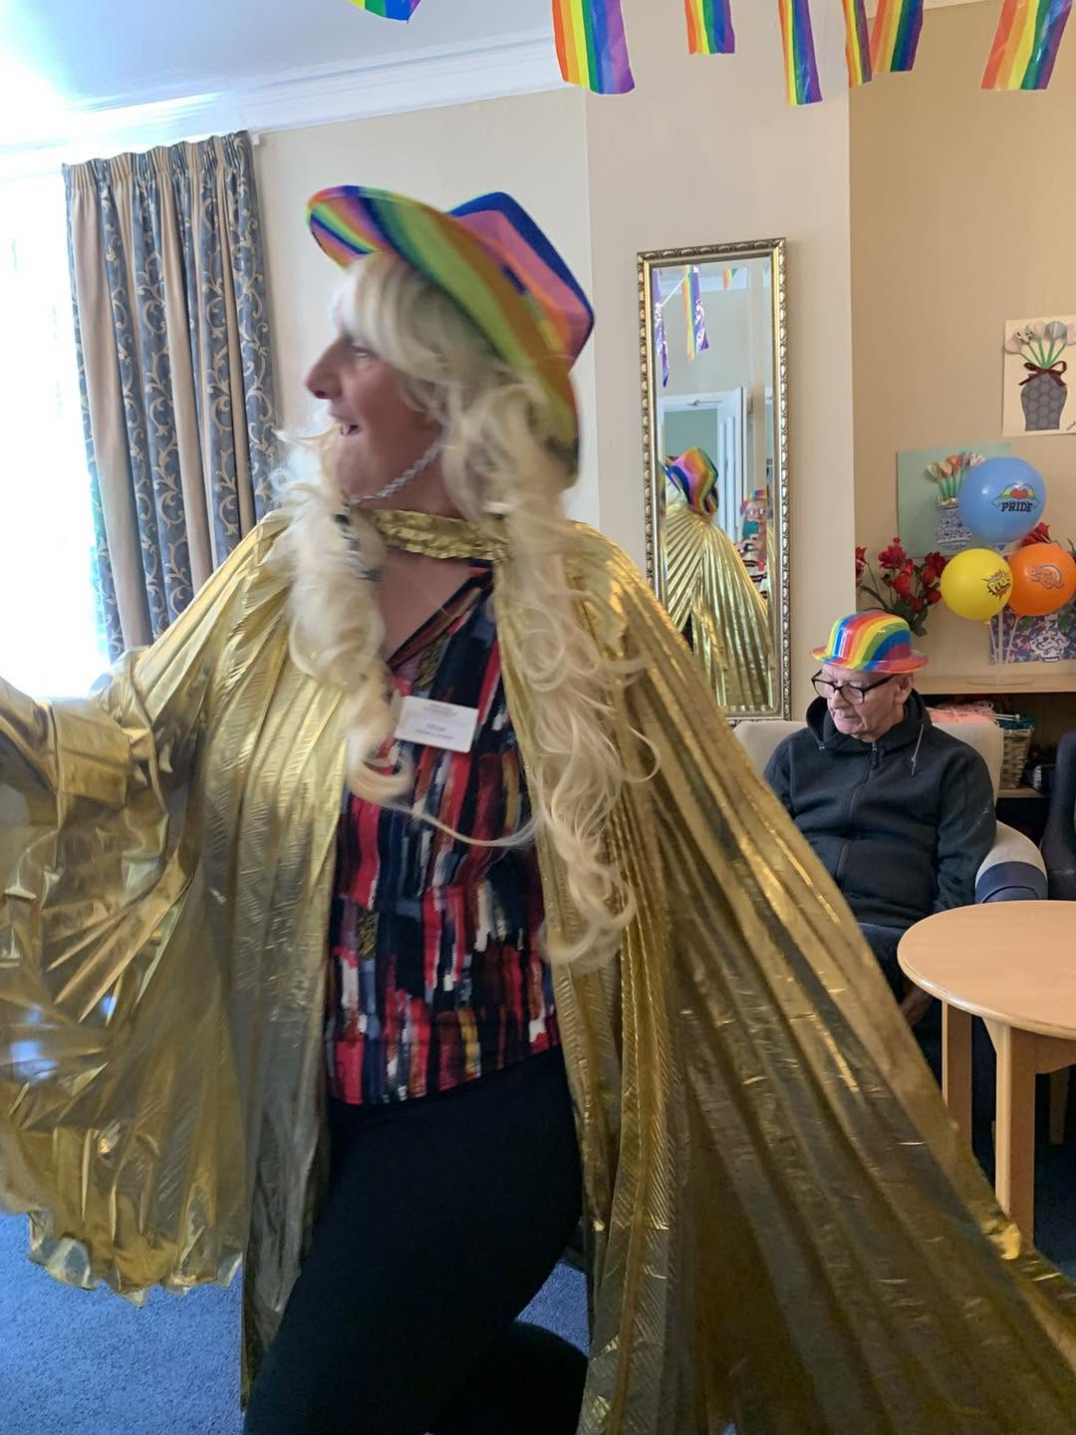

SOME MORE GREAT PICTURES FROM PRIDE PARTY

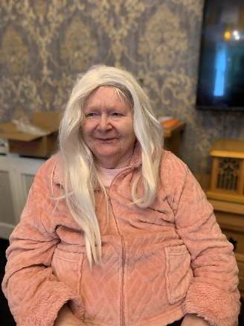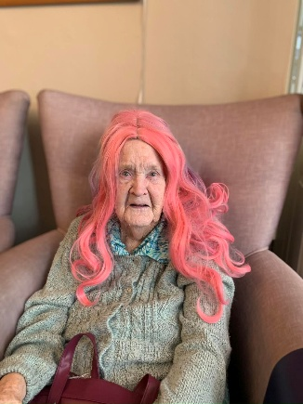

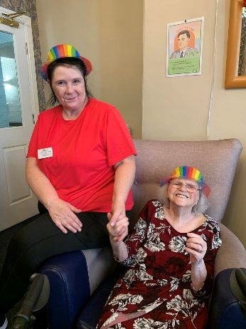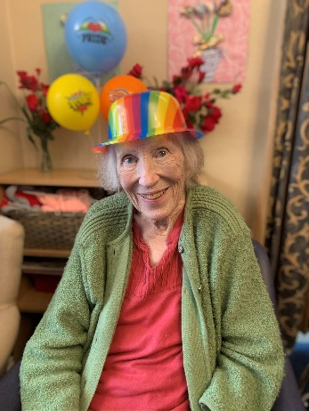

We had so mucn fun at the Disco in Seahouses Social Club, it is held on the first Saturday of every month and we will definatly be going back

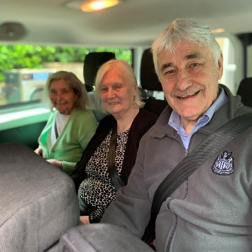

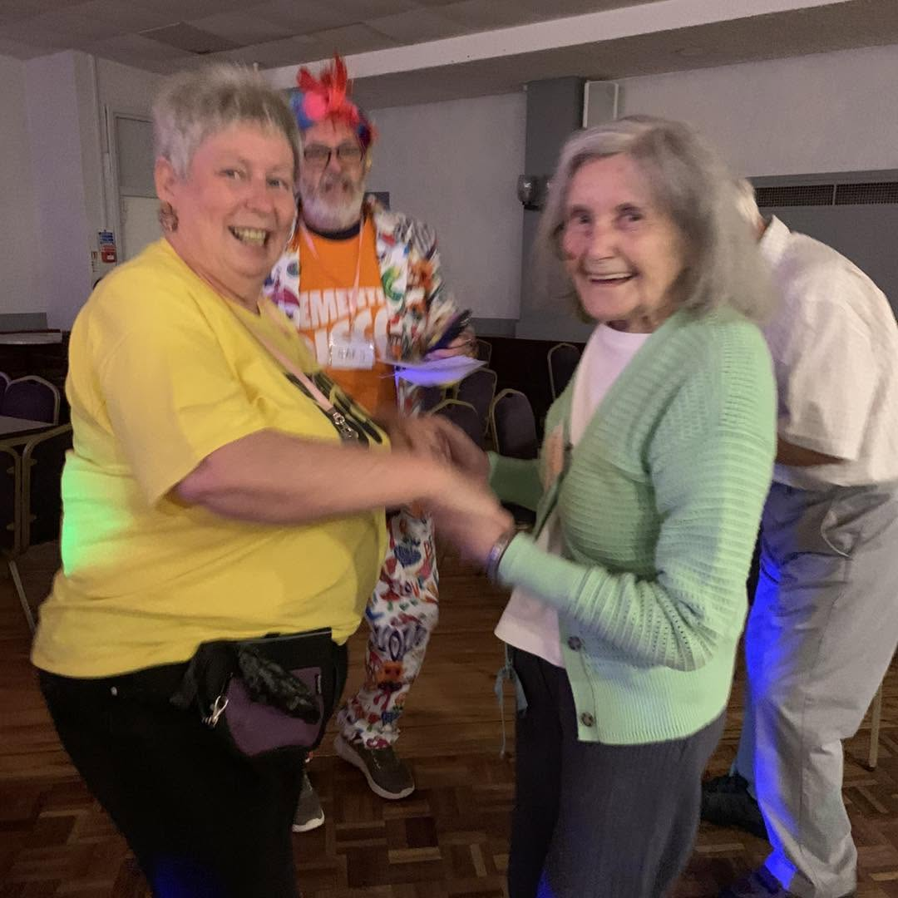

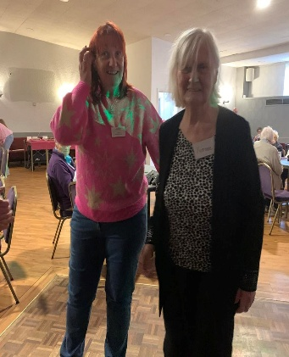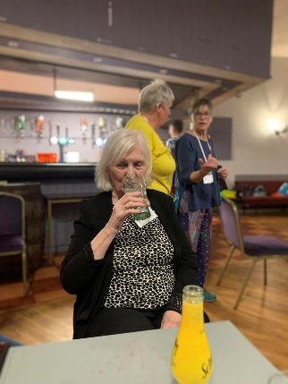


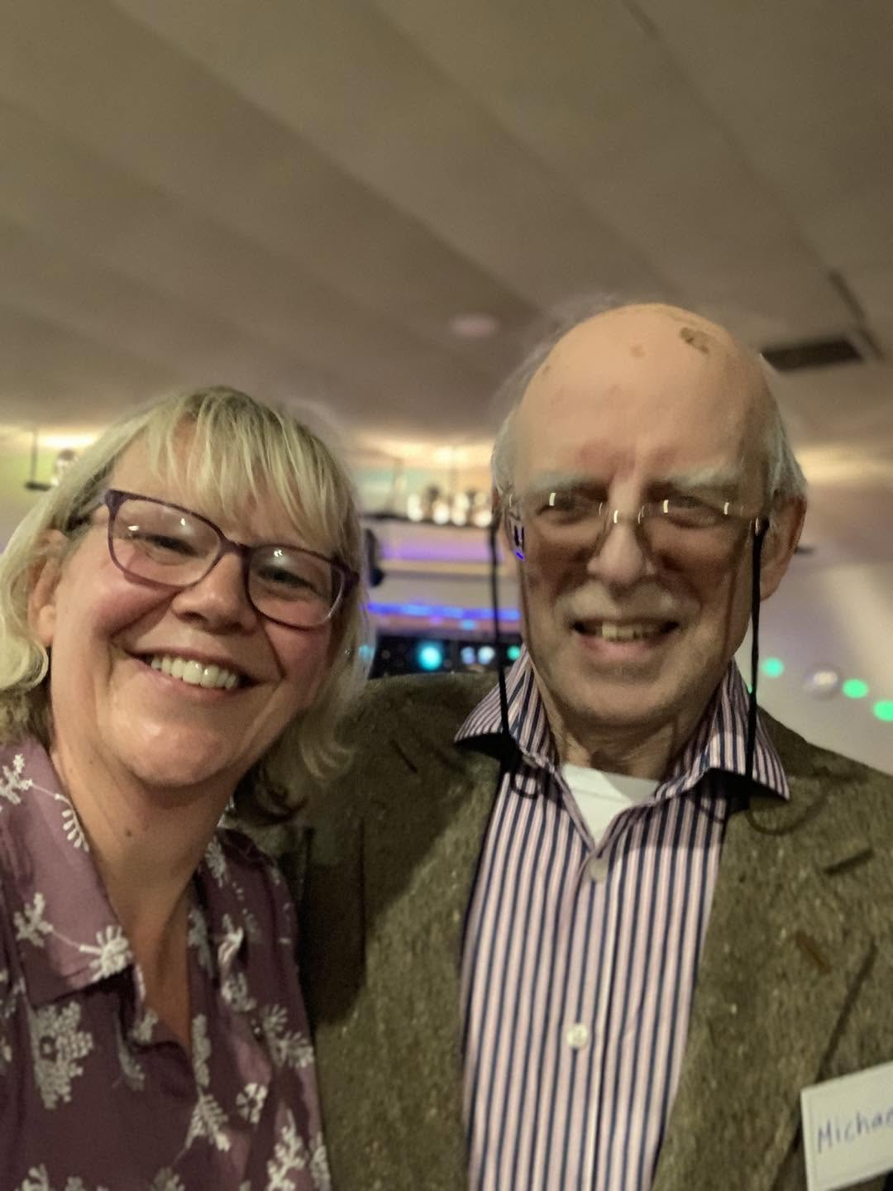

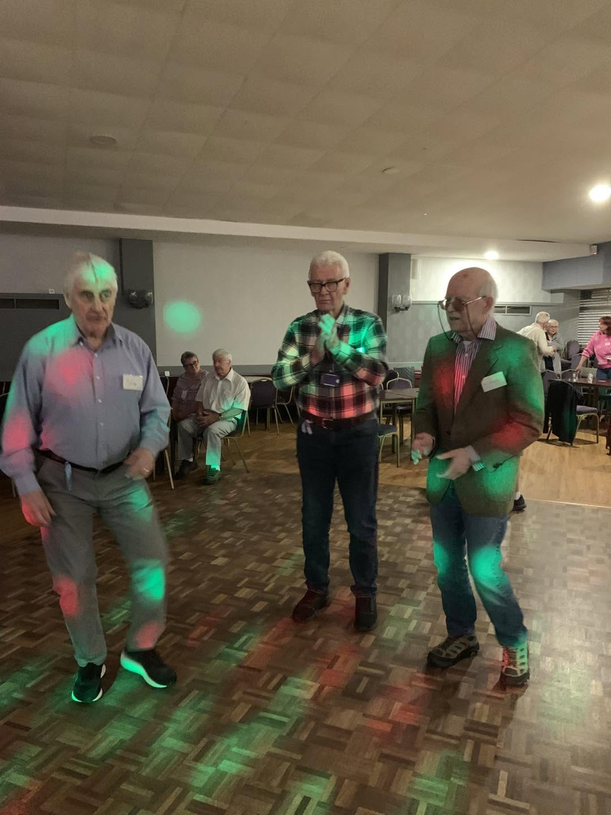

THE LADS DANCING THE NIGHT AWAY

We have enjoyed our usual activities this month, biweekly visits from King, bingo, weekly hairdresser, our monthly visit from Robert Whitehead, church service and some reminiscing thanks to Bailiffe Gate Museum, Alnwick.

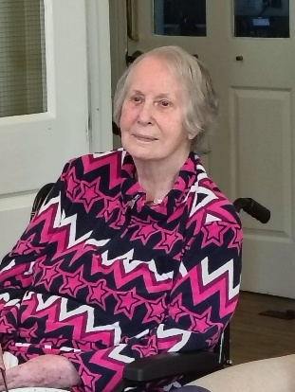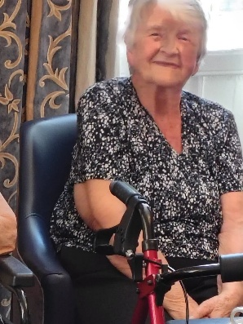
Shirly and Joan enjoying their visit to Robert Whitehead

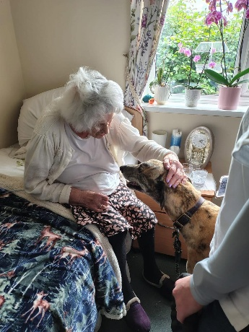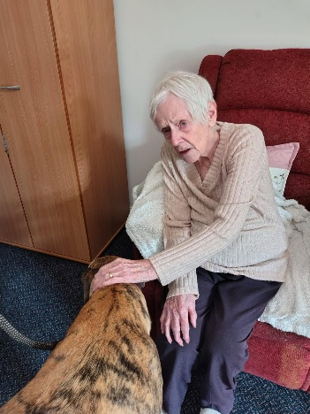

Mary and Margaret enjoying a visit from King

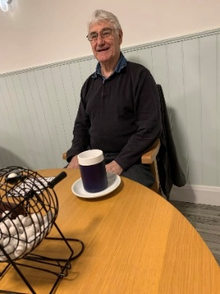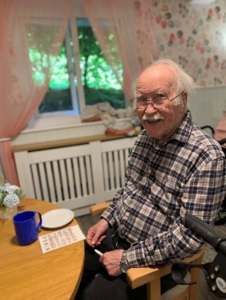

Tom and Ricahard enjoying a game of Bingo

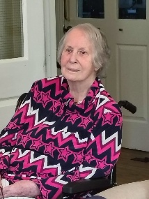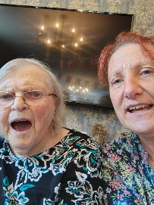
Shirly, Mary and Fiona enjoying Robert Whitehead

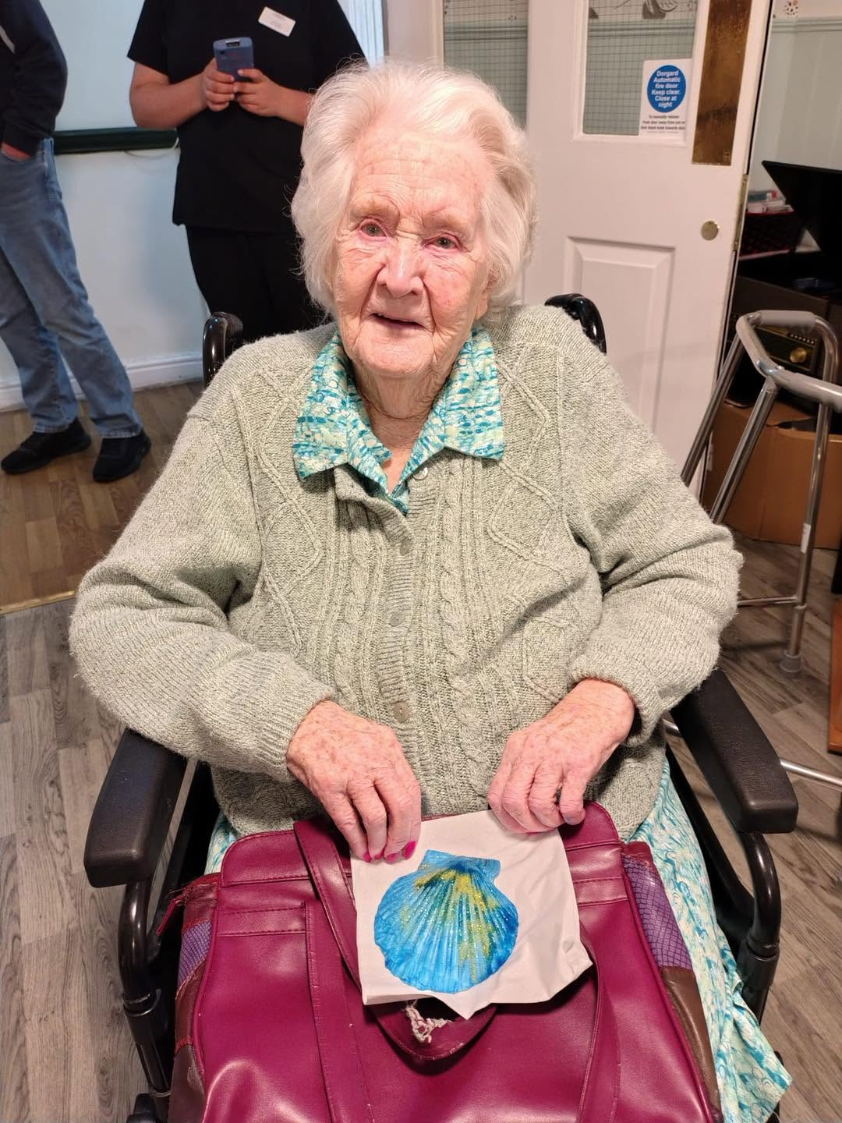

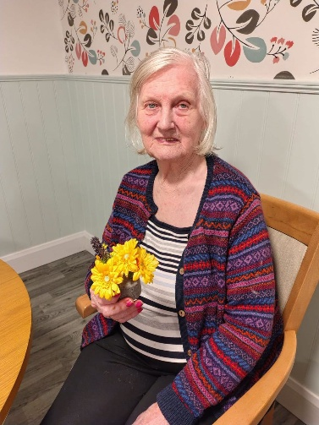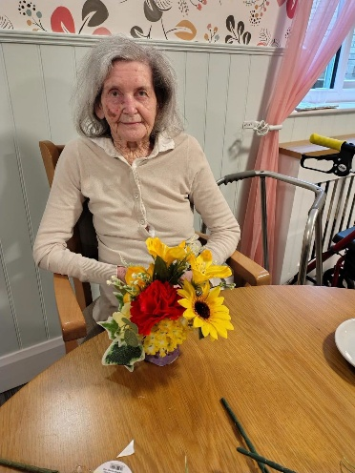

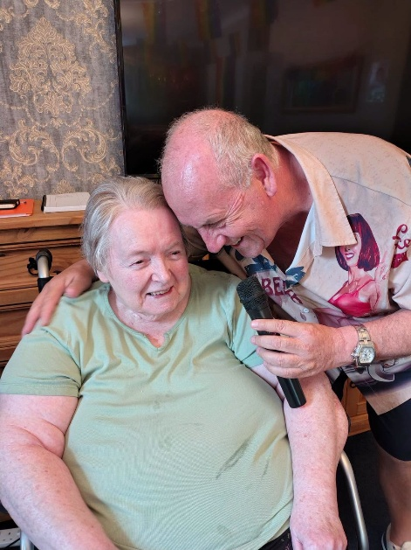

We enjoyed a visit from kev the care home singer – we have some great singers that come and entertain our residents and KEV NEVER DISAPOINTS – THE RESIDENTS ENJOY SEEING KEV’S MANY WONDERFUL SHIRTS

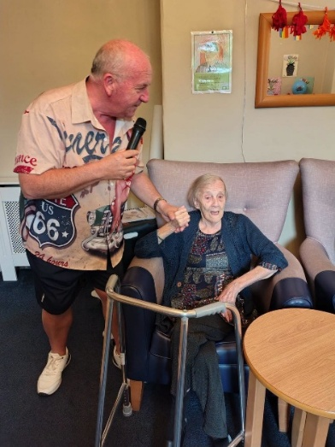

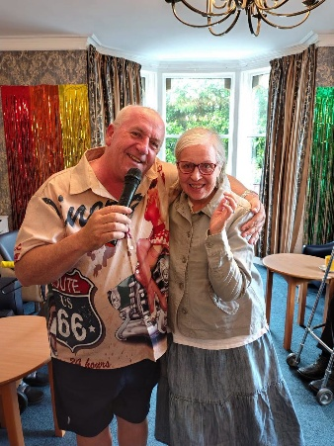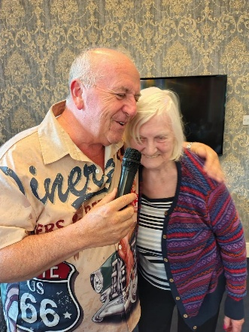

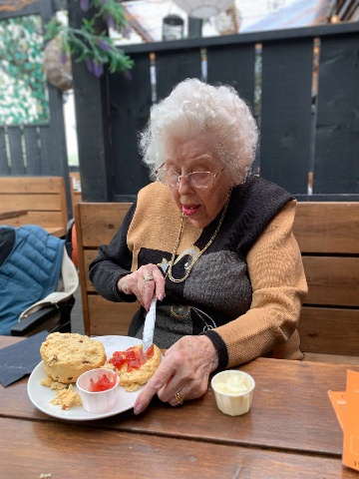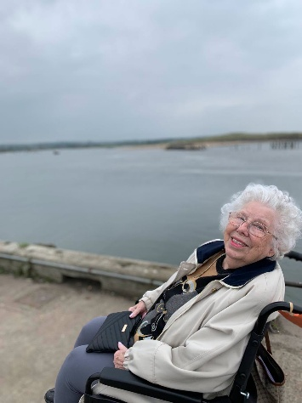

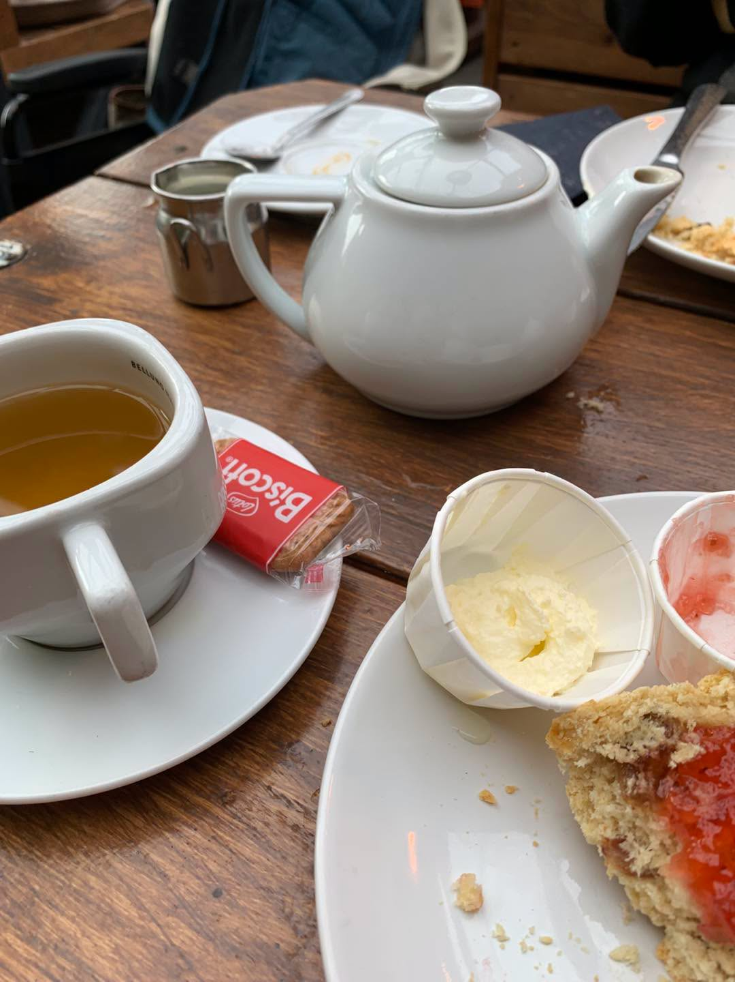

Jean enjoyed a trip out to Amble, she enjoyed driving through Warkworth seeing the Castle. When in Amble we stopped off and enjoyed a cuppa with a scone, jam and cream. I then took Jean for a walk around the pods to have a mooch around – Jean told me after that she really enjoyed herself



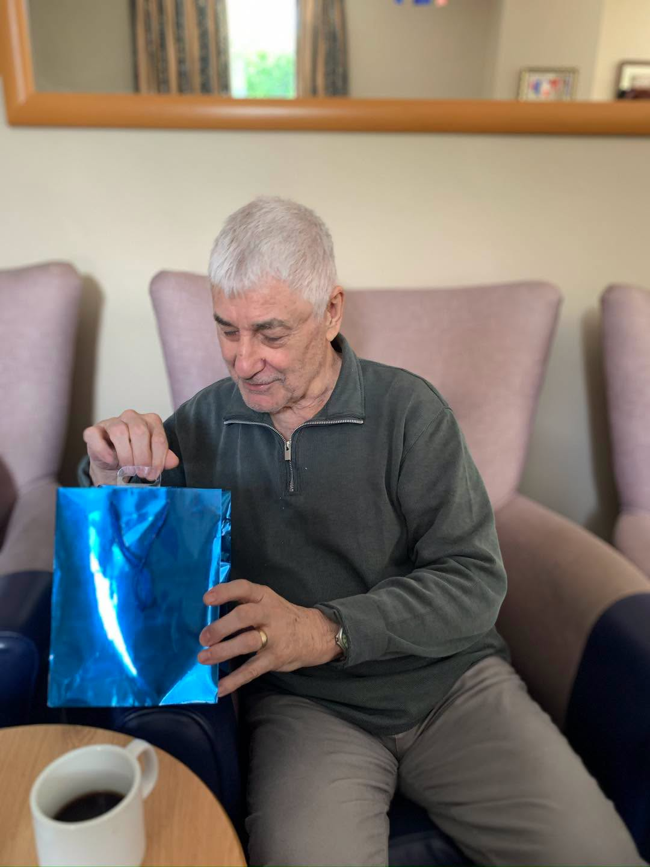

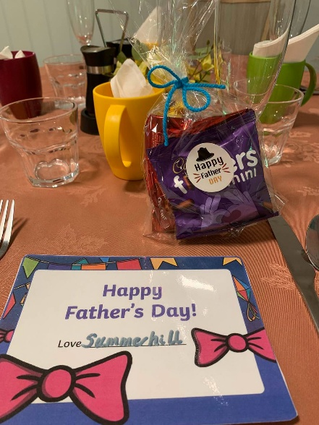

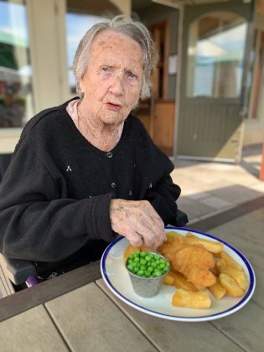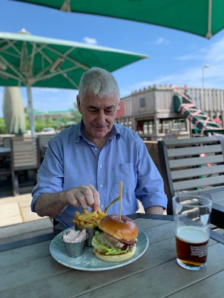

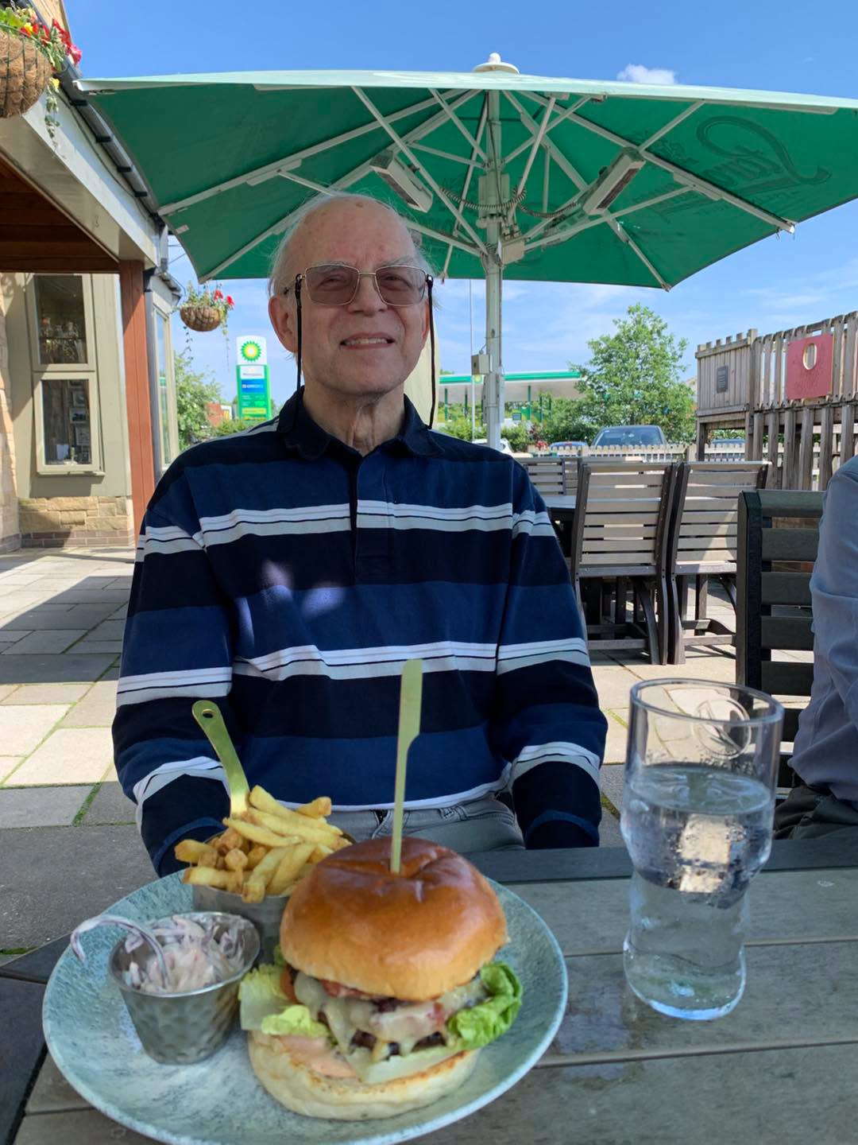


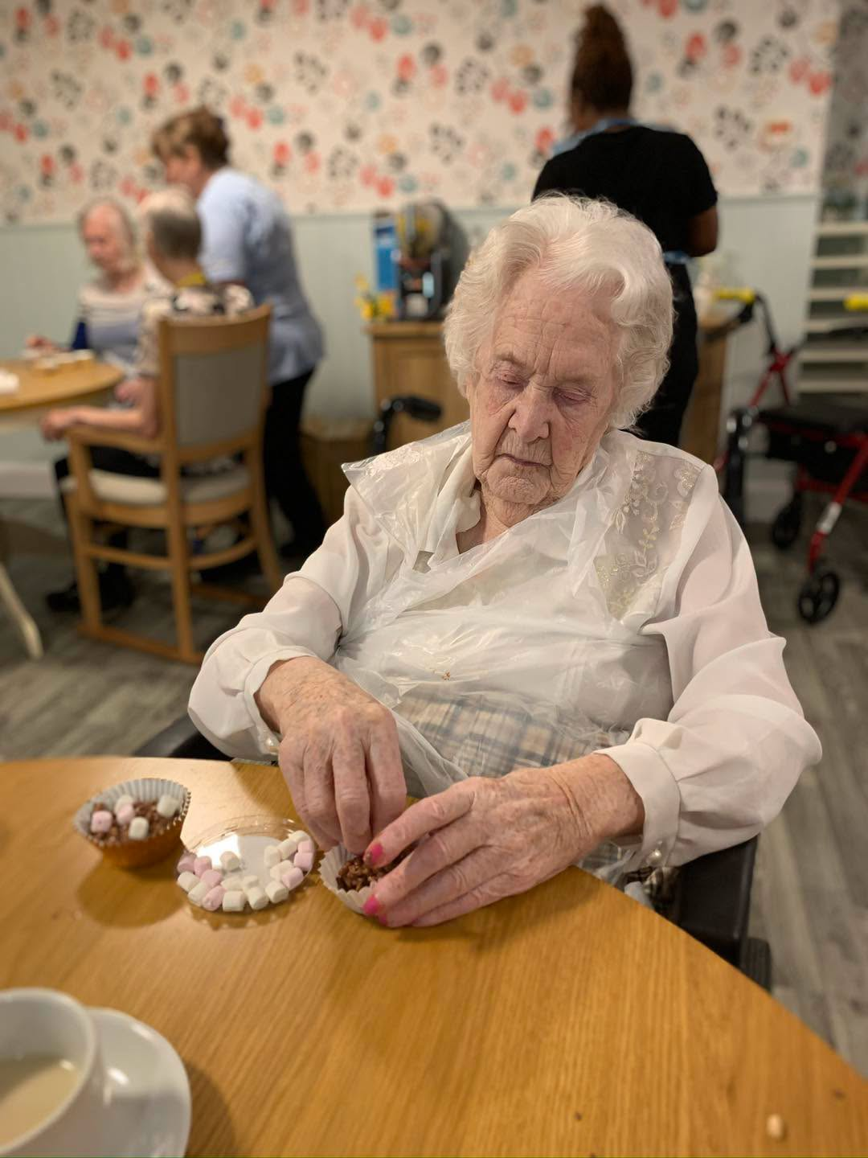

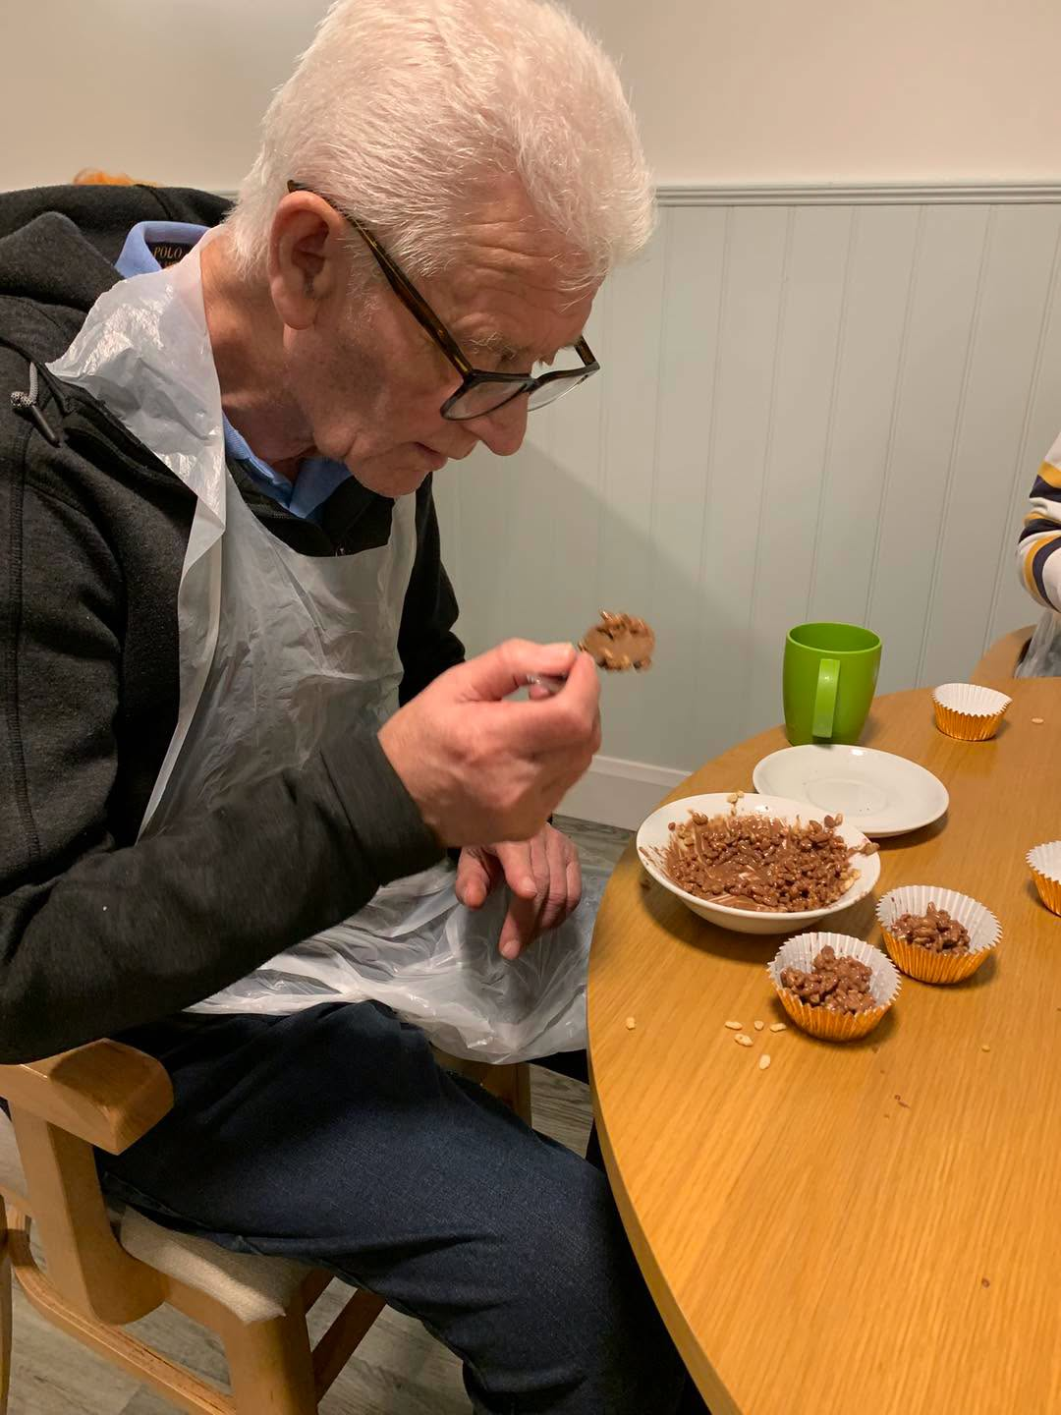

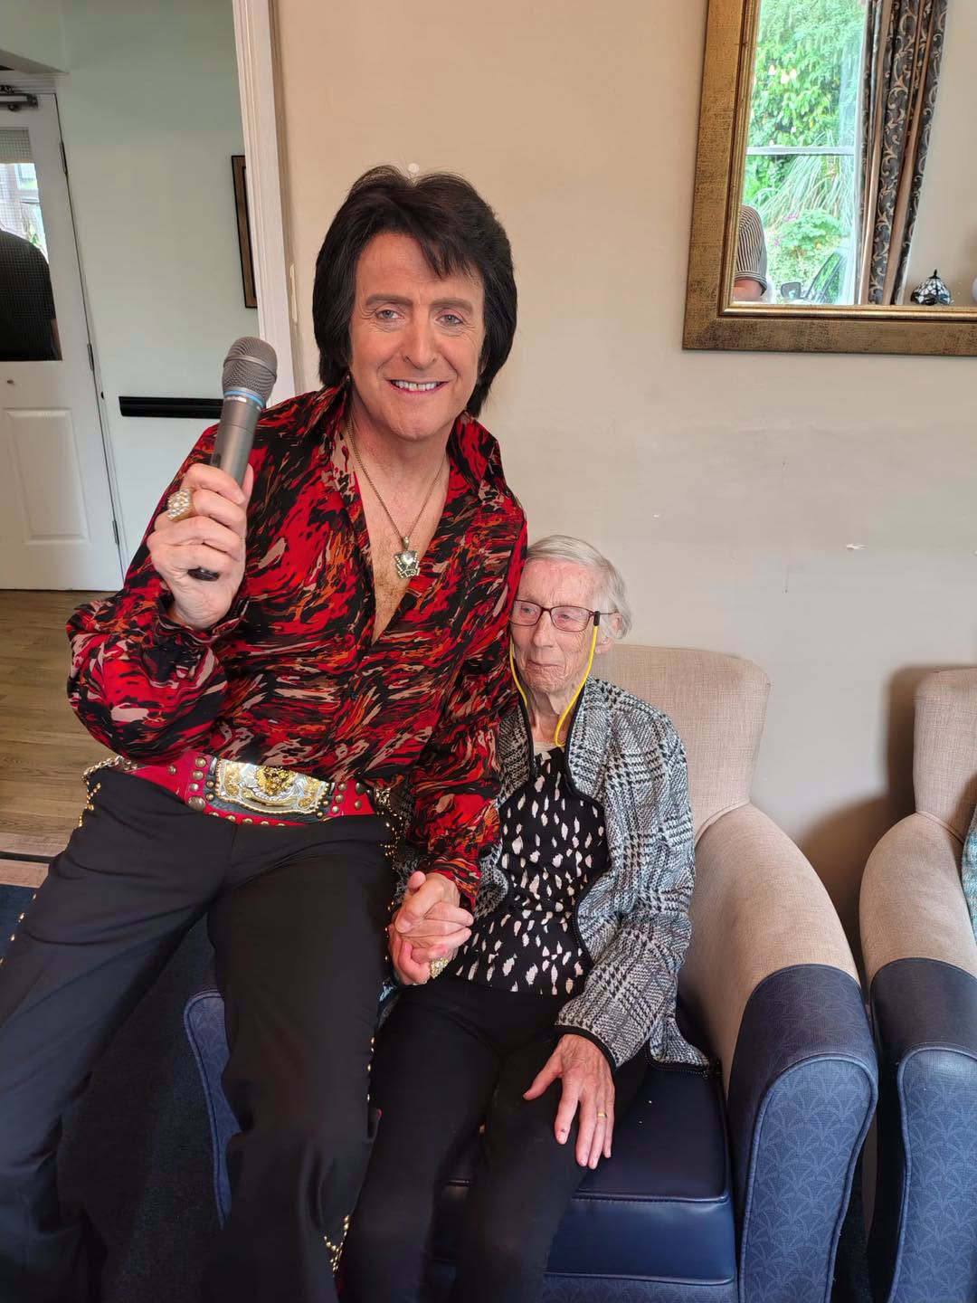

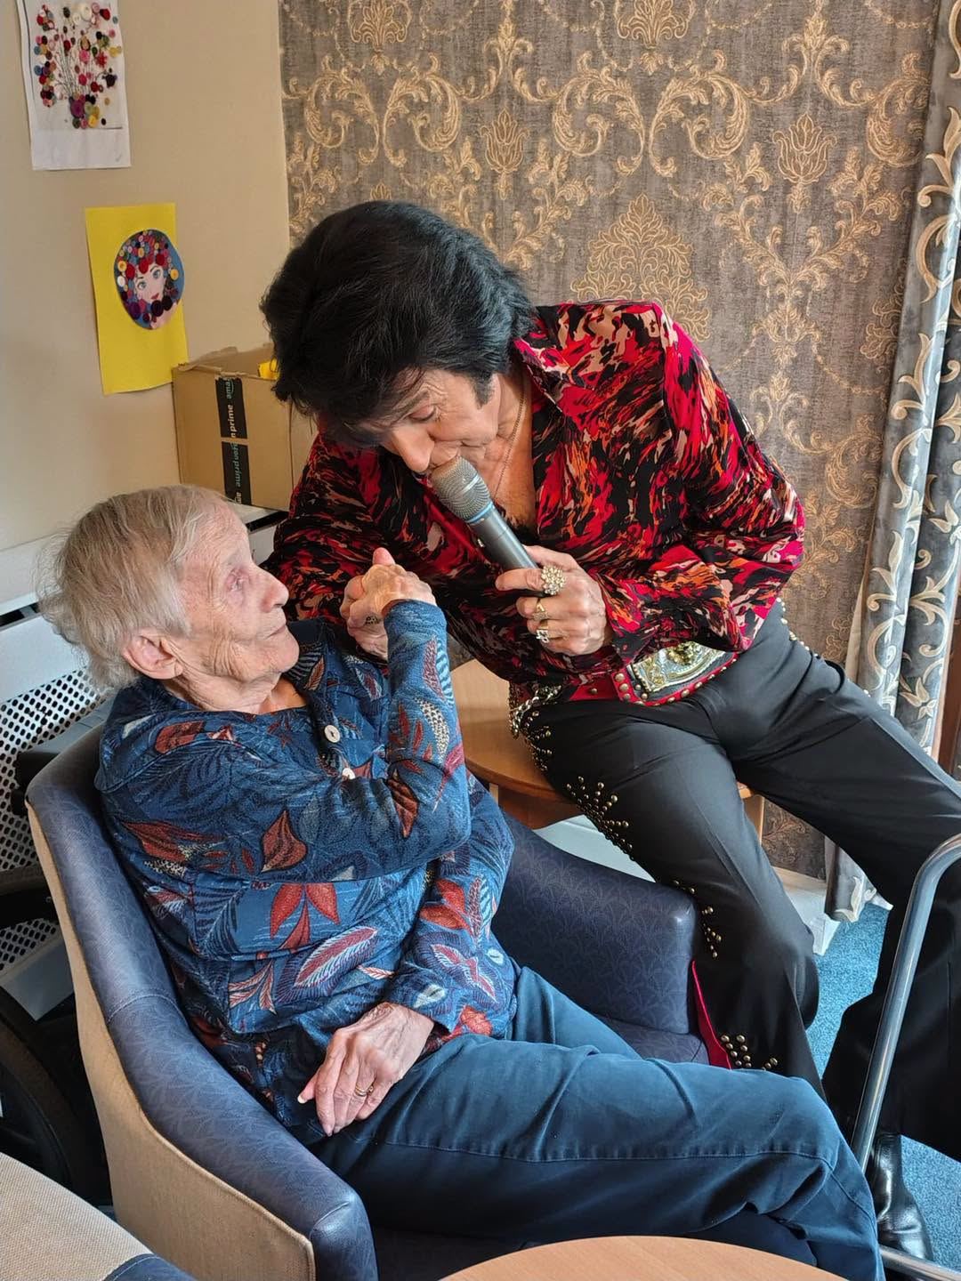

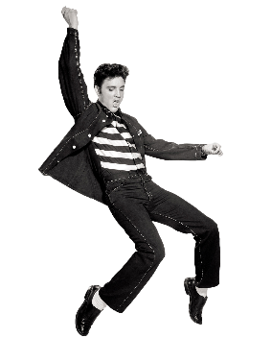
Elvis was in the house this month – the boys enjoyed a dance – this is a grrat way to get their exercise in
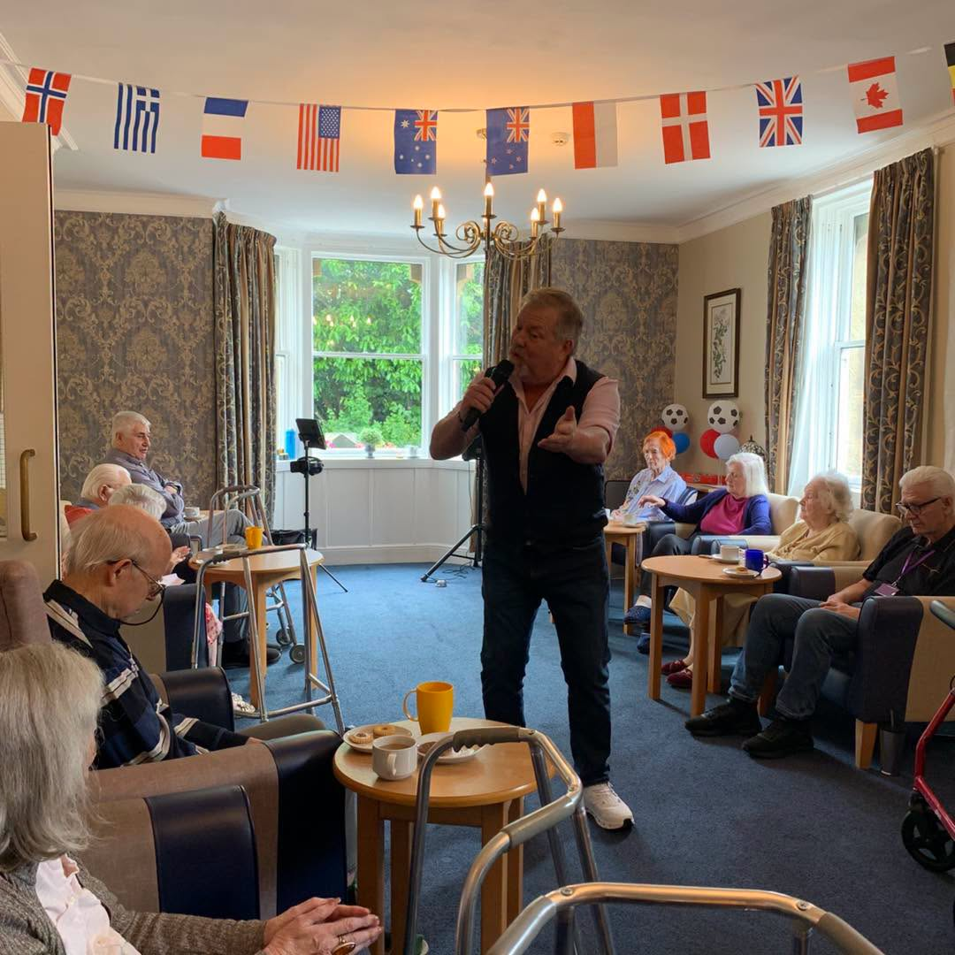

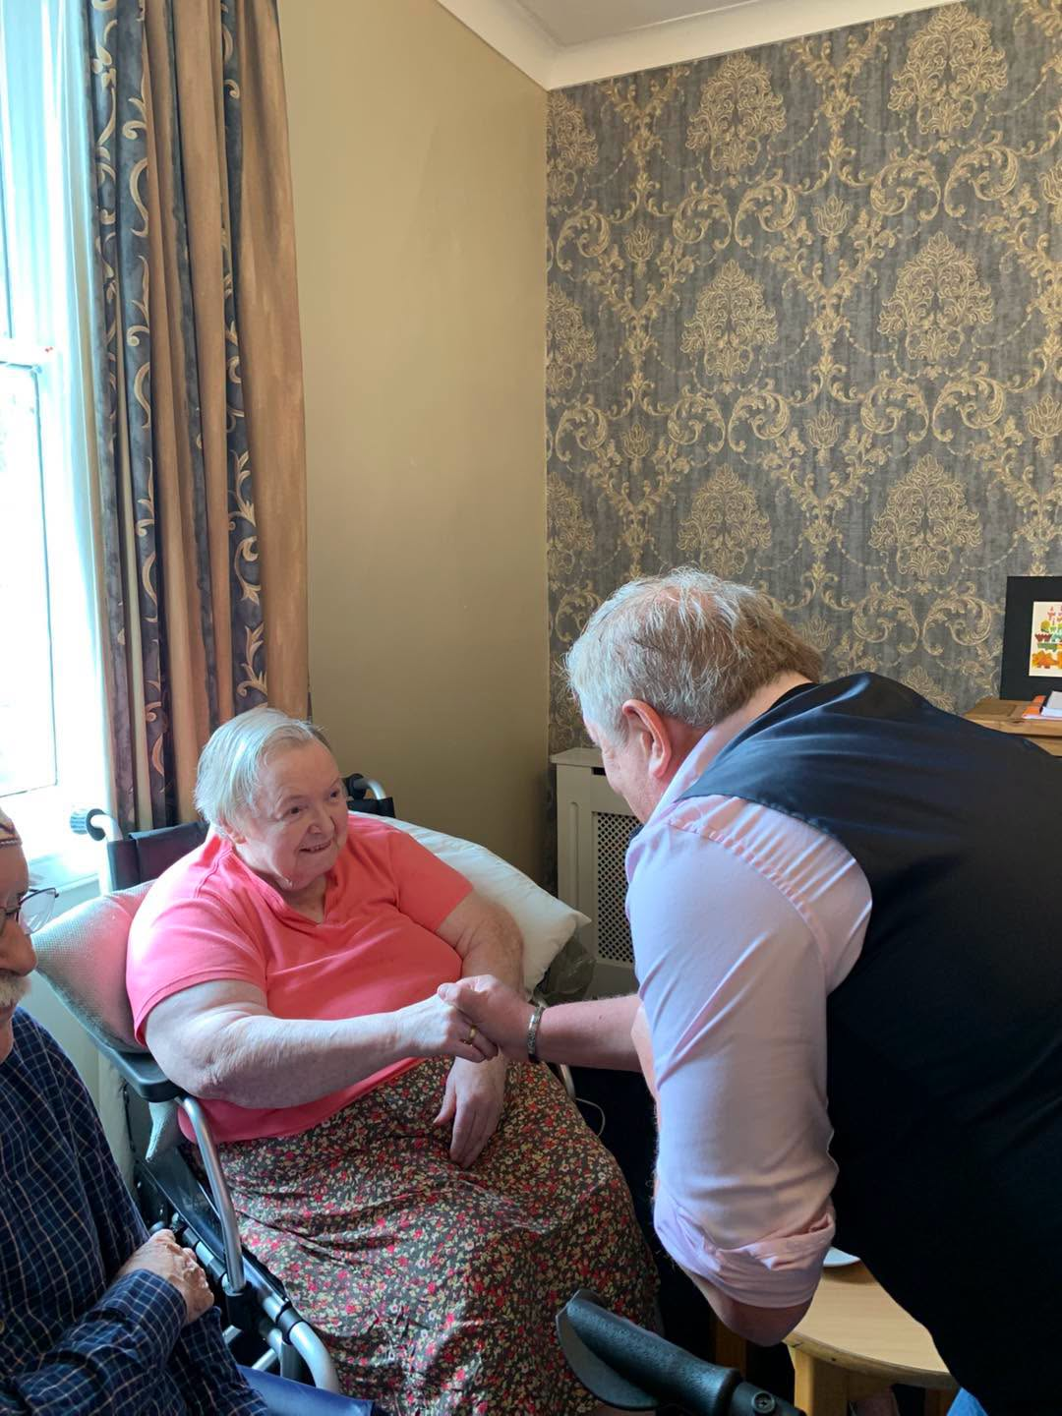

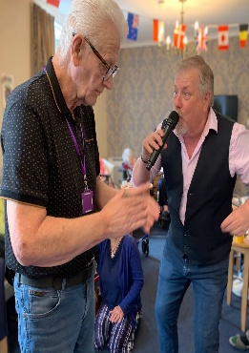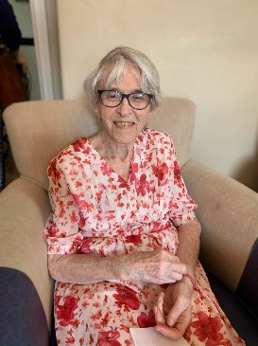

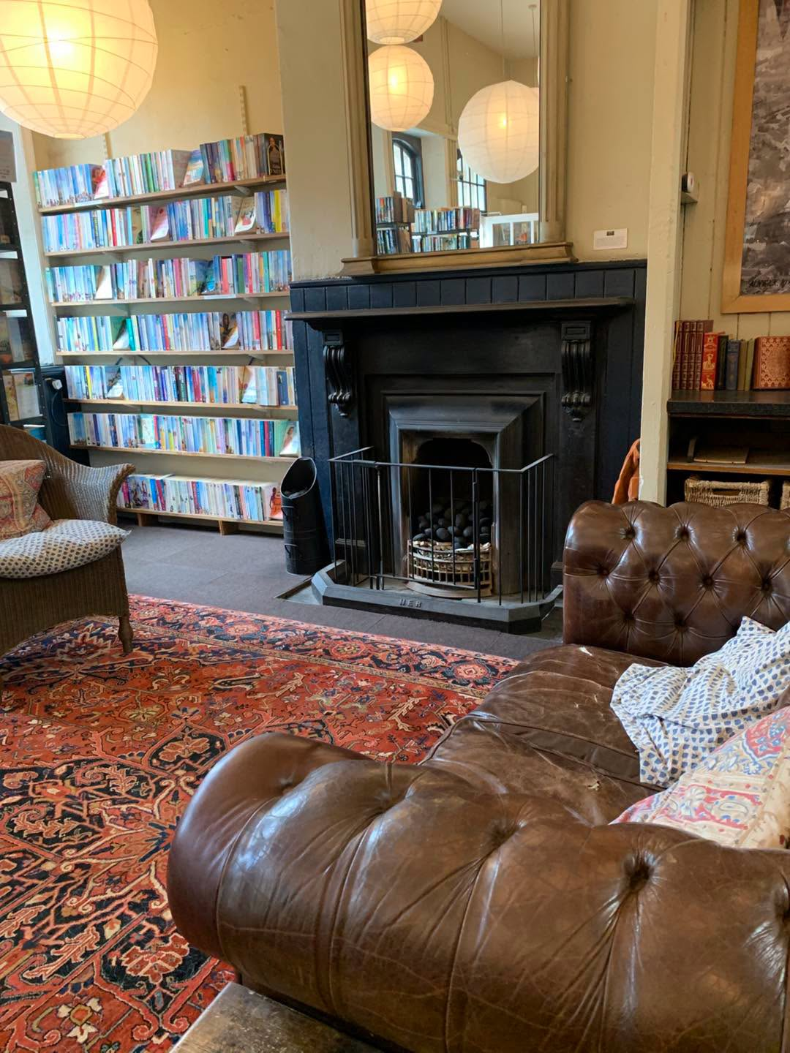

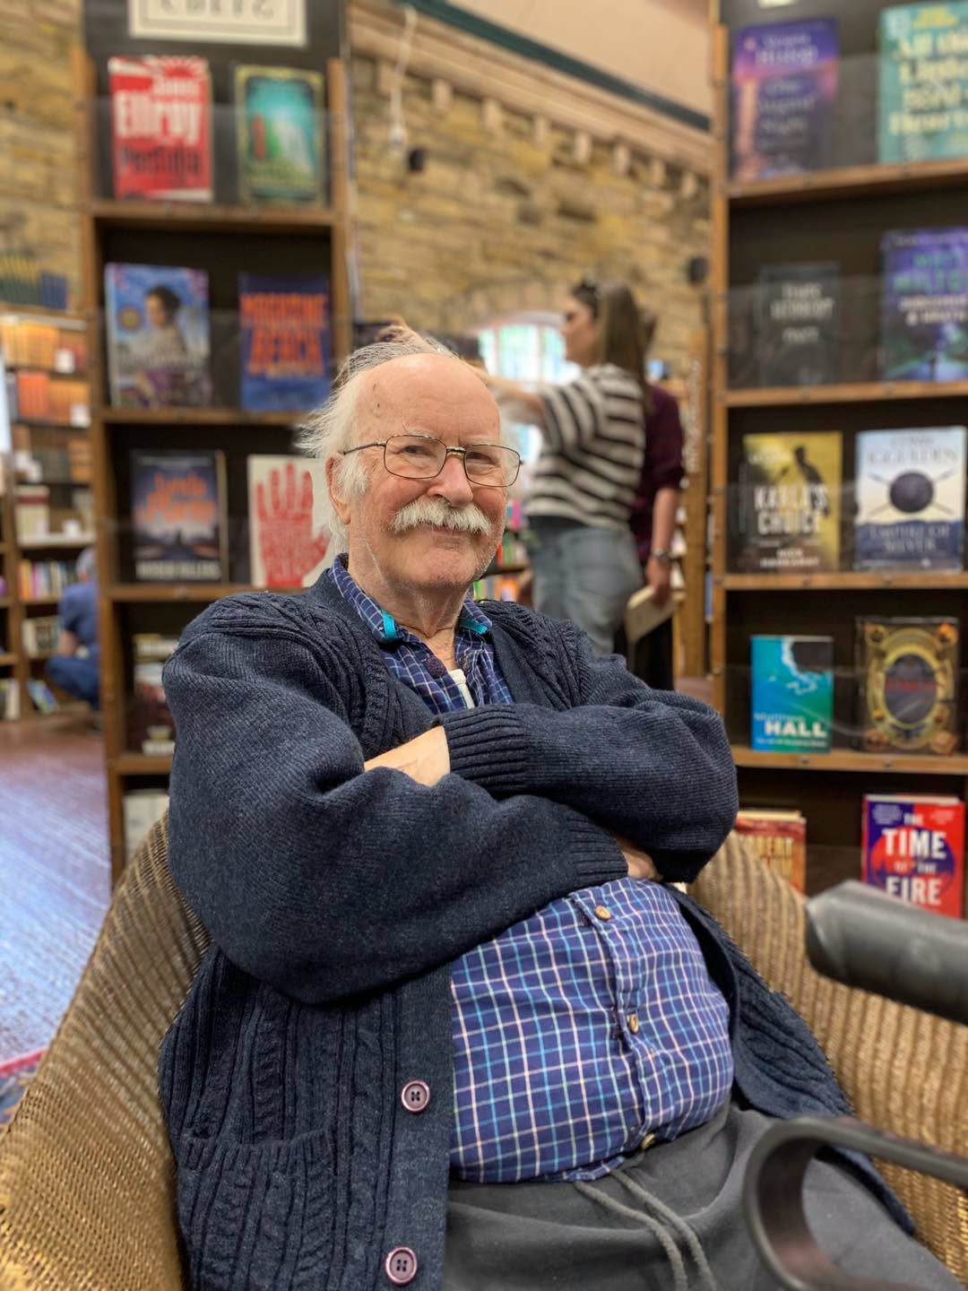

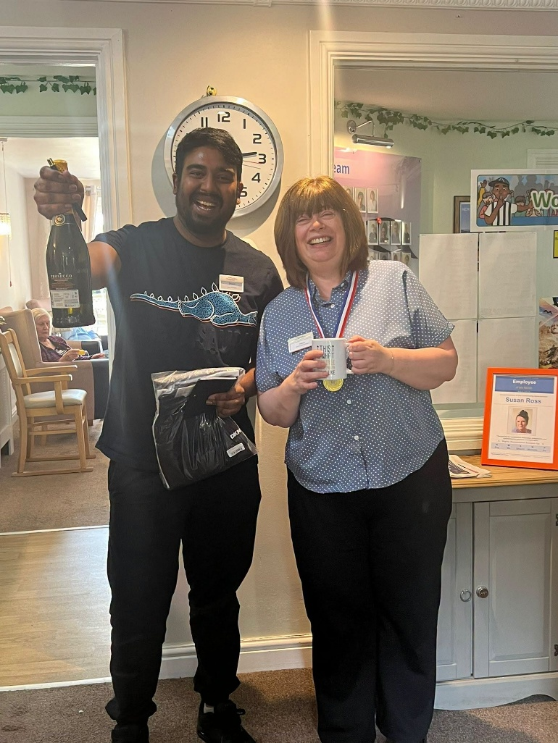

Upcoming Key Dates

Wednesday 1st July – We will be joined by Jack and his guitar, playing some traditional folk songs – 11am in the large lounge

Thursday 2nd July – We will join by the Puppets with their summer sing a long – 11am in the large lounge

Monday 6th July – we will be joined by John Fletcher with his Rat Pack session – 11am large lounge

Tuesday 7th July – We will be joined with Denise for her art and crafts session – 11am in the large lounge

Tuesday 14th July – We will be joined by singer Alex Hall – 11am in the large lounge

Wednesday 15th July – We will enjoy a trip out with some of the residents to the Dementia Gardens inCramlington in the afternoon

Contact details
If you have any questions in regards activities or any suggestions for future activities, please do not hesitate to contact me Michelle Holder via email at wellbeing@summerhillcare.com

