 | Summerhill Care Home
August newsletter
Welcome |  |  | 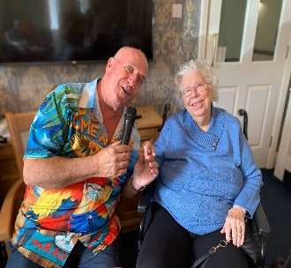
Welcome to August’s newsletter, we have had another busy month, we have also had a couple of trips out with more planned for September, everyone who is able have enjoyed getting out and about, hopefully the weather will continue to be kind to us.

It’s also been our Summer Party this month which went down well and we made £230 from the tombola and bake sale – thankyou to everyone that donated and bought on the day. All the bakes were made by Ruth and Myself and all proceeds go towards the resident’s fund.

We have plenty of singers in September, our residents appear to really enjoy their music as it brings back memories of their younger years.

Activities & Events
BIRTHDAY BOARD    Happy birthday to Myrna, she enjoyd her coffee cake and some time with her family |  | 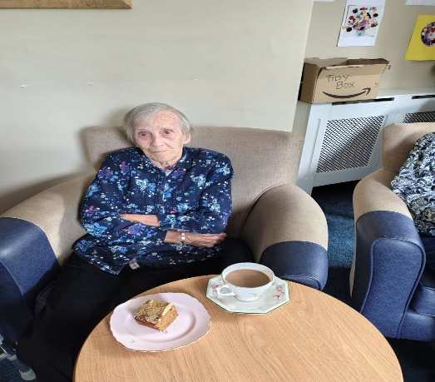  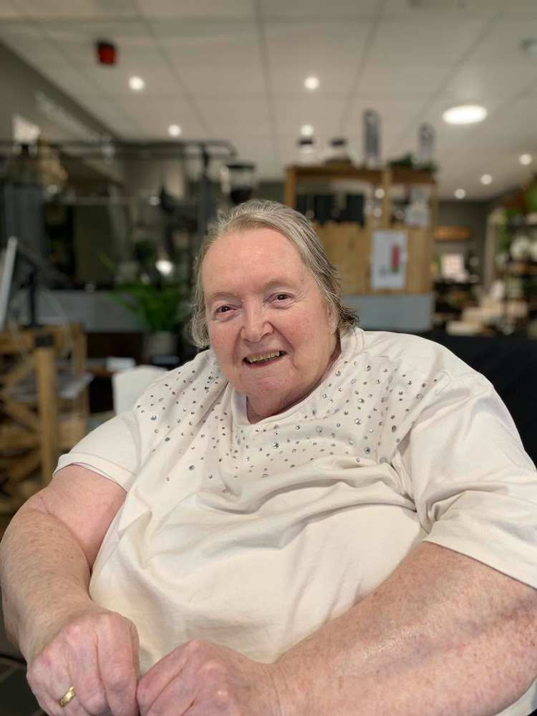  Linda had a wonderful afternoon, when I surprised her by taking her to the Running Fox and iviting her Sister along – It’s been at least 6 years that Linda was out with her sister and it was lovely listnening to the old stories and what they used to get up too    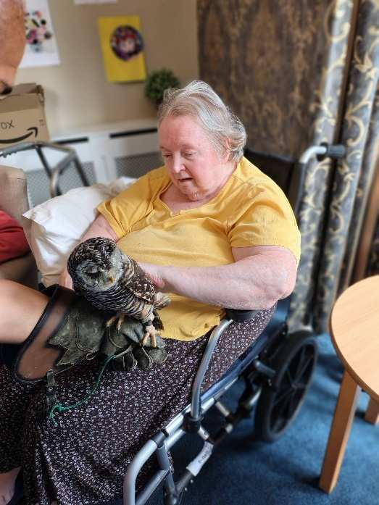  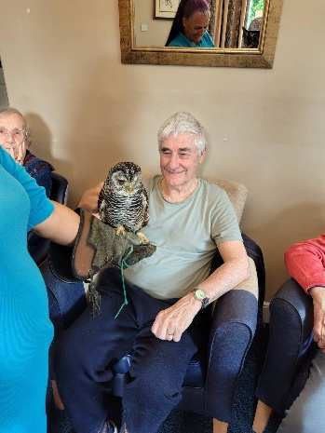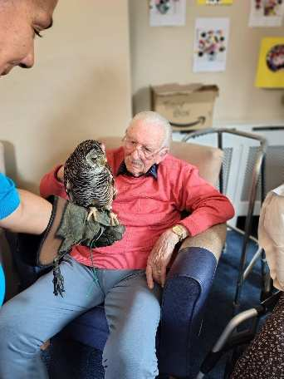  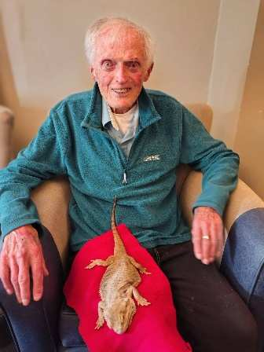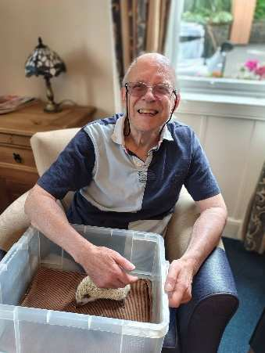  THE RESIDENTS ENJOYED A VISIT FROM ANIMAL ANTICS; IT WAS GOOD TO HAVE BRACKEN THE OWL VISIT ON THIS OCCASION AS THE RESIDENTS LOVE HIS SILKY FEATHERS  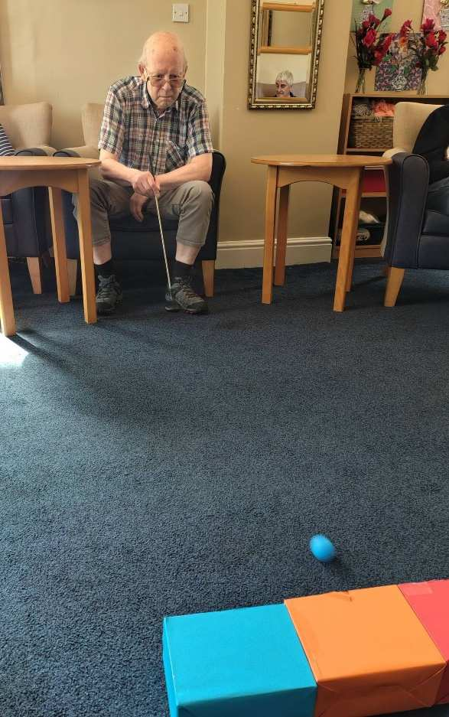  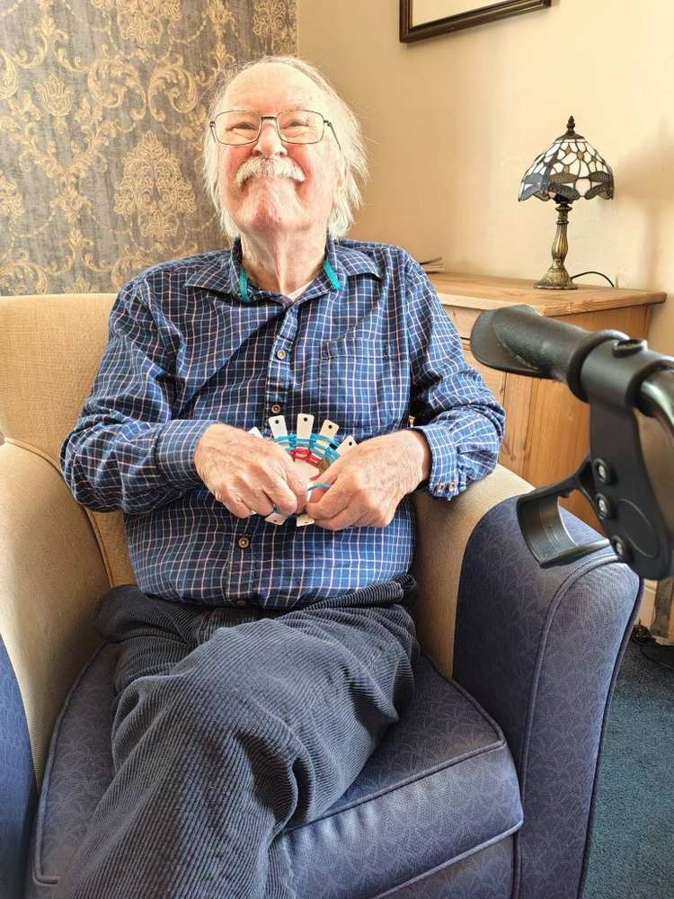  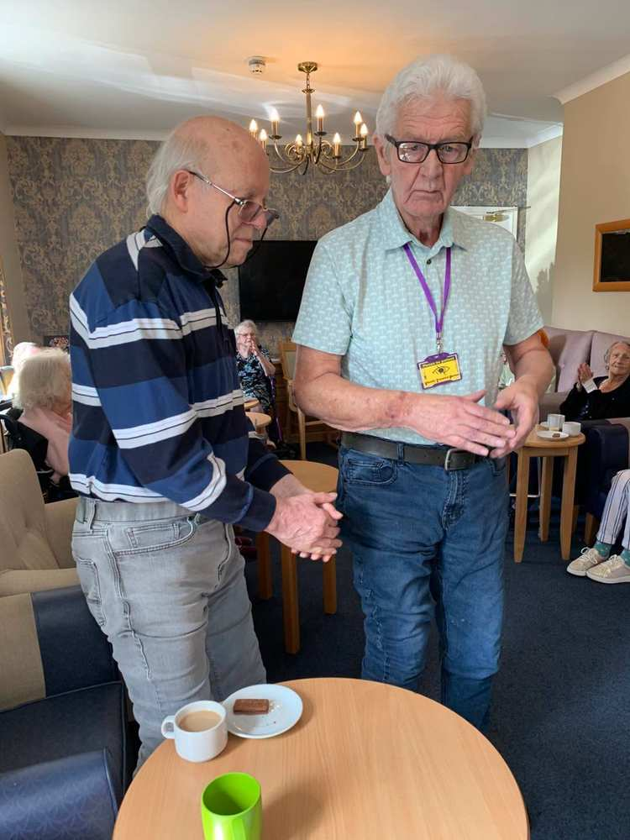  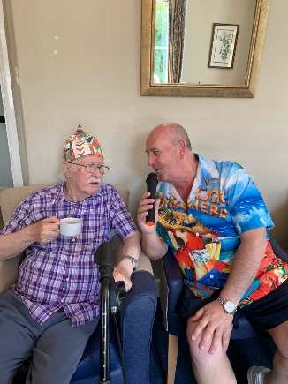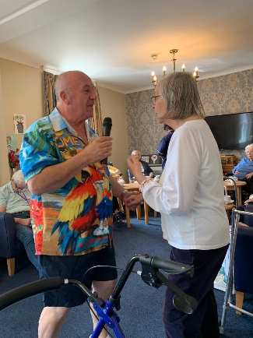  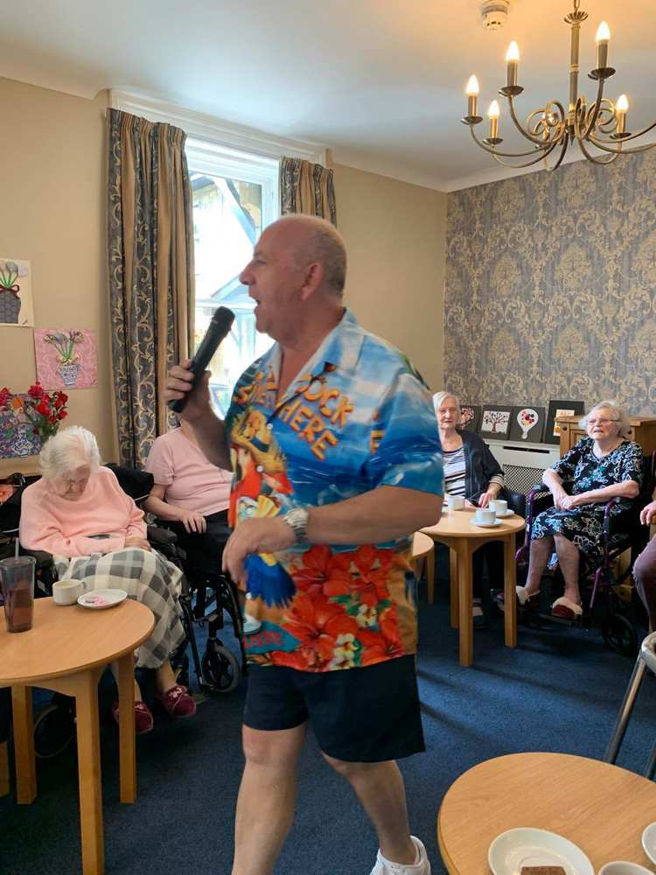  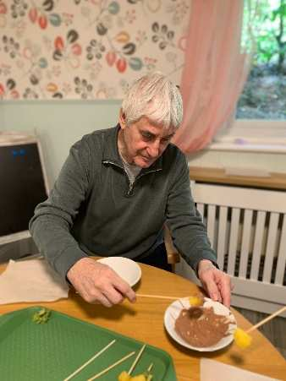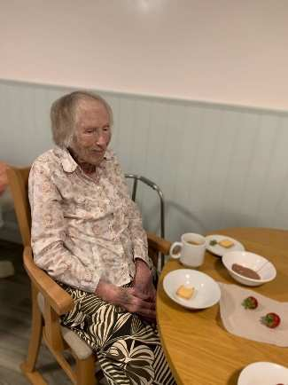  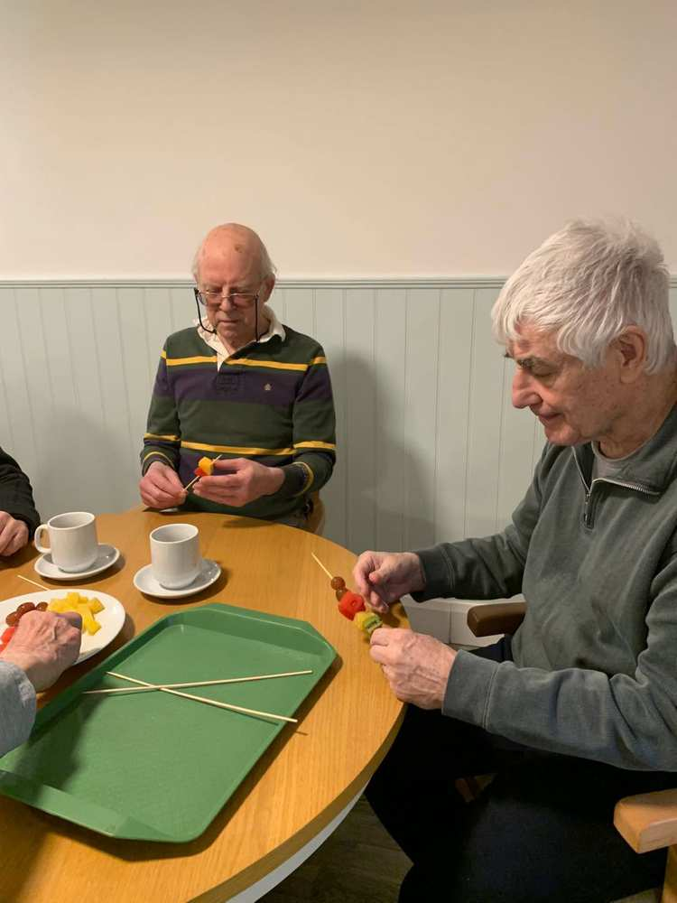  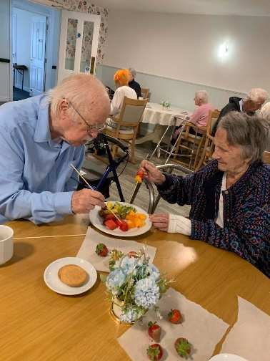  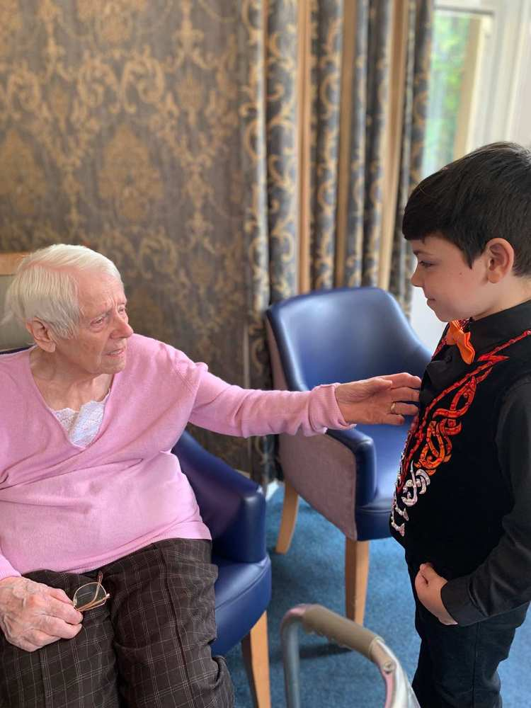  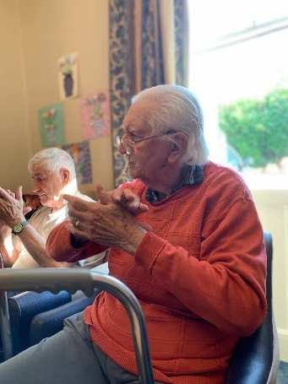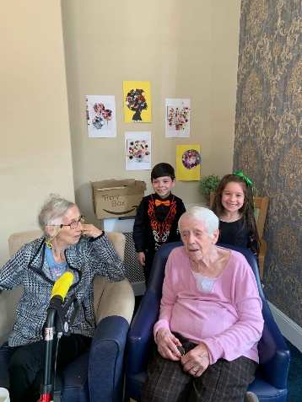  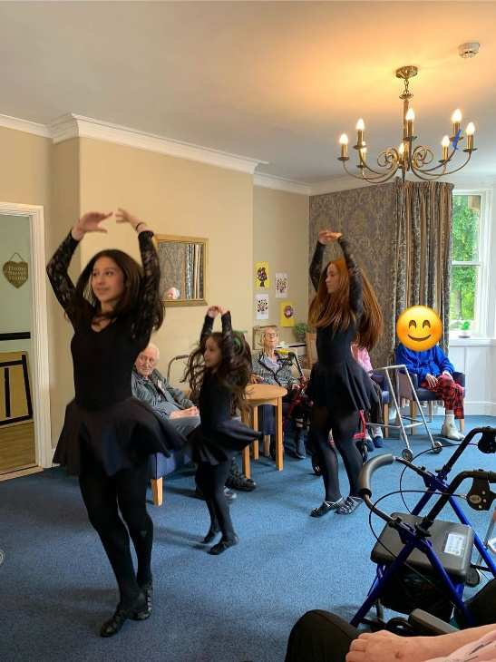  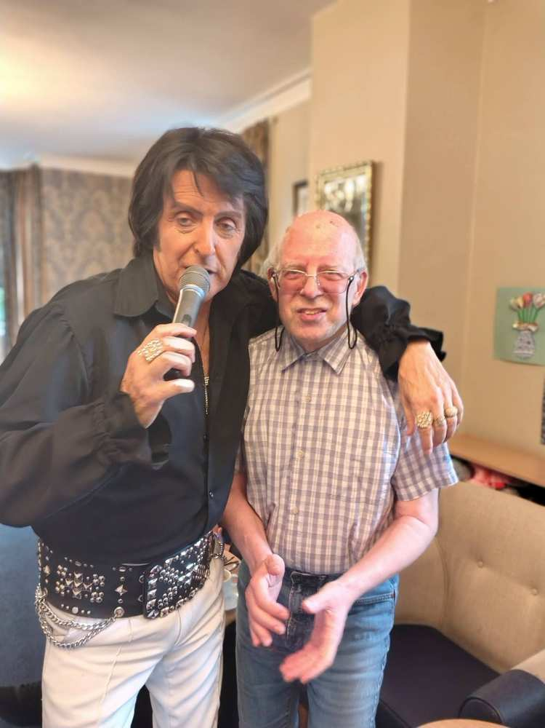  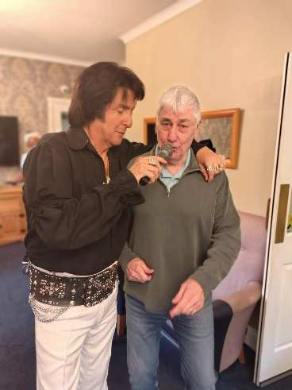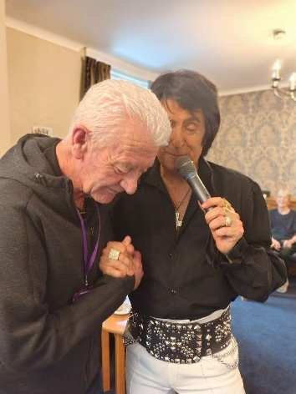    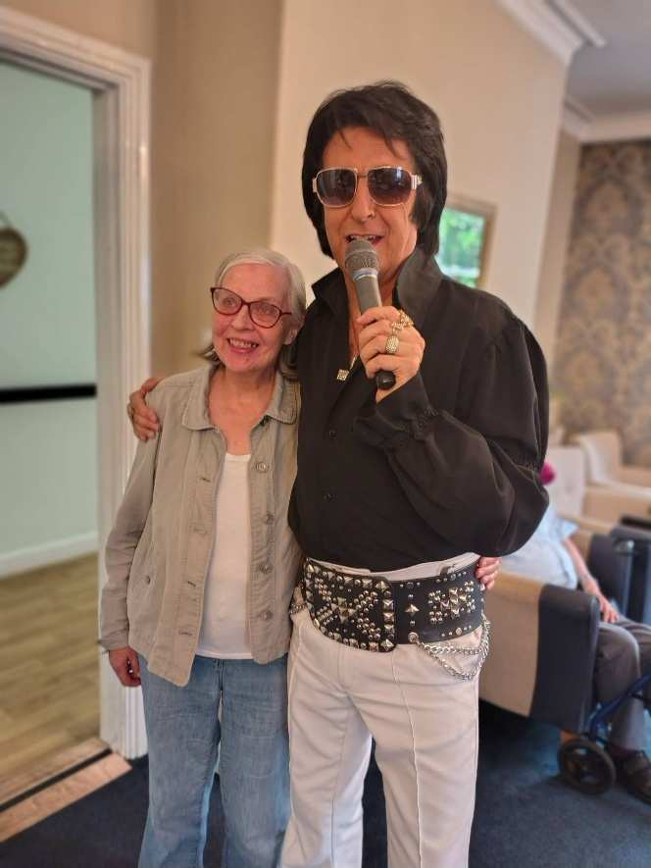  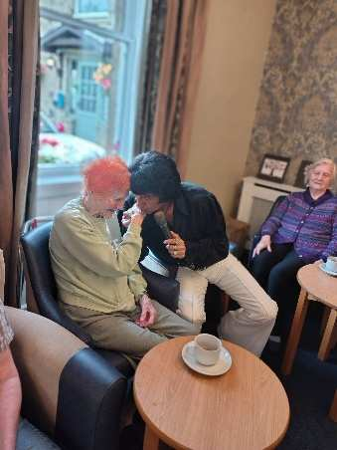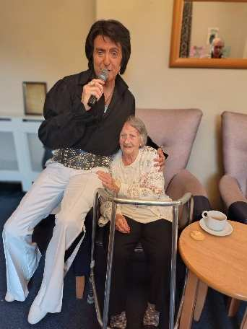  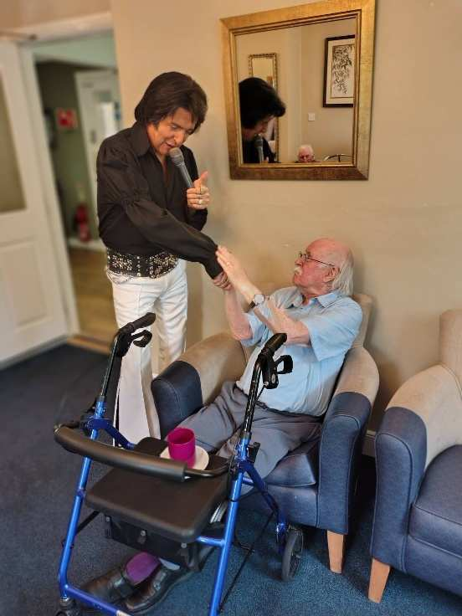  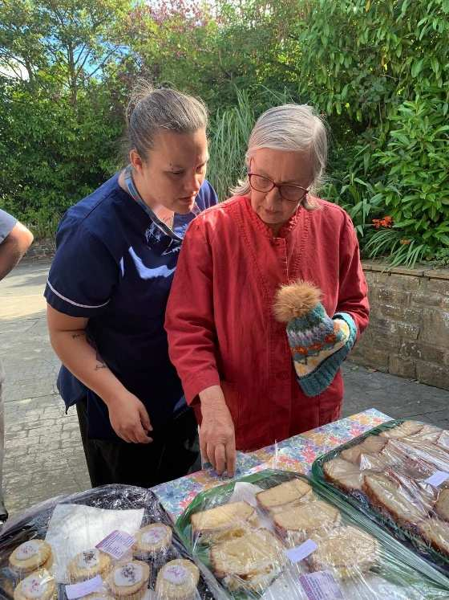  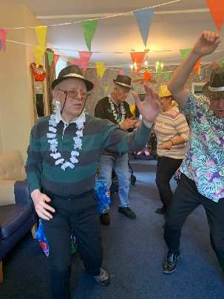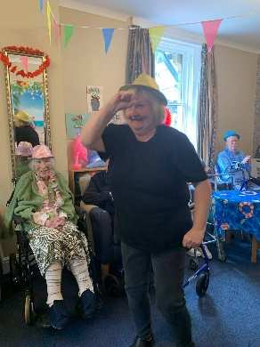  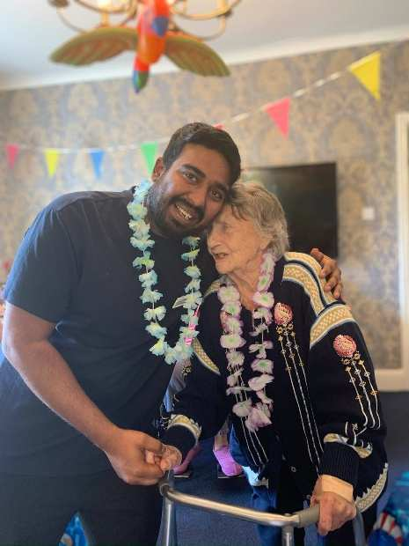  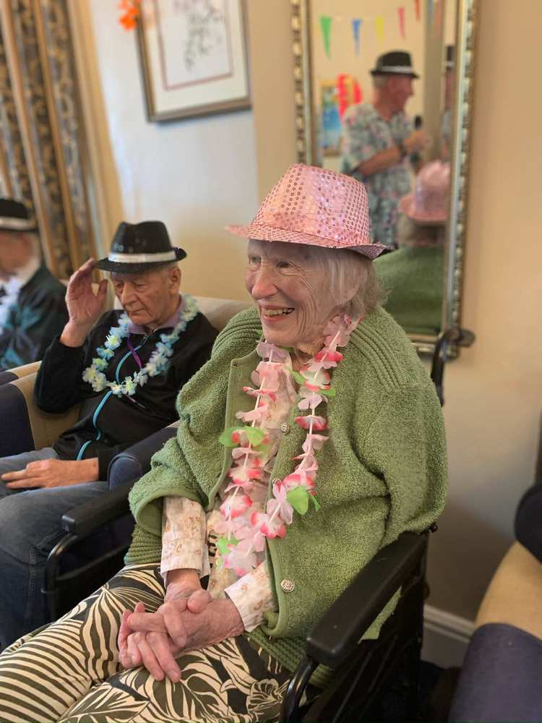  More fabulous pictures from our summer party  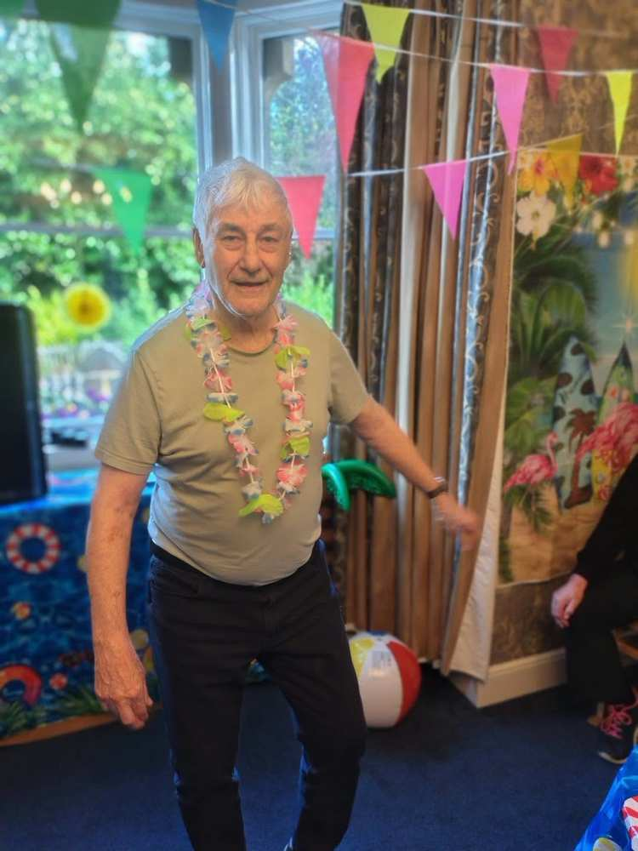  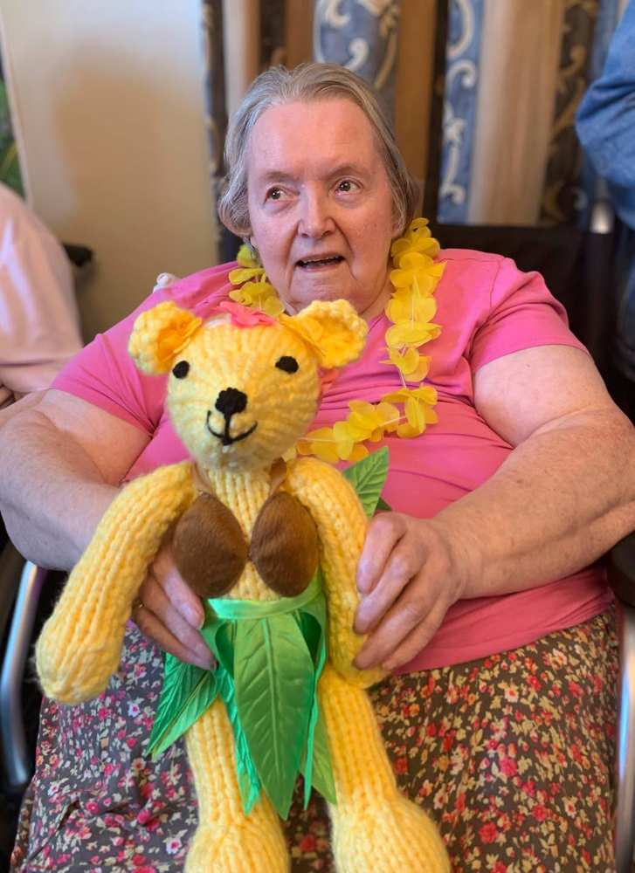  Linda won name the Teddy Bear – her name was Ellen   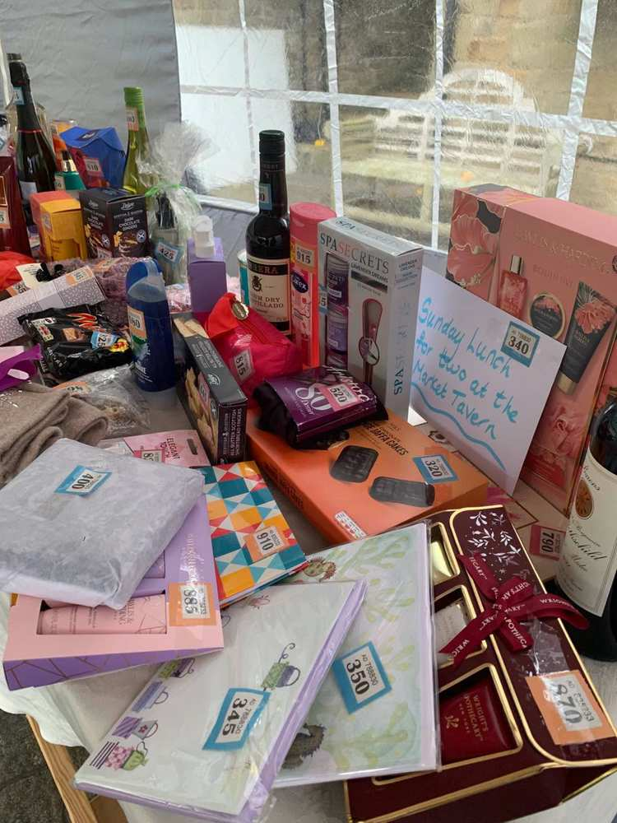  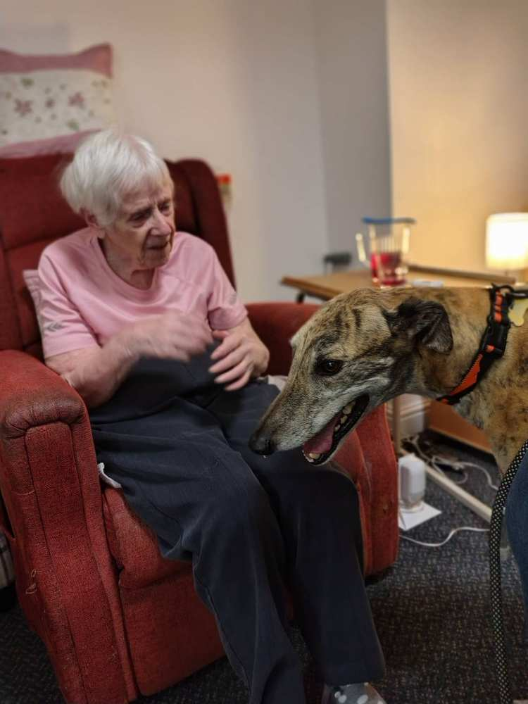  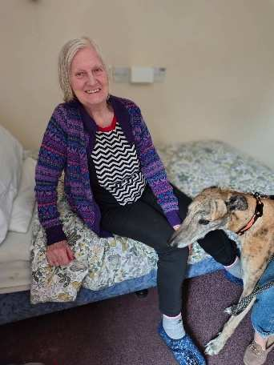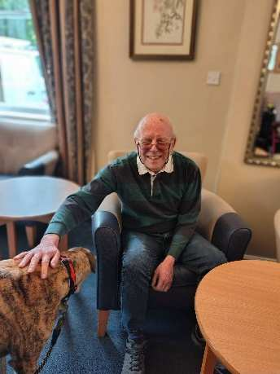  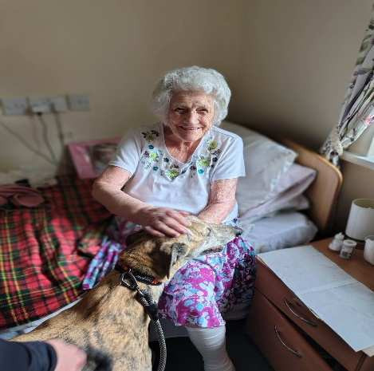  Lovely visit from our friend ship dog, King  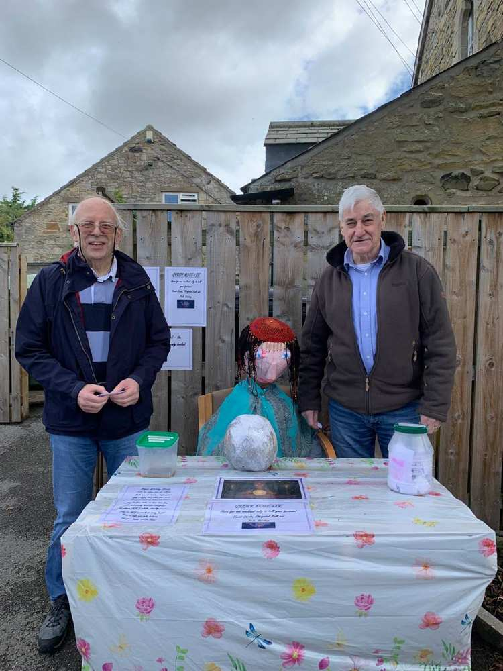    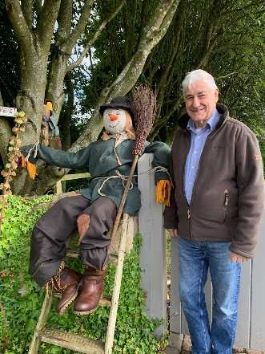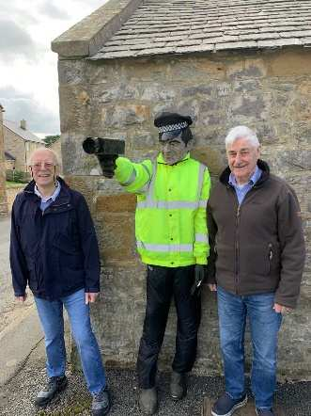  Tuesday 15th September – We will be joined by KL Pony – 11am in the large lounge  Friday 18th September – A few residents will enjoy a morning at Cragside  Monday 21st September – A few residents will enjoy a trip to the Maritime Museum  Tuesday 22nd September – We will be joined by Denise for an arts and craft session – 11am in the dining room  Wednesday 23rd September – We will be joined by Robert Whitehead playing his accordion – 11am in the large lounge  Monday 28th September – We will be joined by The Puppets for a Country music session – 11am in the large lounge  Tuesday 29th September– We will be joined by Fran for our monthly Church Service – 11am in the large lounge
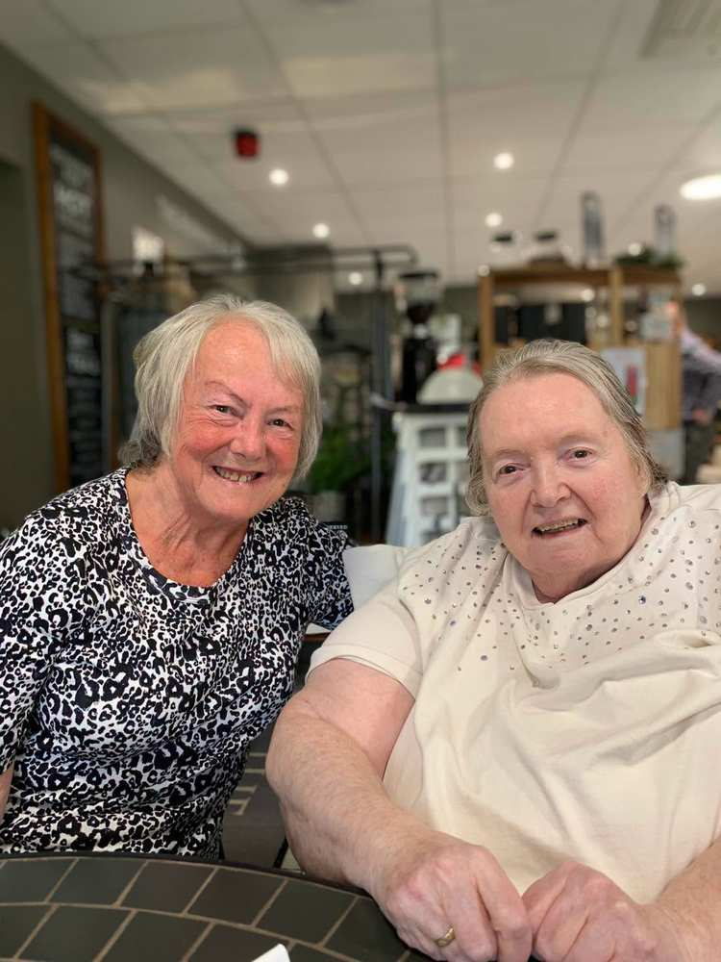

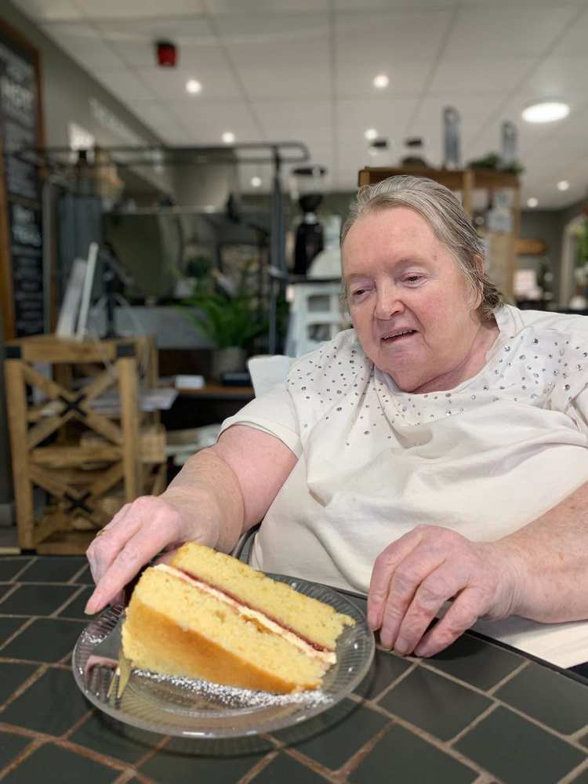

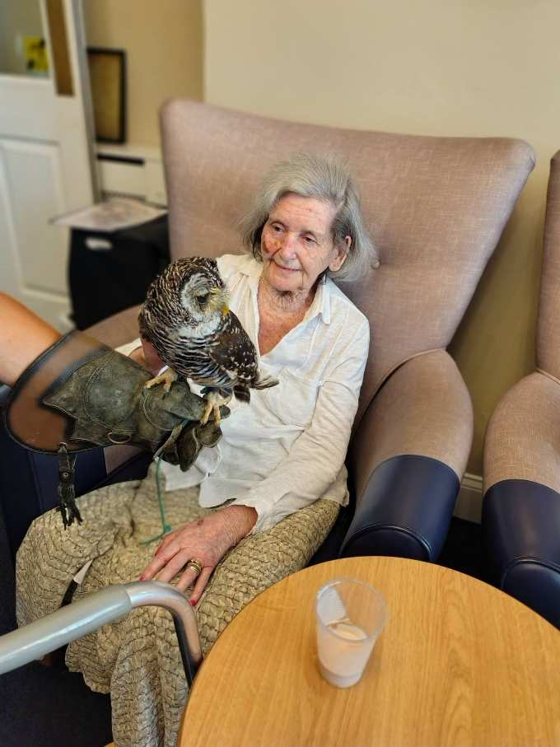

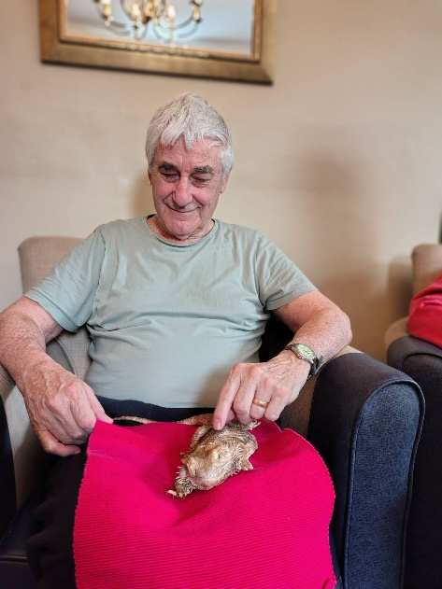

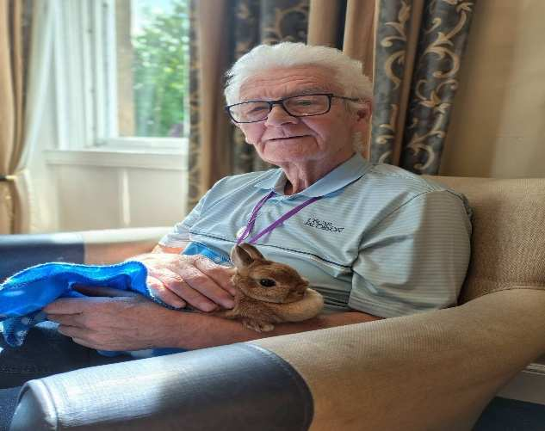

Fiona had some residents enjoying some summer games and some weaving – these kind of activities can inprove cognative function and memory recall, they also reduce stress, negative feelings and reduce feelings of isolation and loneliness

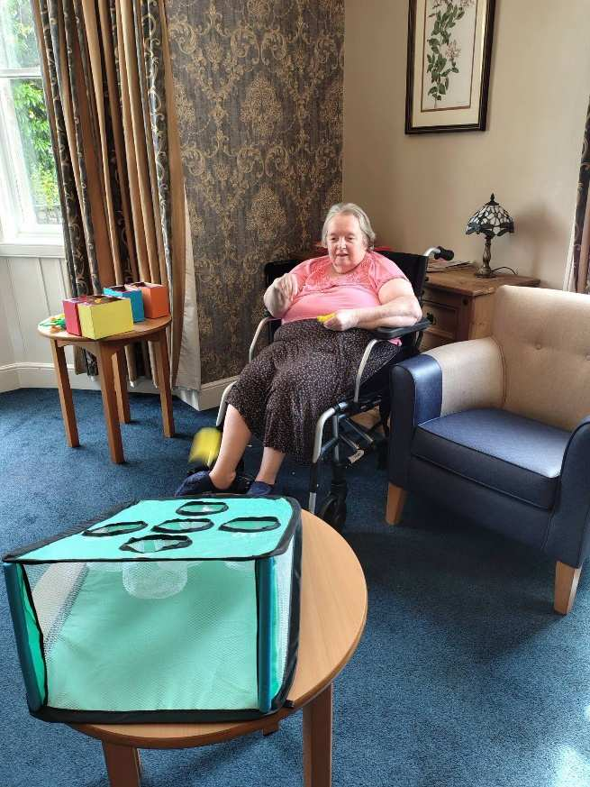

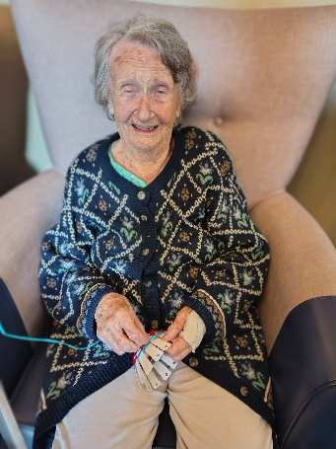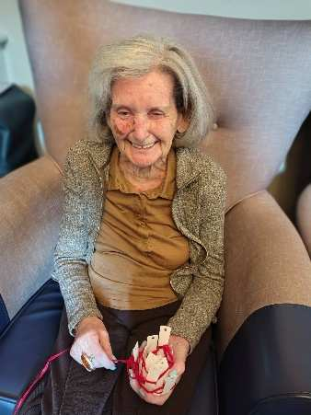

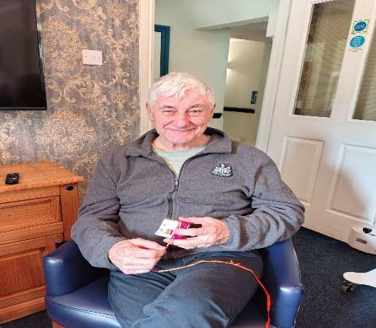
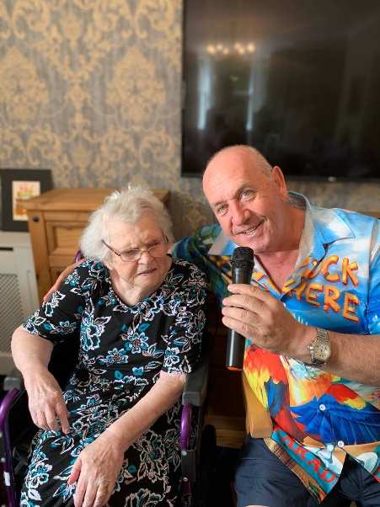

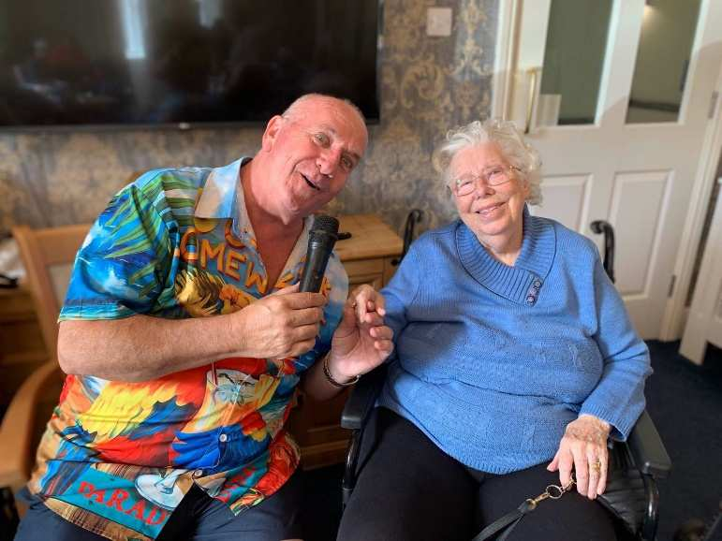

Kev The Carehome Singer joined us for a wonderful morning of old times tunes – the resident love having him here, kev is so relaxed and great with everyone

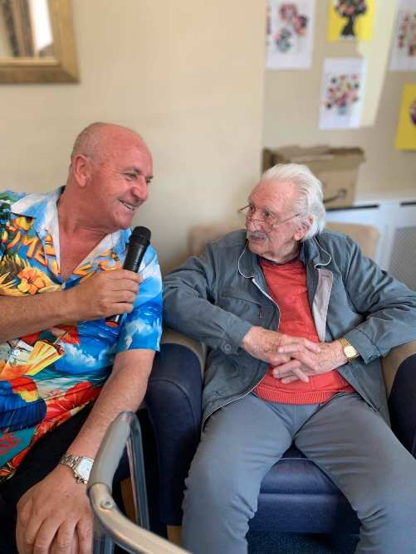
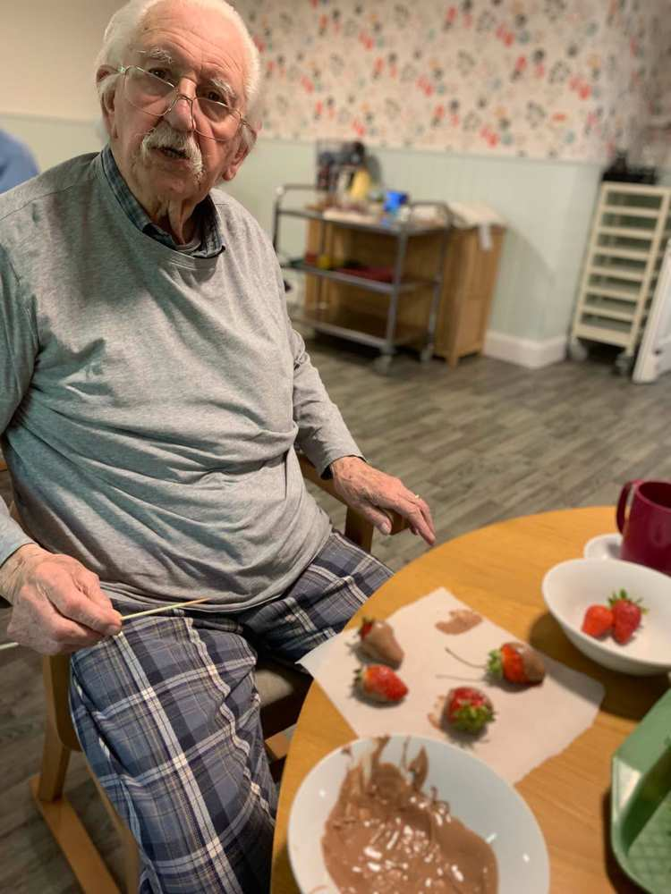

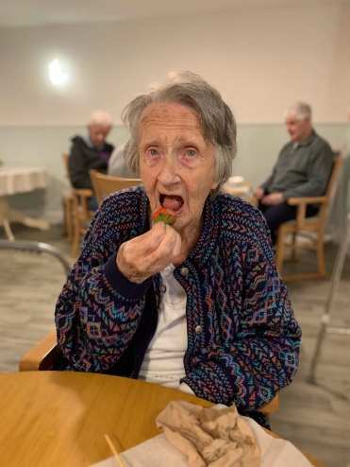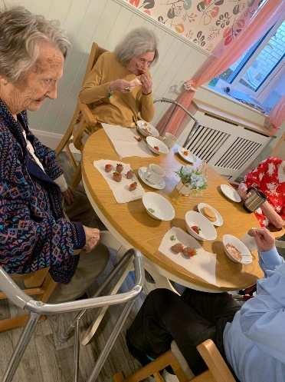

We had a great morning making fruit kebab’s and chocolate strawberries – I think more got eaten than made though


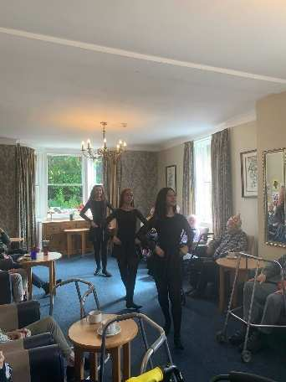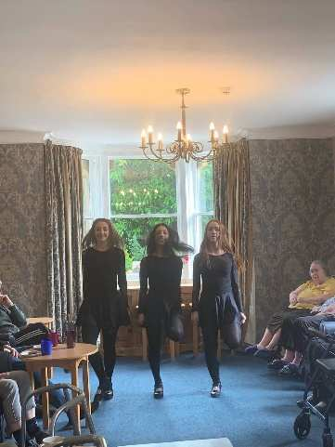

We enjoyed two visits from the Irish Dnacers this month – our residents really loved these sessions, especially the little ones – we look forward to having them back soon

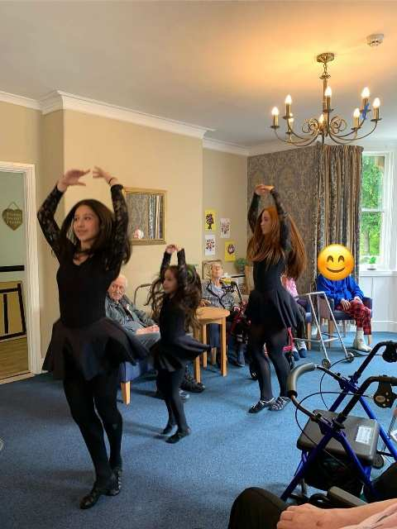

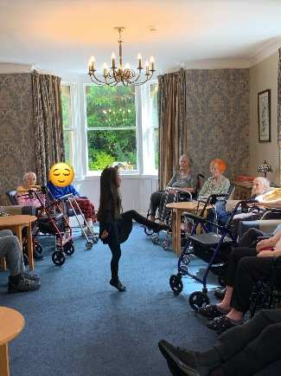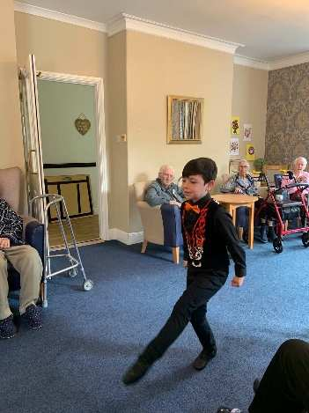

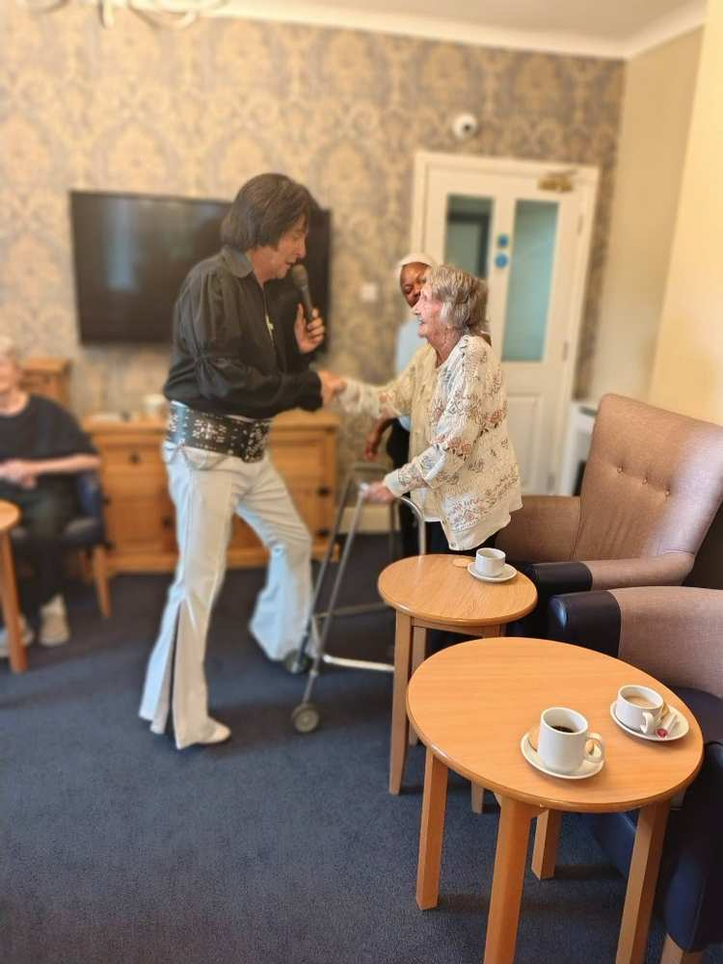

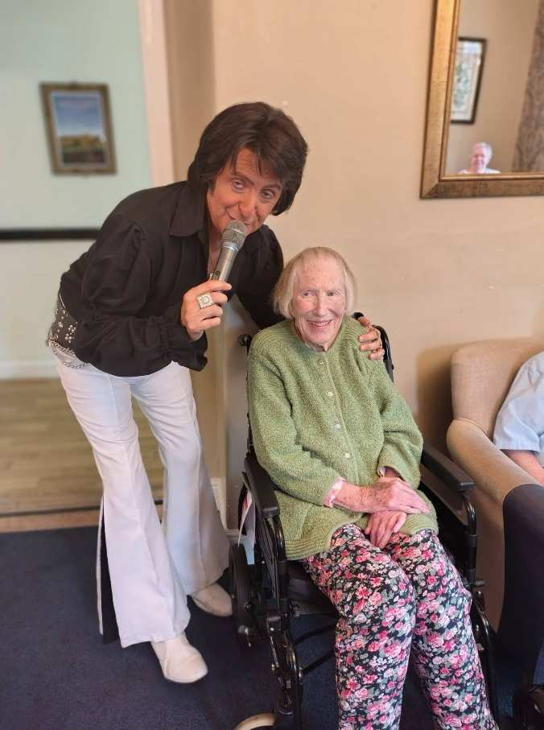

More great pictures from Elvis

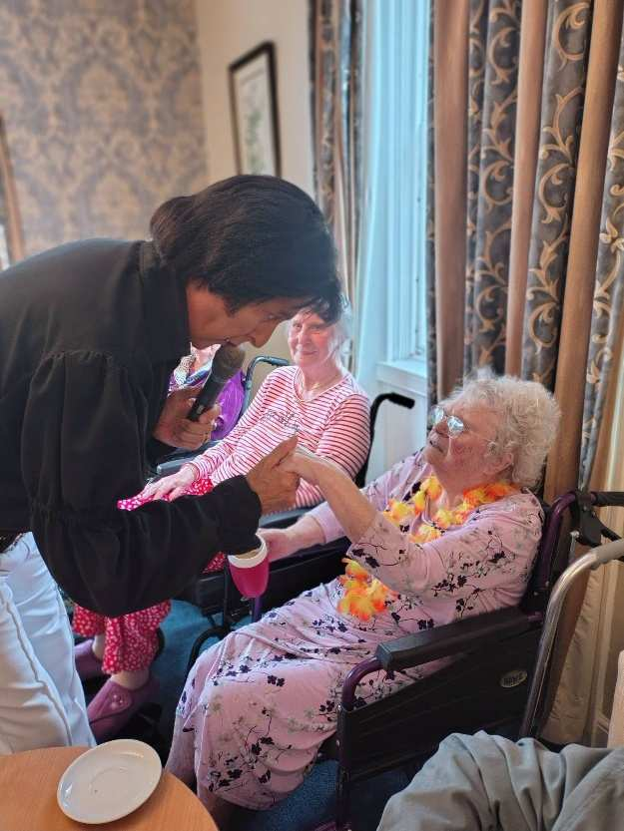

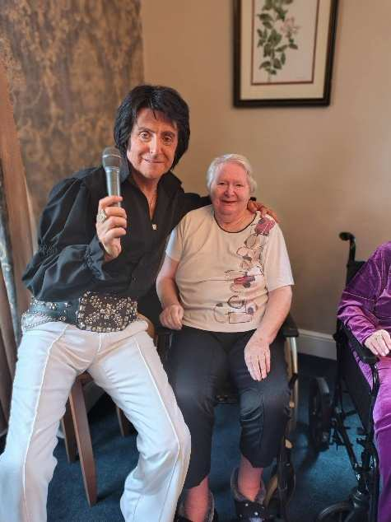

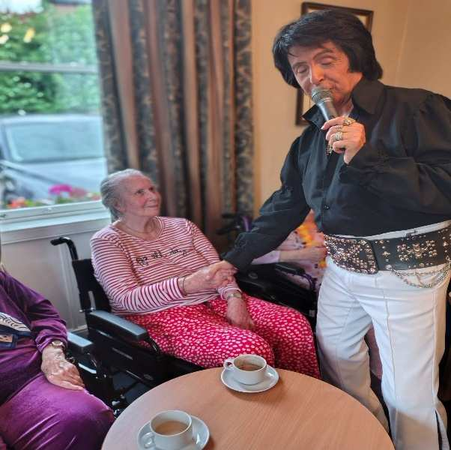

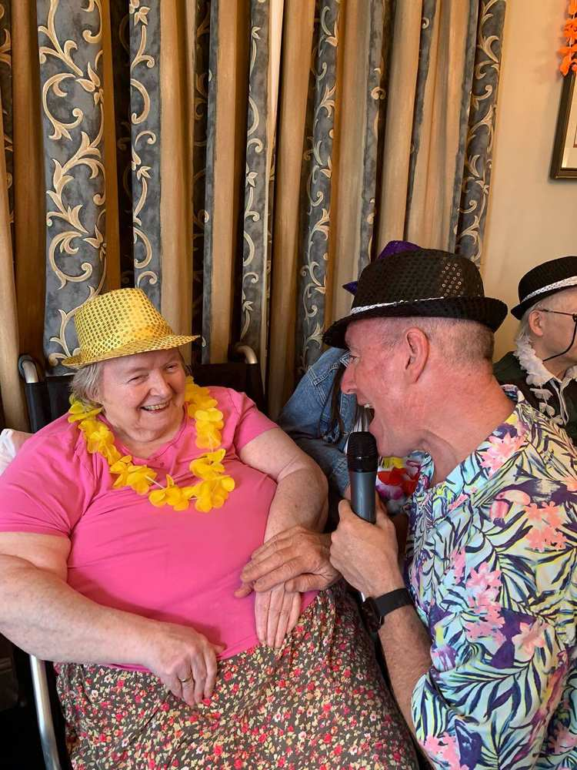

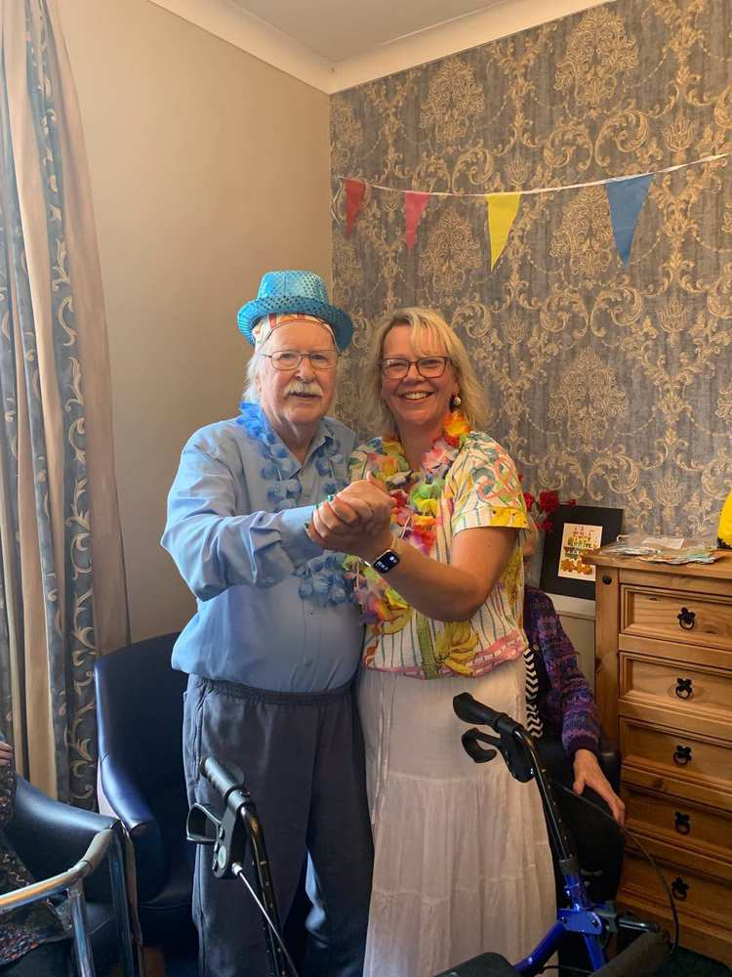

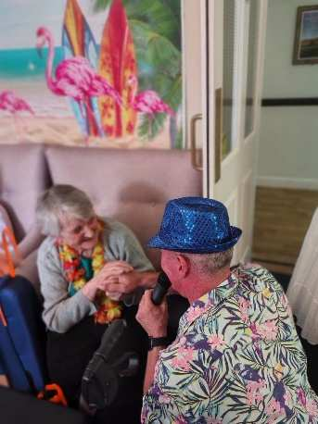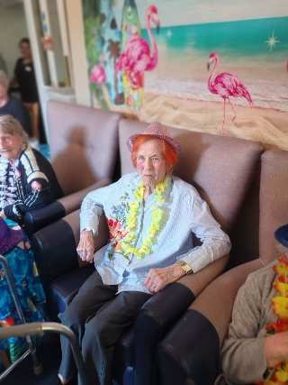

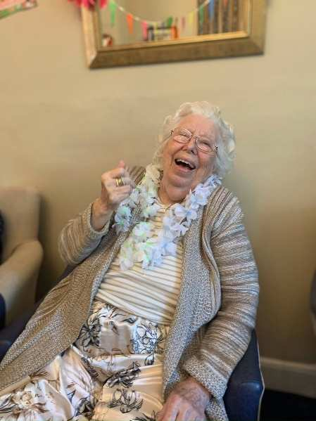

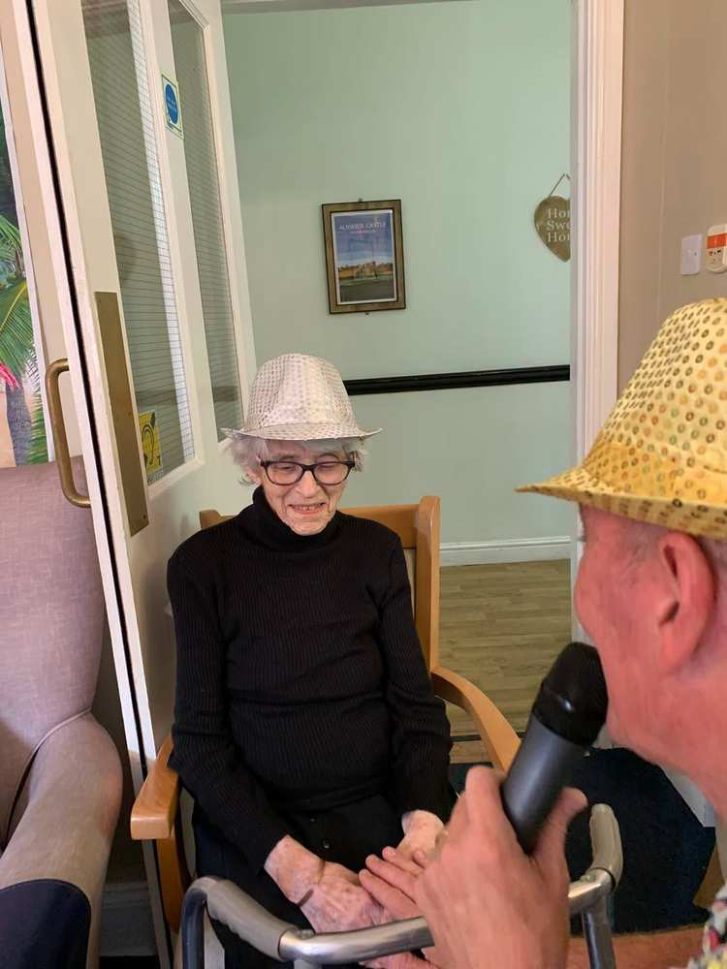

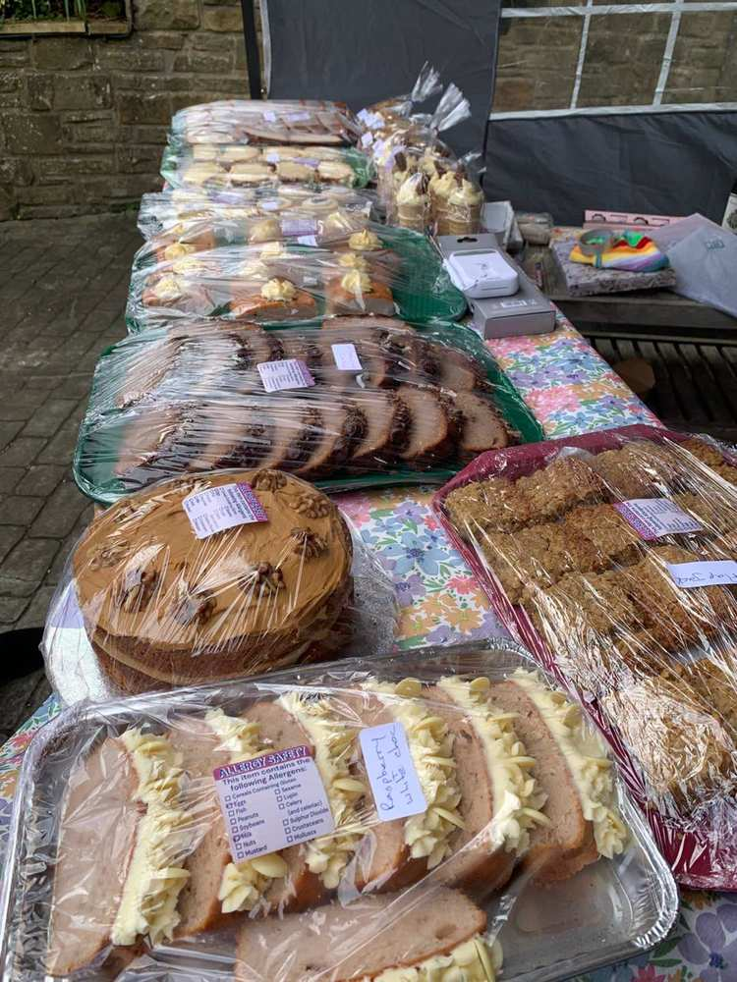

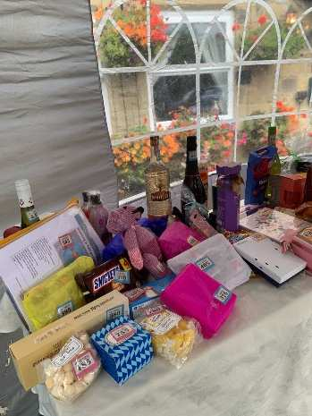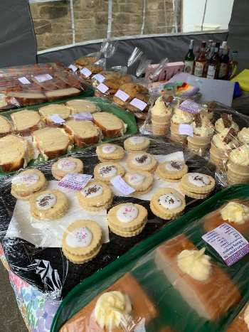

We made a fantasic £230 from the Summer Party, A massive thank you to Ruth, our residernt cook for all the bakes and to all those who donated for the Tombola.

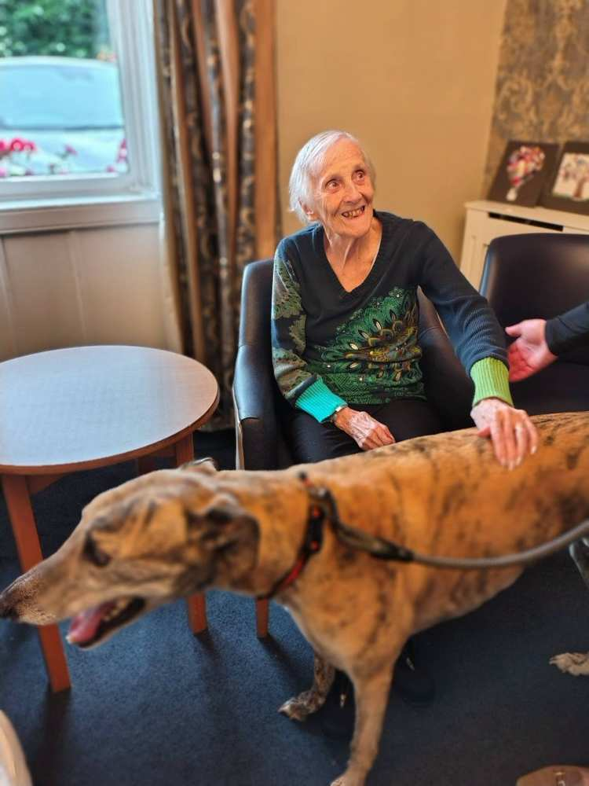

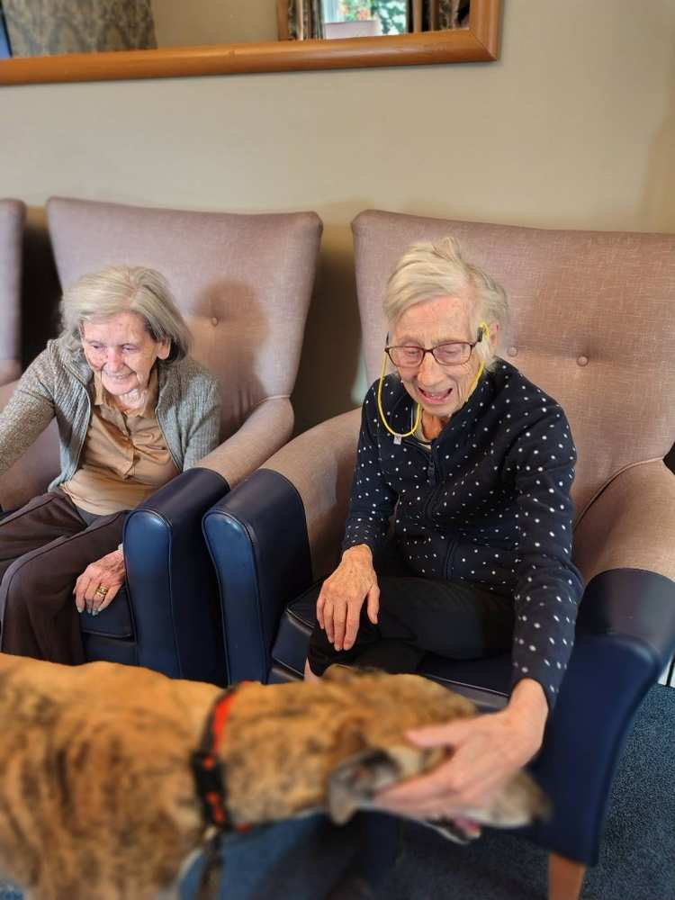

Tom and Michael enjoyed their morning at the Rennington Scarecrow Festival

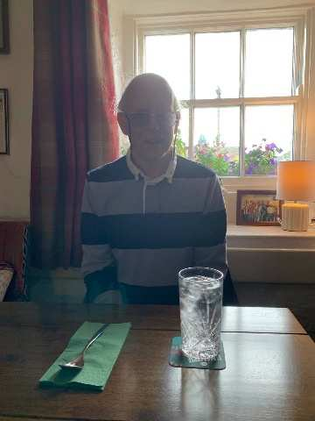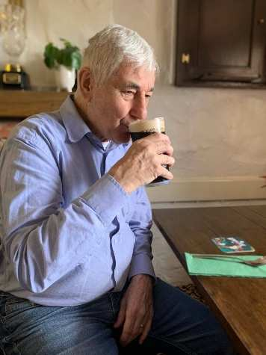

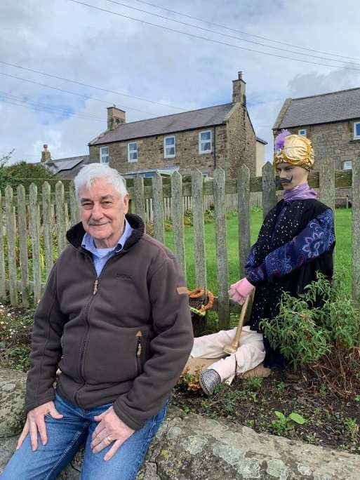

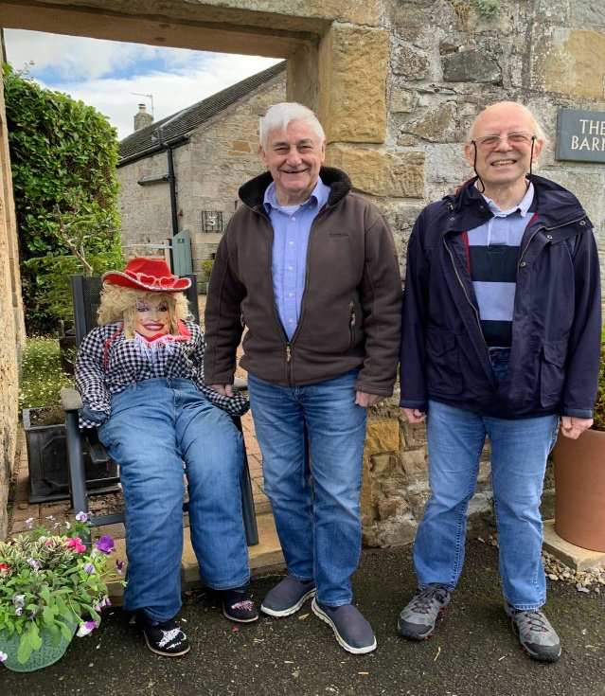

Upcoming Key Dates

Wednesday 2nd September – We will be joined by newcomer singer Gary James– 11am in the large lounge

Thursday 3rd September – we will be joined by singer Sam Naylor – 11am in the large lounge

Monday 7th September – we will be joined by Alan Cutler for some singing and tongue in cheek session– 11am large lounge

Tuesday 8th September– We will be joined by si– 11am in the large lounger Alex Hall – 11am in the large lounge

Thursday 10th September – We will be joined by Elvis – 2pm in the large lounge

Friday 11th September– We will be joined by Rat Pack singer John Fletcher – 11am in the large lounge

Contact details
If you have any questions in regards activities or any suggestions for future activities, please do not hesitate to contact me Michelle Holder via email at wellbeing@summerhillcare.com

